Mã đề 6.1.6 | ĐỀ KIỂM TRA GIỮA HỌC KÌ I  NĂM HỌC 2022-2023  MÔN : TIẾNG ANH 6 – THỜI GIAN 60’
- LISTENING Question 1. Listen then circle the right answers: A, B or C (1.0pt)
- Who went with Sarah?
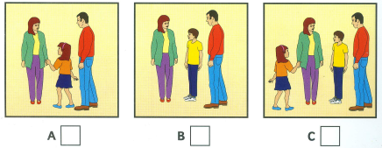
- Which is Sarah’s favourite present?
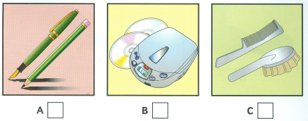
- What does Sarah like most at the circus?
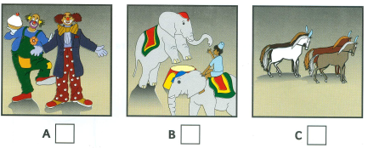
- How are they going to get there?
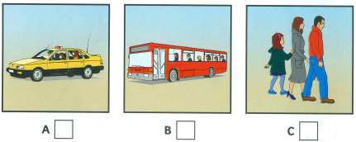
- What are they going to eat the the circus?
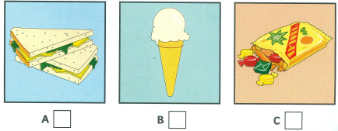
Question 2 . You will hear a conversation between 2 people. Listen and complete questions 1-5.
There’s one example (1.0pt)
Name: Mary Smith
1. How old ………………………….……….…………
2. Hair colour ……………………..…………:………..
3. Eye colour. …………………..:……….……………
4. How many brothers ………………:…………………
5. How many sisters: ………………..………………….
B- VOCABULARY & GRAMMAR
Question 1. Choose the option (A, B, C or D) that best completes each of the following sentences ( 3.0pts).
1. Tim: What's your new friend like? Bella: __________
A. She has blond hair B. She's very kind C. She's tall D. She’s black
2. Duong: Can you pass me the book, please? Phuc: “ ...................”
A. Yes, please B. Yes, sure C. Yes, I can D. No, I don’t mind
3. Nga: Would you like to have a picnic? Lan: “...........................................”
A. Oh, sorry, I can’t B. Yes, please C. No, I don’t D. No, I wouldn’t
4. My mother__________ the gardening every Saturday.
A. does B. works C. makes D. plays
5. Tommy: __________ bedrooms does your apartment have? Jenny: It has two bedrooms.
A. How many B. How C. Where D. What
6. The national library is__________ the bank and the hospital.
A. on B. in C. among D. between
7. There are many dirty clothes on the floor. It is such a _______ room.
A. messy B. tidy C. clean D. clear
8. __________ the right of the room, you will see a big bookshelf.
A. To B. In C. At D. Of
9. Nam is very smart. He always answers the teacher’s question well.
A. happy B. clever C. lazy D. hardworking
10. Hoa is a good friend. She always shares things with her classmate.
A. gives B. needs C. takes D. wants
11. This is Lan. house is new.
A. My B. Your C. Her D. His
12. After school, we often__________ basketball together.
A. do B. play C. have D. study
13. Don't be __________! Share your food with your brother, Sam!
A. confident B. lazy C. selfish D. happy
14. My best friend __________ big brown eyes and a round face.
A. has B. does C. gets D. takes
15. We do_________ in the gym every afternoon.
A. table tennis B. football C. judo D. homework
C. READING
I. Choose the best option marked A, B , C or D for each gap to complete the passage (1.5 pts)
Minh lives (1) _____ his parents in a lovely apartment in Ho Chi Minh City. His apartment is not very big (2) _____ it is comfortable. There are five rooms in the apartment: a living room, two bedrooms, a kitchen and a bathroom. The living room is the (3) _____ of all. The bathroom is very beautiful. It has a sink, a tub and a shower. The kitchen (4) _____ very modern and has everything: refrigerator, washing machine, dishwasher, gas cooker, electric stove, kitchen table, etc. Minh's bedroom is not large, but it is very bright and its colors are nice. Minh (5) _____ his apartment a lot.
1. A. in  2. A. but  3. A. big  4. A. be  5. A. like | B. on  B. and  B. bigger  B. is  B. likes | C. to  C. or  C. biggest  C. are  C. liked | D. with  D. so  D. smallest  D am  D. love
II. Read the passage carefully and choose the correct answer A, B , C or D for each question. (1.5 pts)
Hi, my name is Anna. There are six people in my family: my grandmother, my grandfather, my mother, my father, my elder brother and me. My grandparents are old and retired. They love gardening and doing morning exercise. My father is forty-one and he is a doctor. He works in a big hospital. My mother is thirty-eight. She is an Art teacher. She teaches in a secondary school. My elder brother is Jack. He is sixteen and he is a high school student. I'm ten and I'm the youngest in my family. Our family lives in a small but it's lovely. There is a living room, two bedrooms, a bathroom and a kitchen in my house. However, the thing I love best is the garden behind the house. I like to relax in the garden on weekends.
1. How many people are there in Anna’s family?
A. 5 B. 6 C. 7 D. 8
2. Who loves gardening and doing morning exercise?
A. Anna’s parents B. Anna’s grandparents C. Anna’s brother D. Anna
3. Where does Anna’s father work?
A. in a high school B. in a secondary school C. in the garden D. in a big hospital
4. How many rooms are there in Anna’s house?
A. seven B. six C. five D. four
5. What does Anna like to do on weekends?
A. relax in the garden B. do the housework
C. do morning exercise D. do gardening
C. WRITING
Question 1. Complete the second sentence so that it has the same meaning as the first one. (1pts)
- My house has five rooms, three bed rooms, a living room, and a bath room
=> There are …………………………………………….………………
- My favorite subject is English
=> The subject I like ………………………………………………….
3. My mother is a teacher
=> My mother works ………………………………………………
4. My house is in front of a stadium
=> There is a ………………………………………………………….
5. You don't need to bring candles
=> I think you don't ……………………………………………….
VII. Complete the sentences using the words given. (1.0 pts)
My friend’s name / Hoa. / She/ in/ Class 6B. / she/tall. / She/ have/ chubby face/ and/ short black hair. / She/ very friendly. / She/ often/ go to school/ bicycle./ She/ love/ sports. / Her favourite sport/ badminton. At home/ She/ often/ help/ her mother/ do/ the housework. / She/ always/ feel/ happy.

………………………………………………………………………………………………………………………………………………………………………………………………………………………………
======= The end ========

Mã đề 6.1.6 | HƯỚNG DẪN CHẤM KIỂM TRA GIỮA HỌC KÌ I  NĂM HỌC 2022-2023  MÔN: TIẾNG ANH 6- THỜI GIAN: 60’  Hướng dẫn chấm gồm 01 trang

PART | CONTENT | POINT
A. LISTENING | I. Listen write the name or numbers. (1pts)  1. A 2. C 3. B 4. A 5. B | 0,2/
A. LISTENING | II. Listen and give short answers to these questions. (1pts)  - 9 ( nine ) 2. BLONDE 3. Blue  4. 3 ( three) 5. 4 (four) | 0,2/
B. LANGUAGE | Choose the best option to complete each sentence. Circle A, B, or C. | 0,2/
  1. B | 2. B | 3. A | 4. A | 5. A
  6. D | 7. A | 8. A | 9. B | 10. A
  11. C | 12. B | 13. C | 14. A | 15. C
C. READING | IV. Read the following passage and mark the letter A, B, C, or D on your answer sheet to indicate the correct word or phrase that best fits each of the numbered blanks (1.5 pts) | 0,3/
  1.D | 2.A | 3.C | 4.B | 5.B
C. READING | V. Read the text about Anna’s house and mark the letter A, B, C, or D on your answer sheet to indicate the correct answer for each of the questions. (1.5 pts) | 0,3/
  1.B | 2.B | 3.D | 4.C | 5.A
D. WRITING | VI. Rewrite the sentences that is closest in meaning to each of the following questions, using the words given at the end of each sentence (1.0 pt)  1. There are five room in my house, three bed rooms, a living room, and a bath room  2. The subject I like best / most is English  3. My mother works as a teacher  4. There is a stadium behind my house  5. I think you don't have to bring candles. | 0,2/
 | VII. Complete the sentences using the words given. (1.0 pt)  ❶My friend’s name is Hoa. ❷ She is in Class 6B. ❸She is tall. ❹She has a chubby face and long black hair. ❺She is very friendly. ❻She often goes to school by bicycle . ❼She loves sports. ❽ Her favorite sport is badminton. ❾ At home, she often helps her mother do the housework. ❿She always feels happy. | 0,1/ correct clause (grammar, spelling, punctuation…)

- LISTENING
Part 1 (5 x 0.2 = 1pts)
Part 2 (5 x 0.2 = 1point)
- VOCABULARY - GRAMMAR – LANGUAGE FUNCTION (15 x 0.2 = 3 pts)

C. READING
Part 1.(5 x 0.3 = 1.5pts)
Part II. (5 x 0.3 = 1.5pts)
D. WRITING
Part I: Complete the sentences using the words given (5 x 0.3 = 1.5pts)
Part II. Write a short paragraph (80-100 words) about a person you love (1.5 pts)

Cách tính lỗi:
- 01 lỗi ngữ pháp (cấu trúc, từ vựng…) trừ 0,05
- 01 lỗi chính tả trừ 0,01
- Viết ít hơn số từ qui định trừ 0,2

KÝ HIỆU –CHÚ THÍCH
NB- Nhận biết
TH-Thông hiểu
NP- Ngữ pháp
TV- Từ vựng
VD- Th: Vận dụng - thấp
VD-C : Vận dụng- cao

