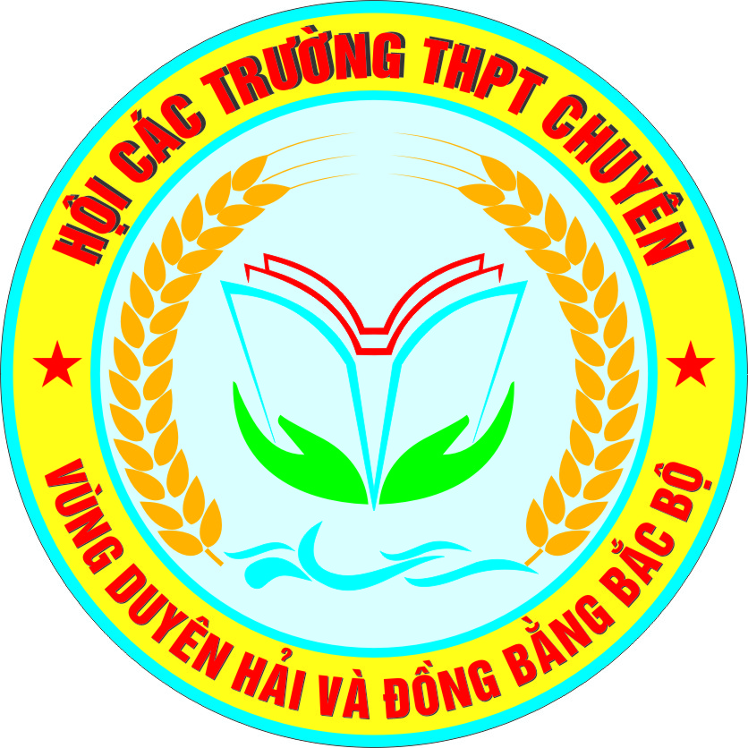  ĐỀ ĐỀ XUẤT | KỲ THI HỌC SINH GIỎI CÁC TRƯỜNG THPT CHUYÊN  KHU VỰC DUYÊN HẢI VÀ ĐỒNG BẰNG BẮC BỘ  LẦN THỨ XIII, NĂM 2023  ĐÁP ÁN ĐỀ THI MÔN: TIẾNG ANH 10  Thời gian: 180 phút (không kể thời gian giao đề)
A. LISTENING (50 points):
Part 1. Complete the notes below. Write NO MORE THAN THREE WORDS AND/ OR A NUMBER for each answer. (10 points)
1. health problems | 2. free entry | 3. peak | 4. guests | 5. photo card(s)

Part 2: Listen to part of a tutorial between two students and their tutor. The students are doing a research project to do with computer use. Listen and decide whether the following sentences are true (T) or false (F). Write your answers in the corresponding numbered boxes provided. (10 points)

1. False | 2. True | 3.False | 4. False | 5. True

Part 3. You will hear a radio interview with the gardening experts Jed and Helena Stone. Choose the answer A, B, C, or D which fits best according to what you hear. (10 pts)
1. C | 2. B | 3. D | 4. B | 5. C

Part 4. Listen to part of a talk and complete the sentences with NO MORE THAN THREE WORDS taken from the recording for each answer in the space provided. (20 points)

1. political satire | 6. charismatic teenaged
2. referring to tremors | 7. revoked the ban
3. utopian dream | 8. incubating in
4. against transient workers | 9. exquisite appeal
5. break the grip | 10. stark difference

B. LEXICO - GRAMMAR (50 points)
Part 1. Choose one of the words marked A, B, C, or D which best completes each of the following sentences. Write your answers in the corresponding numbered boxes. (20 points)
1. D | 5. D | 9. C | 13. D | 17. C
2. B | 6. D | 10. A | 14. D | 18. D
3. C | 7. A | 11. D | 15. A | 19. C
4. A | 8. B | 12. C | 16. C | 20. C

Part 2. Complete each of the following sentences with a suitable particle. Write your answer in the boxes provided. (10 points)
1. out | 2. up | 3. up | 4. into | 5. away
6. on | 7. up | 8. for | 9. out | 10. to

Part 3. Give the correct form of the words in brackets. Write your answers in the corresponding numbered boxes. (10 points)

1. recrimination(s) | 2. do-gooder | 3. mind-bendingly | 4. crack-up | 5. denominator
6. resounding | 7. artisanal | 8. undersigned | 9. aforethought | 10. searchingly

C. READING ( 60 points)
Part 1. (15 points- 1,5 points for each correct answer)
1. B | 2. A | 3. A | 4. C | 5. C
6. D | 7. B | 8. A | 9. C | 10. D

Part 2. (15 points- 1,5 points for each correct answer)
1. cultivated | 2. baffled | 3. insight | 4. property | 5. grip
6. glide | 7. repel | 8. keeps | 9. However | 10. right

Part 3. (15 points- 1,5 points for each correct answer)
1. C | 2. A | 3. B | 4. D | 5. C
6. B | 7. D | 8. A | 9. D | 10. A
Part 4. (15 points- 1,5 points for each correct answer)
1. NO | 2. NOT GIVEN | 3. YES | 4. NO | 5. YES
6. A | 7. F | 8. G | 9. E | 10. C

D. WRITING (50 points)

Part 1:

Content ( 8 points) | - Providing all main ideas and details as required  - Communicating intentions sufficiently and effectively
Language (8 points) | - Demonstration of a variety of vocabulary and structures appropriate to the level of English language gifted upper-secondary school students  - Good use and control of grammatical structures  - Good punctuation and no spelling mistakes  - Legible handwriting
Organization and Presentation (4 points) | - Ideas are well organized and presented with coherence, cohesion, and clarity  - The essay is well-structured
Part 2. Essay writing. (30 points)

Content (12 points) | - Providing all main ideas and details as required  - Communicating intentions sufficiently and effectively
Language (12 points) | - Demonstration of a variety of vocabulary and structures appropriate to the level of English language gifted upper-secondary school students  - Good use and control of grammatical structures  - Good punctuation and no spelling mistakes  - Legible handwriting
Organization and Presentation (6 points) | - Ideas are well organized and presented with coherence, cohesion, and clarity  - The essay is well-structured

TAPESCRIPT
Part 1: Cambridge IELTS 10 Test 1, part 2
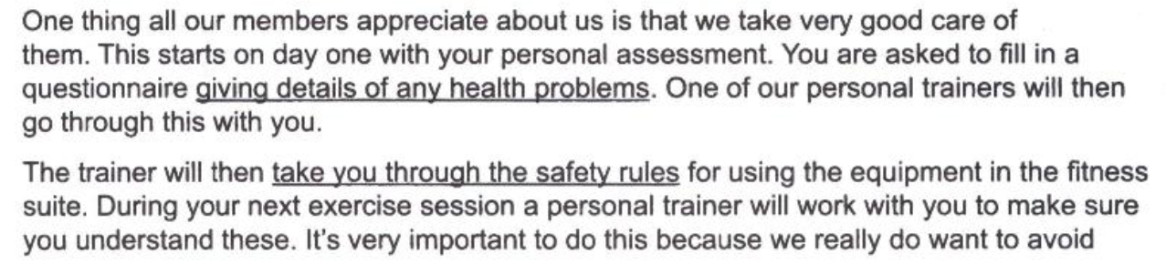
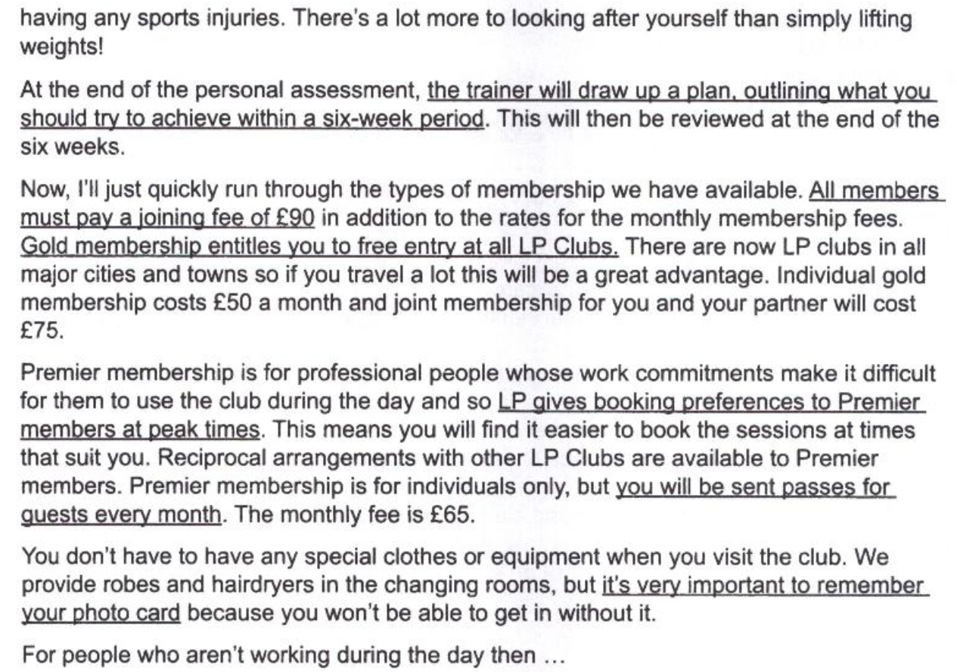
Part 2: https://www.npr.org/2023/04/24/1171570138/number-of-books-banned-or-challenged-up-in-2022-ala
MELISSA BLOCK, HOST:
Every year, the American Library Association releases a list of the top 10 books that people have tried to remove from school and library shelves. But this year, there are 13 titles on the list, and seven of them feature LGBTQ people. NPR's Tilda Wilson reports.
TILDA WILSON, BYLINE: For the second year in a row, Maia Kobabe's "Gender Queer" was the most challenged book. Kobabe talked to NPR in January about their graphic memoir, which details their journey to understanding their nonbinary identity.
MAIA KOBABE: I just kept feeling like I was trying on, like, clothes that didn't fit, and it was the biggest sort of concern of my specifically teenage years and early 20s - was just this, like - what am I? Where do I fit in all of this?
WILSON: Kobabe says their memoir was met with love and support when it was published in 2019. It didn't receive pushback until two years later.
KOBABE: I think what mostly surprised me was, like, the timing of it and then also the level of it.
WILSON: Lessa Kanani'opua Pelayo-Lozada is president of the American Library Association. She says that challenges to LGBTQ books like Kobabe's are part of a trend they've seen over the past couple of years, and the Library Association feels it's important to push back.
LESSA KANANI'OPUA PELAYO-LOZADA: We know that LGBTQ youth who feel seen and heard have reduced instances of self-harm, and so as a library, as an institution, as a community center it is our responsibility to make sure that our community feels reflected in our space and also has the opportunity to understand other points of view.
WILSON: Pelayo-Lozada says that doesn't mean a family shouldn't decide what's appropriate for their own kids.
PELAYO-LOZADA: But what is not right is for them to dictate what other families should read and other families should be exposed to.
WILSON: Nearly 40% more books were challenged last year than in 2021. But Pelayo-Lozada says these numbers are self-reported and likely underrepresent the total, yet a Library Association poll shows a majority of Americans don't believe in banning books. Tilda Wilson, NPR News, Washington.
(SOUNDBITE OF TAYLOR SWIFT SONG, "FEARLESS (TAYLOR'S VERSION)")
Part 3: Cambridge Advanced English 4, test 1, part 3
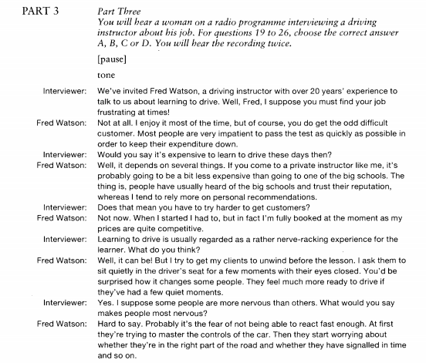
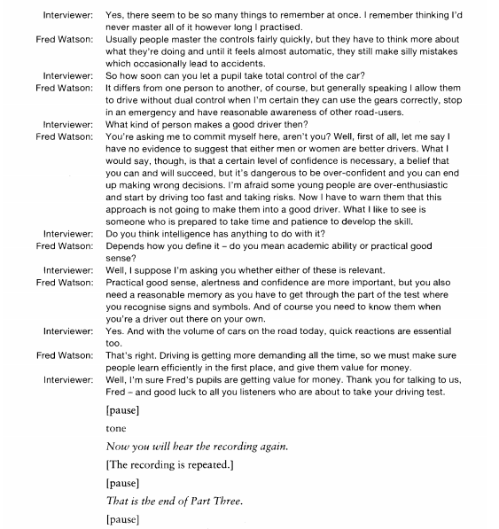
Part 4: Fresh air
This is FRESH AIR. Jess Walter's 2012 novel "Beautiful Ruins" was a best-seller set in Italy and late-Golden Age Hollywood. His other novels have ranged from political satire to literary suspense. Walter's new book, "The Cold Millions," is something else entirely - a sweeping historical novel about the Wobblies and a landmark free speech protest at the turn of the last century. Our book critic Maureen Corrigan has a review.
MAUREEN CORRIGAN, BYLINE: Mention the Wobblies to most Americans today, and they'll likely think you're referring to tremors. The Industrial Workers of the World, or IWW, as the Wobblies are more commonly known, were founded in 1905 as one big union to cut across all trades and industries. The Wobblies have had some notable organizing wins in recent years, but such an expansive union remains a utopian dream. America, I feel sentimental about the Wobblies, declared Allen Ginsberg in his incantatory poem "America," written in 1956.
Jess Walter, like Allen Ginsberg, also feels sentimental about the Wobblies. His new novel, "The Cold Millions," takes place in Spokane, Wash., in 1909 and 1910 and centers on the real-life free speech demonstrations that erupted in that city, pitting police and government officials against transient workers, many of whom identified as Wobblies.
Spokane had instituted a ban on public speaking in response to the orations of Wobbly organizers who were trying to break the grip of corrupt employment agencies in the city. The demonstrations drew some famous participants, among them, the charismatic teenaged Wobbly orator Elizabeth Gurley Flynn, whom the country would come to know as the Rebel Girl. She and more than 500 protesters were jailed before the city revoked the ban, making Spokane an early triumph in the long history of free speech battles in the U.S.
"The Cold Millions" is a novel that's been incubating in Jess Walter's imagination for years, predating his 2012 bestseller, "The Beautiful Ruins." That novel, set in an Italian fishing village, was an exquisite appeal to escapism whereas "The Cold Millions" is politically engaged. Consider the stark difference in setting alone. Spokane in 1909 attracts not a sprinkling of rich American tourists but a flotilla of men looking for work. Here's the Whitmanesque catalogue that opens "The Cold Millions."

