Period
LESSON PLAN
TIẾNG ANH 10 FRIENDS GLOBAL
UNIT INTRODUCTION
LESSON D: GRAMMAR
ARTICLES
I. OBJECTIVES:
By the end of the lesson, Ss will be able to:
1. Knowledge:
- Get some more knowledge to talk about articles; There is / are
- Vocabulary: to describe the school in the future
2. Ability:
- main skills: speaking skills
- sub skills: reading and writing skills
- Describe the school in the future
- To use articles; There is / are
- Ask and answer about school subjects
3. Quality:
- have positive attitude in English language learning so that they can participate enthusiastically in all classroom activities, especially with the topic conducted by the teacher
- know how to describe the school in the future
II. TEACHER AIDS AND LEARNING MATERIALS:
Lesson plan, PPT slides, student’s book, workbook, notebook, personal computer (if any), projector/TV. Speakers, IWB software.
III. PROCEDURES:
A. Warm-up (10’)
a) Objective: Introduce the new lesson and set the scene for Ss to acquire new language; get students' attention at the beginning of the class by means of enjoyable and short activities as well as to engage them in the steps that followed.
b) Content: Warm-up game
c) Outcomes: Students can gain more confidence and interest in the lesson
d) Competence: communication, guessing
e) Organisation of the activity:
TEACHER’S ACTIVITIES | STUDENT’S ACTIVITIES | CONTENTS
Warm-up (10’) T-Ss- T/ Ss – Ss  - T shows the class the pictures  - T asks the class the question “What are the students wearing on the face?”  - Shows the students picture of the paragraph and the instructions  - Shows the questions  - Have students to discuss the topic | - Look at the pictures  - Answer the question  - Look at the picture and read the instructions  - Read the questions  - Discuss the topic | Answer:  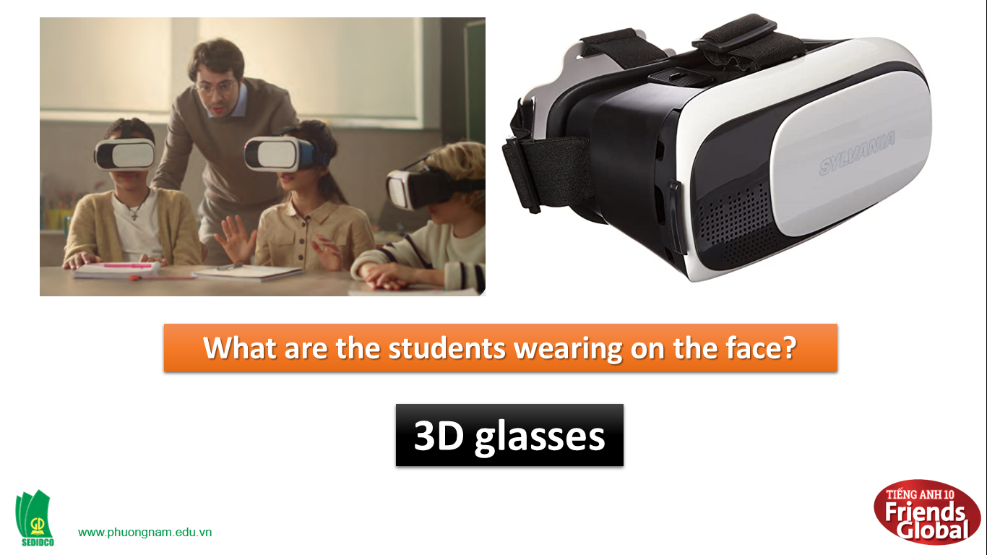  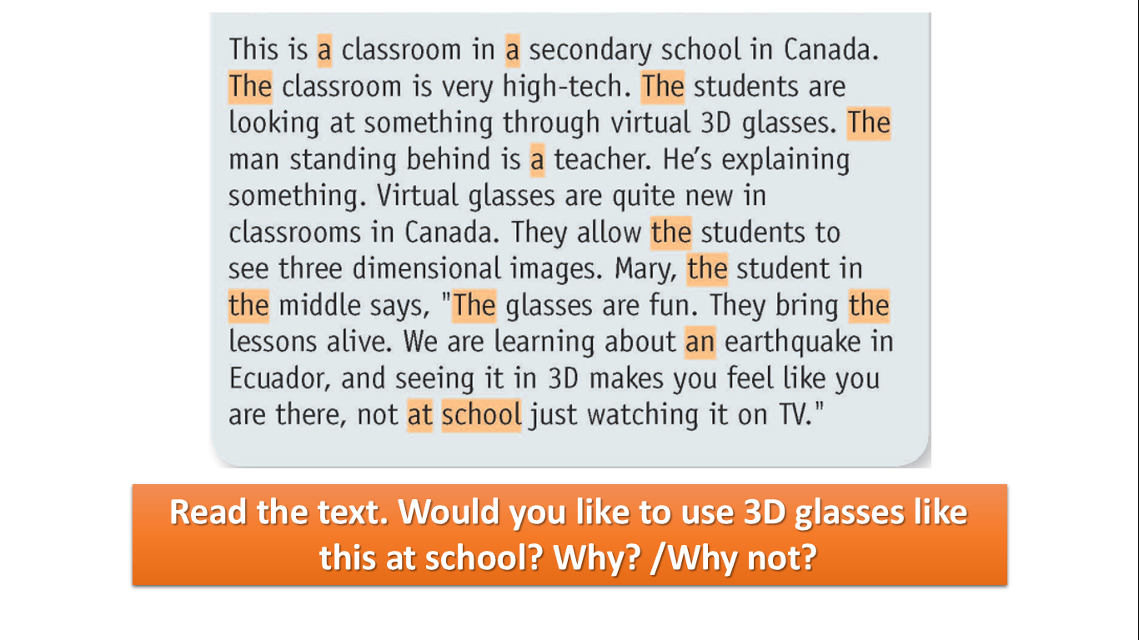

B. New lesson (30’)
- Activity 1: Grammar (10’)
a) Objective: Ss know more about articles;
b) Content:
Grammar points: a/an/the
c) Outcomes: Ss know how to pronounce the new words precisely and use them in appropriate contexts.
d) Competence: communication, collaboration, presentation
e) Organisation of the activity:

TEACHER’S ACTIVITIES | STUDENT’S ACTIVITIES | CONTENTS
PRESENTATION. T -Ss- T/ Ss- Ss/ Individual  Activity 2 (10’): Read the Learn this! box. Complete the rules with a /an, the, or no article (-).  - Show the students the Learn this! box  - Have the students to work in group of 4  - Goes around to help when needed.  - Shows the students the correct answers  - Give the students more explanations about the rules of articles if needed | - Look at the Learn this! box  - Work in group of 4  - Ask for help  - Compare answers with the teachers, and write down the correct answers  - Listen to the teacher’s explanations | Answers:  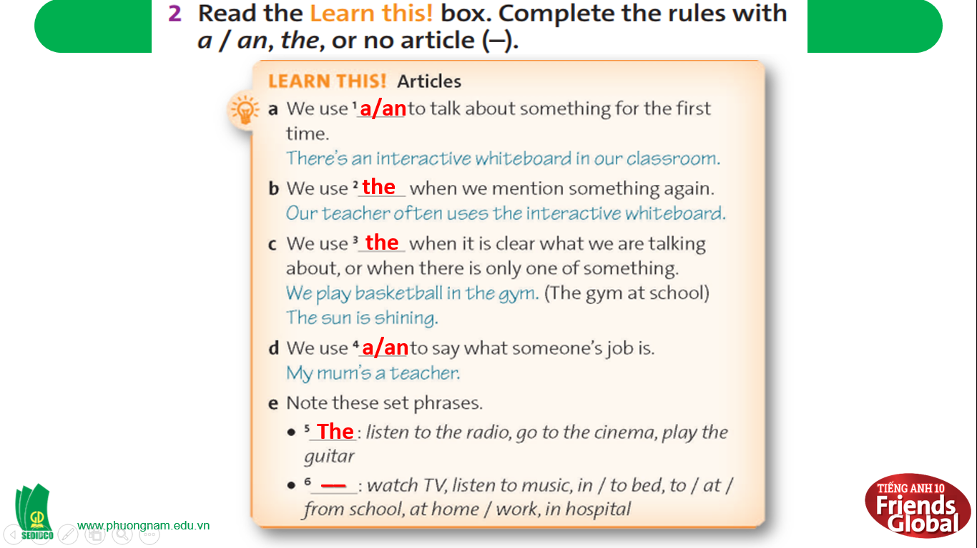
- Activity 2 Practice (20’)
a) Objective: Ss can answer the questions to critical thinking, and they can also finish the tasks in the textbook. Critical thinking skills (guessing/ reasoning) and communication can also be practiced.
b) Content: Students answer questions, classify words, choose the correct answer, read and complete, listen and match.
c) Outcomes: Ss read and listen, and they can apply the useful language in everyday listening and speaking.
d) Competence: collaboration, guessing, matching, communication
e) Organisation of the activity:
TEACHER’S ACTIVITIES | STUDENT’S ACTIVITIES | CONTENTS
PRACTICE. T-Ss- T/ S – S/ Indiv.  Activity 3 (10’) Read the text in exercise 1 again. Match each of highlighted words with a rule in the Learn this! box.  - Asks the students to do Activity 3 in 4 minutes  - Have the students to work in group of 4  - Invites some students go to the board and write their answers  - Correct the students’ answers  - Explain the answers if needed  Activity 4 (7’) Complete the dialogue. Use a / an or the. Explain your choices.  - Asks the students to do Activity 4  - Have the students to work in pair  - Have the students to read the LOOK OUT box  - Shows the students the correct answers  - Have some students to read aloud the dialogue  Activity 5 (3’) Read the Look out! Box. Are the sentences below generalisations or not? Circle the correct words.  - Asks the students to do the Activity 5 individually  - Goes around to help if needed  - Shows the students the correct answers  - Explain the answers | - Do the Acitivity in 4 minutes  - Work in group of 4  - Go to the board and write the answers  - Compare the answers and write down the correct answers  - Listen to the teacher’s explanations  - Do the Activity 4  - Work in pairs  - Read the LOOK OUT box  - Write down the correct answers  - Stand up and take turns to read aloud the dialogue  - Do the Activity 5 individually  - Ask for help  - Write down the correct answers  - Listen to the teacher’s explanations | Possible answers:  Answers:  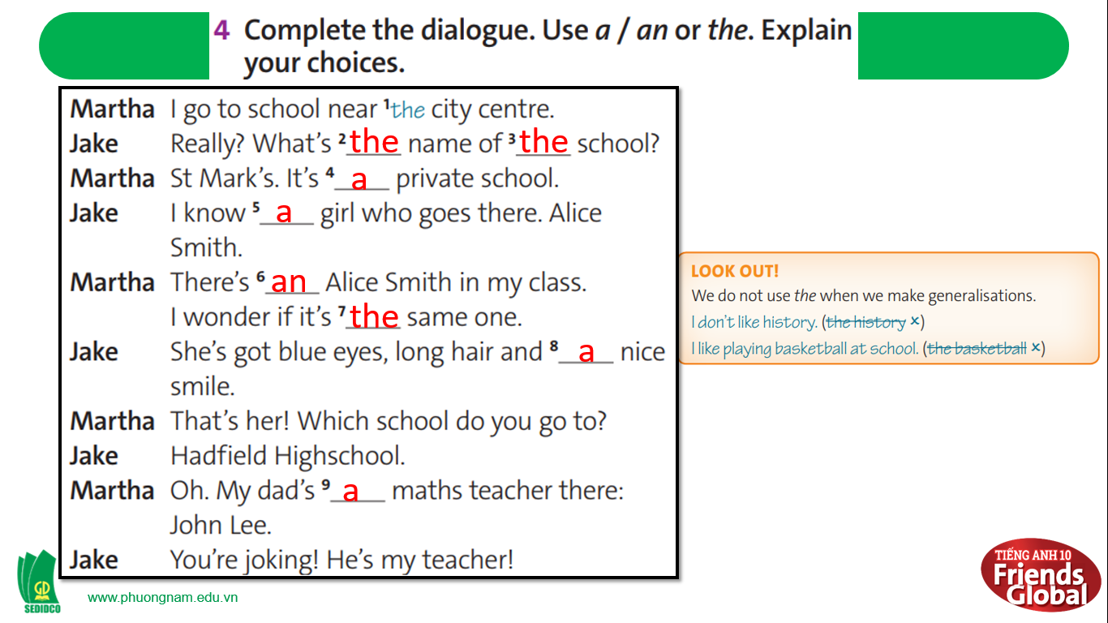  Answers:  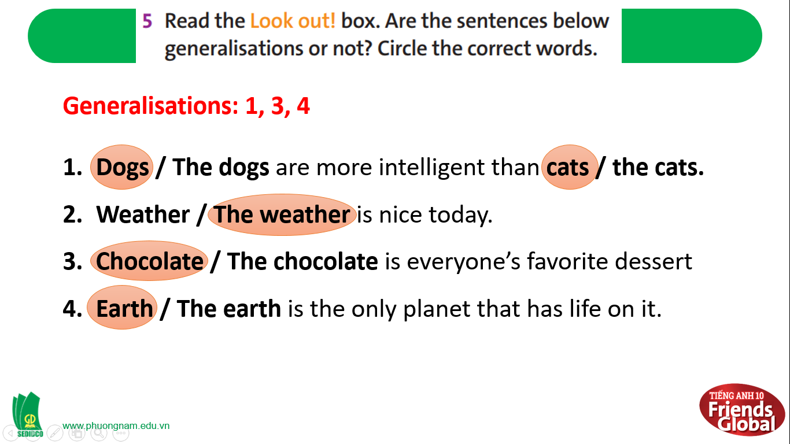

- Activity 3: Outcomes (10’)
a) Objective: Ss can answer the question to describe feelings in some situations. Communication is also be practiced.
b) Content: Students work in pairs, speak and discuss
c) Outcomes: Ss speak and listen mutually, they can new words they have learnt in their conversation.
d) Competence: Collaboration, communication
e) Organisation of the activity:
TEACHER’S ACTIVITIES | STUDENT’S ACTIVITIES | CONTENTS
PRODUCT. S – S/ T – Ss  Activity 6 (10’) Play a game ‘Doraemon English Game’  - Devides the class into groups  - Tells the students the rules of the game  - Ask students to pick from A to H and use the given words to complete the sentences. | - Work in groups  - Follow the instructions of the teacher  - Take turns to pick the questions from A to H and use the given words to complete the sentences | Questions:  A. In 50 years, students/do/Virtual Reality Experiments.  B. In 50 years, there/more/learning apps.  C. In 50 years, there/many/online classrooms/robot teachers.  D. In 50 years, students/do/Face Recognition/take attendance.  E. In 50 years, students/use/ technology devices/in stead of/papers.  F. In 50 years, technology devices/be/ most/important/part/in/classroom.  G. In 50 years, classrooms/have/multi-touch tables.  H. In 50 years, there/more/ techniques/in teaching.
C. Consolidation (3’)
a) Grammar points: Articles; There is / are
b) Talking about the school in the future
D. Homework (2’)
- Learn by heart the rules of articles
- Practice grammar points about articles; There is / are
- Do exercise in the workbook
- Prepare: Unit 1 Feelings – A- Vocabulary (page 10 – SB)

