UNIT 5: NATURAL WONDERS OF VIET NAM

Lesson 1: Getting started – Geography Club!

  - Lesson aim(s)
By the end of the lesson, students will be able to:
- identify the lexical items related to the topic Natural wonders of Viet Nam;
- use the vocabulary and structures to describe wonders of Viet Nam.

  - Language analysis
Form | Meaning | Pronunciation
1. scenery (noun) | the nautural features of an area | /ˈsiːnəri/
2. natural (adj) | not made by human | /ˈnætʃərəl/
3. wonders (noun) | something that fills you with surprise and admiration | /ˈwʌndəs/
4. amazing (adj) | very good | /əˈmeɪzɪŋ/
5. island (noun) | a piece of land that is completely surrounded by water | /ˈaɪlənd/

  - Materials (referenced)
- Grade 6 textbook, Unit 5, Getting started
- Pictures and maps
- sachmem.vn

Anticipated difficulty | Solution
Students may not travel and have no idea of any natural wonders of Viet Nam. | Prepare some short videos of Ha Long Bay, Ganh Da Dia, Son Doong Cave and other wonders of Viet Nam to show them.

  - Board Plan

Date of teaching

Unit 5: Natural wonders of Viet Nam

Lesson 1: Getting started

* Warm-up

I. Vocabulary:
- scenery (noun): [picture]
- natural (adj): [antonym] man-made
- wonders (noun): [picture]
- amazing (adj): [synonym] very good
- island (noun): [picture]
II. Practice:
Task 1: Listen and read. (p. 48)
Task 2: Complete the following sentences with the words from the box. (p. 49)
Task 3: Listen and repeat the words, then label the pictures. (p. 49)
Task 4: QUIZ: Work in groups. Choose the correct answer to each of the questions. (p. 49)
* Homework

Stage | Stage aim | Procedure | Interaction | Time
Warm-up | - To set the context for the listening and reading text.  - To introduce the topic of natural wonders of Viet Nam. | Guess what's behind the boxes.  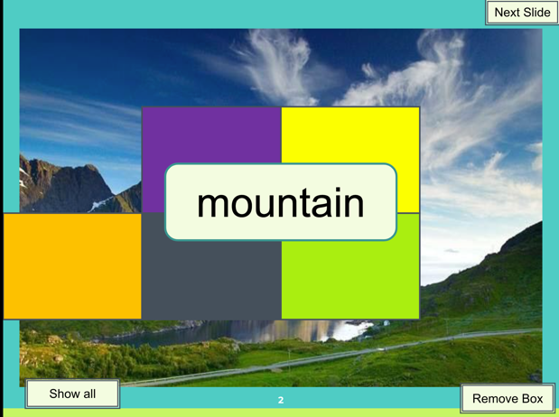  - Teacher shows the colourful boxes on the screen, asks students to look closely, raise their hand to say what they can see behind the boxes aloud.  - Teacher removes the boxes one by one and asks students to guess what is behind the boxes after each box has been removed until students can tell the teacher what it is.  - The team who is the last one will lose the game. | T-Ss | 5 mins
Lead in | To lead in the topic of natural wonders of Viet Nam. | - Teacher draws students’ attention to the picture in the textbook and asks them questions about the picture.  - Who are they?  - What are they looking at?  - What are they talking about?  Suggested answers:  - They are Alice, Elena and Nick.  - They are looking at some photos/ pictures.  - They are talking about attractive places in Viet Nam. | T-Ss | 2 mins
Presentation  (Vocab-  pre-teach) |  | * Vocabulary:  Teacher introduces the vocabulary by:  - showing the pictures illustrating the words;  - providing the synonym or antonym of the words;  - providing the definition of the words.  - scenery (noun): [picture]  - natural (adj): [antonym] man-made  - wonders (noun): [picture]  - amazing (adj): [synonym] very good  - island (noun): [picture]    scenery  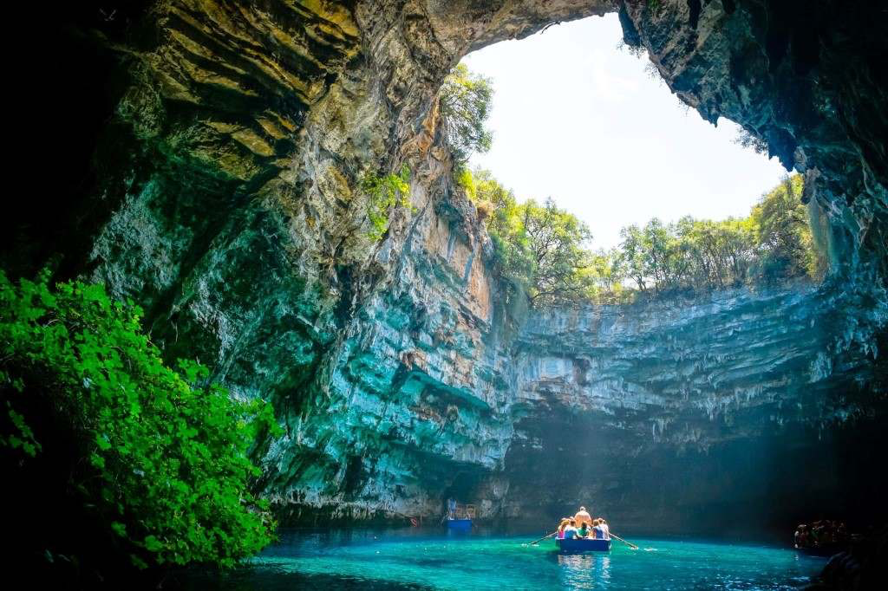    wonder  island | T-Ss | 5 mins
Practice | - To practice the targeted language and the background knowledge of things in nature.  - To help students identify the location of the places mentioned in the conversation.  - To help students focus on the use of lexical items to describe the places.  - To help students visualize some lexical items related to the topic. | Task 1: Listen and read. (p. 48)  - Teacher sets the context for the listening and reading text by asking students some questions:  - What places can you recognize from the photos on their tables?  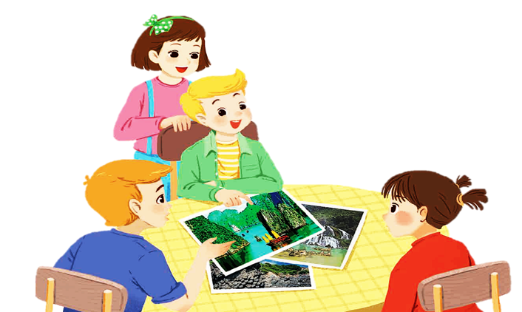  - Why are they attractive? etc.  - Teacher encourages students to give their answers, but do not confirm whether their answers are right or wrong.  - Teacher plays the recording, asks students underline the words they have learned in the vocabulary part.  - Teacher plays the recording more than once if necessary.  - Students listen and read.  - Teacher nominates some pairs of students to read the dialogue aloud.  - Teacher has students say the words in the text that they have underlined.  Task 2: Complete the following sentences with the words from the box. (p. 49)  - Teacher tells students to read the text again in order to find the words to complete the sentences independently.  - Teacher allows students to share their answers before discussing as a class.  - Teacher nominates students to give answers and corrects them if necessary.  Answer key:  - amazing  - islands  - scenery  - natural  - wonders  Task 3: Listen and repeat the words, then label the pictures. (p. 49)  - Teacher asks students to look at the words in the box, listen and repeat.  - Teacher has students match the pictures with the appropriate words independently.  - Teacher allows students to share their answers before discussing as a class.  - Teacher asks students to give answers and corrects them if necessary.  Answer key:  a. desert  b. island  c. cave  d. river  e. waterfall  f. mountain  g. forest  h. beach | T-Ss  T-Ss  T-Ss  Ss  T-Ss  T-Ss  T-Ss | 15 mins
Production | To give students a fun time revising what they have learnt so far in the lesson and more quickly response the questions about natural wonders. | Task 4: QUIZ  Work in groups. Choose the correct answer to each of the questions. (p. 49)  - Teacher divides the class into groups of four or five and provides each group with a set of A and B signs.  - Teacher gives students time to read the quiz carefully and choose the correct answers.  - Then, teacher lets students randomly select a number on the screen to choose the question.  - Students raise the correct signs of A or B choose the answer and say the answer aloud.  - The quickest group gets 5 points for each correct answer.  - At the end of the activity, 3 groups having the high points are the winners. | T-Ss  Group work | 15 mins
Consolidation | To consolidate what students have learnt in the lesson. | Teacher asks students to talk about what they have learnt in the lesson. | T-Ss | 2 mins
Homework | To review and use the language of lexical items related to natural wonders. | Go to the Internet and search for the information on your favourite natural wonder in Viet Nam and prepare a small talk between 1-2 minutes about it. | T-Ss | 1 min

UNIT 5: NATURAL WONDERS OF VIET NAM

Lesson 2: A closer look 1

  - Lesson aim(s)
By the end of the lesson, students will be able to:
- use the lexical items related to the topic Natural wonders of Viet Nam;
- use the vocabularies and structures to talk about famous natural places;
- pronounce and recognize the sounds /t/ and /d/.

  - Language analysis
Form | Meaning | Pronunciation
1. plaster (n) | a small piece of sticky cloth or plastic used to cover a cut in the skin | /ˈplɑːstər/
2. sleeping bag (nph) | a large bag for sleeping in outside | /ˈsliːpɪŋ bæɡ/
3. backpack (n) | a large bag used to carry things on your back when going camping or walking | /ˈbækpæk/
4. compass (n) | a device for finding direction with a needle that can move easily | /ˈkʌmpəs/
5. suncream (n) | ​ a substance that is put on the skin to protect it from being burned by the Sun | /ˈsʌn kriːm/
6. scissors (n) | a device used for cutting materials such as paper, cloth, and hair, consisting of two sharp blades that are joined in the middle, and two handles with holes to put fingers through | /ˈsɪzəz/

  - Materials (referenced)
- Grade 6 textbook, Unit 5, A closer look 1
- Pictures and CDs
- sachmem.vn

  - Assumptions
Anticipated difficulties | Solutions
1. Students may lack knowledge about some lexical items. | Provide students with the meaning and pronunciation of some lexical items.
2. Students may have underdeveloped listening, speaking and co-operating skills. | - Play the recording as many times necessary.  - Encourage students to work in pairs, in groups so that they can help each other.  - Provide feedback and help if necessary.
3. Some students will excessively talk in the class. | - Define expectations in explicit detail.  - Have excessive talking students practise.  - Continue to define expectations in small chunks (before every activity).
  - Board Plan
Date of teaching
Unit 5: Natural wonders of Viet Nam
Lesson 2: A closer look 1
* Warm-up
Name the travel items
I. Vocabulary:
1. plaster (n)
2. sleeping bag (nph)
3. backpack (n)
4. compass (n)
5. suncream (n)
6. scissors (n)
Task 1: Write a word under each picture. Practise saying the word. (p. 50)
Task 2: Complete the following sentences. Use the words in 1. (p. 50)
Task 3: Now put the items in order of usefulness. Number 1 is the most useful, number 6 is the least useful on holiday. (p. 50)
II. Pronunciation:
Task 4: Listen and repeat the words. (p. 51)
Task 5: Listen and repeat. Pay attention to the bold-typed parts of the words. (p. 51)
III. Production:
* Whispering game
* Homework
Stage | Stage aim | Procedure | Interaction | Time
Warm-up | To activate students’ prior knowledge and vocabulary related to the topic, the targeted vocabulary and its pronunciation. | * Names the things needed for going camping:  - Teacher asks students to work in groups of 6.  - Teacher sets the context: “Next week, we are going camping in the forest. What should we bring?”  - Teacher give all groups 3 minutes to write as many things as possible.  - Teacher goes around the class to provide help (if necessary).  - The group with the most correct answers will be the winner.  Suggested answer:  tent  sleeping bag  compass  suncream  mobile phone  food  water  … | T-Ss  Ss-Ss | 5 mins
Lead in | To lead in the lesson about vocabulary and pronunciation. | Teacher leads students into the lesson by telling them that: “In today lesson, we are going to learn more travel items and two sounds /t/ and /d/.” | T-Ss | 2 mins
Presentation  (Vocab-  pre-teach) | To teach students some adjectives describing a city. | VOCABULARY  Teacher introduces the vocabulary by:  - Providing the pictures of the words:  - plaster (n): [picture]  - sleeping bag (nph): [picture]  - backpack (n): [picture]  - compass (n): [picture]  - suncream (n): [picture]  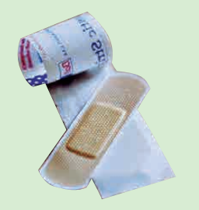  - scissors (n): [picture]  plaster    suncream      sleeping bag  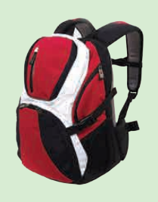  scissors  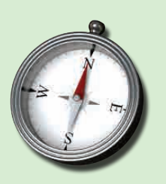  backpack  compass | T-Ss | 5 mins
Practice | To teach students some adjectives describing a city.  To help students use the adjectives in Task 1 in a context.  To teach students some words/ phrases related to a city. | Task 1: Write a word under each picture. Practise saying the words. (p. 50)  - Teacher asks students to write the suitable word under each picture in 2 minutes.  - Students do the task.  - Teacher calls some students to give their answers.  - Teacher gives feedback and corrections (if necessary).  Answer key:  - plaster  - suncream  - sleeping bag  - scissors  - backpack  - compass  Task 2: Complete the sentences with the words in task 1. (p. 50)  - Teacher asks students to work in pairs and use the words in task 1 to complete the sentences.  - Students work in pairs and do the task.  - Teacher calls some pairs to share their answers with the whole class.  - Teacher gives feedback and corrections (if necessary).  Answer key:  - compass  - suncream  - sleeping bag  - backpack  - plaster  Task 3: Now put the items in order of usefulness. Number 1 is the most useful, number 6 is the least useful on holiday. (p. 50)  - Teacher asks students to work in groups of three.  - Teacher gives students 3 minutes to discuss and put the item in the order of usefulness.  - Teacher asks students to share their answers as a whole class.  - Teacher gives corrections (if necessary). | T-Ss  S  T-Ss  Pair work  Ss-Ss  T-Ss  T-Ss  Ss-Ss  T-Ss | 15 mins
Presentation  (Pre-teach the sounds  /t/ and  /d/.) | To help students to identify how to pronounce the sounds /t/ and /d/. | PRONUNCIATION  - Teacher introduces 2 sounds /t/ and /d/ to students and lets them watch a video about how to pronounce these two sounds.  - Teacher asks students to give some words they know containing these sounds.  Suggested answers:  - /t/: plaster, tower, letter, desert, want  - /d/: need, island, guide, holiday, pagoda | T-Ss | 5 mins
Practice | To help students identify and practise the /t/ and /d/ sounds.  To help students practice the sounds /t/ and /d/ in sentences. | Task 4: Listen and repeat the words. (p. 51)  - Teacher asks students listen to the recording for the first time.  - Teacher asks students to listen and repeat the words for the second time.  Task 5: Listen and repeat. Pay attention to the bold-typed parts of the words. (p. 51)  - Teacher plays the recording for students to listen and asks students to repeat the sentences after they listen.  - Teacher calls some students randomly to read the sentences and gives correction (if necessary). | T-Ss  T-Ss  T-Ss | 5 mins
Production | To give students chance to apply what they have learnt. | * Game: Whispering  - Teacher divides the class into 4 big groups and asks students to stand in four lines.  - The member in the last place will make a sentence containing at least a word and a sound they have learnt; then, whisper the sentence to the next member of the group. They will continue until the member in the first place and this member will say the sentence aloud.  - The fastest group will win the game.  Suggested sentences:  - I must bring a plaster when going camping.  - I want to visit a famous desert in the world.  - He lives in a quiet island. | Group work | 5 mins
Consolidation | To consolidate what students have learnt in the lesson. | Teacher asks students to talk about what they have learnt in the lesson. | T-Ss | 2 mins
Homework | To revise what they have learnt. | Find 5 more words with the sound /t/ and 5 more words with the sound /d/. Write them down and practice pronouncing the words. | T-Ss | 1 min

UNIT 5: NATURAL WONDERS OF VIET NAM

Lesson 3: A closer look 2

Countable & uncountable nouns

Modal verbs: must and musn’t

  - Lesson aim(s)
By the end of the lesson, students will be better able to:
- use countable nouns and uncountable nouns;
- use quantifiers some, many, much, a few, a little with countable nouns and countable nouns;
- use “must” and “mustn’t” to make classroom rules.

  - Language analysis
Form | Meaning
- some, many, a few + countable nouns  - some, much, a little + uncoutable nouns | - Countable nouns are for the people and things we can count using numbers. Countable nouns can be singular: a rock, an island ..., or plural: rocks, islands ...  - Uncountable nouns are for the things that we cannot count with numbers. They usually do not have a plural form: cream, chocolate ...
- subject + must + base form  - subject + mustn’t + base form | - We use must to say that something is very necessary or very important.  E.g. I must walk the dog when I get home.  E.g. You must answer all of the questions.  - We use mustn't to say that doing something is not allowed.  E.g. Students mustn't take mobile phones into the exam room.

  - Materials (referenced)
- Grade 6 textbook, Unit 5, A closer look 2
- Pictures, sets of word cards,…
- sachmem.vn

Anticipated difficulties | Solutions
1. Students may be confused because some English uncountable nouns are countable in Vietnamese, and vice versa.  (E.g. rice) | Show and explain by illustrating by pictures or short videos when native people using uncountable nouns.
2. Some students will excessively talk in the class. | - Define expectation in explicit detail.  - Have excessive talking students practise.  - Continue to define expectations in small chunks (before every activity).

  - Board Plan

Date of teaching

Unit 5: Natural wonders of Viet Nam

Lesson 3: A closer look 2
* Warm-up
Game: Unscrambled words
I. Grammar:
1. uncountable nouns don't have a plural form: cream, chocolate,...
countable nouns can be singular: a rock, an island ..., or plural: rocks, islands...
2. some/ many/ a few + countable nouns
some/ much/ a little + uncountable nouns
3. subject + must + base form
subject + mustn’t + base form
II. Practice:
Task 1: Is the underlined noun countable or uncountable?
Write C (countable) or U (uncountable). (p. 51)
Task 2: Choose the correct option for each sentence. (p. 52)
Task 3: Fill each blank with must or mustn’t. (p. 52)
Task 4: Making classroom rules.
* Homework:
Exercise 3 (p. 52)

Stage | Stage aim | Procedure | Interaction | Time
Warm-up | To put students into English mode; attentive,  interested and ready to participate and prime the class for a new topic. | * Game: Unscrambled words  - Teacher divides the class into groups of 3-6 students.  - Teacher delivers a set of unscrambled words which are some countable and uncountable nouns to each group.  - Students will have to work in groups to solve the quiz.  - The group with more correct sentences will be the winner.  Answer key:  1. cream 2. rock 3. island 4. rice 5. juice 6. butter 7. backpack 8. plaster | T-Ss  Ss-Ss | 4 mins
Lead in | To get students interested and find out what they have already known. | - Teacher writes on the board 2 phrases “Countable and Uncountable”.  - Teacher draws students’ attention to the words finished in the game and ask them whether they know the types of these words.  - Teacher gives them the word cards and requires students to identify the category of each word.  - Teacher provides or confirms the answers and lead in the grammar focus of the lesson:  - The words “cream, rice, juice, butter” are uncountable nouns.  - The words “rock, island, backpack, plaster” are countable nouns.  - Today we are going to learn more about countable and uncountable nouns. | T-Ss | 3 mins
Presentation 1 | To elicit/ show the students when and how the uncountable and countable nouns are used in sentences as well as when and how the quantifiers are used. | 1. Countable and Uncountable nouns:  Task 1: Is the underlined noun countable or uncountable? Write C (countable) or U (uncountable). (p. 51)  - Teacher has students complete the underlined activity individually.  - Teacher then asks students to swap their textbooks to check their classmates’ answers.  Answer key:  1 – C  2 – U  3 – U  4 – C  5 – U  - Teacher draws students’ attention to the underlined words and confirm the use of countable and uncountable nouns  “Countable nouns are for the people and things we can count using numbers. Countable nouns can be singular."  “Uncountable nouns are for the things that we cannot count with numbers. They usually do not have a plural form.”  - Teacher then asks students to give some more examples of uncountable nouns that they know.  - Teacher reminds students to the “definition of countable nouns”  “Countable nouns are for the people and things we can count using numbers”. Some English uncountable nouns are countable in Vietnamese. (E.g. rice)  2. Some, many, much,  a few, a little:  - Teacher gives students a handout of each definition of each quantifiers.  - Teacher has students work in groups of 4 to match the words in column A with definitions in column B.  - Answer key:  QUANTIFIERS USE  1. many countable nouns, usually in negative statements and questions  2. much uncountable nouns, usually in negative statements and questions  3. a few countable nouns, means ‘some’  4. a little uncountable nouns, means ‘some’  5. some countable nouns, uncountable nouns  - Teacher then asks students to exchange their handout to check their classmates’ answers. | T-Ss  Ss-Ss  T-Ss  T-Ss  T-Ss  Ss-Ss  T-Ss | 6 mins  5 mins
Controlled practice 1 | To check if students can use countable, uncountable nouns and quantifiers correctly. | Task 2: Choose the correct option for each sentence. (p. 52)  - Teacher has students work on the exercise individually before they compare answers with each other.  - Teacher gives feedback as a class discussion.  Answer key:  - A  - B  - A  - B  - A | T-Ss | 5 mins
Presentation 2 | To elicit/ show the students when must and mustn't are used and how to make a sentence with these modals. | - Students are asked to watch a video concerning school rules, during which they will have to identify any school rules they have already mentioned in the Warm-up activity.  - Teacher provides each pair of students with a copy of the script and the students watch the video a second time checking on the script and highlighting the word(s) before each school rule.  - After watching the video, teacher elicits and discusses what students have understood, including the school rules they recognised from their warm-up activity.  - This will allow the students to begin to identify the language item without a grammar explanation.  Link: http://learnenglishkids.britishcouncil.org/grammar-videos/school-rules  - After gathering answers from students, teacher briefly summarizes the language item:  “We use must to say that something is very necessary or very important.”  “We use mustn’t to say that doing something is not allowed.”  - Teacher asks students to write the form of this targeted grammar into their notebook and make up from 1 to 2 sentences according to their understading.  - Teacher calls out 1 – 2 students to read aloud their answers and check immediately in class. | T-Ss  Ss-Ss  T-Ss  T-Ss | 3 mins  2 mins
Controlled Practice 2 | To give written consolidation of the grammar and to use the grammar correctly. | Task 4: Fill each blank with must or mustn’t. (p. 52)  - Teacher has students work on the exercise individually before they compare answers with each other.  - Teacher gives feedback as a class discussion.  Answer key:  - must  - musn’t  - must  - mustn’t  - must | T-Ss | 5 mins
Freer Practice 2 | To give students speaking practice to use correctly grammar with must and mustn’t to make a set of rules to follow in school. | Task 5. Write some more rules for you and your classmates at school.  (p. 52)  - Teacher divides the class into groups of 6 students.  - Teacher assigns the roles for each member by asking quetions:  + Who's leader?  + Who are rules makers / Idea thinkers?  + Who's a note taker?  + Who's a presenter?  - Teacher asks students to work in group and make at least 3 classroom rules in 3 minutes.  - After that, the presenter of each team goes to the board and present about their rules.  - The other teams listen and give comments on their friends’ ideas.  - Teacher gives complement or good mark to the group with suitable rules after getting suggestions/ comments from the class. | T-Ss  Ss-Ss | 10 mins
Recap | To consolidate what students have learnt in the lesson. | Teacher asks students to talk about what they have learnt in the lesson. | T-Ss | 1 min
Homework | Reactivate the knowledge that students have gained in the Kahoot game. | Do Exercise 3, write the answers on your notebooks. | T-Ss | 1 min

UNIT 5: NATURAL WONDERS OF VIET NAM

Lesson 4: Communication

  - Lesson aim(s)
By the end of the lesson, students will be able to:
- make and accept appointments;
- have knowledge about a travel guide;
- use must and mustn’t to talk about what to prepare for a trip.

Language analysis

  - Materials (referenced)
- Grade 6 textbook, Unit 5, Communication
- Pictures
- sachmem.vn

Anticipated difficulties | Solutions
1. Students may lack knowledge about the necessary things must bring and what to prepare for a trip. | Provide students with information about the knowledge they do not know.
2. Students may have underdeveloped reading, speaking and co-operating skills. | - Encourage students to work in pairs, in groups so that they can help each other.  - Provide feedback and help if necessary.
3. Some students will excessively talk in the class. | - Define expectation in explicit detail.  - Have excessive talking students practise.  - Continue to define expectations in small chunks (before every activity).

  - Board Plan

Date of teaching

Unit 5: Natural wonders of the world

Lesson 4: Communication
* Warm-up

GAME: Pass the ball
I. Everyday English:
Task 1: Listen and read the short conversation, paying attention to the highlighted parts.
Making and accepting appointments
  - Making appointments:
Let’s + V.
How about …?
  - Accepting appointments:
That’s fine.
Sure.
Task 2: Work in pairs. Make a short conversation, following the example. (p. 53)
II. A tour guide:
Task 3: Read the travel guide entry. (p. 53)
Task 4: Make a list of the things you must bring to the Himalayas. Then add things you mustn’t bring. (p. 53)
Task 5: Role-play being a tour guide and a tourist. Tell your partner what to prepare for their trip to the Himalayas and give reasons.
* Homework

Stage | Stage aim | Procedure | Interaction | Time
Warm-up | To review must and mustn’t. | GAME: Pass the ball  - Teacher plays the music. When music’s on, students pass the ball as fast as they can. When music’s off, the student taking the ball has to make a sentence with must/ mustn’t. | T-Ss  Ss-Ss | 3 mins
Lead in | To lead in the lesson about vocabulary and pronunciation. | - Teacher sets the scene.  - They are Duong and Steven. Steven wants Duong to go picnic with him this Sunday. What structures can he use? If Duong agrees, what does he say?  - Students give their answers.  - Teacher leads students into the lesson by telling about what they are going to learn: “We are going to learn how to make and accept appointments”. | T-Ss | 2 mins
* EVERYDAY ENGLISH
Presentation | To introduce make and accept appointments. | * Making and accepting appointments  Task 1: Listen and read the short conversation, paying attention to the highlighted parts.  - Teacher asks students listen and read the short conversation, paying attention to the highlighted parts.  - Teacher writes down highlighted parts on the board and asks students what they are used to, which is used to make appointments and which is used to accepting appointments.  - Teacher calls some students to share their opinions.  - Teacher gives more explanations and elicit the form.  - Making appointments:  Let’s + V.  How about …?  - Accepting appointments:  That’s fine.  Sure. | T-Ss | 10 mins
Practice | To practice making and accepting appointments. | Task 2: Work in pairs. Make a short conversation, following the example in Task 1.  (p. 53)  - Teacher asks students to work in pairs and make a short conversation, following the example.  - Teacher models with a volunteer.  - Students do the task in pairs.  - Teacher calls some pairs to make a conversation in front of the class.  - Teacher gives feedback and corrections (if necessary). | Pair work  Ss-Ss  T-Ss | 7 mins
* A TOUR GUIDE
Pre-Reading | To help students set the scene. |   - Teacher shows the picture and ask students some questions:  Next week, I am going mountain climbing. Can you guess where I am going to? (Himalayas)  Before we go, what should we read? A tour guide  What information can you read in a tour guide? | T-Ss | 3 mins
While-Reading | To help students have knowledge about a travel guide. | Task 3: Read the travel guide entry. (p. 53)  Teacher asks students to read the travel guide entry to check their guess and sets the time limit for reading task for 2 minutes.  Task 4: Make a list of the things you must bring to the Himalayas. Then add things you mustn’t bring. (p. 53)  - In group of 3, students write as many things they must and mustn’t bring to the Himalayas as they can in 2 minutes.  - Teacher calls some groups to give their answers and checks. | T-Ss  Group work | 7 mins
Post-Reading | To help students talk about what to prepare for a trip | Task 5: Role-play being a tour guide and a tourist. Tell your partner what to prepare for their trip to the Himalayas, and give reasons.  - Teacher divide the class into 2 main group. One is a tour guide and one is a tourist.  - The tourist prepares the questions and the tour guide prepare the information in 2 minutes.  - Students work in pair. Make a conversation.  - Teacher calls some pairs to talk in front of the class.  - Peer check and then teacher gives feedback. | Group work | 10 mins
Consolidation | To consolidate what students have learnt in the lesson. | Teacher asks students to talk about what they have learnt in the lesson. | T-Ss | 2 mins
Homework | To prepare for the next lesson: Skills 1. | Choose a natural attraction in your city and find out the information about it (interesting things about the place as well as what they must and mustn’t do there). | T-Ss | 1 min

UNIT 5: NATURAL WONDERS OF VIET NAM

Lesson 5: Skills 1

  - Lesson aim(s)
By the end of the lesson, students will be able to:
- develop reading skill for general and specific information about the topic;
- use the lexical items related to the topic ‘things in nature’ and ‘travel items’;
- use what they have learnt to talk about a famous place, and what people must/ mustn’t do there.

Language analysis
Form | Meaning | Pronunciation
1. tourist attraction (n) | a place that people visit for pleasure and interest, usually while they are on holiday | /ˈtʊə.rɪst/ /əˈtrækʃən/
2. wonder (n) | kỳ quan | /ˈwʌndər/
3. popular (adj) | liked, enjoyed, or supported by many people | /ˈpɒpjələr/
4. landscape (n) | everything you can see when you look across a large area of land, especially in the country | /ˈlændskeɪp/
5. slope (n) | a surface that rises at an angle, esp. a hill or mountain, or the angle at which something rises | /sləʊp/
6. sand dune (n) | a hill of sand made by the wind on the coast or in a desert | /ˈsænd ˌdjuːn/

  - Materials (referenced)
- Grade 6 textbook, Unit 5, Skills 1
- Pictures, sets of words, games, audio
- sachmem.vn

Anticipated difficulties | Solutions
1. Students may lack knowledge about some lexical items. | Provide students with the meaning and pronunciation of words.
2. Students may have underdeveloped reading, speaking and co-operating skills. | - Let students read the text a gain  (if needed).  - Create a comfortable and encouraging environment for students to speak.  - Encourage students to work in pairs, in groups so that they can help each other.  - Provide feedback and help if necessary.
3. Some students will excessively talk in the class. | - Define expectation in explicit detail.  - Have excessive talking students practise.  - Continue to define expectations in small chunks (before every activity).

  - Board Plan

Date of teaching

Unit 5: Natural wonders of Viet Nam

Lesson 5: Skills 1

* Warm-up

Discussion

Task 1: Before you read, look at the pictures and make predictions about the reading. Then read and check your ideas.
I. Reading:
* Vocabulary:
- tourist attraction (n)
- wonder (n)
- popular (adj)
- landscape (n)
- slope (n)
- sand dune (n)
Task 2: Complete the sentences, using the words from the box. (p. 54)
Task 3: Read the text and answer the following questions. (p. 54)
II. Speaking:
Task 4: Work in pairs. Make notes. Add your own ideas. (p. 54)
Tell your partner about the place.
Task 5: Some foreign visitors are visiting your city/ town/ area. Tell them some interesting things about the place; what they must do or mustn’t do there.
(p. 54)
* Homework

Stage | Stage aim | Procedure | Interaction | Time
Warm-up | To introduce the topic of reading. | * Set the scene  - Teacher sets the scene: “Next month, I am going travelling. Guess where I will visit.”  - Let’s students guess the places by opening the boxes one by one. The pictures are hidden behind the boxes.    - Teacher shows the pictures on the screen.  - Teacher leads in the lesson by asking questions:  “Have you ever been to these places?”  “Today, let’s see what do they have.”  * Discussing:  Task 1: Look at the pictures and make predictions about the reading. (p. 54)  - Teacher asks students to close the book.  - Teacher shows the pictures of the places and asks students to answer the questions:  1. What are the places?  2. What do you know about these places?    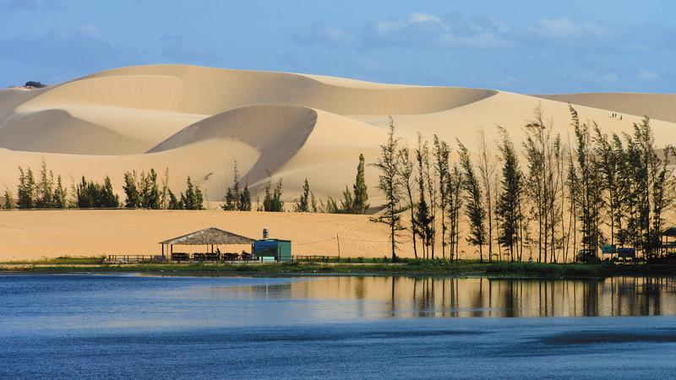  - Teacher invites some students to share their discussion in front of the class.  - Teacher asks students to open the book. Read the text and check their ideas. | T-Ss  Ss  T-Ss  T-Ss | 2 mins  3 mins
Pre-reading (Pre-teach vocabulary) | To provide students with some lexical items before reading the text.  To check students understanding of using correct lexical items about the topic. | * Vocabulary  - Teacher introduces the vocabulary by:  - Providing the synonym or antonym of the words.  - Providing the pictures of the words.  - Providing the definition of the words.  - Providing the meaning by translating.  1. tourist attraction (n): a place that people visit for pleasure and interest, usually while they are on holiday  2. popular (adj) =  well-known, common  3. wonder (n): kỳ quan  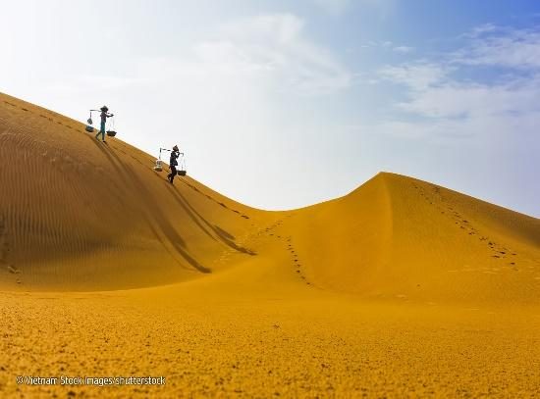  sand dunes  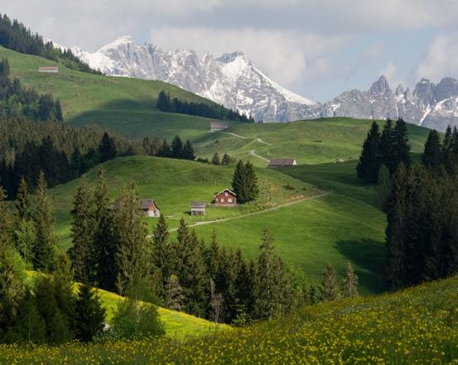  landscape  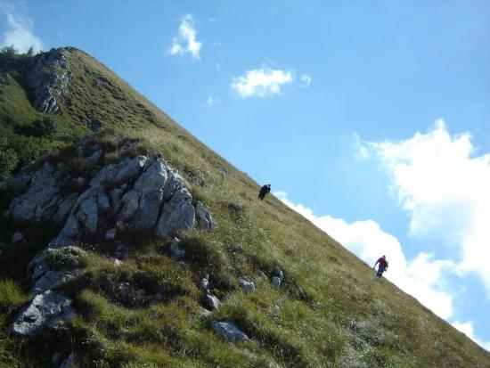  slope  Task 2. Complete the sentences, using the words from the box. (p. 54)  - Teacher askes students to do Exercise 2 individually, in 3 minutes.  - After 3 minutes, teacher lets students swap their answers with their partner.  - Check the answers.  Answer key:  1. islands  2. wonder  3. desert  4. Remember  5. visit | T-students  S  Ss-Ss | 5 mins  2 mins
While-Reading | To develop reading skill for general and specific information. | Task 3: Read the text and answer the following questions. (p. 54)  - Teacher asks students to go through the questions (1 – 5) to make sure that they understand them and know what information is being asked.  - Students underline the key word(s) in each question to locate the answer in the reading text.  - Teacher asks students to work individually to answer the questions.  - Teacher checks the answers.  Answer key:  - Ha Long Bay is in Quang Ninh.  - You can enjoy great seafood and join in exciting activities.  - No, there isn’t. It’s like a desert, not a real desert.  - You can have a picnic in Mui Ne by the beach.  - The best time to visit the Mui Ne Sand Dunes is early morning or late afternoon. | T-Ss  Ss  T-Ss | 8 mins
Post-Reading | To check students’ reading comprehension and prepare for the next part. | Task 4: Work in pairs. Make notes about one of the places in the reading. You can add your own ideas. (p. 54)  - Teacher asks students to work in groups of 3 and make notes about one place in the reading.  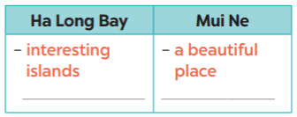  - Compare the notes with other groups.  - Teacher asks students to tell their partner about the place by looking at the notes.  Example:  Ha Long Bay has a lot of interesting islands. It ….  - Teacher goes around and offers help if needed.  - Students share their ideas with the whole class. | S-S | 5 mins
Pre-Speaking | To help students form the ideas for their speaking. | Task 5: Some foreign visitors are visiting your city/ town/ area. You are their tour guide. Tell them some interesting things about the place as well as what they must and mustn’t do there.  - Teacher askes students to work in groups of 6.  + Leader?  + Idea thinkers?  + Presenters?  + Drawers?  - Teacher asks students to choose a famous place in their city or area.  - Teacher asks students to discuss and make notes of the information they want to share with the class.  - Teacher asks students to refer to the questions as suggestions for their notes or they can do it in their own way.  + Where is it?  + What does it have?  + Are there any interesting things here?  + What must they do or mustn’t do there?  - Teacher goes around and offers help if needed. | Group work | 7 mins
While-Speaking | To help students use what they have learnt so far to talk about a famous place. | - Teacher asks students to practice presenting in their groups.  - Teacher makes sure that students speak in full sentences.  - Then, teacher invites some groups to go to the board and share their preparation with the whole class. | T-Ss | 15 mins
Post-Speaking | To help students improve next time. | - Teacher allows students to give comments for their friends and vote for the most interesting and informative presentation.  - Teacher gives feedback and comments. | T-Ss  Ss-Ss | 5 mins
Consolidation | To consolidate what students have learnt in the lesson. | Teacher asks students to talk about what they have learnt in the lesson. | T-Ss | 2 mins
Homework | To prepare for the next lesson: Skills 2. | Teacher asks students to search for information about Phu Quoc Island. | T-Ss | 1 min

UNIT 5: NATURAL WONDERS OF VIET NAM

Lesson 6: Skills 2

  - Lesson aim(s)
By the end of the lesson, students will be able to:
- listening for specific information about a natural wonder;
- writing a paragraph about a natural wonder.

  - Materials (referenced)
- Grade 6 textbook, Unit 5, Skills 2
- Pictures
- sachmem.vn

Anticipated difficulties | Solutions
1. Students may lack knowledge and experiences about the topic. | Prepare some hand-outs in which key language of the key language of describing tourist attractions.
2. Students may have underdeveloped listening, writing and co-operating skills. | - Play the recording many times if any necessary.  - Encourage students to work in pairs, in groups so that they can help each other.  - Provide feedback and help if necessary.
3. Some students will excessively talk in the class. | - Define expectation in explicit detail.  - Have excessive talking students practise.  - Continue to define expectations in small chunks (before every activity).

  - Board Plan

Date of teaching

Unit 5: Natural wonders of Viet Nam

Lesson 6: Skills 2

Warm-up:
* Game: Hidden picture
I. Listening:
Task 1: Work in groups. Discuss and answer the question. (p. 55)
Task 2: Listen and tick True or False. (p. 55)
II. Writing:
Task 3: Fill each blank in the network with the information about a travel attraction you know. (p. 55)
Work in pairs. Talk about a travel attraction you know, using the filled network in task 3. (p. 55)
Task 4: Write a paragraph about 50 words about a travel attraction you know. Use the information in Task 3. (p. 55)
* Homework:
Rewrite the paragraph in your notebook.

Stage | Stage aim | Procedure | Interaction | Time
Warm-up | To introduce about the destination in the talk. | * Game: Hidden picture  - Teacher sticks show the slide with the picture that was hidden.  - Teacher gradually unhide the picture while having the class to guess the name of the destination.    Suggested answers:  1. Phu Quoc Island | T-Ss | 2 mins
Lead in | To lead in the listening task. | Teacher draws students’ attention to Phu Quoc island.  “Today we are going to listen to a talk about a famous natural wonder of Viet Nam. It’s Phu Quoc Island.” | T-Ss | 1 min
Pre-Listening | To help students brainstorm about destination in the talk. | Task 1: Work in groups. Discuss and answer the question. (p. 55)  1. Teacher asks students to work in groups of four to answer the question:  “What do you know about Phu Quoc Island?”  2. Teacher asks students to talk in Vietnamese (sometimes) if they do not have enough vocabulary in English.  3. Teacher asks students to share what they have discussed to see what they know about Phu Quoc Island.  Suggested answers:  - Phu Quoc is a beautiful island in Viet Nam.  - Tourists can enjoy many entertaining activities such as visiting the night market, sightseeing, visiting the Safari,...  - The food in here is delicious and unique. | T-Ss  Group work | 4 mins
While-Listening | To help students develop listening skill for specific information (T / F). | Task 2: Listen and tick True or False. (p. 55)  * True – False prediction:  - Teacher asks students to go through the statements (1 – 5) to make sure that they understand and know what information they have to catch for the answers.  - Students underline the key word(s) in each statement and guess whether they are True or False individually.  * Listen and decide True or False:  - Teacher plays the recording once or twice.  - Teacher asks students to listen and tick the answers.  - Teacher asks students to compare their answers with the prediction made previously.  - Teacher calls on some students to read aloud their answers and correct the false one(s).  - Teacher checks students answers as a class.  Answer key:  1. T  2. F (It has beautiful beaches and green forest.)  3. T  4. F (Sailing and fishing are popular water sports.)  5. T | T-Ss  S  S  Ss-Ss  T-Ss | 10 mins
Pre-Writing | To help students talk about a travel attraction they know and collect information for their later writing. | Task 3: Fill each blank in the network with the information about a travel attraction you know.  (p. 55)  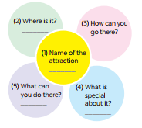  - Teacher models the task by summarizing the information of the talk with a student using the questions in the network below:  Suggested answers:  Teacher: What is the name of the attraction?  Student: It’s Phu Quoc island  Teacher: Where is it?  Student: It’s in Kien Giang  Teacher: How can you go there?  Student: You can fly to the island because it has an international airport.  Teacher: What can you do there?  Student: I can visit the fishing villages, the national parks, beautiful beaches, temples, pagodas, etc. I can enjoy some water sports like Sailing and fishing or buy interesting things at the night market.  Teacher: What is special about it?  Student: It’s one of the most famous natural wonders of Viet Nam and thousands of tourists visit it every year.  - Teacher asks students to choose a travel attraction they know and individually brainstorm about that place using the network in Task 3.  (p. 55)  - Teacher goes round and help if needed.  - Teacher asks students to work in groups of four to introduce about their chosen places using the filled network.  - Teacher asks 1-2 students to stand up and talk about their chosen place then give them comments. | T-Ss  S  Group work  T-Ss | 10 mins
While-Writing | To teach students how to write a paragraph about 50 words about a travel attraction they know.  What are you writing about? | Task 4: Write a paragraph about 50 words about a travel attraction you know. Use the information in Task 3.  (p. 55)  - Teacher shows the picture in Task 4 and explains to students that they should begin the paragraph with a topic sentence for  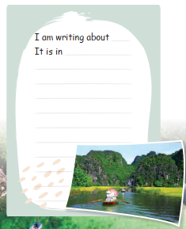  - Teacher asks students to use ideas they have brainstormed to write a paragraph about 50 words about a travel attraction they know.  - Teacher asks students to refer to the Reading passages in Skills 1 if needed.  - Teacher goes round and help if needed. | T-Ss  Other information  S | 12 mins
Post-Writing | To peer check, cross check and final check students’ writing. | - Teacher asks students to exchange their textbooks to check their friends’ writing.  - Teacher then gives feedback as a class discussion. | Ss-Ss  T-Ss | 3 mins
Consolidation | To consolidate what students have learnt in the lesson. | Teacher asks students to talk about what they have learnt in the lesson. | T-Ss | 2 mins
Homework | To allow students finalize their paragraph after being checked by friends and the teacher. | Rewrite the paraghraph in your notebook. |  | 1 min

UNIT 5: NATURAL WONDERS OF VIET NAM

Lesson 7: Looking back & Project

  - Lesson aim(s)
By the end of the lesson, students will be able to:
- review language use and skills student have learned in Unit 5;
- apply what they have learnt (vocabulary and grammar) into practice through a project.

  - Materials (referenced)
- Grade 6 textbook, Unit 5, Looking back & Project
- Pictures, A0 paper
- sachmem.vn

Anticipated difficulties | Solutions
1. Students may have underdeveloped speaking, writing and co-operating skills when doing project. | - Encourage students to work in pairs, in groups so that they can help each other.  - Provide feedback and help if necessary.
2. Some students will excessively talk in the class. | - Define expectation in explicit detail.  - Have excessive talking students practise.  - Continue to define expectations in small chunks (before every activity).

  - Board Plan

Date of teaching

Unit 5: Natural wonders of Viet Nam

Lesson 7: Looking back & Project

* Warm-up:
Brainstorming: things in nature and travel items
I. Looking back:
Task 1: Write the name for each picture. (p. 56)
Task 2: Matching. (p. 56)
Task 3: Write the words. (p. 56)
Task 4: Find the mistakes. (p. 56)
Task 5: Complete the dialogue, using must/ mustn’t. (p. 56)
II. Project:
Dream destination (p. 57)
* Homework

Stage | Stage aim | Procedure | Interaction | Time
Warm-up | To revise the vocabulary related to the topic and lead in the next part of the lesson. | * Brainstorming:  - Teacher divides the class into 2 big teams A and B.  - Then, teacher asks students to work in groups of 6.  - Write 2 main words on the board.  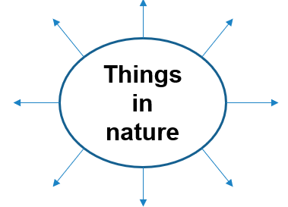  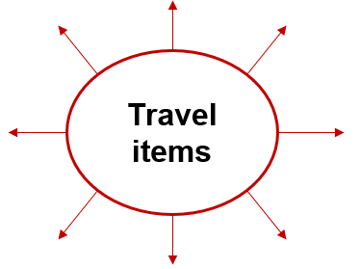  - One team (team A) finds all the words related to things in nature. Another team (team B) finds all the travel items they know.  - Teacher asks students to make a web map in 2 minutes, try to add as many words as possible.  - The fastest group with the most correct answers is the winner.  Suggested answers:  - Things in nature: desert, forest, mountain, lake, river, valley, cave, island, beach,…  - Travel items: lighter, scissors, sleeping bag, compass, plastic, backpack,…. | T-Ss  Group work | 5 mins
Looking back | To help students revise the vocabulary items they have learnt in the unit.  To help students revise the use of must/ mustn’t in context. | Task 1: Write the name for each picture. (p. 56)  - Teacher encourages students to complete the task individually.  - Teacher asks students to swap their books with their partners.  - Teacher shows the answer and check.  Answer key:  1. waterfall  2. cave  3. desert  4. lake  5. beach  6. island  Task 2: Match the name of a natural wonder on column A with a word indicating it in column B.  - Teacher asks students to work in pairs.  - Teacher monitors the activity lets them do it in 2 minutes.  - Teacher lets each pair answer.  - Teacher checks the answers with the whole class.  Answer key:  1. d  2. c  3. a  4. e  5. f  6. b  Task 3: Write the words under the pictures. (p. 56)  - Teacher asks students to do this exercise individually.  - Teacher lets students compare their answers in pairs before checking as a class.  Answer key:  1. scissors  2. sleeping bag  3. compass  4. backpack  5. plaster  Task 4: Find the mistake in each sentence and correct it. (p. 56)  - Teacher asks students to work independently.  - Teacher asks students to read the sentences carefully and correct the mistakes.  - Students complete the task and discuss about the answers.  - Teacher gives feedback as a class discussion.  ANSWER KEY:  1. is → are  2. are → is  3. instrument →  instruments  4. are → is  5. luggages → luggage  Task 5: Complete the dialogue, using must / mustn’t. (p. 56)  - Teacher lets students to work in pairs and complete the activity.  - Teacher asks students to stand up and make a role play.  - Teacher checks the answers with the whole class.  Answer key:  1. must  2. must  3. mustn’t  4. must  5. mustn’t | S  S-Ss  T-Ss  T-Ss  Ss-Ss  Ss-Ss  T-Ss  S  T-Ss  T-Ss  S-S  T-Ss  S-S  T-Ss | 16 mins
Project | To allow students to apply what they have learnt (vocabulary and grammar) into practice through  a project. | * DREAM DESTINATION:  (Making a poster/ travel brochure)  - Teacher sets the context:  + Teacher will be a tourist who is looking for a dream destination to go on holiday.  + Students will be the travel agents who have to suggest the tourist by providing their travel brochure (poster).  - Teacher divides the class into groups of 6. Each group will act as a travel agency.  - Teacher asks “the travel agencies” to discuss and choose an interesting place they would like to visit (in Viet Nam or in the world).  - Teacher asks them to look for necessary information for the visit, basically by discussing the suggested questions.  What the natural wonder is?  Where is it?  How can you go there?  What is it special about?  What can you do there?  …  - Students summarise the information and design A0 size posters about the places they would like to promote.  - Teacher asks the class to listen to the reports and ask questions if they would like to.  - Students will critically evaluate all the posters, then give 1 vote for the most attractive poster/ place.  - Teacher gives comments and feedback to all groups and awards special prize the group which has the most votes. | T-Ss  Group work  T-Ss | 20 mins
Consolidation | To consolidate what students have learnt in the lesson. | Teacher asks students to talk about what they have learnt in the lesson and how they feel with their project. | T-Ss | 3 mins
Homework | To prepare for the next lesson. | Prepare for the next lesson: Unit 6 – Getting started. | T-Ss | 1 min
* Pictures’ source: From Internet

