SPEAKING TEST FOR UNIT 5 – ENGLISH 7
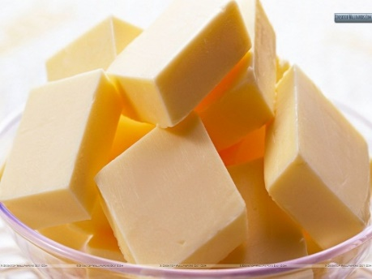  1 | 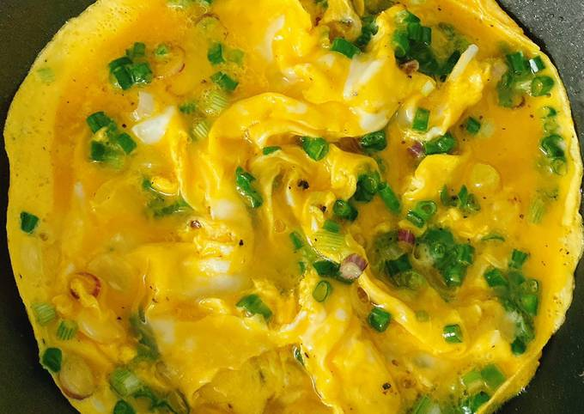  2 | 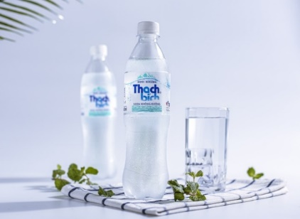  3 | 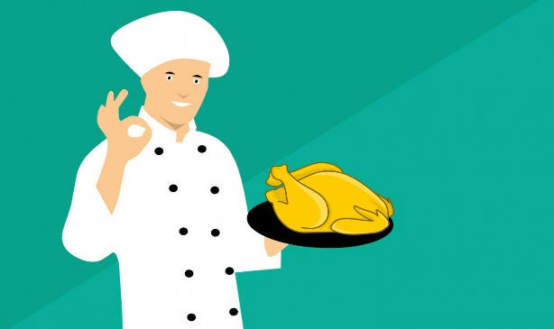  4
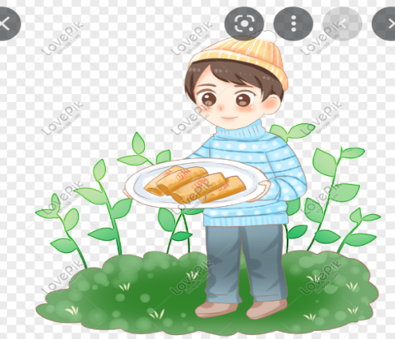  12 | - What food / drink is this? (1,2,3,5,8,9,10)  - What’s his / her favorite food / drink? (7,12)  - What does he / she have for breakfast / lunch /dinner? (6,7,12)  - What food can he / she cook? (4,11)  - It’s a kind of food that is made from eggs, butter/cooking oil, salt and pepper. (2)  - It’s a kind of drink that is made from water, and tea leaves. (9)  6 |  | 5  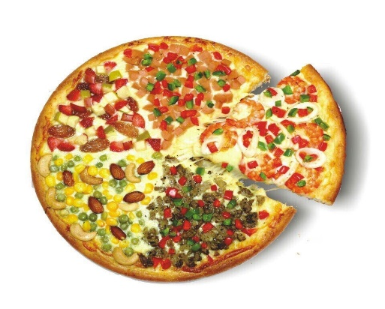
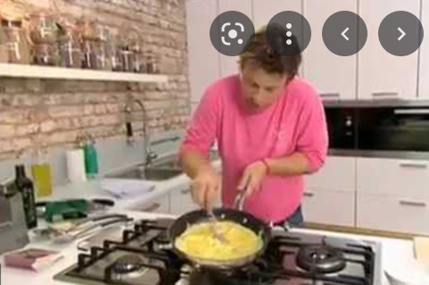  11 |  |  |   6
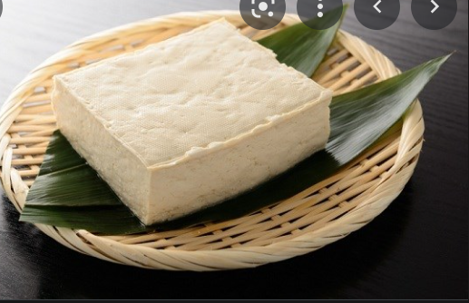  10 | 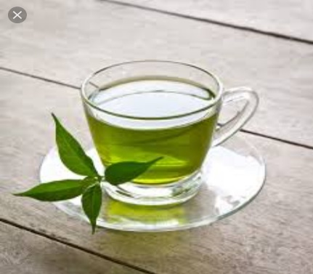 | 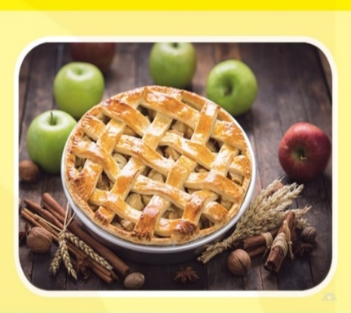  8  9 | 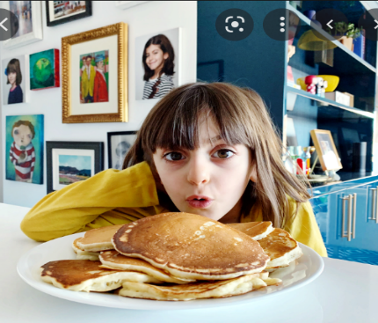  7

III. INTERVIEW / ROLE PLAY
- What time do you have breakfast / lunch / dinner?
- What do you have for breakfast / lunch / dinner?
- What’s your favorite food / drink?
- When do you usually have it?
- Do you think it’s good for your health? Why or why not?

KEY: II/ TOPIC SPEAKING
1. BUTTER
2. OMELETTE
3. MINERAL WATER
4. SALT
5. PIZZA
6. PEPPER
7. PANCAKES
8. APPLE PIE
9. GREEN TEA
10. TOFU
11. OMELETTE
12. SPRING ROLLS
1. MINERAL WATER ; BEEF NOODLE SOUP; APPLE PIE; GREEN TEA; TOFU
2. PANCAKES; SPRING ROLLS
3. EEL SOUP; PANCAKES; SPRING ROLLS
4. OMELETTE
5. PANCAKES
6. BEEF NOODLE SOUP; APPLE PIE; OMELETTE
7. GREEN TEA

