|  |  |
| --- | --- |
| **School: “A” Long Giang Primary School. Name:** .............................................................  **Class: 4**........ | **KIỂM TRA CUỐI HỌC KỲ I MÔN: TIẾNG ANH – LỚP 4 NĂM HỌC: 2022-2023**  **Thời gian: 35 phút** |

|  |  |  |  |  |  |
| --- | --- | --- | --- | --- | --- |
| **SKILL** | **Listening** | **Reading** | **Writing** | **Speaking** | **TOTAL** |
| **MARK** |  |  |  |  |  |
| **COMMENT** | ..........................................................................................................................  ..........................................................................................................................  .......................................................................................................................... | | | | |

# PART 1: LISTENING (15 minutes)

**Question 1: Listen and number (1pt): *(Nghe và đánh số)***

|  |  |
| --- | --- |
| **a**  | **b**  |
| **c**  | **d**  |

**Question 2: Listen and tick (1pt): *(Nghe và đánh dấu*** *✓****)***

|  |  |  |  |
| --- | --- | --- | --- |
| **1.**    **a**  | **b**  | **2.**    **a**  | **b**  |
| **3.**    **a**  | **b**  | **4.**    **a**  | **b**  |

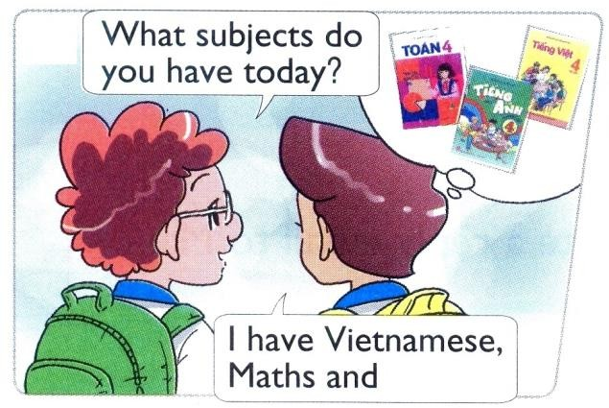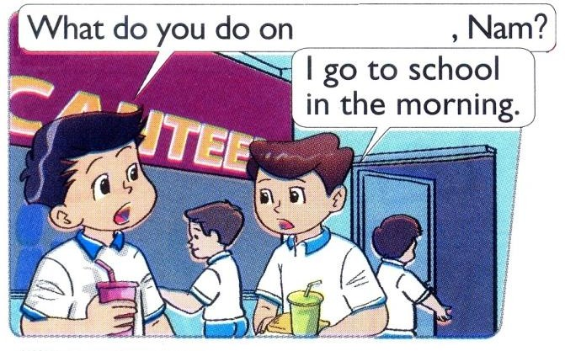**Question 3: Listen and write** ✓**(tick) or** ✗ **(cross) (1pt): *(Nghe và viết*** ✓ **hoặc** ✗***)***

|  |  |  |  |
| --- | --- | --- | --- |
| **1.** |  | **2.** |  |
| **3.** |  | **4.** |  |

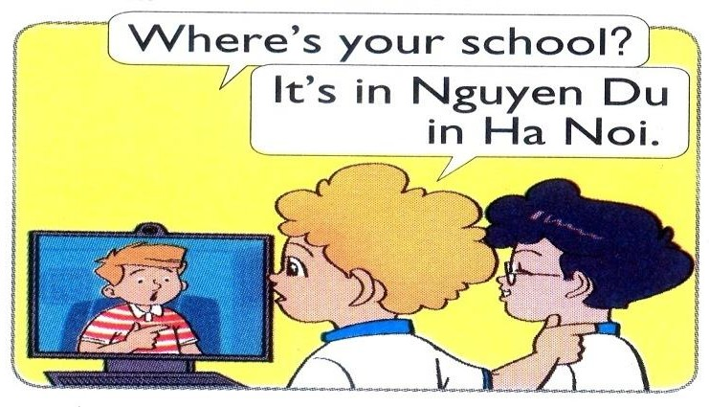**Question 4: Listen and write a missing word (1pt): *(Nghe và viết 1 từ còn thiếu)***

|  |  |
| --- | --- |
| **1.**  ………… | **2.**  …………… |
| **3.**  …………… | **4.**  ………… |

# PART 2: READING (10 minutes)

**Question 5: Read and match (1pt): *(Đọc và ghép)***

|  |  |  |
| --- | --- | --- |
| **1.** Where are you from, Akiko? |  | **a.** It’s on the second of September. |
| **2.** What are Linda and Mai doing? |  | **b.** I have Maths, IT and English. |
| **3.** When’s your birthday? |  | **c.** They’re skipping. |
| **4.** What subjects do you have today? |  | **d.** I’m from Japan. |

**Question 6: Read and complete (1pt): *(Đọc và hoàn chỉnh)***

|  |  |  |  |
| --- | --- | --- | --- |
| **playing** | **doing** | **flying** | **play** |

*Peter:* I have a new kite. Let’s fly it.

*Nam:* I’m sorry but I don’t like (1) …………………. kites.

*Peter:* What do you like (2) ………………….?

*Nam:* I like (3) …………………. chess.

*Peter:* OK, let’s (4) ………………….

# PART 3: WRITING (10 minutes)

**Question 7: Look and write (1pt): *(Nhìn và viết)***

|  |  |  |
| --- | --- | --- |
|  | **1.** | A: What class are you in?  B: I’m in Class ……………… |
| **2.** | A: What are they doing?  B: They’re ……………… a mask. |
| **3.** | A: What do you like doing? B: I like ……………… |
| **4.** | A: Where were you yesterday? B: I was at the ……………… |

**Question 8: Put the words in order (1pt): *(Xếp các từ theo đúng vị trí)***

|  |  |
| --- | --- |
| **1. What / the date / is / today?**  → ........................................................... | **2. My school / Nguyen Du / is in / Street.**  → ............................................................. |
| **3. collecting / I / stamps / like.**  → ........................................................... | **4. nationality / What / you / are?**  → ............................................................. |

# PART 4: SPEAKING (3 minutes for one student)

## Question 9: Getting to know each other (1pt):

1. What’s your name?
2. How old are you?
3. What class are you in?
4. What do you like doing?

## Question 10: Describing the picture (1pt):

1. How many boys are there in the picture?
2. How many girls are there?
3. Where are they?
4. What are they doing?

### --- THE END ---

**ANSWER KEYS – GRADE 4 ĐÁP ÁN – LỚP 4**

**PART 1: LISTENING (15 minutes)**

### Question 1: Listen and number (1pt):

a. 1 b. 4 c. 3 d. 2

### Question 2: Listen and tick (1pt):

1. a 2. b 3. a 4. a

### Question 3: Listen and write ✓(tick) or ✗ (cross) (1pt):

1. ✗ 2. ✓ 3. ✓ 4. ✗

### Question 4: Listen and write a missing word (1pt):

* 1. Street 2. watching 3. English 4. Fridays

# PART 2: READING (10 minutes)

## Question 5: Read and match (1pt):

a. 3 b. 4 c. 2 d. 1

**Question 6: Read and complete (1pt):**

1. flying 2. doing 3. playing 4. play

**PART 3: WRITING (10 minutes)**

**Question 7: Look and write (1pt):**

1. 4A 2. painting 3. swimming 4. zoo

**Question 8: Put the words in order (1pt):**

1. What is the date today? 2. My school is in Nguyen Du Street.

3. I like collecting stamps. 4. What nationality are you?

**PART 4: SPEAKING (3 minutes for one student)**

**Question 9: Getting to know each other (1pt):**

1. My name’s ………… 2. I’m ………… (years old).

3. I’m in Class ………… 4. I like …………

## Question 10: Describing the picture (1pt):

1. There are two boys. 2. There is one girl.

3. They are at home. 4. They’re watching TV.