**LỚP HỌC THẦY (CÔ) ___________________________** **ĐỀ ÔN TẬP: READING SIGNS/ NOTICES – A2**

**Test 18**

*Thời gian làm bài: [Time]*

Họ và tên: ________________________________________________ Lớp: 9/___

**Question 1:** What does this sign indicate?

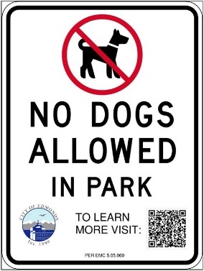**A.** Pets are allowed in the park.  
**B.** You are not allowed to bring pets here.  
**C.** Pets are not allowed unless they are on a leash.  
**D.** Pets are not allowed in this area**.**

**Question 2:** What does the notice say?

Paradise Restaurant Booking is requested

Call: 20242025

**A.** You have to book in advance to eat at PR

**B.** You mustn't book before hand to eat at PR

**C.** You can eat at PR without calling

**D.** You are requested to eat at PR

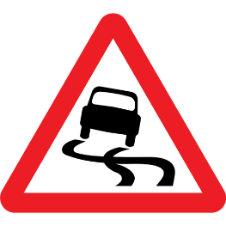**Question 3:** Choose the best answer for the question.

**A.** Be careful as there is ice on the street.

**B.** Be careful when driving as the road is bumpy.

**C.** Be careful as the road is narrow ahead**.**

**D.** Be careful when driving as the road is slippery.

**Question 4:** What does the notice say?

**Ocean View Resort Booking is necessary**  
Call: 40456789

**A.** You need to book in advance to stay at Ocean View Resort.  
**B.** You can stay at Ocean View Resort without booking.  
**C.** Booking is not allowed at Ocean View Resort.  
**D.** You are requested to stay at Ocean View Resort.

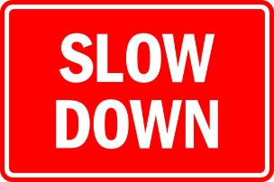**Question 5:** Where might you see this notice?  
**A.** On a highway where there are no speed limits.  
**B.** In a school zone or in a residential area**.**  
**C.** In a commercial district where roads are high-speed**.**  
**D.** In a parking lot.

**Question 6:** What does the message mean?

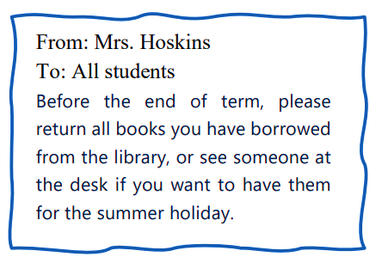

**A.** If there are library books you want, borrow them before the end of term.

**B.** You must take back all the library books you've got before the summer holiday.

**C.** To keep any library books for holiday reading, you don't need to ask for any permission.

**D.** You can keep the books from the library until you finish your summer holiday.

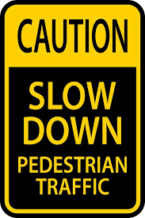**Question 7:** Choose the best answer for the question.

**A.** Pedestrians will obstruct traffic**.**

**B.** You should drive carefully because there are slow pedestrians.

**C.** You should slow down and pay attention to pedestrians.

**D.** Pedestrians should not walk too fast.

**Question 8:** What does the message mean?

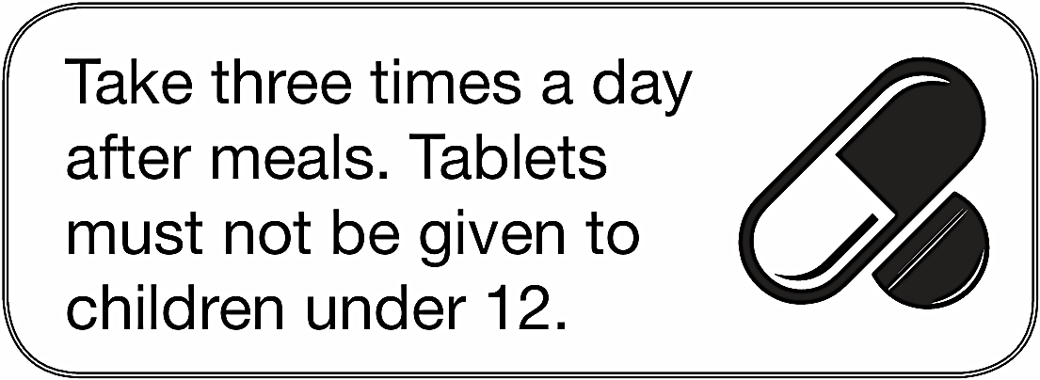

**A.** Take tablets three times a day after meals; suitable for children under 12.  
**B.** Take tablets three times a day after meals; not for children under 12.  
**C.** Take tablets once a day; suitable for children under 12.  
**D.** Take tablets three times a day before meals; suitable for children under 12.

**Question 9:** What does this sign indicate?

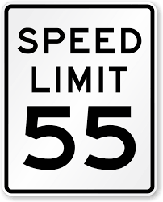 **A.** The fastest you can drive is 55 miles per hour.  
**B.** You should drive at 55 kilometers per hour.  
**C.** You are encouraged to drive as fast as possible.  
**D.** You must drive at least 55 miles per hour.

**Question 10:** What does the message mean?

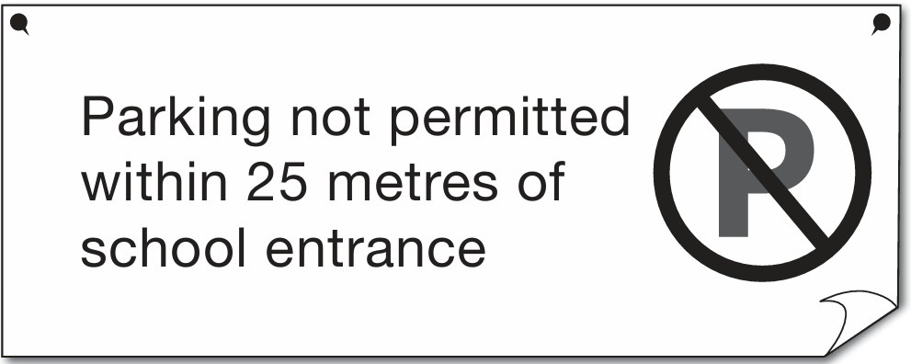

**A.** You can park very close to the school entrance.  
**B.** You must park at least 25 metres away from the school entrance.  
**C.** You can park in front of the school entrance.  
**D.** You must park inside the school entrance.

**[HẾT]**