**LỚP HỌC THẦY (CÔ) ___________________________** **ĐỀ ÔN TẬP: READING SIGNS/ NOTICES – A2**

**Test 7**

*Thời gian làm bài: [Time]*

Họ và tên: ________________________________________________ Lớp: 9/___

**Nội dung:**

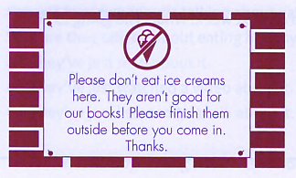**Question 1:** Where might you see this?

**A.** in a café **B.** in a swimming pool

**C.** in a library **D.** in a picnic area

**Question 2:** Who is this message for?

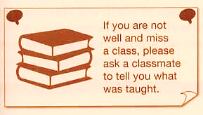

**A.** Pupils who are feeling not well **B.** Pupils who couldn't go to a lesson

**C.** Pupils who would like to help their friends **D.** The student does not study.

**Question 3:** What does the sign say?



**A.** Please go to the science room now.

**B.** You cannot go out through this door.

**C.** The science lab is being used by others today.

**D.** Use this door to get to the science room now.

**Question 4:** What should the club members do?

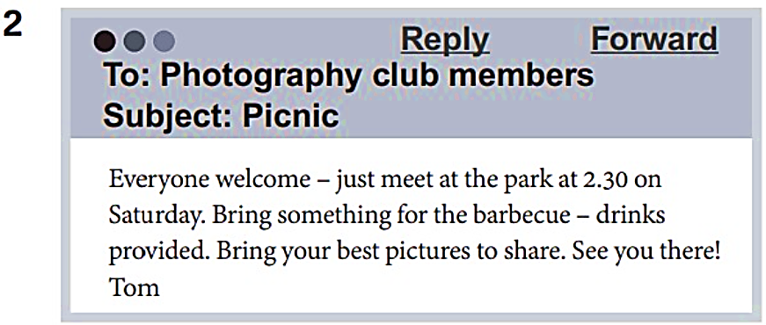

**A.** bring food to cook on the picnic **B.** take lots of photos at the picnic

**C.** tell Tom if they want to go on the picnic **D.** have a barbecue on the picnic

**Question 5:** What does the sign mean?

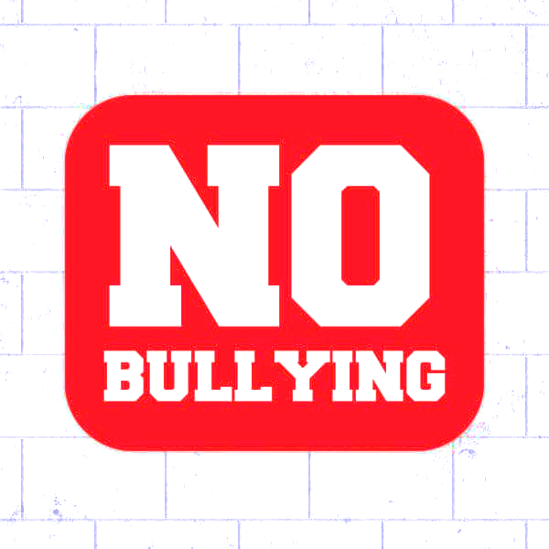

**A.** Bad students will be punished at school.

**B.** Violence is not allowed at school.

**C.** Classmates should not talk too much to each other.

**D.** Younger students mustn't obey their monitors at school.

**Question 6:** Who are this message for?

How about joining the school singing group? It doesn't matter if you can't read music. All staff and pupils welcome! Mondays after lessons at 4 p.m.

**A.** Anyone at the school **B.** Pupils who have music lessons

**C.** People who can already read music **D.** You must know how to sing

**Question 7:** What does the sign say?

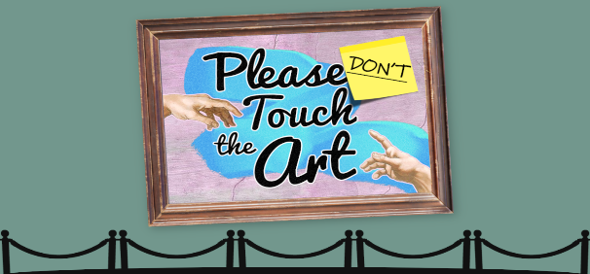

**A.** Do not touch the artwork or you may be fined**.**

**B.** Touch the artwork if you need a closer look.

**C.** Only touch the artwork that is labeled for touching.

**D.** Do not touch the artwork to keep it safe and clean.

**Question 8:** Which of the following information is correct?

DAN'S ICE CREAMS

Buy one, get one free! (Special offer 12-2 p.m. only)

**A.** The ice cream shop is open for only 2 hours. **B.** Two ice creams will cost the same as one.

**C.** You can get free ice creams all afternoon. **D.** You can only buy 2 ice creams at a time.

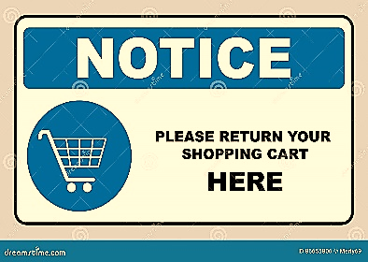**Question 9:** What does the sign tell you?

**A.** Return your cart anywhere in the parking lot.

**B.** Return the cart to the designated cart area**.**

**C.** Keep the cart in your car until you get home.

**D.** Return the cart at the store entrance.

**Question 10:** Who is this message for?

Bring your parents to the school’s Open Day this Saturday! All students are encouraged to attend with their families from 10 a.m. to 2 p.m.

**A.** Only new students. **B.** All students and their families.  
**C.** Teachers and staff. **D.** Parents only.

**[HẾT]**