Chỉ 100k/12 tháng, bạn tải rất nhiều tài liệu tiếng anh file word hay tại: Giaoandethitienganh.info Mong bạn ghé ủng hộ !
ĐỀ VIP 9+ - ĐỀ SỐ 12
Read the following advertisement and mark the letter A, B, C, or D to indicate the correct option that best fits each of the numbered blanks from 1 to 6.

Parenting Skills Workshop
Are you struggling with parenting conflicts? Join our workshop, Effective Parenting Strategies, designed to help you (1) daily challenges while nurturing strong family bonds. Gain insight into practical solutions for managing family dynamics, requiring a great (2) of patience and resilience. The workshop provides tools and strategies to encourage (3) healthy communication, creating a positive environment for your children.
Led by experienced coaches, this session offers a supportive (4) , bringing together parents facing similar challenges, allowing everyone to share and learn. Tailored exercises, addressing real-life scenarios, will empower you with techniques to build confidence (5) your parenting journey. Don’t miss this chance to learn valuable skills, (6) to handle common struggles faced by families today.
Sign up now and invest in a rewarding journey of growth and understanding for you and your family!
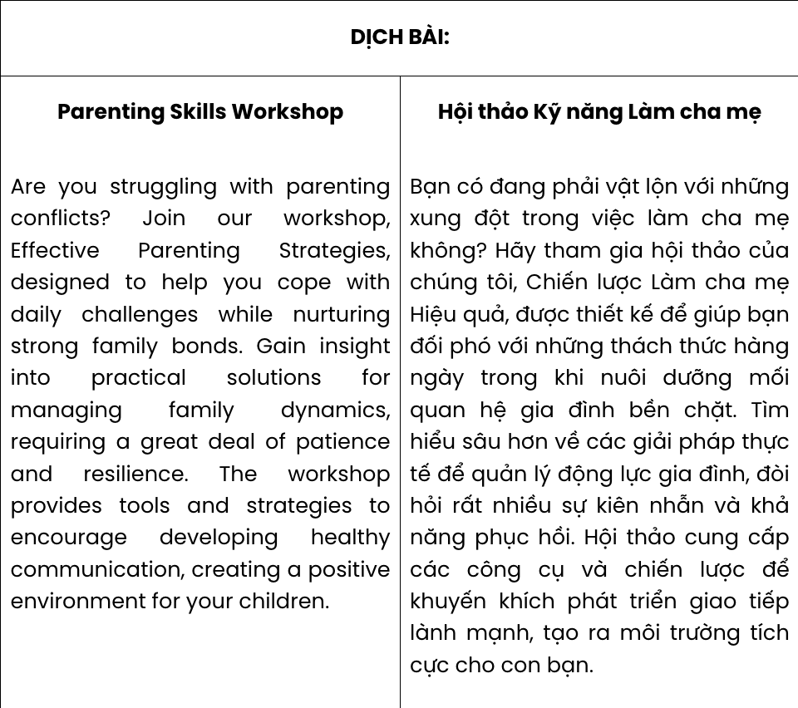
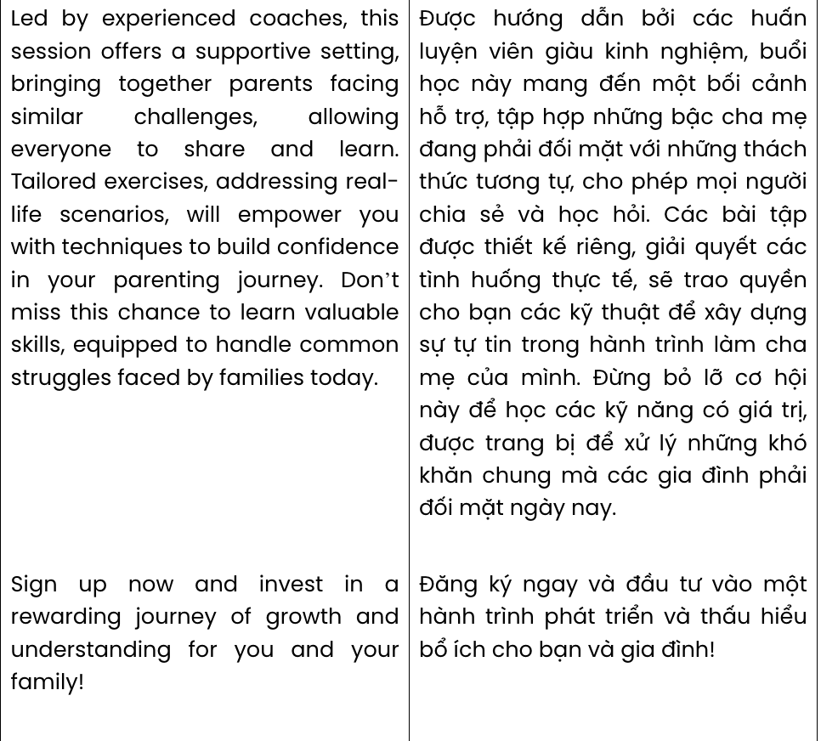
Question 1. A. give away B. take up C. cope with D. bring in
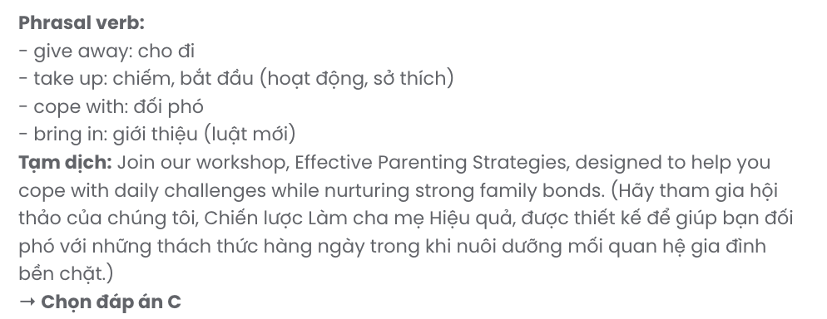
Question 2. A. quality B. deal C. number D. handful
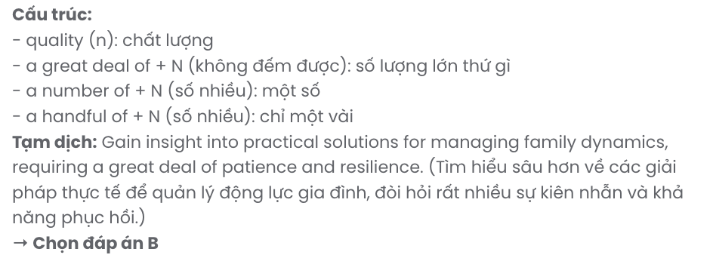
Question 3. A. developing B. develop C. to developing D. to develop
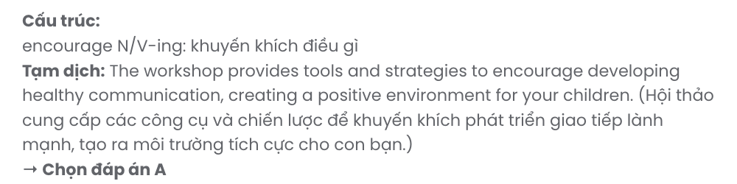
Question 4. A. sight B. setting C. situation D. occasion
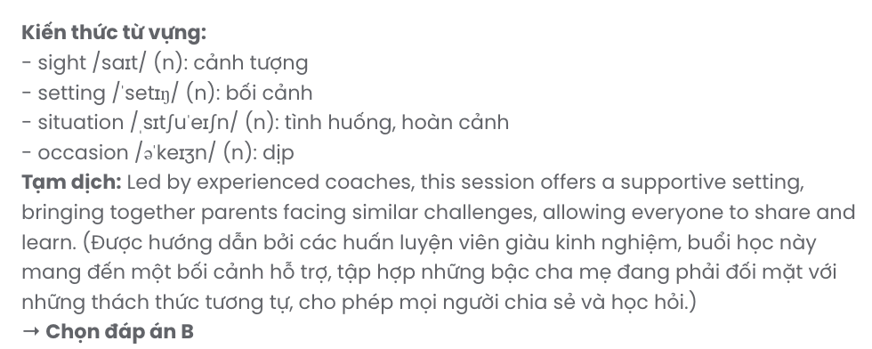
Question 5. A. on B. for C. with D. in
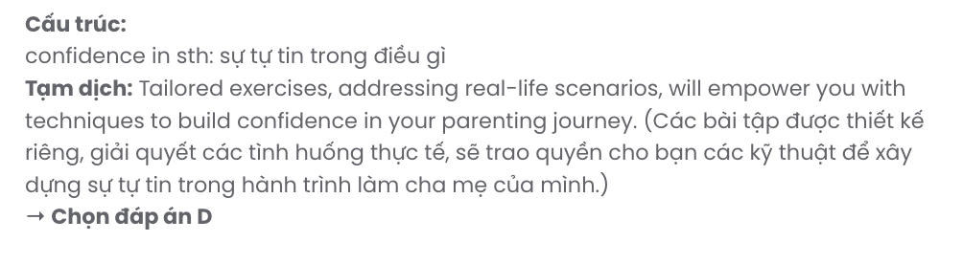
Question 6. A. which equip B. are equipped C. equipped D. equipping
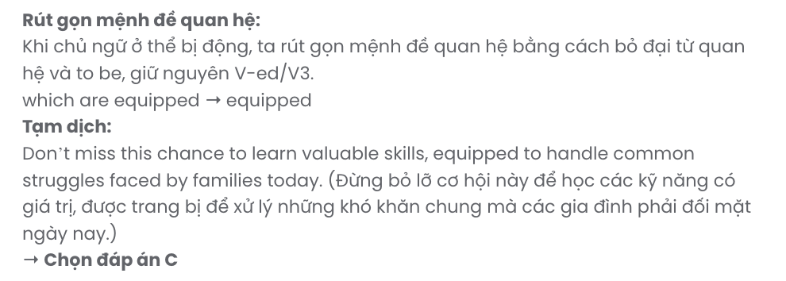
Read the following article and mark the letter A, B, C, or D to indicate the correct option that best fits each of the numbered blanks from 7 to 12.

COMMUNITY CHARITY EVENT BRINGS HOPE TO LOCAL FAMILIES
This weekend, our community came together for an inspiring charity event aimed at supporting families in need. Volunteers and organisers joined hands to create a(n) (7) , filled with food, games, and performances, bringing smiles to all participants. The event welcomed people of all ages, with the local community eager to give back, (8) personal resources.
Donations poured in as neighbours, friends, and (9) community members shared in the spirit of giving. From setting up stands to running activities, everyone contributed to (10) a difference. All (11) from the event will go directly toward providing essential resources for families in crisis, helping to ease their hardships.
Thanks to this (12) event, local families can look forward to a brighter future, supported by a community that cares. Together, we’re building a more compassionate and connected neighbourhood.

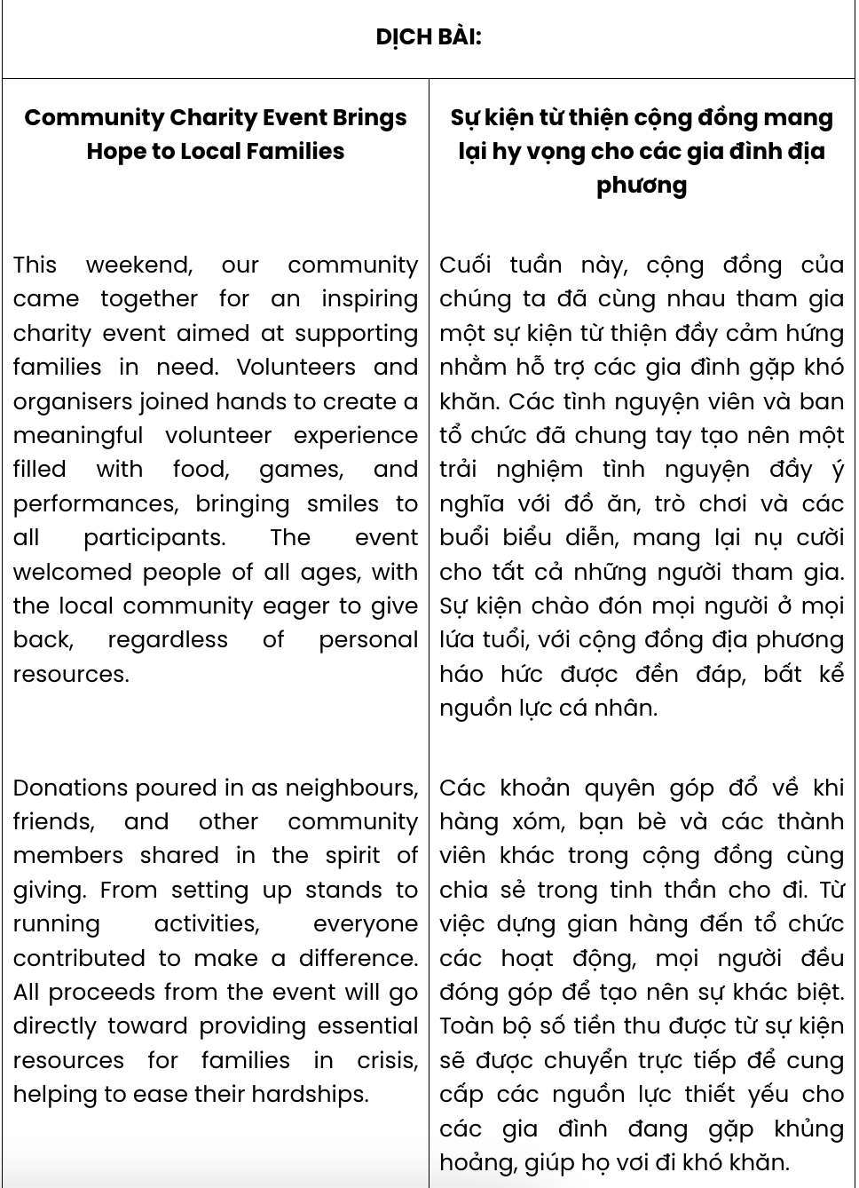

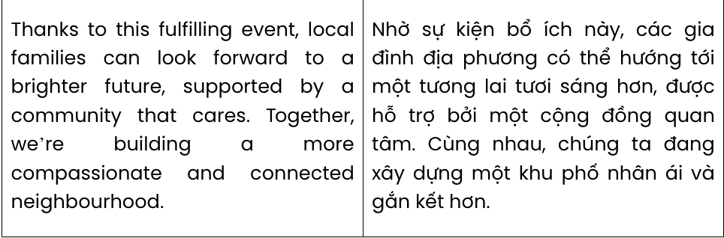

Question 7. A. volunteer meaningful experience B. experience meaningful volunteer
C. meaningful volunteer experience D. meaningful experience volunteer
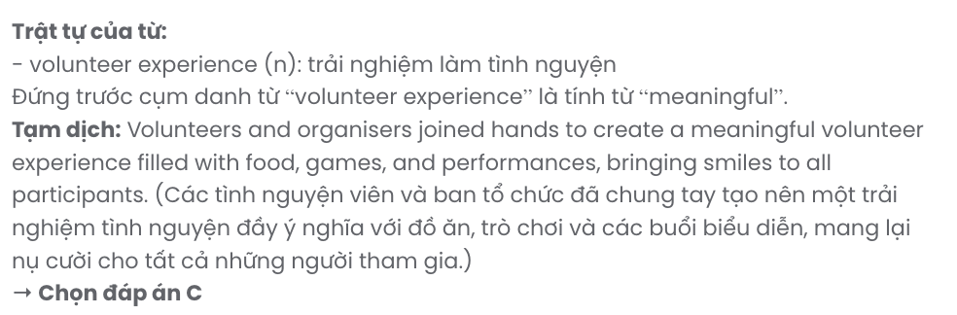
Question 8. A. in place of B. regardless of C. on account of D. owing to
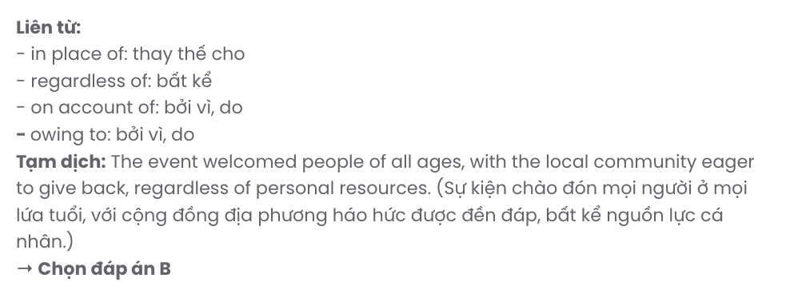
Question 9. A. the others B. another C. each D. other
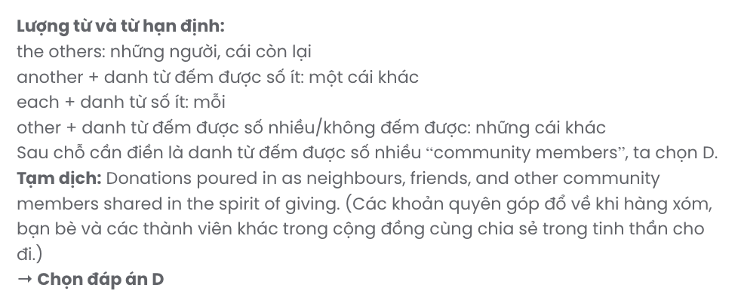
Question 10. A. put B. take C. lead D. make
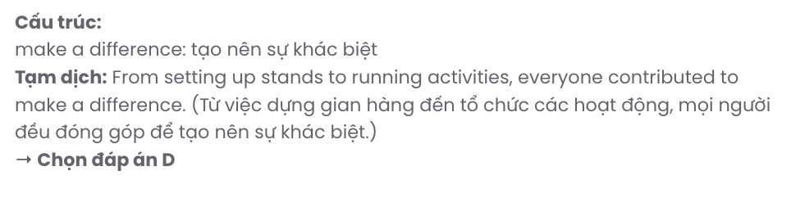
Question 11. A. salaries B. fares C. expenses D. proceeds
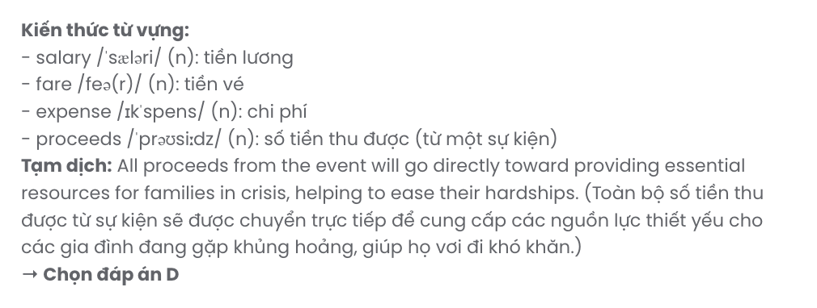
Question 12. A. fulfil B. fulfilment C. fulfilled D. fulfilling
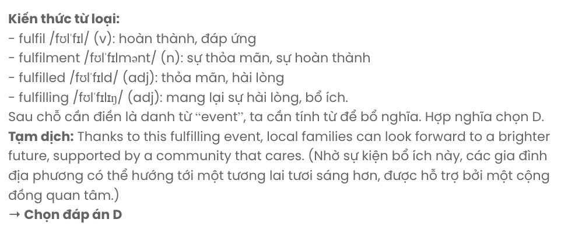
Mark the letter A, B, C or D to indicate the best arrangement of utterances or sentences to make a meaningful exchange or text in each of the following questions from 13 to 17.

Question 13.
- Dan: Hey, Lily! It was nice. I actually tried baking for the first time.
- Lily: Really? Baking sounds fun and rewarding!
- Lily: Hi, Dan! How was your weekend? Did you do anything special?
A. c – b – a B. c – a – b C. a – c – b D. b – a – c
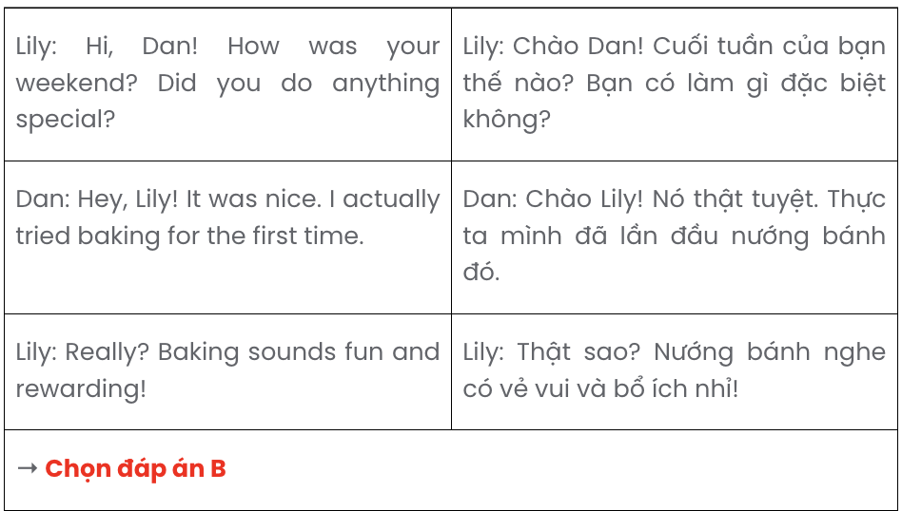

Question 14.
- Ultimately, I feel privileged to have a career that allows me to make a tangible difference in the lives of animals and their caretakers.
- This dynamic field brings fresh challenges each day, making my work both intellectually stimulating and deeply rewarding.
- At my clinic, I provide meticulous care for a wide range of animals, from beloved household pets to injured wildlife needing rehabilitation.
- Although some cases are emotionally taxing, witnessing an animal’s recovery brings a profound sense of fulfilment to this role.
- My profound passion for animal welfare and fascination with veterinary science led me to pursue a career as a veterinarian.
A. c – b – e – d – a B. b – c – d – e – a C. d – c – e – b – a D. e – c – b – d – a
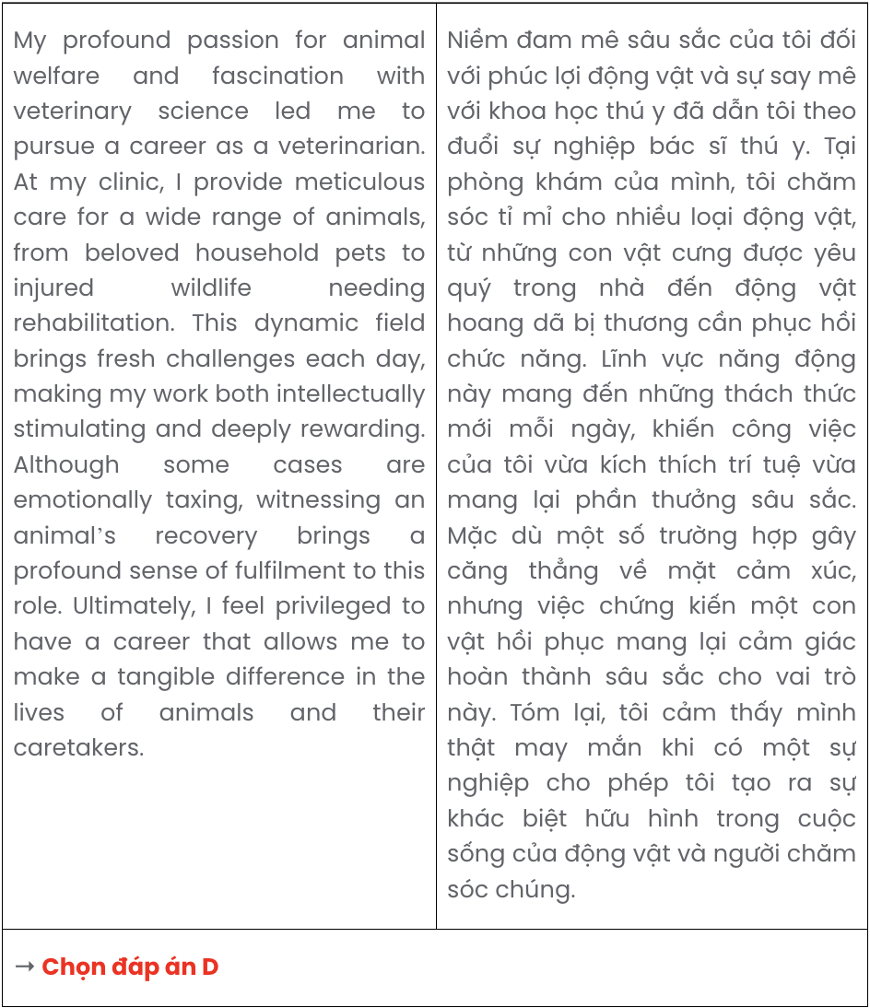

Question 15.
Hi Jenna,
- Your suggestion for where to buy affordable ingredients was also helpful - it’s a fantastic alternative to my usual store.
- Trying my hand at baking is such a great way to unwind, though I haven’t had the chance lately.
- Hopefully, we can set aside a day to bake together. Let me know if you’re up for it!
- The cinnamon roll recipe, in particular, caught my eye; I can almost imagine how delicious it’ll smell in the kitchen.
- I wanted to thank you for the baking recipes you sent over - they all look amazing! Write back soon,
Ella
A. c – e – a – d – b B. b – d – e – a – c C. a – b – c – e – d D. e – b – d – a – c
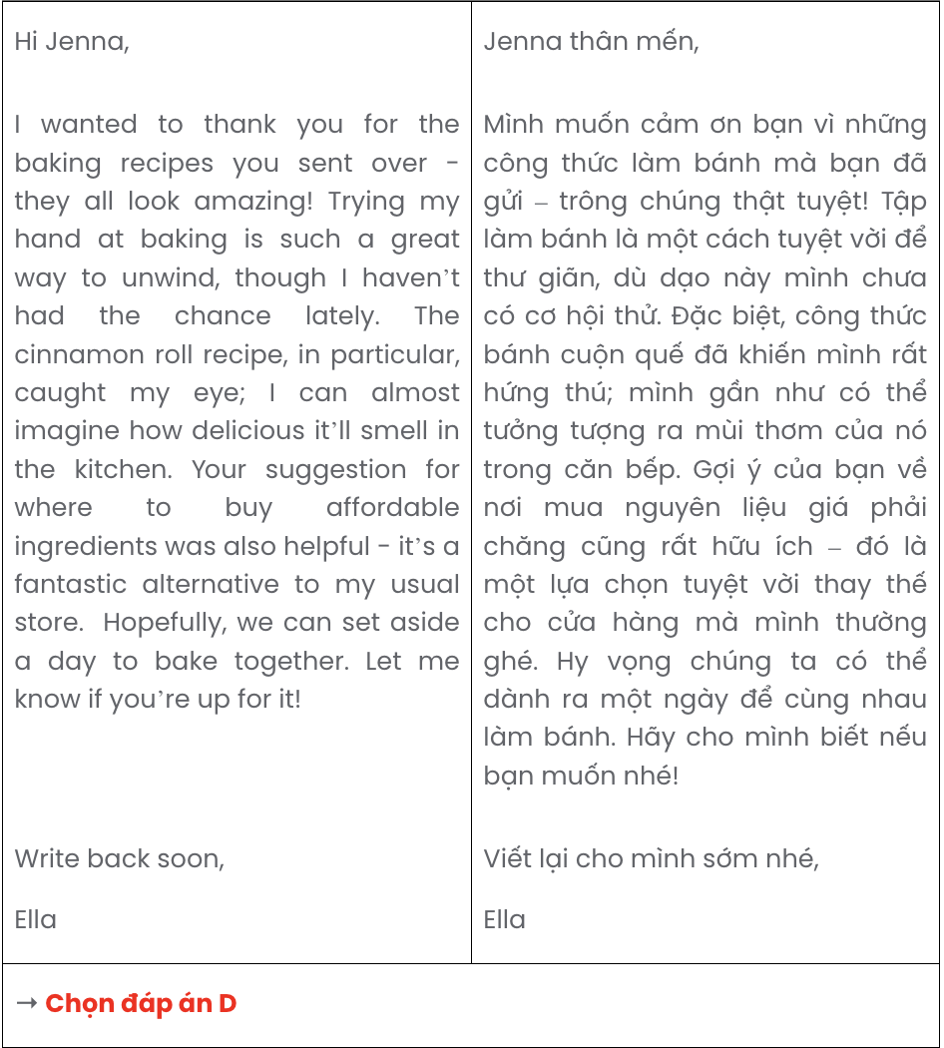

Question 16.
- Sarah: I feel that spending a year volunteering abroad could be a great experience for me.
- Linda: I’m not convinced. It seems risky to put everything on hold for a year.
- Linda: Are you sure taking a gap year is the best decision?
- Sarah: I know, but I believe this break could actually help me come back to school with a fresh perspective.
- Linda: I’m concerned about what this might do to your studies.
A. c – a – e – d – b B. c – d – b – a – e C. e – d – b – a – c D. e – a – c – d – b
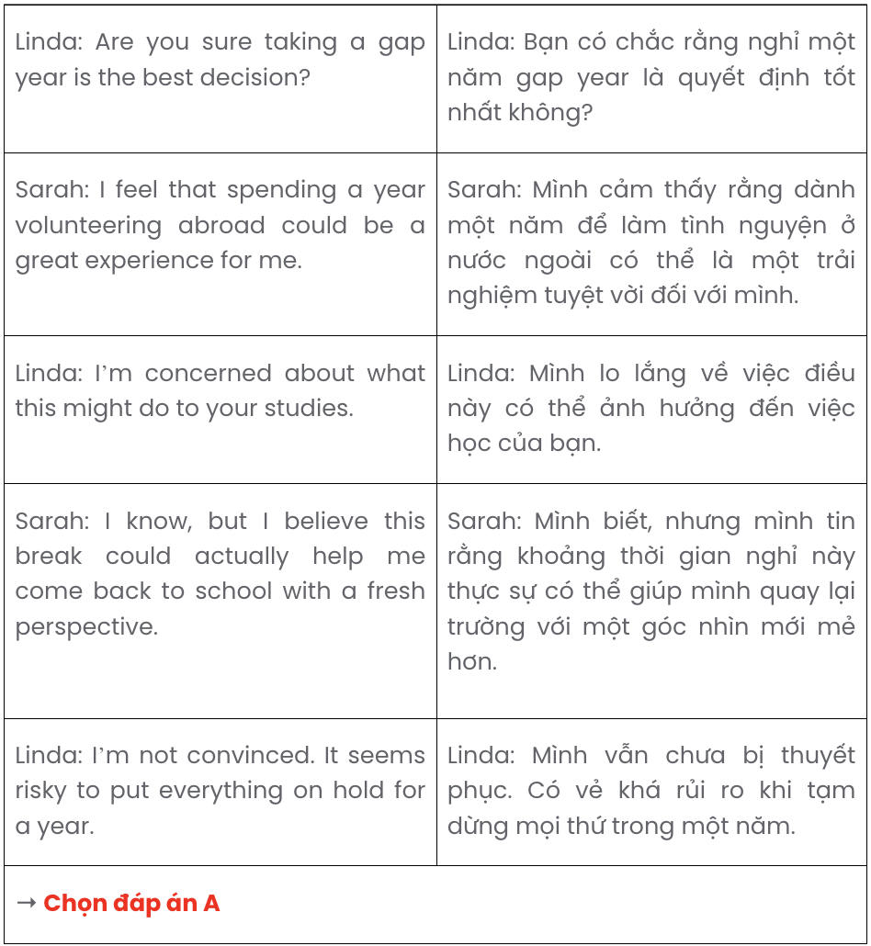

Question 17.
- In the wake of this storm, many communities were left to rebuild their homes and restore essential infrastructure.
- This resilience coupled with the efforts of relief agencies and volunteers has brought much-needed supplies, though challenges remain in some isolated areas.
- Yet, for many families, the journey to full recovery continues, as resources are still stretched thin in the affected regions.
- When the powerful Super Typhoon Yagi struck Vietnam a few months ago, it caused widespread destruction.
- This catastrophe highlighted the resilience of local residents, who worked tirelessly to clear the debris and support one another.
A. d – b – c – a – e B. d – e – a – b – c C. d – a – e – b – c D. d – c – e – a – b

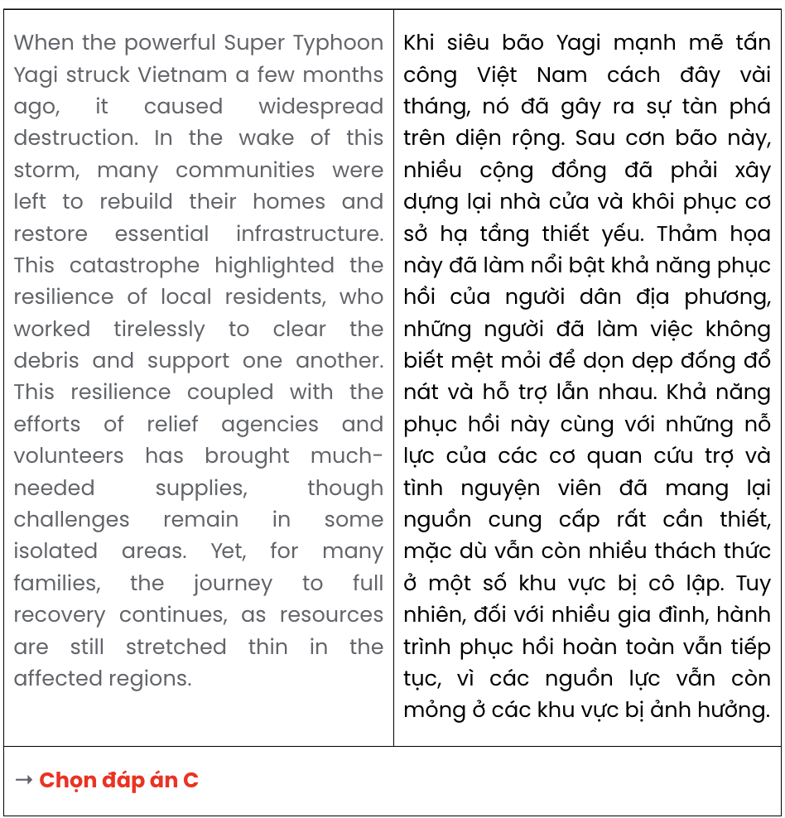
Read the following passage about Black Friday and e-waste and mark the letter A, B, C, or D to indicate the correct option that best fits each of the numbered blanks from 18 to 22.
Black Friday, once just an American shopping phenomenon, has now spread globally, enticing millions of consumers with massive discounts and limited-time deals. Black Friday, originally associated with the day after Thanksgiving in the United States, (18) . In recent years, this event has expanded to last an entire week, drawing in eager shoppers worldwide. However, with this surge in consumer activity, there comes a significant downside: the rise in electronic waste, commonly known as e-waste.
Each year, Black Friday contributes to a dramatic increase in sales of electronic devices, from smartphones to laptops. Many of these items quickly become outdated or replaced, fuelling a cycle of consumption (19) . This surge has created serious environmental challenges, as most electronics contain hazardous materials that require special disposal methods.
Electronic waste represents a growing environmental crisis, impacting landfills and releasing harmful chemicals into ecosystems. The materials in many electronic devices, such as metals and plastics, take years to break down. When improperly discarded, (20) . In response, (21) .
Black Friday highlights both the excitement of consumerism and the pressing need for environmental awareness. Having embraced sustainable practices, (22) . This urges consumers to think beyond short-term discounts and prioritise long-term environmental health.
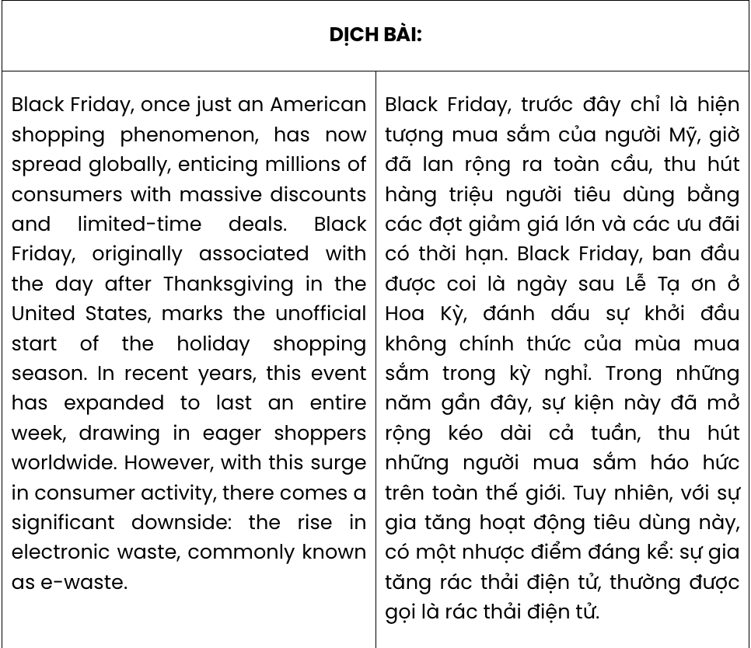
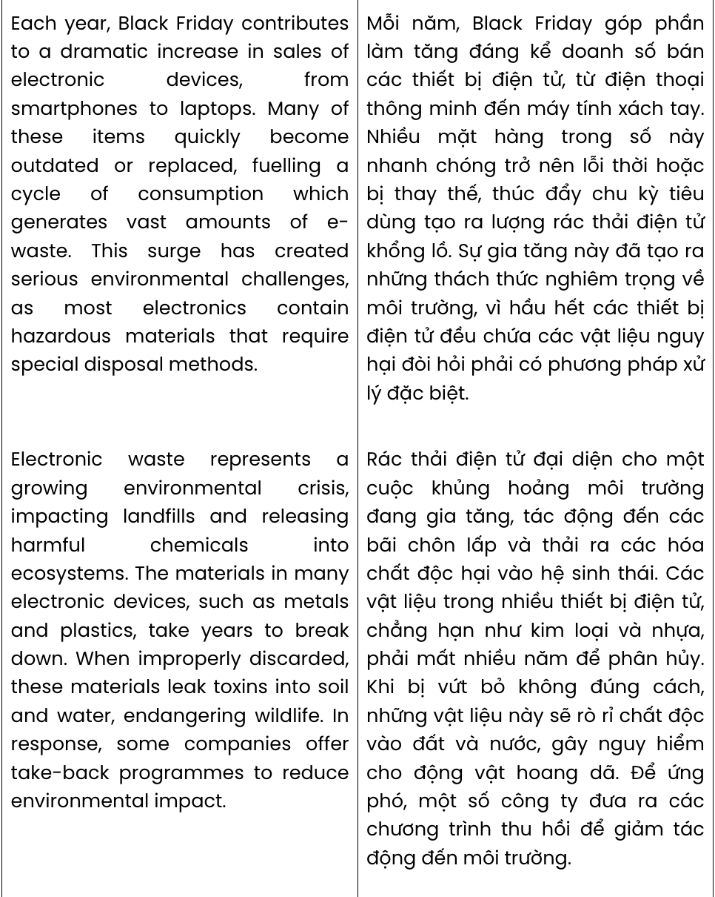
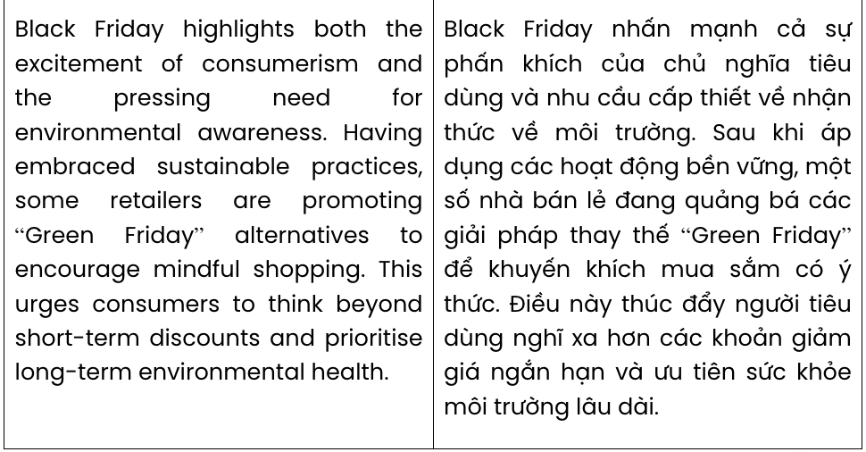

Question 18.
  - which serves as the unofficial launch of the holiday shopping season
  - of which the informal kick-off to the holiday shopping season is marked
  - marks the unofficial start of the holiday shopping season
  - signalling the informal start of the holiday shopping season

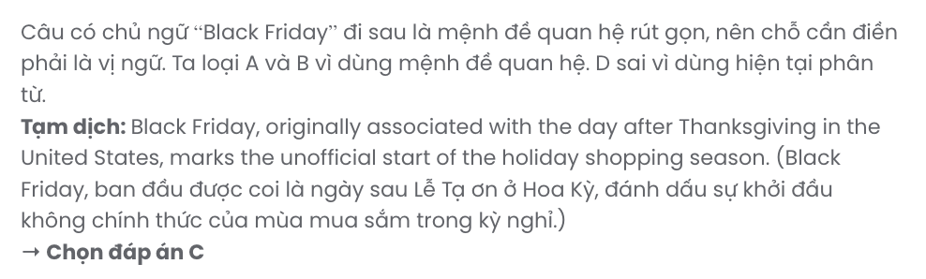

Question 19.
- resulted in large quantities of e-waste
- whose production of large amounts of e-waste
- which generates vast amounts of e-waste
- led to significant amounts of e-waste. GIA SƯ TẠI HUẾ (079.3833.272)
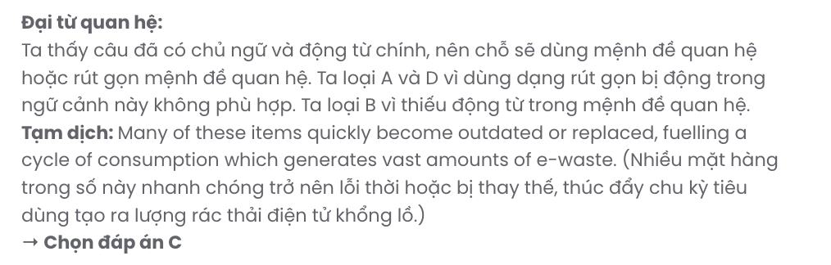

Question 20.
- leaked toxins into soil and water endangers wildlife by these materials
- these materials leak toxins into soil and water, endangering wildlife
- wildlife is endangered by toxins leaked by these materials into soil and water
- soil and water suffer from leaked toxins by these materials, harming wildlife
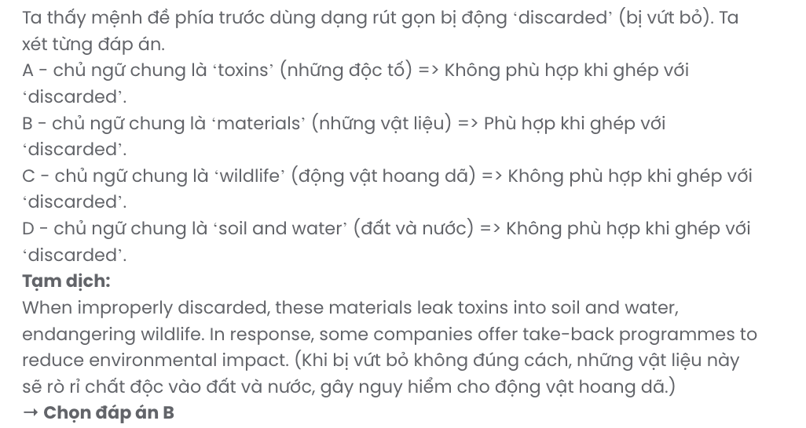

Question 21.
- some companies offer take-back programmes to reduce environmental impact
- take-back programmes require some companies to reduce environmental impact
- the environmental impact is reduced thanks to some companies’ take-back programmes
- adopting take-back programmes helps reduce the environmental impact of some companies
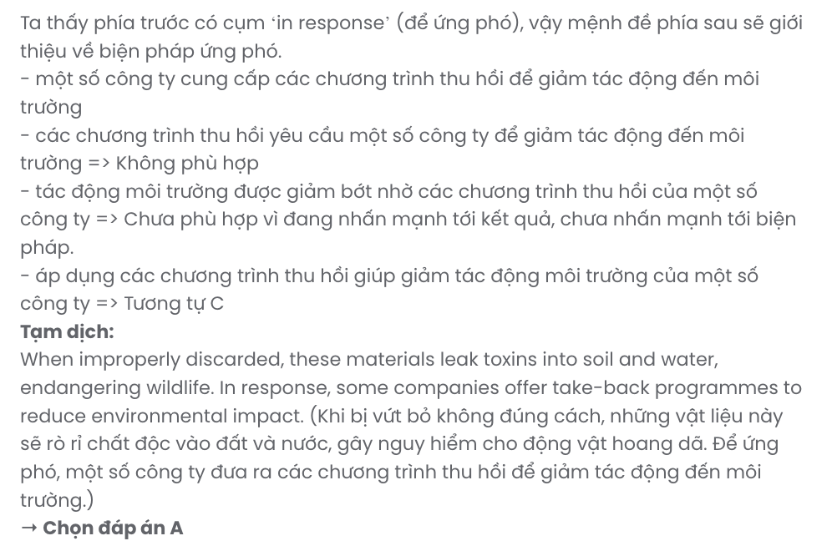

Question 22.
- “Green Friday” alternatives help encourage mindful shopping among some retailers
- mindful shopping through “Green Friday” alternatives is encouraged by some retailers
- some retailers are promoting “Green Friday” alternatives to encourage mindful shopping
- encouraging mindful shopping via “Green Friday” alternatives is done by some retailers
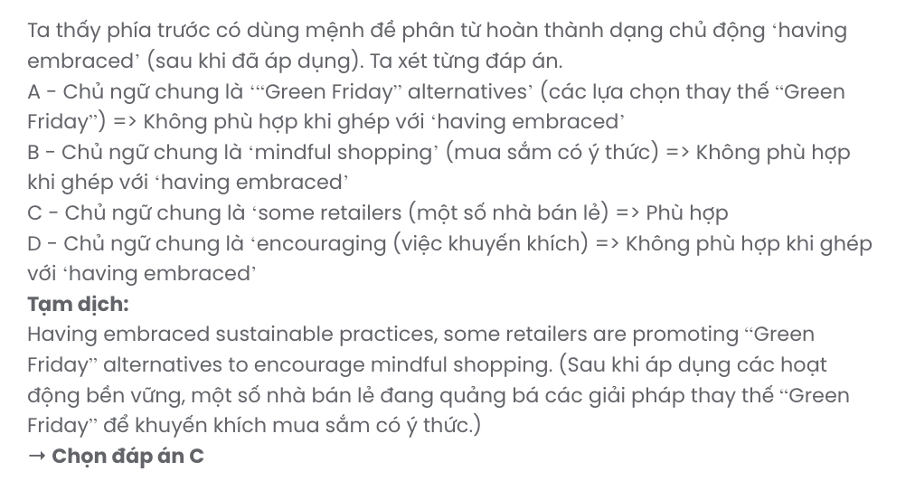
Read the following passage about parents and teens and mark the letter A, B, C, or D to indicate the correct answer to each of the questions from 23 to 30.
Do you ever get the feeling that your parents just don't listen to you? It's not that your parents ignore you completely; it's more that they don't see things in quite the same way as you. And this isn't the only problem you may face.
As you grow up, your personality develops and you're trying to become more independent, so naturally you have more questions and opinions about all aspects of your life. You start wondering whether your parents actually know what they're talking about. These doubts can lead to arguments and it's hard for parents to know how to deal with this. That's often because it's the first time they've been responsible for a teenager and they're learning to cope!
Obviously, it's important to respect your parents and you should try to understand why they might have a different point of view from yours. Their priority is to provide you with a structured environment, where they can guide and support you. However, it's vital that they try and see your point of view. They also need to give you the freedom to make your own decisions.
The important thing is to keep talking. Remember that there's no reason why people should automatically understand all your views. The more you can discuss things with your parents in a mature way, the happier you will feel. On the other hand, if you really find it impossible to talk to your parents, it might be a good idea to find a family member, teacher or professional counsellor who can help you. Above all, stay positive and remember that it won't be long before you'll be able to make your own decisions.
(Adapted from Complete First for Schools)
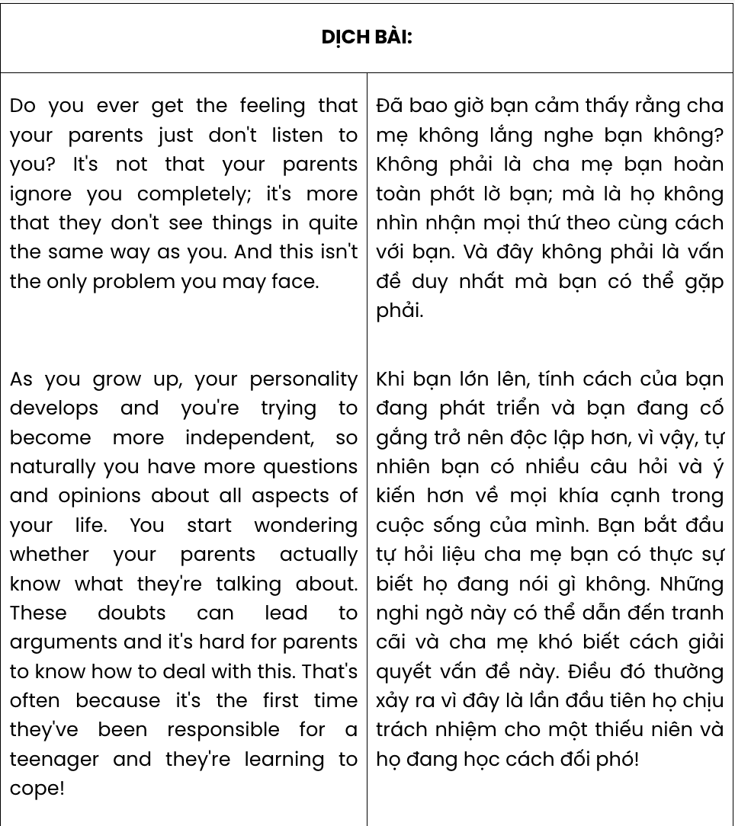
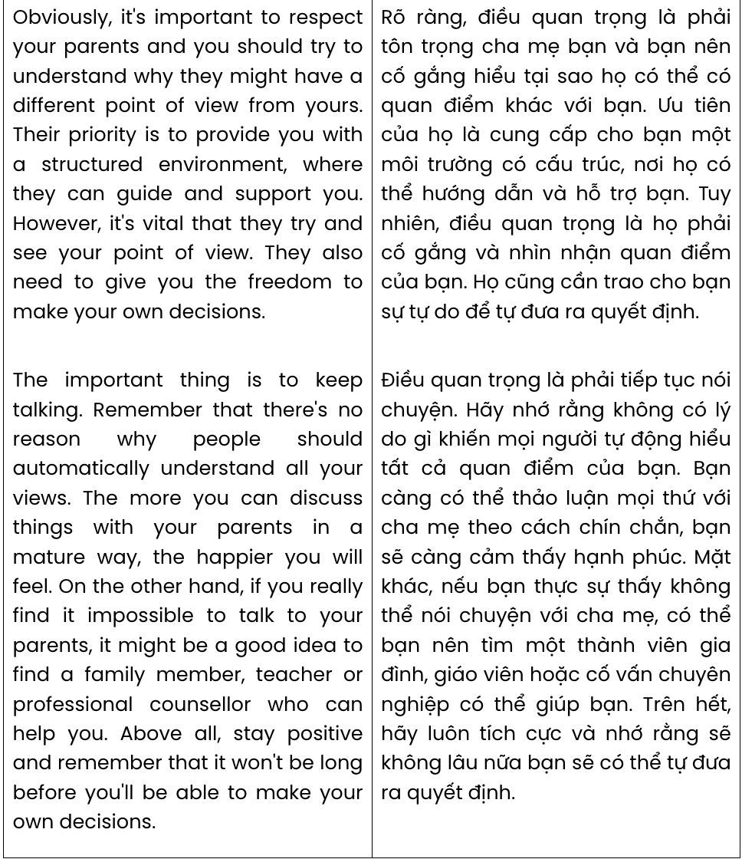
Question 23. The word they in paragraph 1 refers to .
A. parents B. things C. opinions D. aspects

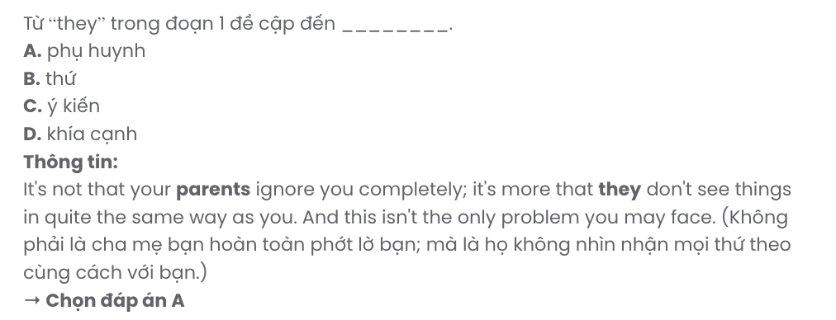
Question 24. According to paragraph 2, teenagers’ doubts about their parents .
- make it hard to maintain harmony in the family
- endanger their future career choices
- cause a lot of confusion about their lives
- cause daily conflicts between them and their friends
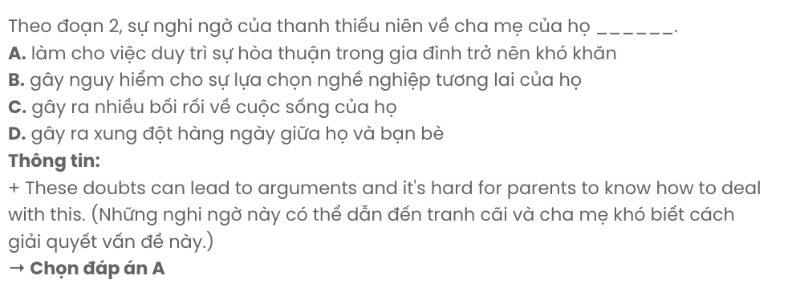
Question 25. The word cope in paragraph 2 can be best replaced by .
A. inspire B. manage C. accept D. protect
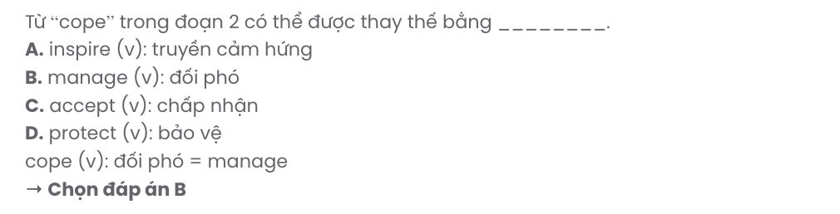
Question 26. The word guide in paragraph 3 is OPPOSITE in meaning to .
A. separate B. approve C. neglect D. nurture
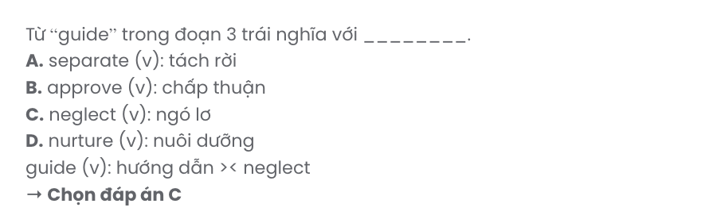
Question 27. Which of the following best paraphrases the underlined sentence in paragraph 4?

Remember that there's no reason why people should automatically understand all your views.
- Remember that it’s unreasonable to expect that everyone agrees with your views.
- Bear in mind that your views should naturally be clear to others without explanation.
- Be clear that people don’t always understand your views because they lack information.
- Keep in mind that it’s not necessary for others to inherently understand all your perspectives.
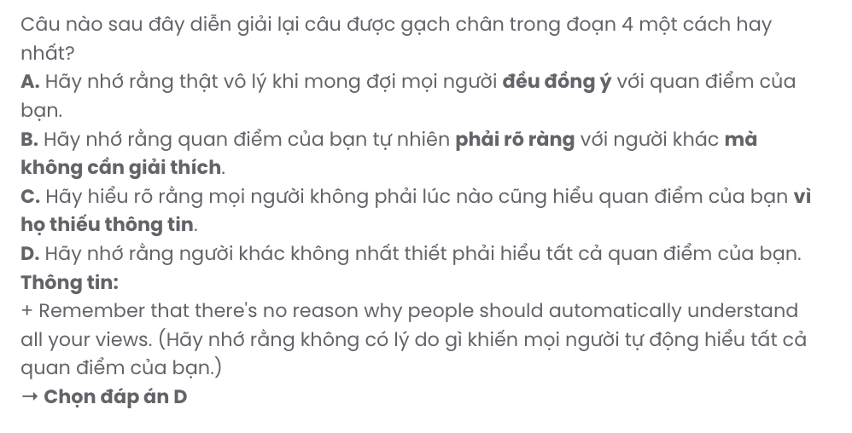
Question 28. Which of the following is TRUE according to the passage?
- As teens become more independent, they completely disagree with their parents.
- Parents should allow teens the independence to make choices on their own.
- It is not uncommon for parents to completely ignore their children’s opinions.
- Trying to figure out why parents hold opposing views is a complete waste of time.
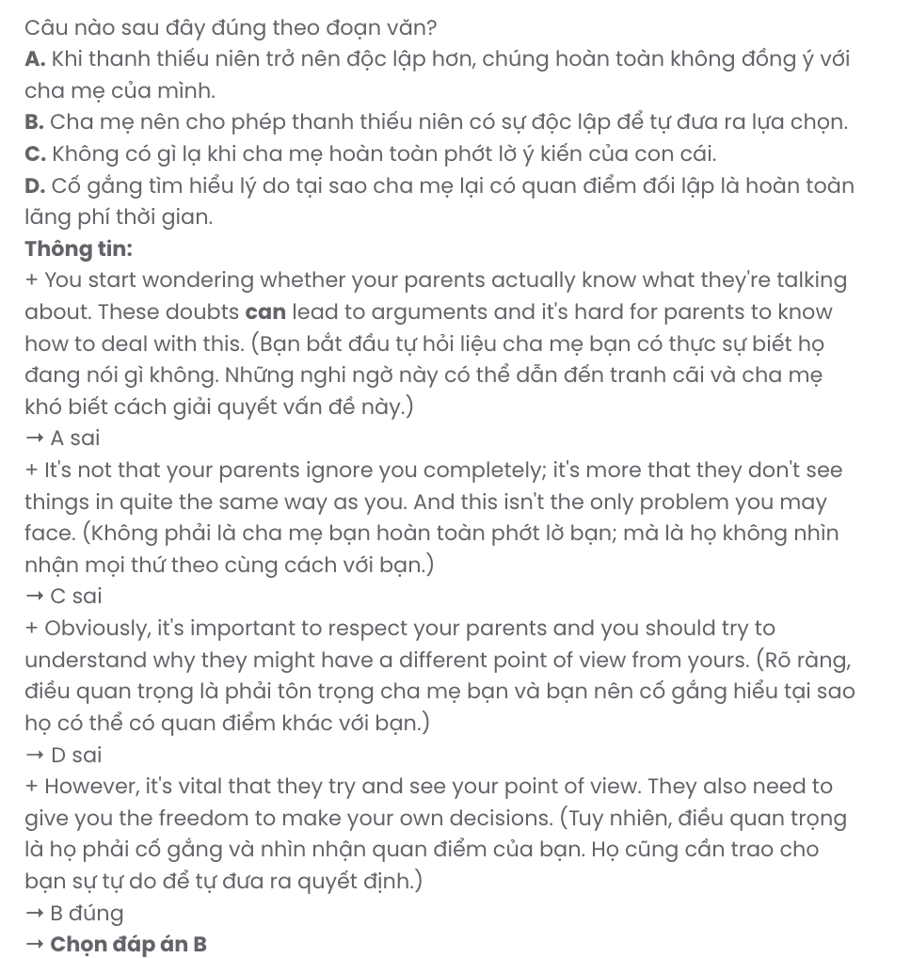
Question 29. In which paragraph does the writer mention seeking guidance and assistance?
A. Paragraph 1 B. Paragraph 2 C. Paragraph 3 D. Paragraph 4
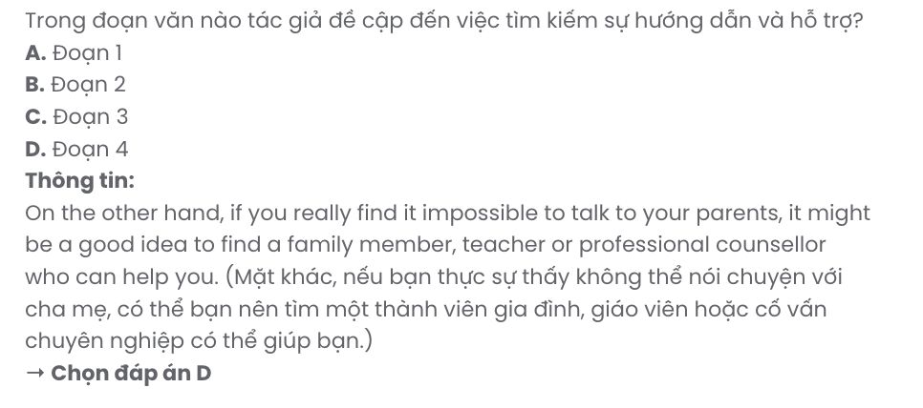
Question 30. In which paragraph does the writer discuss why conflicts arise between parents and teens?
A. Paragraph 1 B. Paragraph 2 C. Paragraph 3 D. Paragraph 4
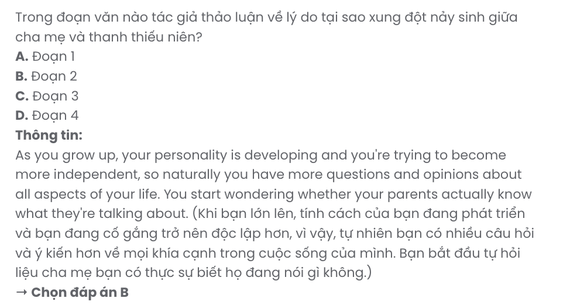
Read the following passage about the idea of the country in the city and mark the letter A, B, C, or D to indicate the correct answer to each of the questions from 31 to 40.
Cities are often noisy and dirty places, and many people prefer the peaceful atmosphere of the countryside, with open fields and forests. However, there are many good reasons to live in cities - jobs, exciting things to do and plenty of new people to meet. Some architects are now trying to bring the country into the city by creating ‘green skyscrapers’.
The Bosco Verticale in Milan is a skyscraper which tries to create a ‘forest in the sky’. It opened in 2014 and has two towers. Inside, it is mainly apartments, but there are also some offices. The special thing about this skyscraper is that there are nearly 1,000 trees, and also hundreds of smaller plants, growing all over it.
Skyscrapers like this are more difficult and more expensive to build. There are problems with planting trees so high up - not all kinds of trees can live in the strong winds at this height. Also, someone has to look after the plants, water them in hot weather and cut them back when they grow too big, so they don't spoil the view for the people who live there. This could be a lot of work for the people who live there, but at Bosco Verticale, a special team of professional gardeners takes care of it.
[I] The trees and plants clean the air, keep the apartments cool in hot weather and reduce the amount of noise that people hear inside the building. [II] More importantly, most people would agree that they are much more appealing to look at than the usual metal and glass. [III] Some architects believe that over the next 20 years, green buildings could change the skyline of our cities, to make them look more like forests. [IV]

(Adapted from Open World)
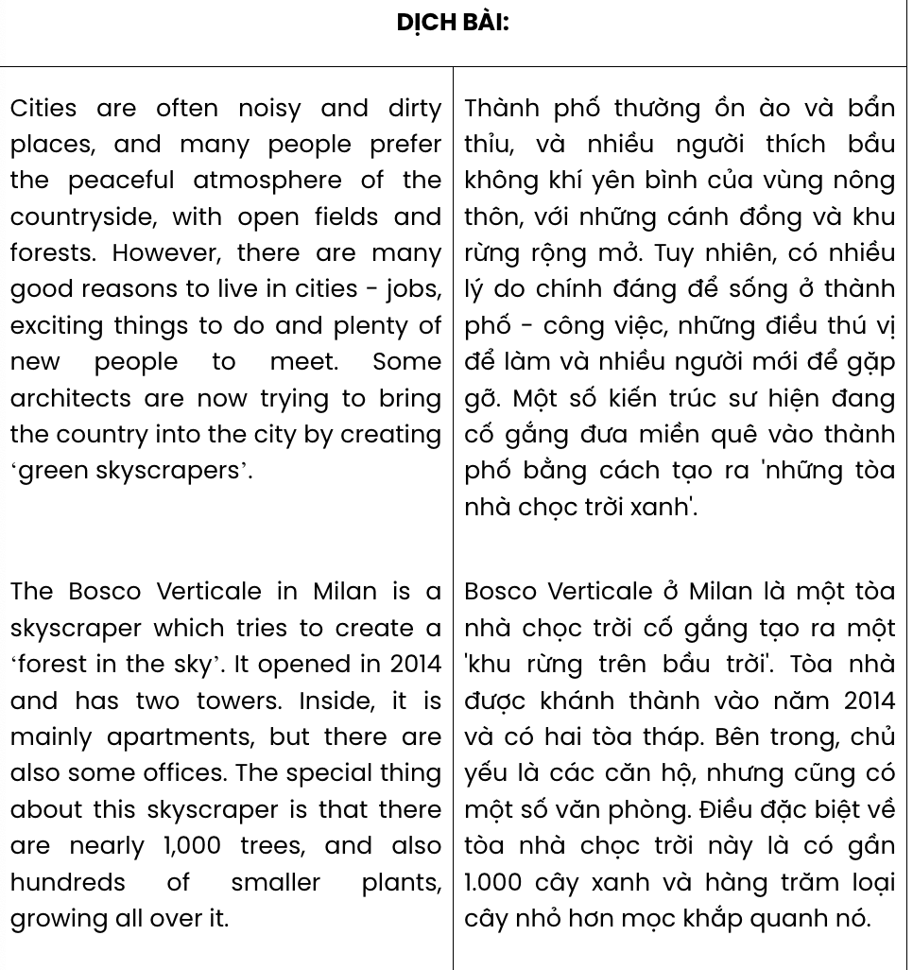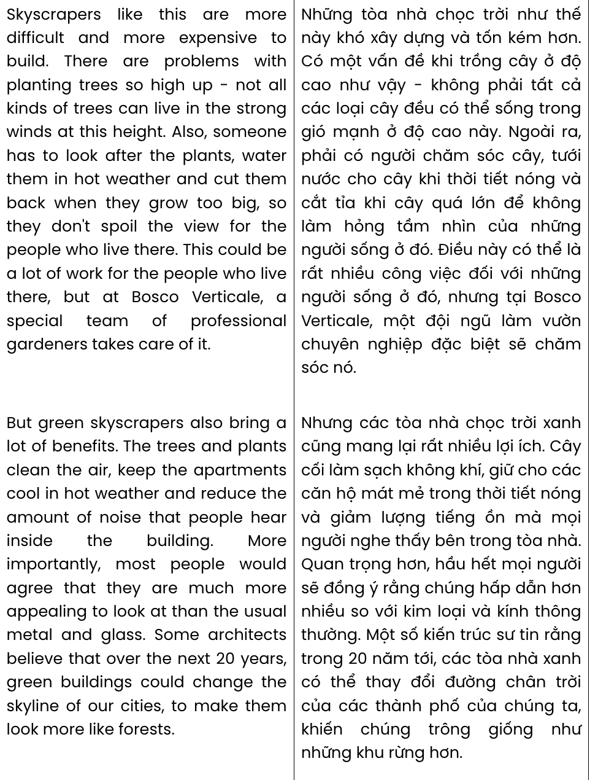

Question 31. According to paragraph 1, living in cities is considered rewarding because .
A. there are a lot of open fields and forests B. well-paid jobs exist in abundance
C. it offers a chance to meet new people D. it has become less polluted
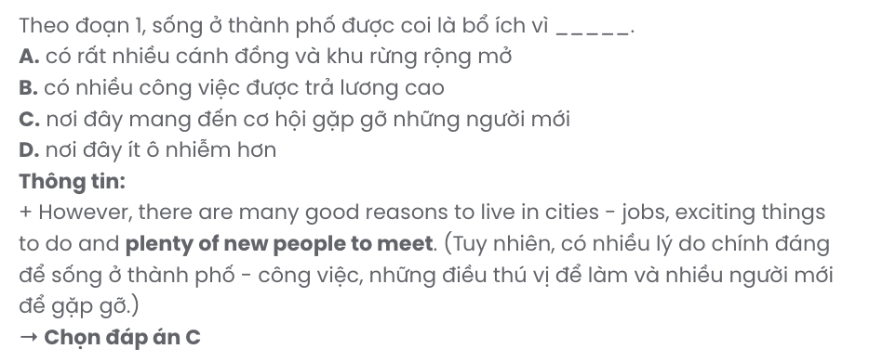
Question 32. Which of the following best paraphrases the underlined sentence in paragraph 1?

Some architects are now trying to bring the country into the city by creating ‘green skyscrapers’.
A. Some architects aim to incorporate nature into urban spaces through ‘green skyscrapers.’
B. Some architects think that cities need more parks and green spaces for the public.
C. Some architects are focused on building taller skyscrapers to create more space for nature.
D. Some architects believe that ‘green skyscrapers’ are key to the long-term development of modern city life.
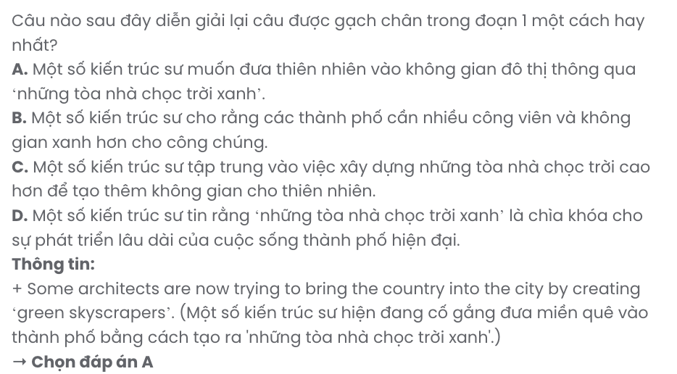
Question 33. The word it in paragraph 2 refers to ?
A. forest B. skyscraper C. sky D. countryside
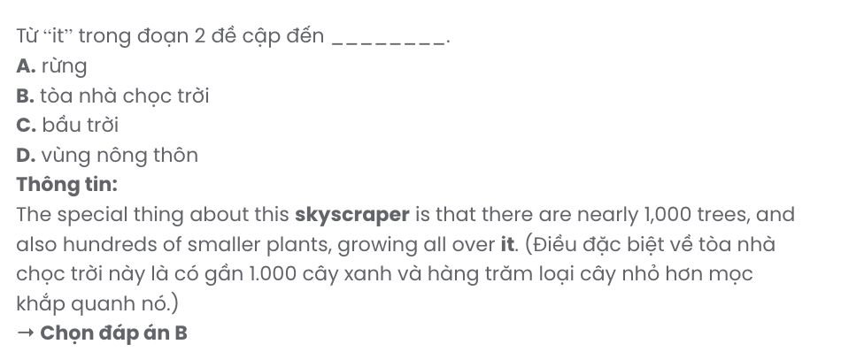
Question 34. The word spoil in paragraph 3 is closest in meaning to .
A. change B. pause C. share D. ruin
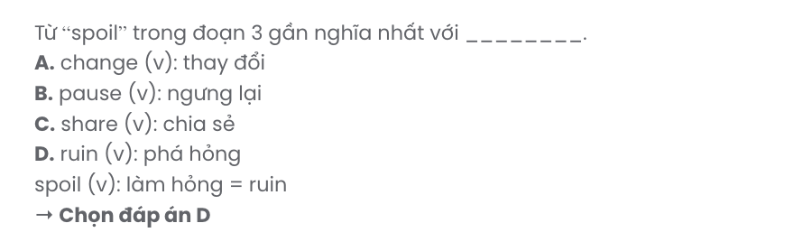
Question 35. Which of the following best summarises paragraph 3?
A. Residents at Bosco Verticale face challenges in maintaining plants due to the skyscraper’s height and wind.
B. Bosco Verticale’s design makes plant care complex and costly, requiring residents to manage upkeep themselves.
C. Planting trees on skyscrapers like Bosco Verticale is challenging, with height and weather making maintenance difficult.
D. Green skyscrapers are challenging to build and maintain, but professional gardeners manage the plants at Bosco Verticale.
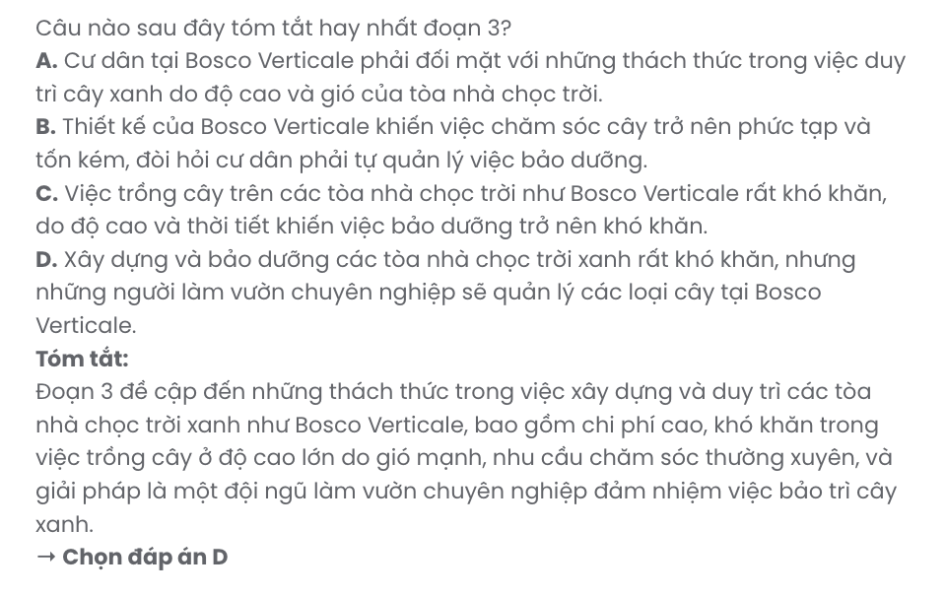
Question 36. Where in paragraph 4 does the following sentence best fit? GIA SƯ TẠI HUẾ (079.3833.272)

But green skyscrapers also bring a lot of benefits.
A. [I] B. [II] C. [III] D. [IV]
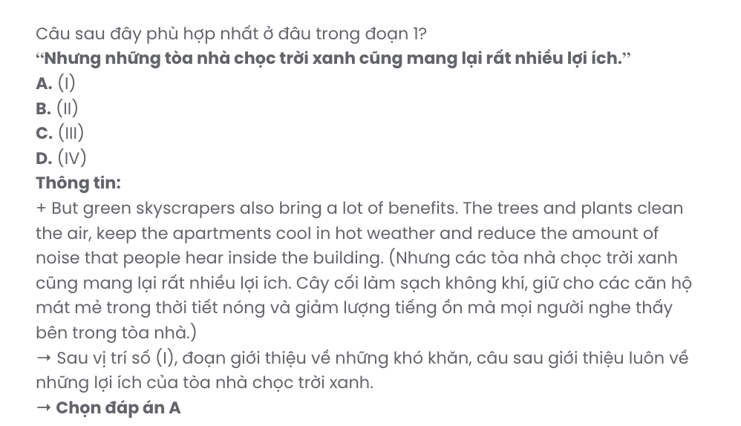
Question 37. The word appealing in paragraph 4 is OPPOSITE in meaning to .
A. disqualified B. unlimited C. unpleasant D. imperfect
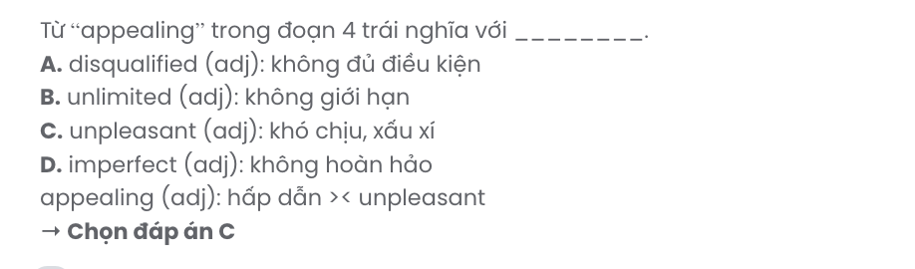
Question 38. Which of the following is TRUE according to the passage?
A. Bosco Verticale in Milan contains only small apartments, designed to optimise space within the green skyscraper.
B. Certain types of trees cannot withstand the conditions in green skyscrapers, making them unsuitable for high-rise planting.
C. Constructing green skyscrapers is gradually becoming a less complicated process with advancements in technology and design.
D. The plants on skyscrapers provide insulation, helping to lower electricity bills during the colder winter months.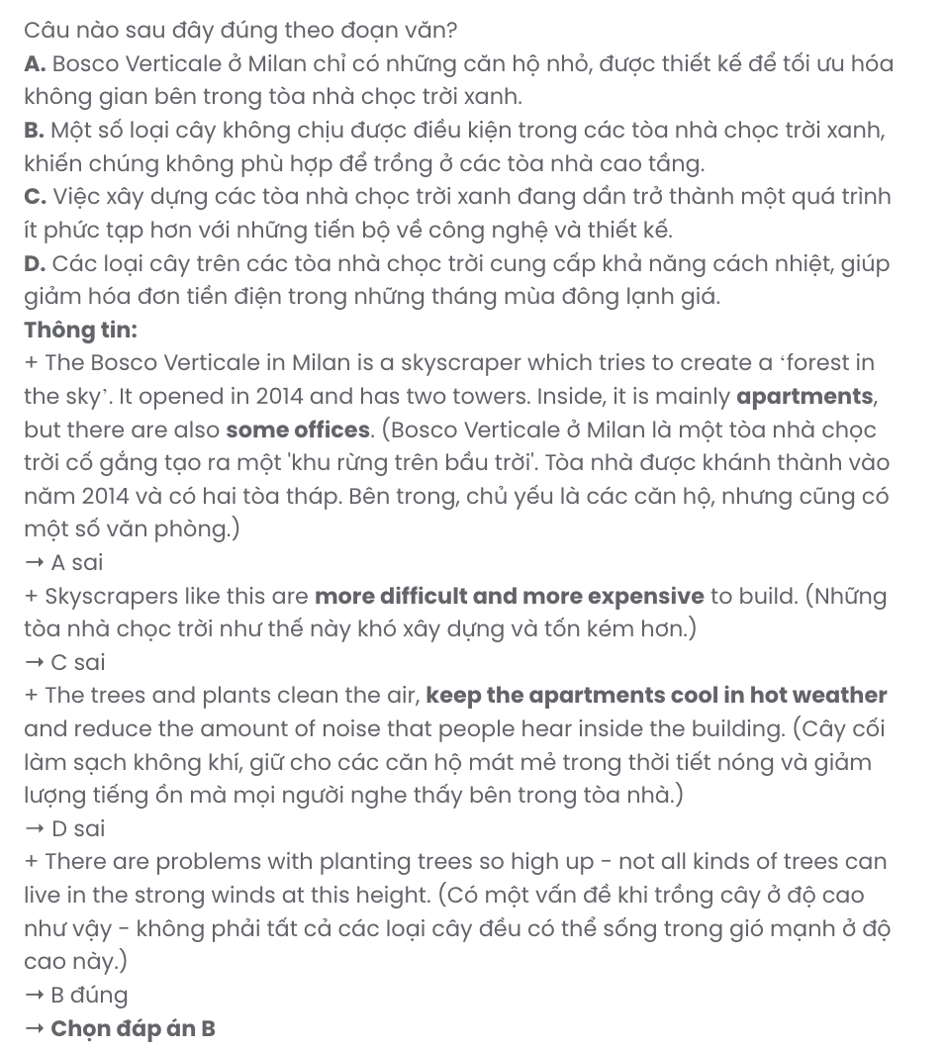

Question 39. Which of the following can be inferred from the passage?
A. The disadvantages of green skyscrapers outweigh their environmental benefits.
B. Building green skyscrapers can create more job opportunities for those in rural areas.
C. Traditional structures in big cities will be replaced by green skyscrapers soon.
D. There may be a shift in architectural trends towards sustainability in the future.

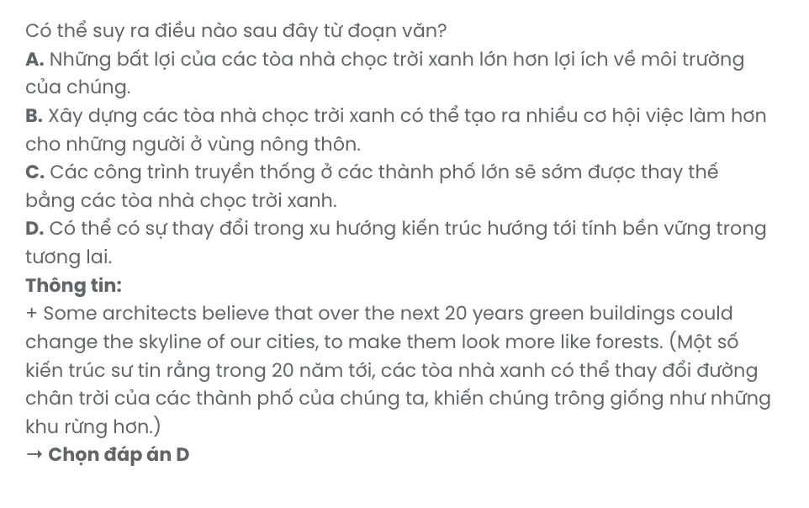
Question 40. Which of the following best summarises the passage?
A. Cities are adopting green skyscrapers like Bosco Verticale, which feature trees and plants to improve air quality, reduce noise, and provide a more attractive appearance compared to traditional buildings of metal and glass.
B. Bosco Verticale in Milan demonstrates the concept of green skyscrapers, incorporating nearly 1,000 trees to enhance urban aesthetics and purify air, though maintenance and construction challenges remain significant for this type of design.
C. Green skyscrapers like Bosco Verticale, though challenging and costly to maintain, provide environmental and aesthetic benefits, cooling apartments, reducing noise, and may transform urban skylines into forest-like landscapes over the next decades.
D. Architects are building skyscrapers like Bosco Verticale to incorporate trees and plants, although only certain species survive the strong winds, and residents must handle ongoing upkeep to ensure proper growth and appearance.

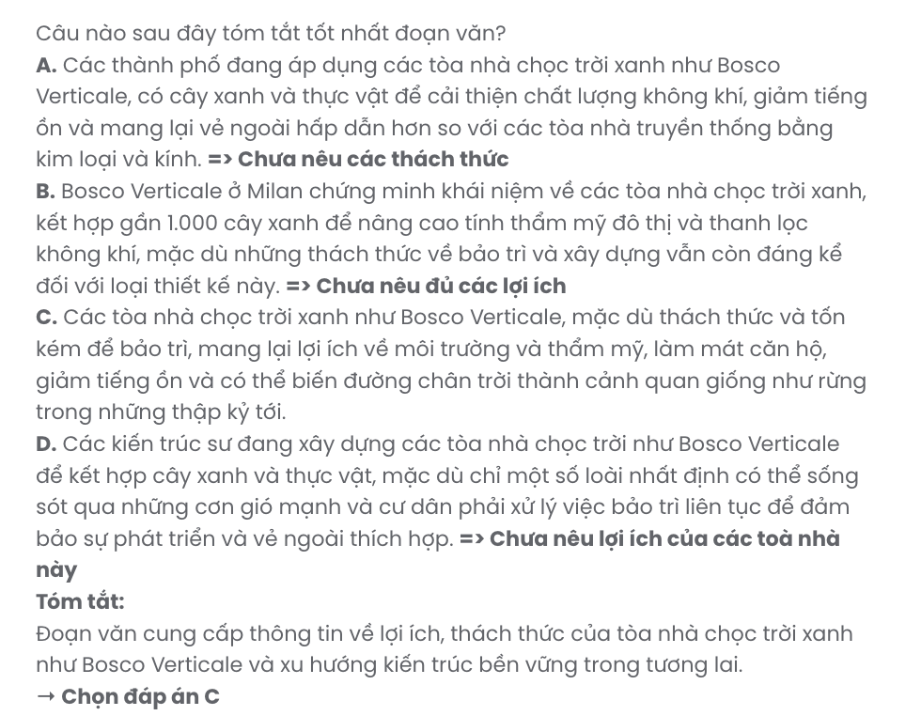
BẢNG TỪ VỰNG
STT | Từ vựng | Từ loại | Phiên âm | Nghĩa
1 | parenting | n | /ˈpeərᵊntɪŋ/ | việc làm cha mẹ
2 | conflict | n | /ˈkɒnflɪkt/ | mâu thuẫn
3 | workshop | n | /ˈwɜːkʃɒp/ | hội thảo
4 | strategy | n | /ˈstrætəʤi/ | chiến lược
5 | nurture | v | /ˈnɜːʧə/ | nuôi dưỡng
6 | bond | n | /bɒnd/ | mối quan hệ
7 | insight | n | /ˈɪnsaɪt/ | cái nhìn sâu sắc
8 | practical | adj | /ˈpræktɪkᵊl/ | thực tiễn
9 | dynamic | n | /daɪˈnæmɪk/ | sự tương tác
10 | patience | n | /ˈpeɪʃᵊns/ | sự kiên trì
11 | resilience | n | /rɪˈzɪliəns/ | khả năng phục hồi
12 | coach | n | /kəʊʧ/ | huấn luyện viên, người  hướng dẫn
13 | setting | n | /ˈsetɪŋ/ | bối cảnh, môi trường
14 | supportive | adj | /səˈpɔːtɪv/ | hỗ trợ
15 | tailor | v | /ˈteɪlə/ | điều chỉnh, thiết kế riêng
16 | scenario | n | /sɪˈnɑːriəʊ/ | viễn cảnh, tình huống
17 | empower | v | /ɪmˈpaʊə/ | trao quyền
18 | handle | v | /ˈhændᵊl/ | xử lý
19 | rewarding | adj | /rɪˈwɔːdɪŋ/ | đáng giá
20 | inspiring | adj | /ɪnˈspaɪərɪŋ/ | truyền cảm hứng
21 | donation | n | /dəʊˈneɪʃᵊn/ | khoản quyên góp
22 | proceeds | n | /ˈprəʊsiːdz/ | số tiền thu được (từ một sự  kiện)
23 | ease | v | /iːz/ | làm vơi đi
24 | hardship | n | /ˈhɑːdʃɪp/ | khó khăn
25 | compassionate | adj | /kəmˈpæʃənət/ | trắc ẩn
26 | tangible | adj | /ˈtænʤəbᵊl/ | hữu hình
27 | stimulating | adj | /ˈstɪmjəleɪtɪŋ/ | kích thích
28 | meticulous | adj | /məˈtɪkjələs/ | tỉ mỉ
29 | rehabilitation | n | /ˌriːəˌbɪlɪˈteɪʃn/ | sự phục hồi, cải tạo
30 | taxing | adj | /ˈtæksɪŋ/ | đòi hỏi cao, gây căng thẳng
31 | pursue | v | /pəˈsjuː/ | theo đuổi
32 | alternative | n | /ɒlˈtɜːnətɪv/ | lựa chọn thay thế
33 | unwind | v | /ʌnˈwaɪnd/ | thư giãn
34 | recipe | n | /ˈresɪpi/ | công thức nấu ăn
35 | perspective | n | /pəˈspektɪv/ | góc nhìn
36 | restore | v | /rɪˈstɔː/ | khôi phục
37 | infrastructure | n | /ˈɪnfrəˌstrʌkʧə/ | cơ sở hạ tầng
38 | relief | n | /rɪˈliːf/ | viện trợ
39 | isolated | adj | /ˈaɪsəleɪtɪd/ | cô lập
40 | tirelessly | adv | /ˈtaɪələsli/ | không biết mệt mỏi

41 | debris | n | /ˈdebriː/ | mảnh vụn vỡ
42 | phenomenon | n | /fəˈnɒmɪnən/ | hiện tượng
43 | entice | v | /ɪnˈtaɪs/ | thu hút
44 | surge | n | /sɜːʤ/ | sự gia tăng
45 | downside | n | /ˈdaʊnˌsaɪd/ | mặt hạn chế
46 | outdated | adj | /aʊtˈdeɪtɪd/ | lỗi thời
47 | hazardous | adj | /ˈhæzədəs/ | nguy hiểm
48 | disposal | n | /dɪˈspəʊzᵊl/ | sự vứt bỏ, xử lý
49 | landfill | n | /ˈlændfɪl/ | bãi rác
50 | improperly | adv | /ɪmˈprɒpəli/ | không đúng cách
51 | discard | v | /dɪˈskɑːd/ | vứt bỏ
52 | embrace | v | /ɪmˈbreɪs/ | đón nhận, chấp nhận
53 | consumerism | n | /kənˈsjuːmərɪzᵊm/ | chủ nghĩa tiêu dùng
54 | prioritise/ prioritize | v | /praɪˈɒrɪˌtaɪz/ | ưu tiên
55 | leak | v | /liːk/ | rò rỉ
56 | guide | v | /ɡaɪd/ | hướng dẫn
57 | spoil | v | /spɔːɪl/ | huỷ hoại, làm hỏng
58 | appealing | adj | /əˈpiːlɪŋ/ | hấp dẫn
59 | maintain | v | /meɪnˈteɪn/ | bảo trì
60 | skyscraper | v | /ˈskaɪˌskreɪpə/ | toà nhà chọc trời

STT | Cấu trúc | Nghĩa
1 | struggle with | vật lộn với
2 | cope with | đối phó
3 | encourage doing something | khuyến khích làm gì
4 | join hands | chung tay
5 | regardless of | bất chấp
6 | make a difference | tạo nên sự khác biệt
7 | set aside | tiết kiệm, dành ra (thời gian)
8 | put something on hold | hoãn lại
9 | break down | phân huỷ
Chỉ 100k/12 tháng, bạn tải rất nhiều tài liệu tiếng anh file word hay tại: Giaoandethitienganh.info Mong bạn ghé ủng hộ !

