**SỞ GIÁO DỤC VÀ ĐÀO TẠO LÂM ĐỒNG ĐỀ CHÍNH THỨC  
Ngày thi: 02/6/2025  
MÃ ĐỀ 379**

**For questions 1 – 5, read the following passage and mark the letter A, B, C, or D on your answer sheet to indicate the correct answer to each of the questions.**

Saturn is easy to recognize thanks to its beautiful rings, which make it unique in the solar system. Despite being the second largest planet, Saturn is so light that it would float on water if a large enough body existed. Saturn is the sixth planet from the Sun and was the farthest known planet in ancient times.

Saturn is a gas giant, like Jupiter, Uranus, and Neptune. It is made mostly of hydrogen and helium and has no solid surface. What looks like a surface in pictures are actually clouds. Its famous rings are thin, made mostly of ice and rocks, and extend up to 175,000 miles from the planet. Saturn also has more than 140 moons, with Titan being the largest. Titan is unique because it has a thick atmosphere and clouds, unlike any other moons in the solar system.

A year on Saturn lasts about 29 Earth years, while a day is much shorter — just 11 Earth hours. People have observed Saturn for centuries, but it was first viewed through telescope in 1610 by Galileo. NASA has sent several spacecrafts to study Saturn, including Pioneer 11, Voyager 1 and 2, and Cassini. Cassini orbited Saturn for 13 years and even dropped a probe on Titan, making it the first spacecraft to land on a moon in the outer solar system.  
(*Adapted from:* [*http://spaceplace.Nasa.gov/*](http://spaceplace.nasa.gov/))

**1. What is the main idea of the passage?**  
A. Saturn’s size makes it unique in the solar system.  
B. Saturn is a gas giant which has many interesting features.  
C. Saturn’s rings and moons make it special among planets.  
D. Saturn is the farthest planet ever known from the Sun.

**2. Why would Saturn float on water?**  
A. Because it has a very thin atmosphere.  
B. Because it is made mostly of solid materials.  
C. Because its rings are not very heavy.  
D. Because it is less dense than water is.

**3. How long is one day on Saturn?**  
A. About 24 hours in Earth time.  
B. About 16 hours in Earth time.  
C. About 11 hours in Earth time.  
D. About 29 hours in Earth time.

**4. What was the first spacecraft to land on Titan?**  
A. The Pioneer 11 mission.  
B. The Cassini mission probe.  
C. The Voyager 2 mission.  
D. The Voyager 1 mission.

**5. What are Saturn’s rings mostly made of?**  
A. Ice and rocky particles.  
B. Rocks and metal particles.  
C. Clouds and thin gas layers.  
D. Hydrogen and helium gases.

**For questions 6 – 7, mark the letter A, B, C, or D on your answer sheet to indicate the word whose underlined part is pronounced differently from that of the rest in each of the following ones.**

**6.** A. *published*   B. *weaved*  C. *wandered*   D. *informed*

**7.** A. *ancient*   B. *replace*  C. *shame*   D. *abrupt*

**For questions 8 – 12,** mark the letter A, B, C, or D on your answer sheet to indicate the sentence that has the same meaning as the original one.

**8.** “Are you joining us for the party this weekend?”, Tom asked his classmate.  
A. Tom asked his classmate if he is joining them for the party that weekend.  
B. Tom asked his classmate if he was joining them for the party that weekend.  
C. Tom asked his classmate if he was he joining them for the party that weekend.  
D. Tom asked his classmate if is he joining them for the party that weekend.

**9.** You can improve your English pronunciation by talking to native English speakers.  
A. Unless you improve your English pronunciation, you can talk to native English speakers.  
B. Unless you talk to native English speakers, you can improve your English pronunciation.  
C. If you improve your English pronunciation, you can talk to native English speakers.  
D. If you talk to native English speakers, you can improve your English pronunciation.

**10.** I’m really unhappy because my brother doesn’t help me with my homework.  
A. I wish my brother would help me with my homework.  
B. I wanted my brother to help me with my homework and he did.  
C. I’m unhappy but my brother has helped me with my homework.  
D. I wish I could help my brother with his homework.

**11.** The problem was too complicated for us to solve.  
A. The problem wasn’t very complicated, so we solved it.  
B. It was such a complicated problem that we solved it.  
C. The problem was complicated enough for us to solve.  
D. The problem was so complicated that we couldn’t solve it.

**12.** We broke the computer. It belongs to my father.  
A. We broke the computer which belongs to my father.  
B. We broke the computer which it belongs to my father.  
C. We broke the computer whose belongs to my father.  
D. We broke the computer, which belongs to my father.

**For questions 13 – 17,** mark the letter A, B, C, or D on your answer sheet to indicate the underlined part that needs correcting.

**13.** I love **the spicy food** in this city. The **hottest** the food **is**, **the more** I like it.

**14.** His family wanted **to know** where **was he** last night **when** they could reach him **by** phone.

**15.** **The** teacher felt **badly** about **not giving** us permission to go on an outing **overnight**.

**16.** **The English summer course** **will** start **in July 1st** and **finish** in August.

**17.** It was such **a worrying news** that **they all** kept **silent** **on being informed**.

**For questions 18 – 22,** read the following passage and mark the letter A, B, C, or D on your answer sheet to indicate the word that best fits each numbered blank.

Hobbies are important, even when life gets busy. We should make time for them, just like we do for school or work, because hobbies make us happier and less stressed.

One study shows that people who spend time (18) _______ fun activities have fewer bad feelings and feel less stressed. Today, trying a new hobby, like coloring, can be fun and relaxing. It might seem hard at first, (19) _______ it’s worth giving it a try.

Being creative in your free time can help you in other parts of life too. A study found that doing something creative for just 45 minutes can (20) _______ your confidence and make you better at other tasks. You can color while watching TV, listening to music, or even when you are not doing anything else. Coloring quietly can help you focus and feel more mindful.

After trying coloring, it turned out to be a really enjoyable hobby. It was easy to do and didn’t require too much thinking, but it still helped (21) _______ some creativity. Sometimes, it felt a little boring, especially when coloring without anything else going on. It was strange at first to sit quietly, but that’s (22) _______ it might be a good hobby – it’s different from what we’re used to. Coloring could be the perfect hobby if you want to do something creative, need a break from too much screen time, or just love using your favorite crayon.

*(Adapted from:* [*https://lbhbr.org*](https://lbhbr.org/)*)*

**18.**A. in   B. on   C. of   D. at

**19.**A. or   B. nor   C. so   D. but

**20.**A. destroy   B. lose   C. increase   D. damage

**21.**A. encourage   B. reduce  C. lack   D. discourage

**22.**A. which   B. what   C. why   D. who

**For questions 23 – 50**, mark the letter A, B, C, or D on your answer sheet to indicate the correct answer to each of the following sentences.

**23.** You should have a dictionary to _______ the words that you don’t know their meanings.  
A. look for   B. look into   C. look up   D. look after

**24.** If you don’t start studying harder, you _______ repeat the course next year.  
A. ought to   B. will have to   C. could   D. should

**25.** Our listening skill is not good, so I suggest _______ it by listening to podcast or music.  
A. improving   B. improve   C. to improving   D. to improve

**26.** It’s important to _______ in touch with your family, no matter where you are.  
A. make   B. come   C. lose   D. keep

**27.** The Internet brings us many benefits in life, but it has some _______ too.  
A. incomes   B. advantages   C. drawbacks   D. profits

**28.** Rapid changes in society and lifestyle have made the _______ in many families wider.  
A. experiences   B. family values   C. generation gap  D. family relation

**29.** Jack asked me where _______ my holiday the following summer.  
A. would I have  B. I would have   C. I will have   D. I had

**30.** My sister and I are trying to _______ sweet food and soft drinks to stay healthy.  
A. carry out   B. come down with  C. hand down   D. cut down on

**31.** John always makes everyone laugh because he has a great sense of _______.  
A. taste   B. direction   C. humor   D. achievement

**32.** The bus number 32 stops here to _______ passengers to the National Museum.  
A. get off   B. pick up   C. get on   D. take off

**33.** _______ there is much pollution in this city, it is an ideal place to live.  
A. In spite of   B. Despite   C. Although   D. Since

**34.** People in that village don’t know how _______ the natural beauty of their region.  
A. preserve   B. preserving   C. to preserve   D. preserved

**35.** The city council announced a _______ to residents about the upcoming drought.  
A. celebration   B. complaint   C. schedule   D. warning

**36.** Could you recommend me a local tour guide _______ has good knowledge about the attractions in Dalat?  
A. which   B. who   C. where   D. whose

**37.** I must congratulate you _______ your very impressive show.  
A. in   B. for   C. at   D. on

**38.** My father hates living in the city centre because there is always _______ traffic at rush hour.  
A. full   B. heavy   C. plenty   D. crowded

**39.** The longer the talk about the matter is, _______.  
A. the worse the situation seems   
B. the worse seems the situation   
C. the situation seems worse   
D. the situation seems the worse

**40.** _______ Sun, which is one of millions of stars in the universe, provides us with heat and light.  
A. An  B. A  C. The  D. Ø

**41.** When I came in, the television was on, but nobody _______ it.  
A. was watching  B. had watched  C. is watching  D. watched

**42.** The stadium has _______ that the music can be heard clearly from every corner.  
A. such a powerful sound system   
B. so a powerful sound system   
C. so powerful a sound system   
D. such powerful sound system

**43.** My father has promised _______ us on a three-day trip to some historical places in Hue.  
A. taking   B. take   C. to take   D. taken

**44.** Ha Noi, _______ is the capital of Viet Nam, is famous for its culture and traditions.  
A. who   B. where   C. that   D. which

**45.** Before you ask someone for help, wait until he or she is in a good _______.  
A. emotion   B. mood   C. feeling   D. opinion

**46.** We have prepared for the test carefully, so now we feel _______.  
A. friendly   B. confident   C. nervous   D. confused

**47.** David finished _______ his homework and then he went to the party with George and Bill.  
A. do   B. doing   C. to do   D. to be done

**48.** I met a man _______ first language is Arabic at the conference in Paris yesterday.  
A. who   B. which   C. whose   D. that

**49.** He put on a large hat and glasses as a disguise and hoped no one would _______ him.  
A. see   B. watch   C. realize   D. recognize

**50.** I wish I _______ an electric bike. I’m tired of catching the bus to the school every day.  
A. will have   B. had   C. have   D. have had

**—THE END—**

**ĐÁP ÁN**

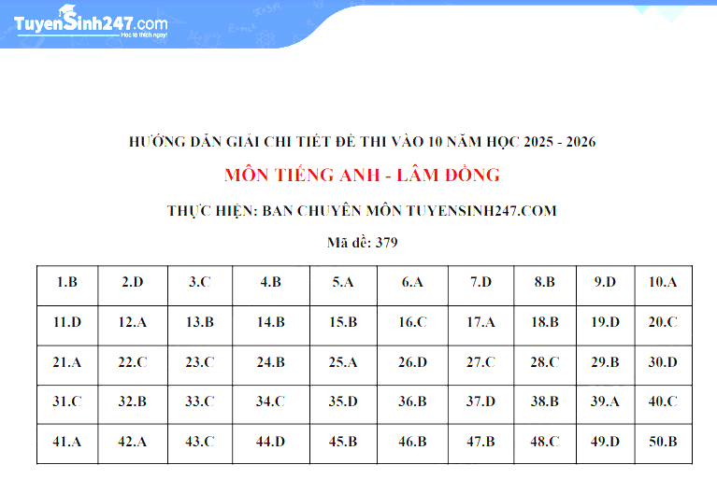

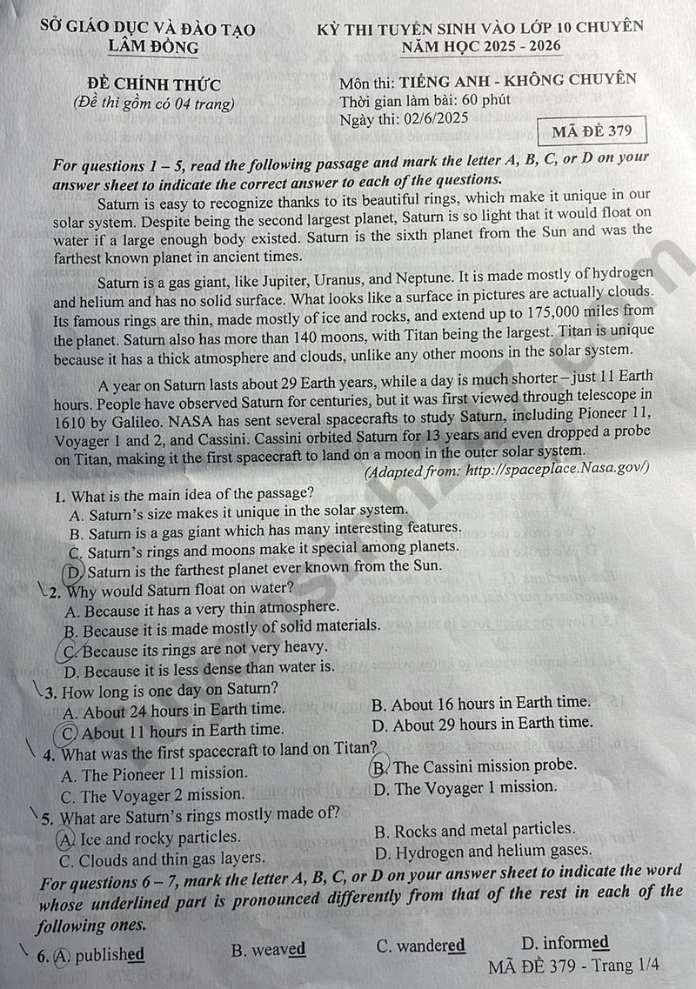

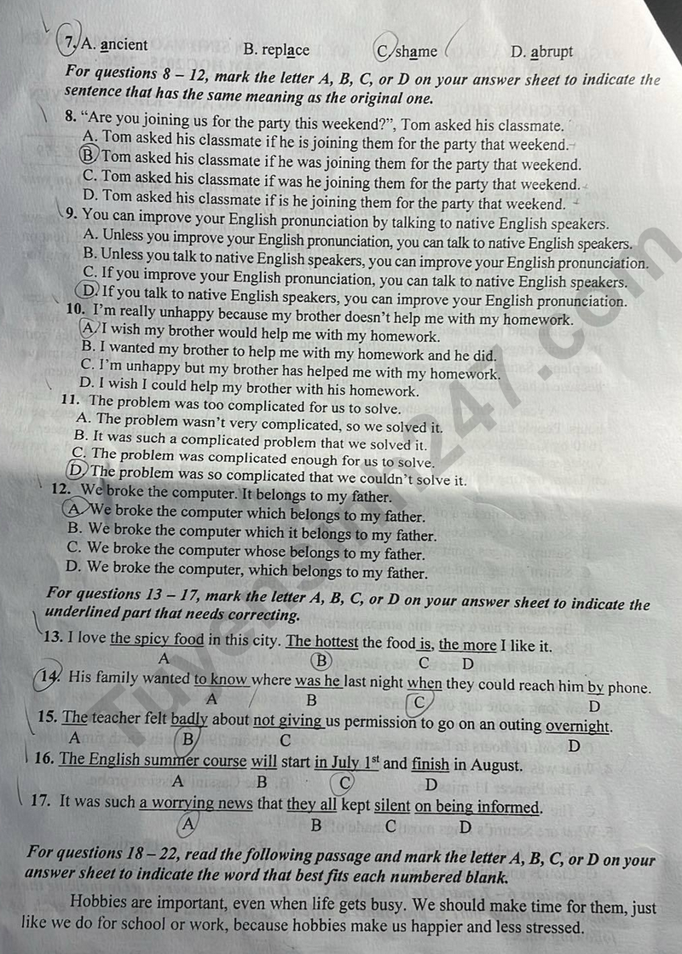

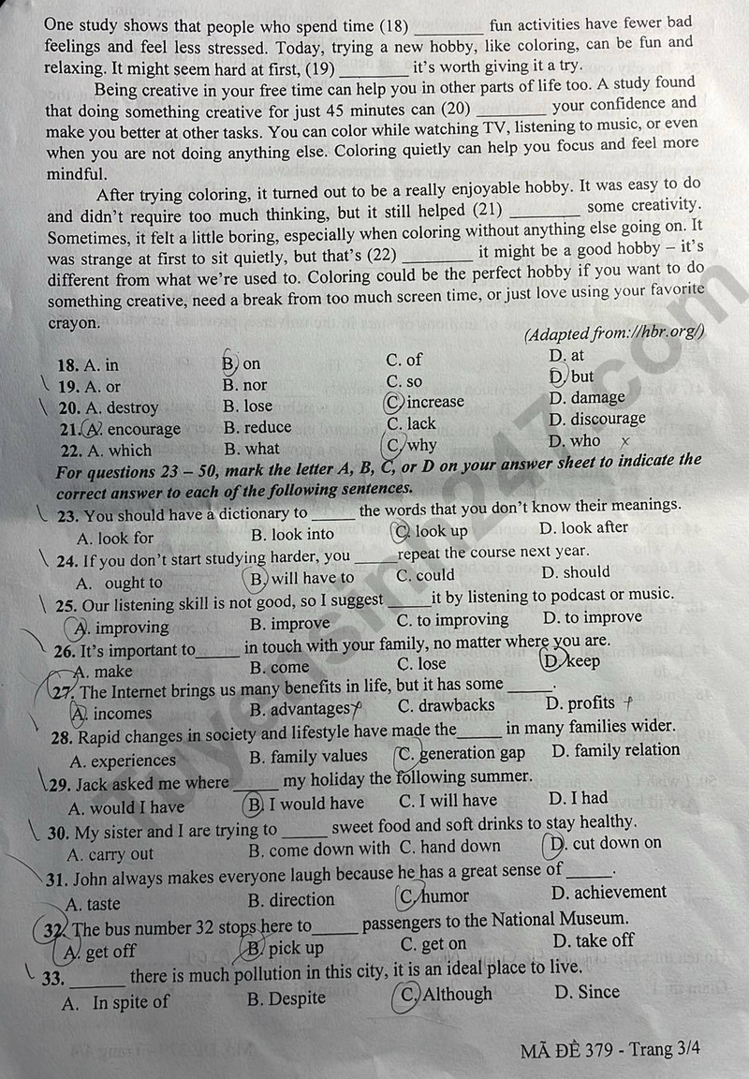

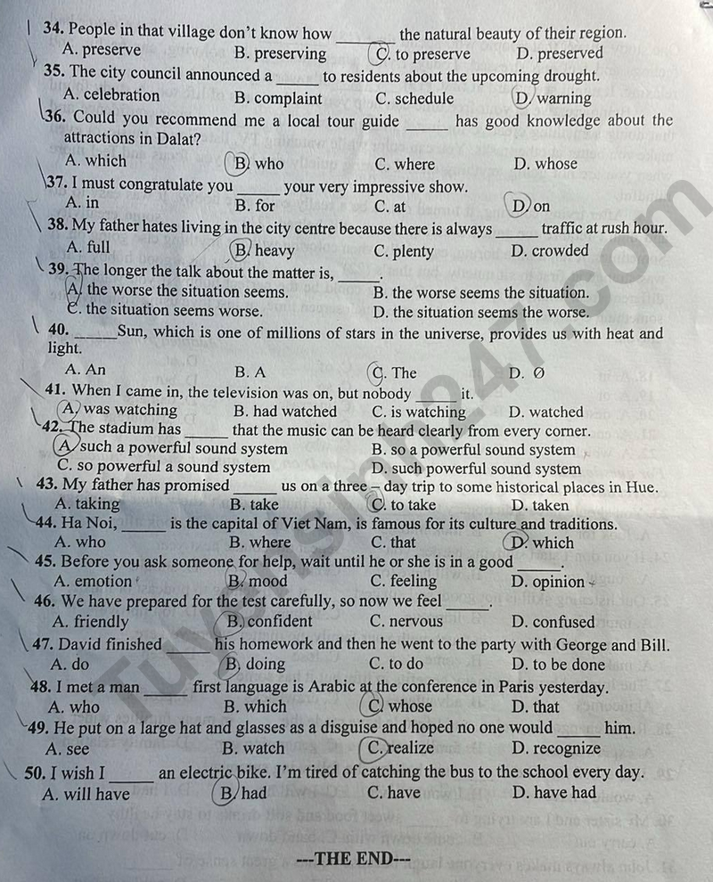

Chỉ 100k/12 tháng, bạn tải rất nhiều tài liệu tiếng anh file word hay tại: ***Giaoandethitienganh.info***  Mong bạn ghé ủng hộ !