UNIT 9: FESTIVALS AROUND THE WORLD
Lesson 5: Skills 1

I. OBJECTIVES
By the end of this lesson, Ss will be able to gain:
1. Knowledge:
- Develop reading skill about an unusual festival
- Develop speaking skill: talking about a festival they enjoy
2. Core competence:
- Develop communication skills and creativity
- Be collaborative and supportive in pair work and teamwork
- Develop presentation skill
- Actively join in class activities
3. Personal qualities
- Develop self-study skills
II. PREPARATIONS
1. Teacher
- Grade 7 textbook, laptop, TV/Projector/ pictures and cards, speakers, lesson plan, sachmem.vn…
2. Students
- Grade 7 textbook, notebooks, school things….
III. TEACHING PROCEDURES
ACTIVITY 1 – WARM – UP & INTRODUCTION (5’)
a) Aims:
- To introduce the topic of reading.
- To enhance students’ skills of cooperating with team mates.
b) Contents: Play the game “Who is faster?”
c) Products: Ss’ answers
d) Teaching steps:
Teacher’s and students’ activities | Content
* Teacher divides the class into 2 teams.  - Each team has to run in a relay to the board to write the correct types of festivals and their symbols and meaning under the posters.  - The team with more correct answers will be the winner.  ** Students play the game in team mode.  *** Teacher and students discuss the answers.   Teacher confirms the answers and gives feedback. | Game: Who is faster?
ACTIVITY 2 – PRESENTATION (10’)
a) Aims:
- To lead in the reading skills.
- To provide students with some lexical items before reading the text.
b) Contents:
-
- Work in pairs. Discuss the following questions.
- Read Phong’s blog. Match the underlined words in the text with their meanings.
c) Products:
- Lists of vocabularies
- Answer key
d) Teaching steps:
Teacher’s and students’ activities | Content
* Teacher has students work in pairs, look at the pictures in the book. Ask Ss to discuss what/who they see in the pictures and answer the questions.  ** Students works in pairs.  *** Teacher and students discuss the questions and answers.   Teacher accepts all students’ questions.  * Teacher introduces the vocabulary.  ** Teacher asks students to get the meaning in context and try to make up sentences with of the following words:  1. join (v)  2. feature (v)  3. performance (n)  *** Teacher and students discuss the answers.   Teacher confirms student’s answers and checks their pronunciation and gives feedback. | READING  Task 1: Work in pairs. Look at the pictures. Which events do you think happen at the Twins Day Festival? (p.97)  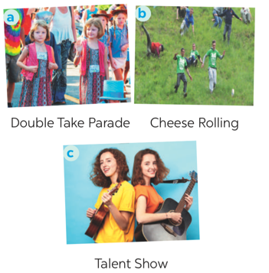  Vocabulary  1. join (v)  2. feature (v)  3. performance (n)  Answer key:  Pictures 1 + 3: Twins Day Festival
ACTIVITY 3 – PRACTICE (20’)
a) Aims:
- To develop the skill of guessing the meanings of new words in context.
- To develop reading skill for specific information (scanning).
- To help students identify how to ask and answer about a festival they attended.
b) Contents:
- Match each word from the email in 1 with its meaning.
- Read the email again. Complete each sentence with no more than TWO words
- Match the questions and answer about a festival someone joined
c) Products:
- Answer key
d) Teaching steps:
Teacher’s and students’ activities | Content
* Teacher tells Ss what they are going to do. Ask Ss how to do the exercise and elicits answers from Ss.  If needed, tell them that to do the exercise they can follow these steps:  + Read the words in the left column  + Locate each word in the text  + Read around the word to get the general meaning  + Read the definitions in the right column, find the suitable meaning to match each word.  Ask Ss to repeat the steps (they can speak in Vietnamese).  ** Students read the text and do the task in individuals.  *** Teacher allows students to share their answers before discussing as a class and encourages them to give evidence.   Teacher calls some students to give the answer, explain which sentence give them the information.  * Teacher can set a longer time limit for students to read the text again and complete the sentences.  Briefly tell them the steps: read the sentences – underline key words – locate the key words in the text – find the words to complete the sentences.  ** Teacher asks students to work in individuals and find the answer.  *** Teacher allows students to share their answers before discussing as a class and encourages them to give evidence.   Teacher calls a student to write his/her answer on the board, then check sentence by sentence with class.  * Teacher tells Ss they are going to ask and answer about a festival they attended and that this activity can serve as a model for them to follow in the writing task.  ** Teacher asks students to work individually and then check in pairs.  *** Teacher can go around to help weaker students.   Teacher call on some pairs to give the answers and check as the whole class. | Task 2: Match each word from the email in 1 with its meaning (p.98)  Answer key:  1. b  2. d  3. a  4. c  Task 3: Read the email again. Complete each sentence with no more than TWO words (p.98).  Answer key:  1. first weekend  2. countries  3. walked together  4. performance  5. Fun Run  6. exciting  SPEAKING  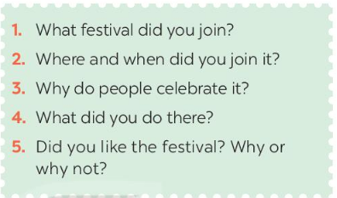  Talk about a festival  Task 4: Match the questions and answer about a festival someone joined (p.98).  Answer key:  1. d  2. b  3. e  4. c  5. a
ACTIVITY 4 – PRODUCTION (7’)
a) Aims:
- To give Ss practice in asking and answering about a festival Ss attended.
- To help students improve next time.
- To help some students enhance presentation skill
b) Contents:
- Work in pairs. Ask and answer about a festival you and your friend joined, using the questions in 4 as cues. Tell the class about the festival your partner joined.
c) Products:
- Ss’ speaking
d) Teaching steps:
Teacher’s and students’ activities | Content
* Teacher has students to work in pairs, ask and answer about a festival they attended.  ** Students work in pairs to do the task.  *** Teacher goes around to help students.   After finishing, teacher can call some pairs to give presentations in front of the class. | Task 5: Work in pairs. Ask and answer about a festival you and your friend joined, using the questions in 4 as cues. Tell the class about the festival your partner joined.  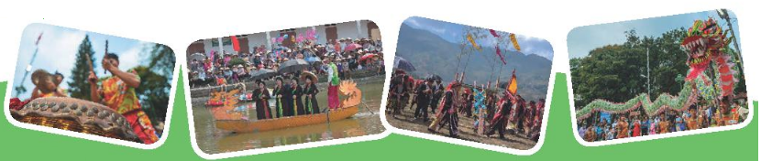
IV. WRAP-UP & HOMEWORK (3’)
- Teacher has Ss summarise what they have learnt in the lesson with the two skills.
- read skill for specific information about an unusual festival
- talk about a festival you enjoy
- Teacher asks Ss to make a conversation, video and upload on given drive link.
- Teacher asks Ss to prepare the next lesson “Unit 9 – Skills 2”
V. FEEDBACK

……………………….…, ngày………….tháng…………..năm 2022
Duyệt của Tổ chuyên môn

