THE FINAL EXAMINATION
Chu Van An Primary School
Class: 5
Name: ………………………………….
SUBJECT: ENGLISH
Time alloted : 40 minutes
Listening (2.5ms) | Speaking (2.5ms) | Reading (2.5 ms) | Writing (2.5 ms) | Total
Part 1: Listening (2.5 ms)

Question 1: Listen and tick (). (0.5m)
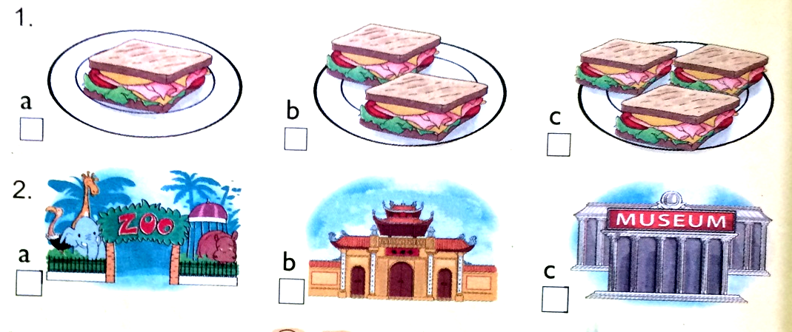
Question 2: Listen and number. (0.5 m) .
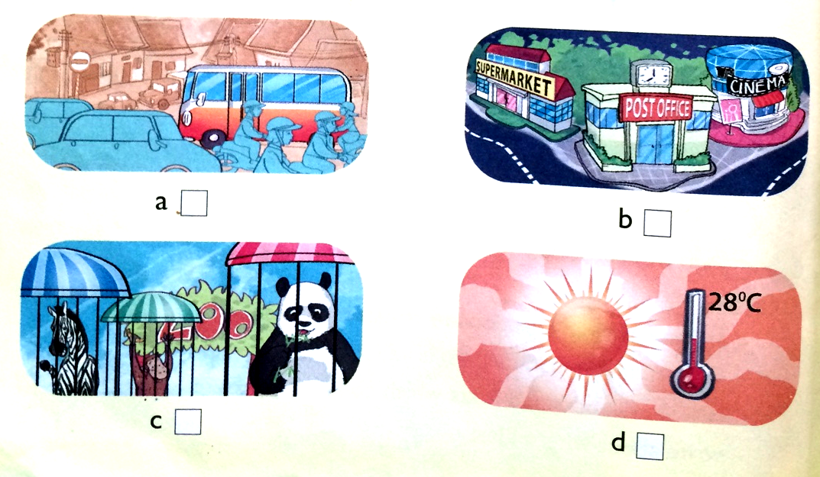
Question 3: Listen and circle a, b, or c. (1 m)
- How many bananas does Tom eat every day?
- one b. three c. two
- How much rice does Nam eat every day?
- Four bowls b. three bowls c. two bowls
- How much water does Mai drink every day?
- Five bottles b. four bottles c. three bottles
- How many sausages does Tom eat every day?
- Three b. two c. one
Question 4: Listen and write ( 0.5m)
- Tony lives in _______________ . It’s __________________ than Nha Trang.
- Linda lives in ______________ . It’s __________________ than Da Lat.

Part II: Reading and Writing (5 ms)
Question 5: Read and match (1m)
1. How can I get to Sa Pa? A. I’d like a glass of milk.
2. What do you think of Ha Long Bay? B. It’s cool and rainy.
3. What’s autumn like in your country? C. You can go by plane.
4. What would you like to drink? D. It’s more attractive than I expected.
Question 6: Read and tick True or False (1m)
My name is Nam. Yesterday I visited Tran Quoc Pagoda. It is on an island in the middle of West Lake and not far from the centre of Ha Noi. I went there by car. Tran Quoc Pagoda is very quiet. It is more beautiful than I expected. There are a lot of statues and trees in the yard. I met some friends there. My friends and I learnt more about the history of Ha Noi after the visit.
True False
- Nam visited Phu Quoc Island yesterday.
- He went there by car.
- Tran Quoc Pagoda is very beautiful.
- There are not a lot of statues in the yard.
Question 7 : Read and do the tasks (1m)
- Complete the passage.
wind November season picnic south

My name is Quang. I live in Can Tho. It is in the (1) _____________ of Viet Nam. There are only two seasons here. They are the dry season and the rainy season. The dry season lasts from (2) ______________ to April. It is usually cool and dry in this time of the year. This is my favourite season because I can go for a (3) ______________ with my friends. The rainy (4) ______________ lasts from May to October. It is usually hot and wet. There is a lot of (5) _______________ too.
- Answer the questions.
- How many seasons are there in Can Tho?
______________________________________________________ .
- What are they?
_______________________________________________________
- What is the dry season like?
______________________________________________________
- What is the rainy season like?
______________________________________________________
- Why does Quang like the dry season?
_______________________________________________________
Question 8: Put the words in the correct order. (1m)
- pharmacy/ where/ the/ is/?

- is/ opposite/ market/ the/ it/.
_____________________________________________________
- museum/ to/ can/ I/ the/ how/ get/?
_____________________________________________________
- a/ bus/ can/ you/ take/.
_____________________________________________________
Question 9: Write about where you live. (1m)
My name is ________________________ . I live in ____________________________.
It is a ________________________________ in Viet Nam.
There are _______________________________________________________________ .
It is ____________________________________________________________________ .
I enjoy living here because it is ________________________________________________.
Part III: Speaking
a)Listen and repeat (0,5m)
1. What will the weather be like tomorrow?
2. How much rice do you eat every day?.
3. Which one is noisier, Hoan Kiem Lake or West Lake?
4. Sydney is quieter than New York.
b) Point, ask and answer (1m)
- What would you like to eat/ drink?
+) I’d like …………………………………………..…
- How many / much………. do you …………………….every day?
+) I eat /drink………………………………….…
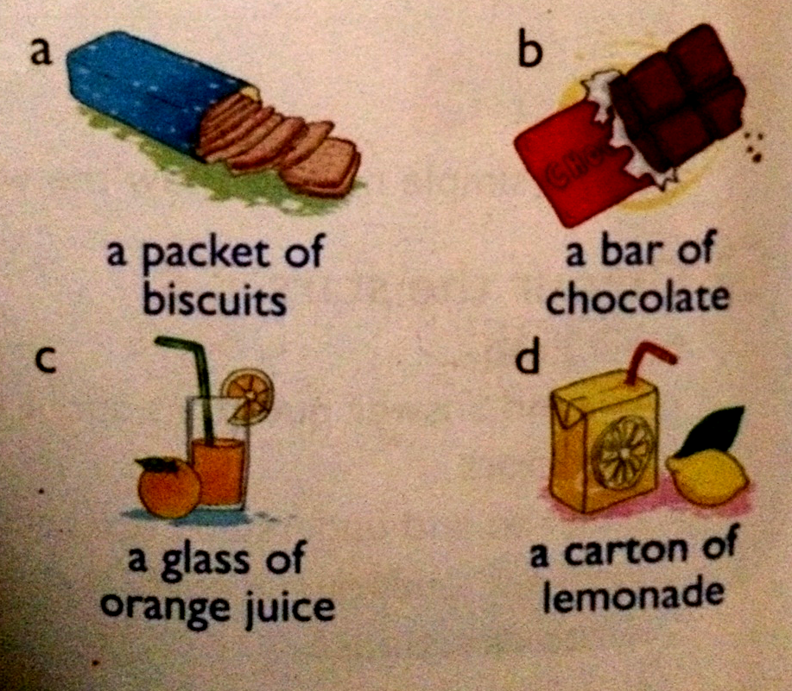
c)Interview: (1m)
1. Where do you live?
2. How many seasons are there in your country ?
3. What’s your favourite season?
4. Why do you like it?

ANSWER KEY (ĐÁP ÁN)

*Part 1:
Q.1: 1b 2c
Q.2: a 2 b 1 c4 d 3
Q.3: 1.c 2.a 3b 4b
Q.4: 1.Sydney/ noisier 2.London/ larger
*Part 2:
Q.5 : 1.c 2.d 3.b 4.a
Q.6 : 1.F 2 T 3T 4F
Q.7: a. 1.south 2.November 3picnic 4season 5wind
b. 1 There are two seasons.
2 They are the dry season and the rainy season.
3 It is usually cool and dry.
4 It is usually hot and wet.
5 Because he can go for a pinic.
Q.8:
1. Where is the pharmacy?
2. It is opposite the market.
3. How can I get to the museum?
4. You can take a bus.
Q9:
(pupil’s name)…/… Long Xuyen City/…small/big city/ …(not).many people/ shops…/
…quiet/ noisy…/ beautiful/exciting….

