Date of planning: 6/2/2022  Date of teaching: 7/2/2022 | Peroid 62 : UNIT 8 : SPORTS AND GAMES  Lesson 1: GETTING STARTED  At the gym

THIS UNIT INCLUDES:
Vocabulary  - Sport and games  Pronunciation:  Sounds: /e/ and /æ/.  Grammar  - Past simple.  - Imperatives. | Skills:  - Reading about favourite sports stars.  - Talking about a favourite sports, people.  - Listening about sport(s)/ game(s).  - Writing a paragraph about a sport and game  Everyday English  Expressing and responding to congratulations.

I. OBJECTIVES:
* By the end of this unit, students will be able to: (Over all)
- use the words related to the topic Sports and Games;
- pronounce the sounds /e/ and /æ/ correctly;
- use the past simple;
- use imperatives to tell someone to do something;
- express and respond to congratulations;
- read for specific information about favourite sports stars;
- talk about famous sports people;
- listen for general and specific information about sport(s) / game(s);
- write a paragraph about a sport / game.
1. Knowledge:
- To introduce topic of the lesson Sports and Games. To teach listening and reading.
+ Vocabulary: - use the words related to the topic Sports and Games;;
+ New words :aerobic; career; competition, equipment, fit, goggles, gym, karate, marathon, racket, score, shoot, sporty, take place, tournament
- To pronounce the sounds /e/ and /æ/ correctly;
- express and respond to congratulations;
+ Grammar: - use the past simple;
- use imperatives to tell someone to do something;
2. Competence: Students will be able to pratice listening and reading the conversation between Duong and Mai about tha sports/ games they play.
3. Quality/ behavior :- the love for doing sports and games they play in daily life. Having a good behavior toward sports/ games , the fair play and friend ship in doing sports.
II. TEACHING AIDS:
- Teacher: Text book, laptop, louspeaker, projector…
- Students : Text books, ….
- Work Arrangements: T-Ss , group works; individual ……

III. PROCEDURE:
1. WARM UP & INTRODUCTION (3’-5’)

Aims:
– To creat an active atmosphere in the class before the lesson;
– To lead into the new unit.
* Content: Review the previous leson or have some warm-up activities to creat a friendly and relaxed atmostphere to inspire Ss to warm up to the new lesson.
* Output: Having a chance to speak English and focus on the topic of the lesson..
* Organisation :Teacher’s instructions…

Teacher’s & Student’s activities | Content
+ Greeting  + Review the old lessons  - Begin the lesson by reviewing the previous unit before Ss open their books.  T may have Ss revise the words learnt in Unit 7, or ask them what TV programmes they like to watch, or whether they like to watch sports programmes on TV.  - Then lead Ss to the new unit. Write the unit title Sports and Games on the board.  - Ask Ss to guess what they are going to learn about in this unit. After Ss give the answers, ask them to open their books to page 16.  - Draw their attention to the box and introduce what they are going to learn in this unit | + Greeting  + Do the tasks.  - T_ Ss  - Students (Ss) listen and learn how to do it .  - Answer the teacher’s questions and enquirements.  + Students (Ss) listen and learn how to do the tasks.  - Open their book and write .
2. PRESENTATION/ NEW LESSON ( 12’)

ACTIVITY 1: At the gym
Aim: To set the context for the introductory text;
To introduce the topic of the unit.
* Content: To listen to conversation to get used to the topic; the vocabulary; the grammar points.
* Output: Know more new words. Understanding the conversation; topic of the lesson, grammar points…
* Organisation : ..….

Teacher’s & Student’s activities | Content
1. Listen and read.  *) Pre- teach vocabulary:  - Teacher uses different techniques to teach vocabulary (situation, realia, translation .....)  + Teacher may introduce the vocabulary by:  - providing explanations of the words;  - showing picture illustrating the word.  + Follow the steps to teach vocabulary  * Vocabulary  - gym (n) Trung tâm TDTT  - karate (n) môn võ ka-ra-te  - equipment (n) thiết bị, dụng cụ  - aerobics (n) thể dục nhịp điệu  - chess (n) cờ tướng  - table tennis (n) bóng bàn  - Repeat in chorus and individually  + Check vocabulary  * To introduce the topic of the unit.  - Set the context for the introductory text: Ask Ss to look at the title of the conversation and the picture.  - Ask Ss to look at the picture and guess what it shows or what the conversation between Duong and Mai might be about.  - Ask Ss questions about the picture. E.g. Who do you see in the picture? Where are they? What do you think they're talking about?  - Tell Ss that Duong and Mai are at the gym, talking about the sports / games they play.  - Tell Ss to listen to their conversation.  - Play the recording two or three times, or more if necessary. Ask Ss to listen and read along.  - Have Ss underline the words related to the unit's topic while they are listening and reading.  - Call on some pairs of Ss to read the conversation aloud.  - Correct pronunciations if needed.  - Comment on Ss'answers. | 1. Listen and read.  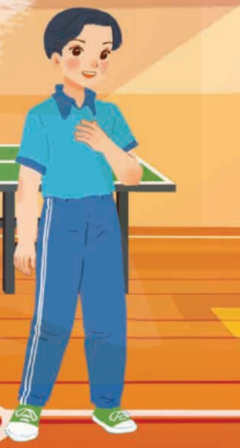 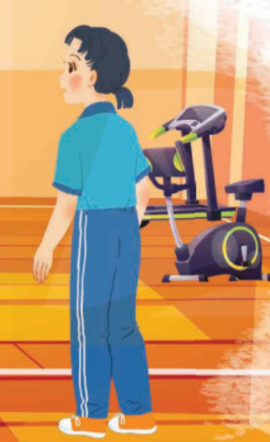  - T_ Ss  - Listen carefully to the context  - Answer the teacher’s questions.  - Listen carefully and read aloud.  Note:  - gym  - karate  - sporty  - equipment.  - fit  - aerobics
3. PRACTICE ( 15’)
ACTIVITY 2:
Aims: To help Ss practise using words related to the topic Sports and Games;
- To help Ss understand the conversation better.
* Content: Put the word from conversation in each gaps to practice the use the words.
* Output: Ss can know more new words and lear how to use them correctly.
* Organisation : ..…

Teacher’s & Student’s activities | Content
2. Put a word from conversation in each gap.  - Ask Ss to do this activity independently. Remind them of the ways to do the activity if needed. Ss may refer back to the conversation for the context of the words they need to fill the gaps.  - Allow them to share their answers before discussing them in pairs or as a class.  - Write the correct answers on the board.  - T explains the meanings of some words if necessary. Ss practise saying the sentences together.  - T gives the correct answers.  - Confirm the correct answers. | 2. Put a word from conversation in each gap.  - T_ Ss.  - Listen carefully to the instructions  - Follow the teacher’s instructions  - Give the answers and check.  * Key:  1. fit 2. gym 3. table tennis  4. Club 5. cycle
ACTIVITY 3:
Aim: To help Ss revise / learn names of some sports and games through pictures.
* Content: Names of some sports and games through pictures using the word given
* Output: Ss understand more about the use of word given.
* Organisation : ..…

3. Name these sports and games, using the words from the box.  - Ask Ss to label the pictures with the correct words given. Ss can work in pairs. Elicit Ss' answers.  - Then provide the correct words.  - Ask them for the meanings of the words. Provide them with the meanings of the words they don't know. T may also ask them if they play these sports and games or if people in Viet Nam play them.  - Allow Ss to share answers before discussing as a class.  - T gives correct answer  Watch out!  - Help Ss differentiate between a sport and a game:  A sport: an activity that you do for pleasure and that needs physical exercise.  A game: an activity or a sport with rules in which people or teams compete against each other.  - T may ask Ss to give the names of some sports and some games they know. For example:  Sports: running, cycling, mountain climbing, ...  Games: chess, football, card games, computer games, ... | 3. Name these sports and games, using the words from the box.  - Listen to the instructions clearly  - Learn how to do it  - Ss to work in pairs  - Compare the answers  - Give the answers.  - Copy them  *Key :  1. cycling 2. aerobics  3. table tennis 4. swimming  5. chess 6. volleyball
4. PRODUCTION/ APPLICATION (8’)

ACTIVITY 4: What is the difference between a sport and game?
Aim:To help Ss practise speaking and learn about how sporty they are.
* Content: Ask and answer to find out how sporty they are.
* Output: Ss can answer the questions correctly.
* Organisation : ..…

4. Work in pairs. Ask your partner these questions to fine out how sporty they are.  - Have Ss work in pairs (or in groups) to ask and answer the questions. Some pairs (or groups) may report their results to the class. (In their groups, how many Ss with answers "A", how many with answers "B" and who is the sportiest in their groups.)  - T may want to find out how sporty the class is by writing the results on the board.  - Allow Ss to share their answers and discuss.  - Check the answers as a class  Confirm the correct answers. | 4. Work in pairs. Ask your partner these questions to fine out how sporty they are.  - T_ Ss  - Listen carefully and learn how to do.  - Ss do themselves. Give the answers
5. WRAP-UP & HOMEWORK (2’)

*Ask one or two Ss to tell the class what they have learnt.
- Ask Ss to say some words they remember from the lesson.
- If there is a visualizer in the classroom, show the dialogue, highlight the key words related to the topic.
* HOMEWORK
- Read again the conversation on page 6.
- Do more exercises in workbook.
- Prepare new lessons.

=====================

