Period
LESSON PLAN
TIẾNG ANH 10 FRIENDS GLOBAL
UNIT 4: OUR PLANET
LESSON 4E: WORD SKILLS – PHRASAL VERBS
I. OBJECTIVES:
By the end of the lesson, Ss will be able to:
1. Knowledge:
- understand and use a variety of phrasal verbs
- discuss about a problem in groups
2. Ability:
- main skills: reading and writing skills
- sub skills: listening and speaking skills
- discuss and share ideas about the environment, pollution, etc.
3. Quality:
- have positive attitude in English language learning so that they can participate enthusiastically in all classroom activities, especially with the topic conducted by the teacher
- keen on studying English
II. TEACHER AIDS AND LEARNING MATERIALS:
Lesson plan, PPT slides, student’s book, workbook, notebook, personal computer (if any), projector/TV, speakers, IWB software.
III. PROCEDURES:
A. Warm-up (5’)
a) Objective: Introduce the new lesson and set the scene for Ss to acquire new language; get students' attention at the beginning of the class by means of enjoyable and short activities as well as to engage them in the steps that followed.
b) Content: Task 1 page 51
c) Outcomes: Students can gain more confidence and interest in the lesson.
d) Competence: communication, collaboration, guessing
e) Organisation of the activity:
TEACHER’S ACTIVITIES | STUDENT’S ACTIVITIES | CONTENTS
WARM-UP. T-Ss/ S-S/ Indiv  Task 1 page 51  - Ask students to discuss with their partners and describe the photo using the words given  - Invite some students to give the answers  - Lead in the lesson: Negative adjective prefixes | - Discuss with their partners  - Volunteer to answer  - Open the course book page 51 | 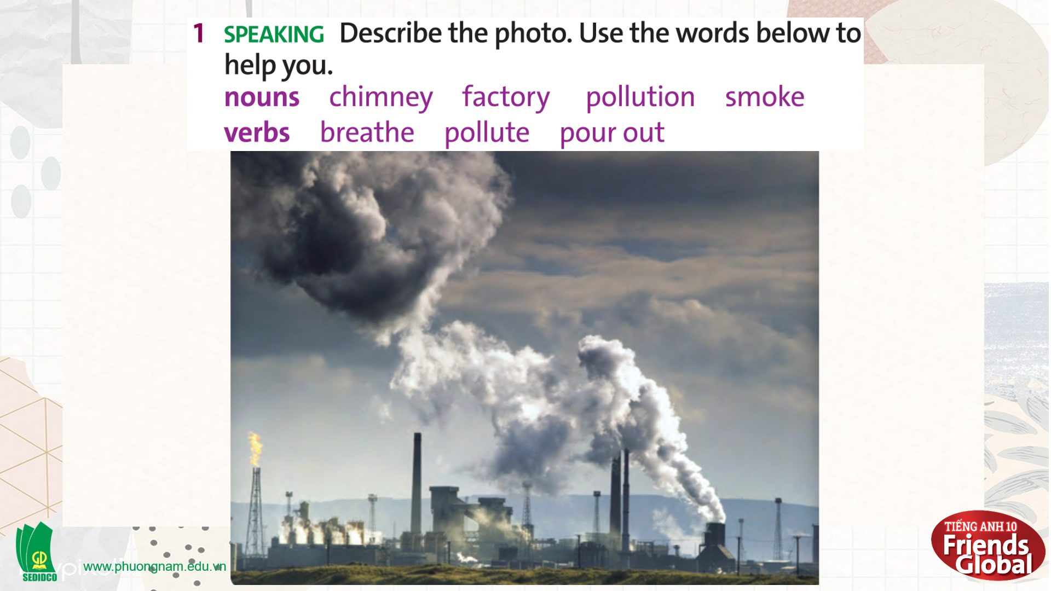  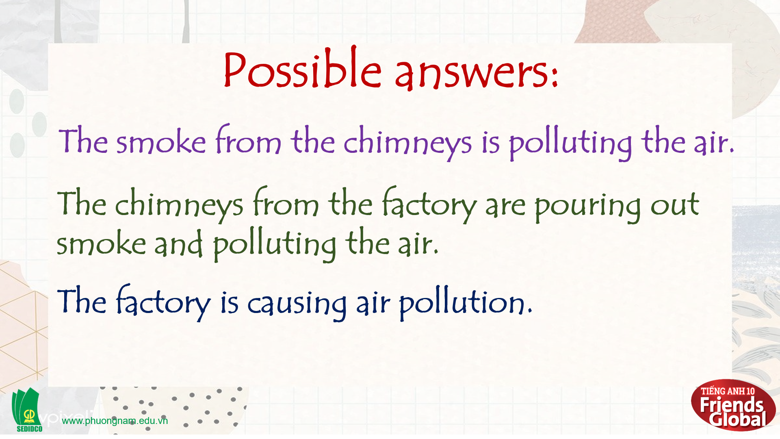

B. New lesson (35’)
- Activity 1: Presentation (12’)
a) Objective: Students learn some new phrasal verbs
b) Content:
Grammar
Reading
c) Outcomes: Students know how to pronounce the new words precisely and use them in appropriate contexts.
d) Competence: communication, presentation
e) Organisation of the activity:

TEACHER’S ACTIVITIES | STUDENT’S ACTIVITIES | CONTENTS
PRESENTATION. T-Ss/ S-S/ Indiv  Activity 1 (5’): Task 2 page 51  - Ask students to complete the compound nouns in the fact file  - Play the audio to check the answer  Activity 2 (7’): Task 3 page 51  - Go through the Learn this! box with students and highlight main ideas  - Ask students to find five phrasal verbs in the text  - Check answers as a class  - Ask students to distinguish five phrasal verbs based on its meaning  - Check answers as a class | - Work in pairs to complete the task  - Listen to the audio and check the answer  - Read the Learn this! box and highlight main ideas  - Work in pairs to complete the task  - Check the answers with the teacher  - Work in pairs to complete the task  - Check the answers with the teacher | 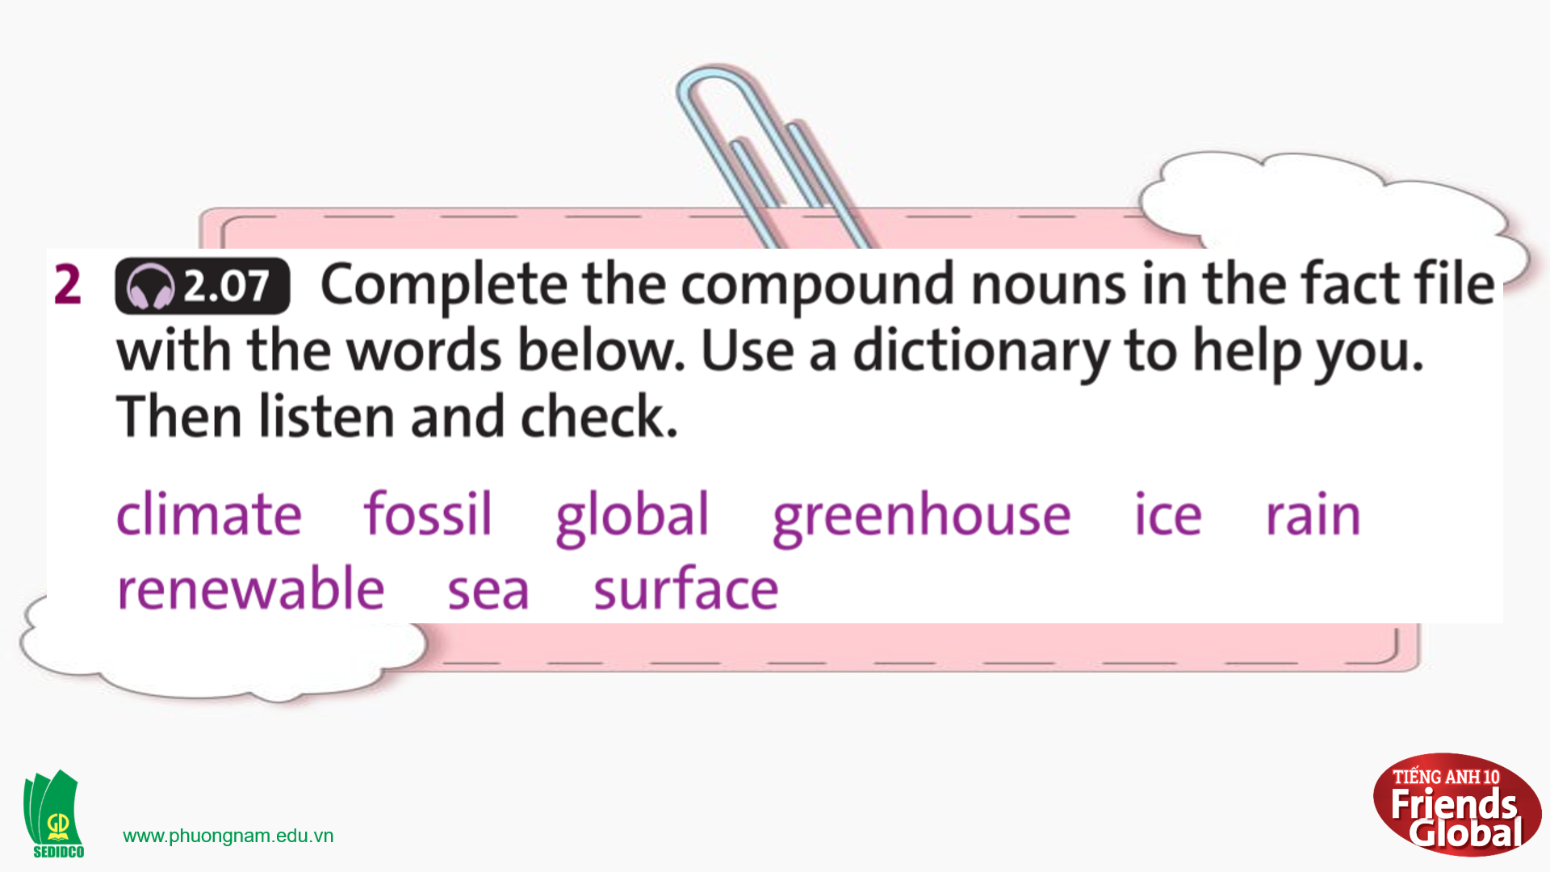  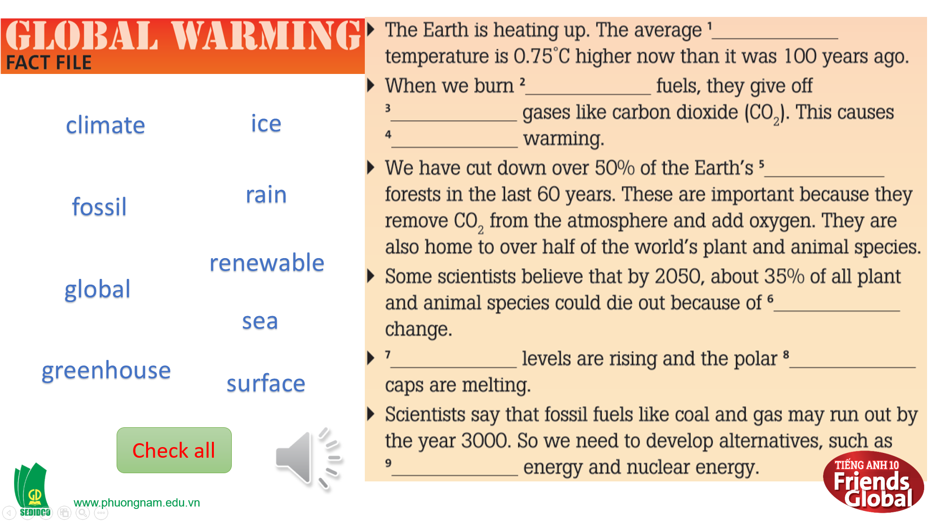  Answers:  1. surface 2. fossil  3. greenhouse 4. global  5. rain 6. climate  7. sea 8. ice  9. renewable  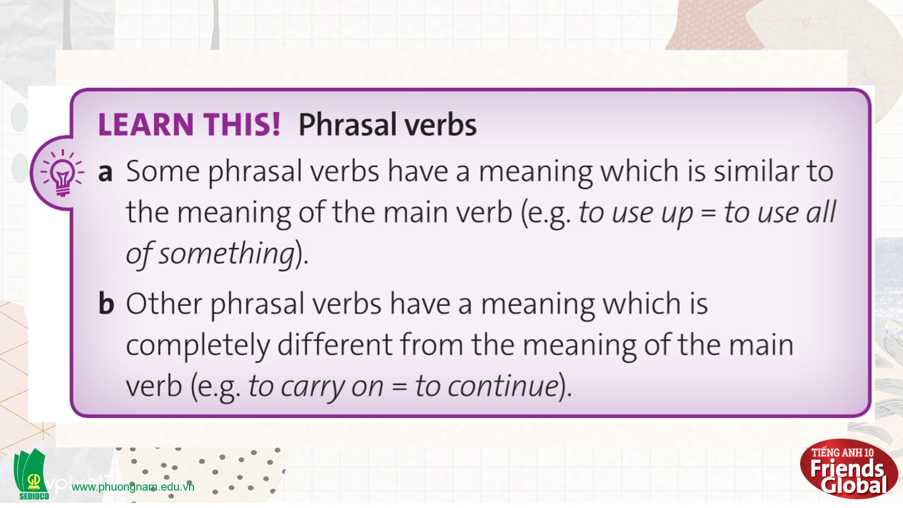  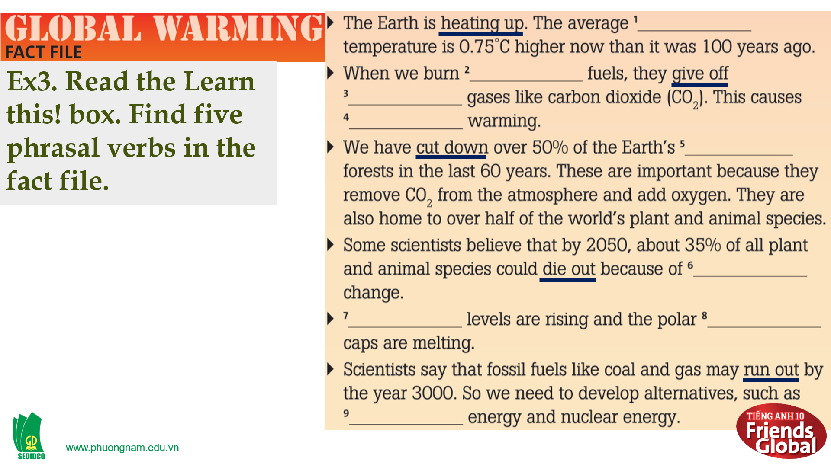  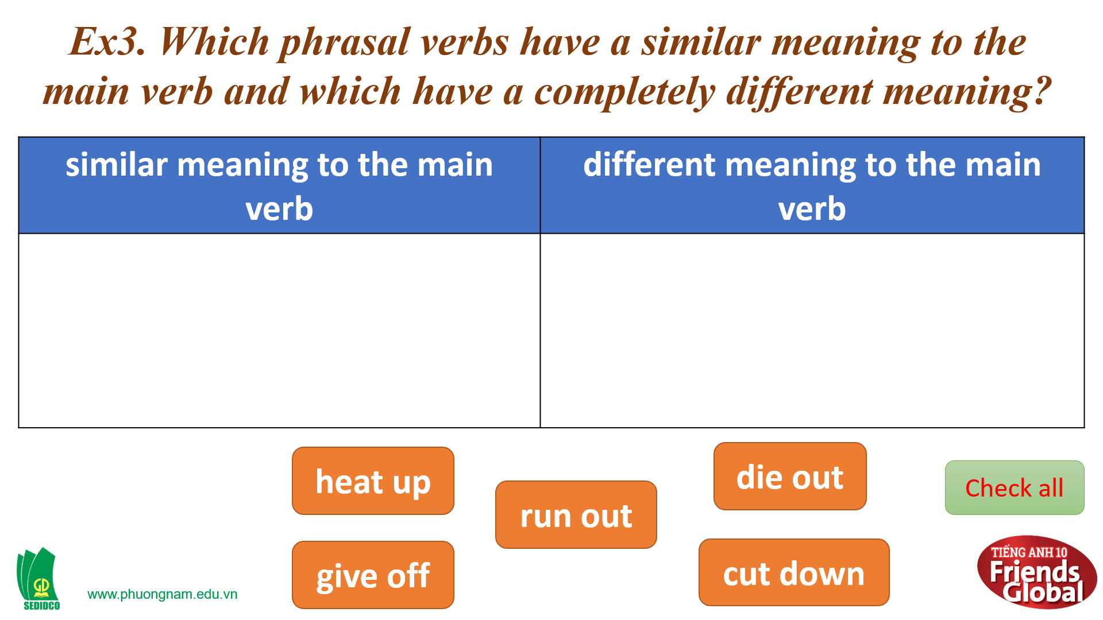  Answers:  similar meaning: heat up, give off, die out, cut down  different meaning: run out
- Activity 2: Practice (13’)
a) Objective: Students can answer the questions to critical thinking, and they can finish the tasks in the textbook. Critical thing skills (guessing/ reasoning) and communication can also be practiced.
b) Content: Students learn more about phrasal verbs, they also learn how to form and use phrasal verbs properly in complete sentences.
c) Outcomes: Students know how to form and use phrasal verbs properly in exercises and also daily conversations.
d) Competence: communication, collaboration, presentation
e) Organisation of the activity:
TEACHER’S ACTIVITIES | STUDENT’S ACTIVITIES | CONTENTS
PRACTICE. T-Ss/ S-S/ Indiv  Activity 1 (3’): Task 4 page 51  - Ask students to read the text about the view of two students and answer question  - Check the answers  Activity 2 (10’): Task 5 page 51  - Ask students to find nine phrasal verbs in the texts  - Check answers as a class  - Ask students to match five of them with the definitions given  - Check the meaning of the others in the dictionary  - Ask students to distinguish the main verbs based on its meaning  - Check answers as a class | - Read the text and answer questions  - Check the answers with the teacher  - Work in pairs to complete the task  - Check the answers with the teacher  - Work in pairs to complete the task  - Check the meaning of the others with the teacher  - Work in pairs to complete the task  - Check the meaning of the others with the teacher | 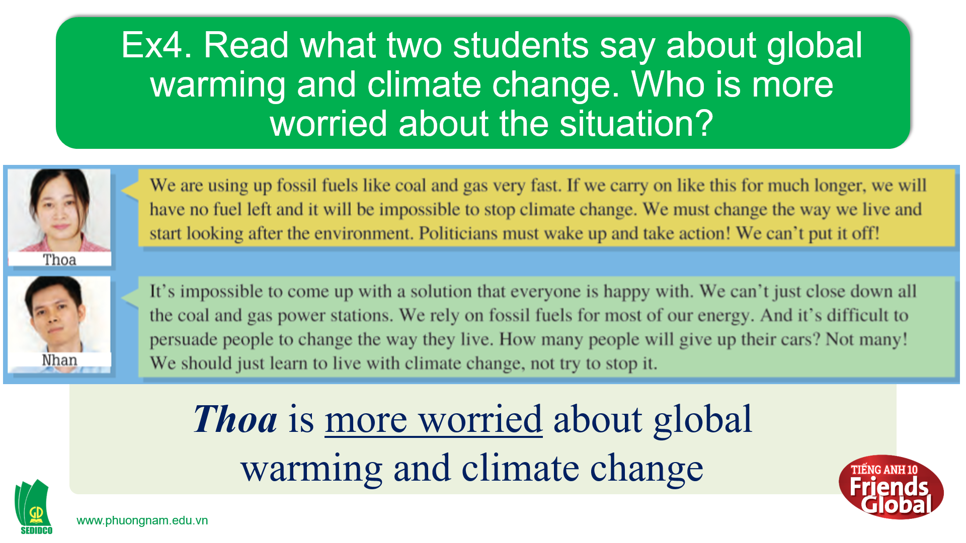  Answers:  Thoa is more worried about global warming and climate change  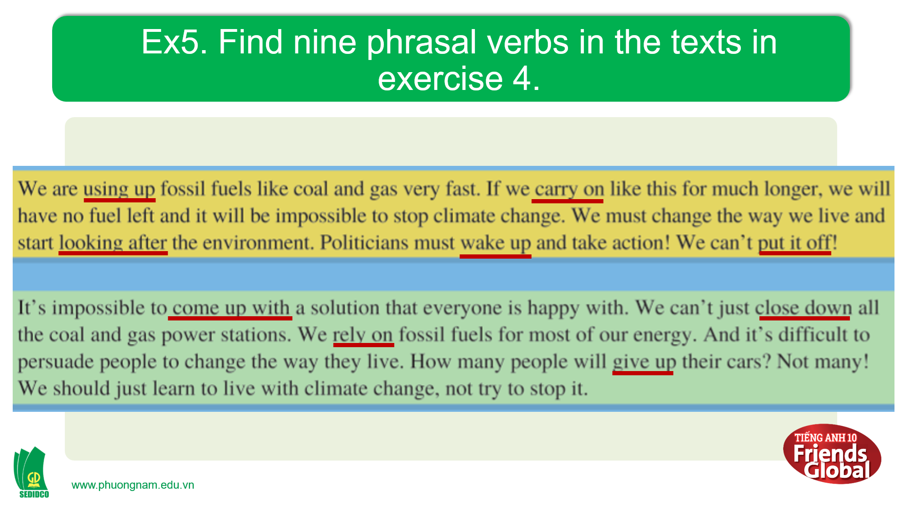  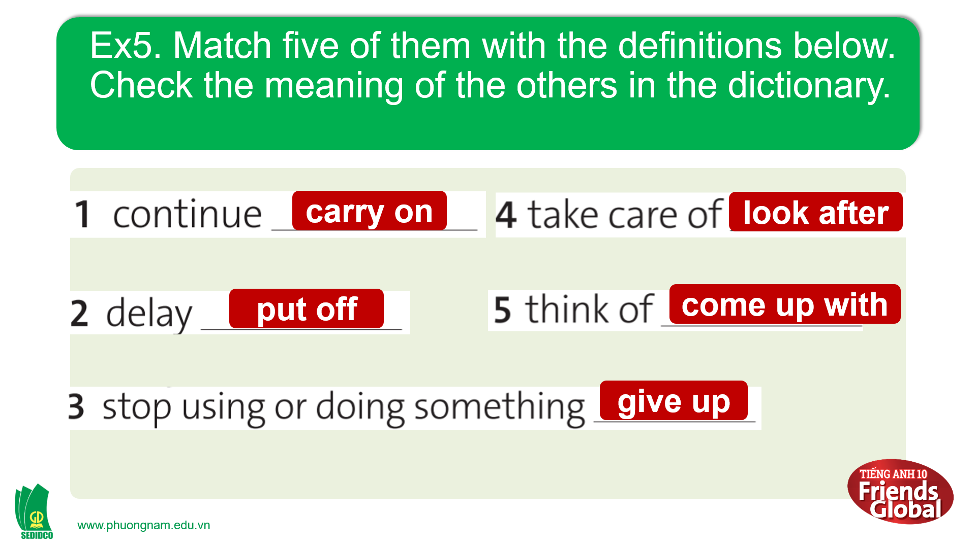  Answers:  1. carry on 2. put off 3. give up  4. look after 5. come up with  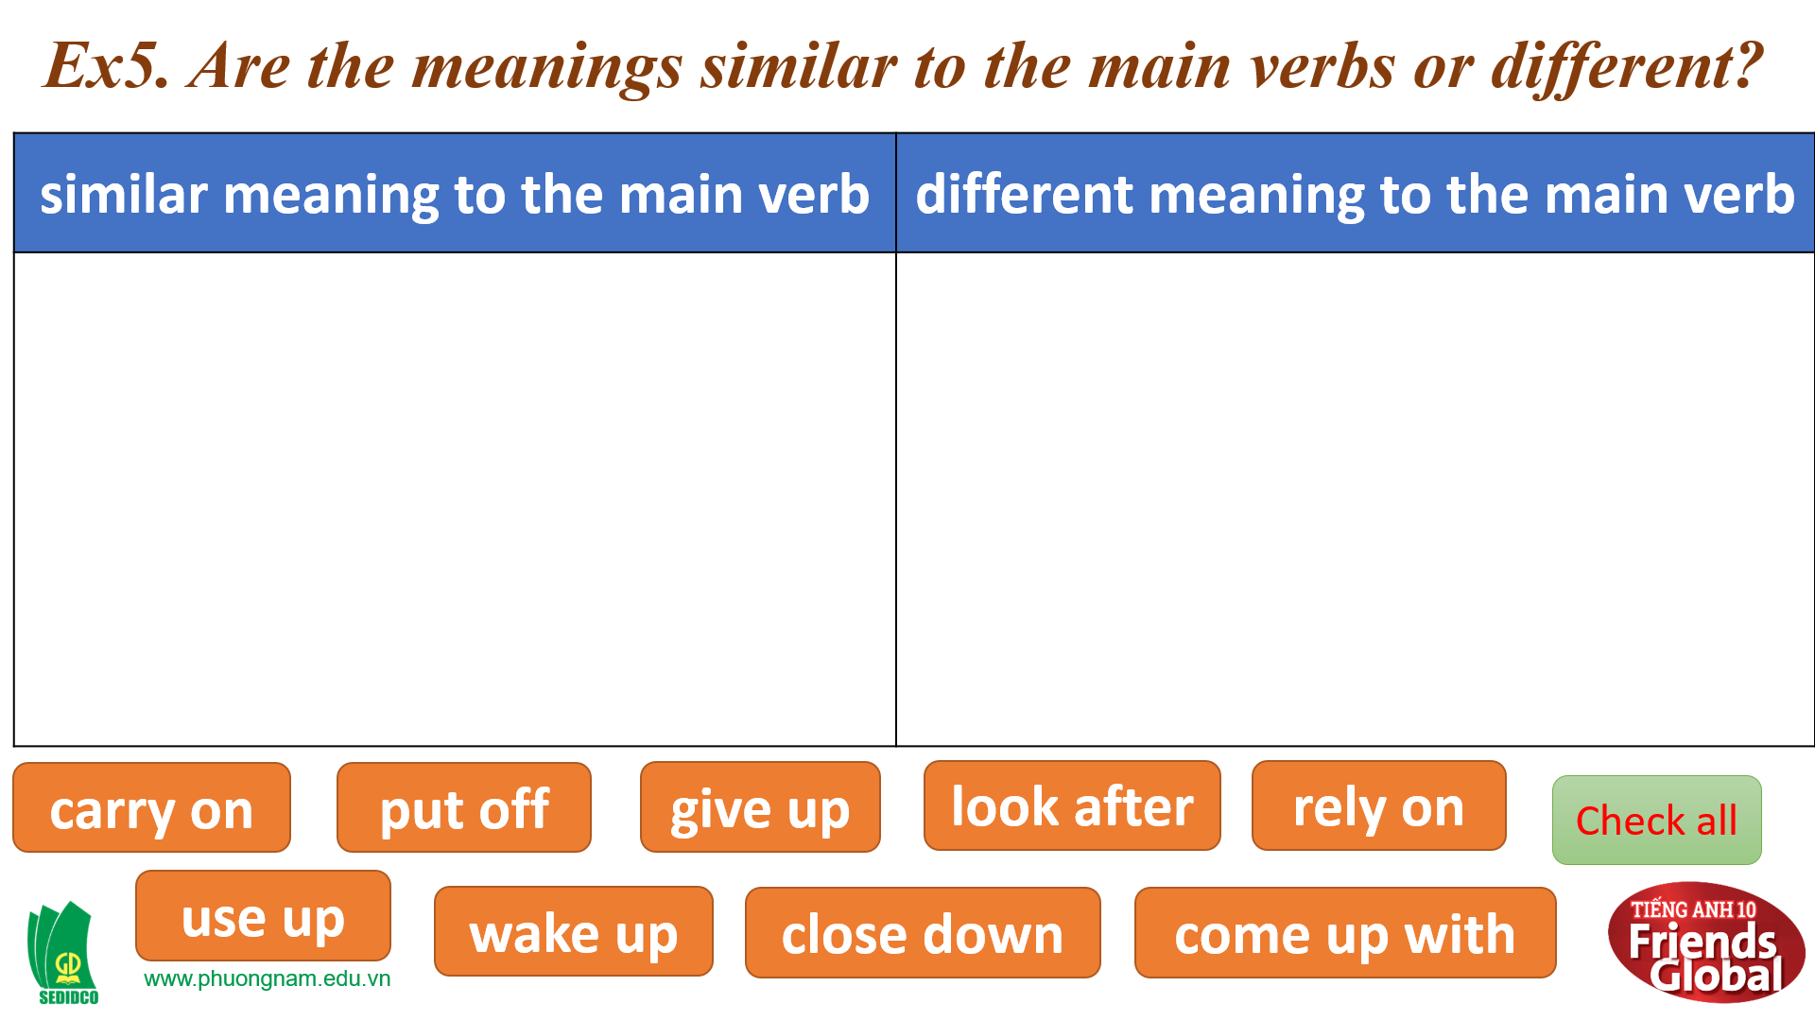  Answers:  similar meaning: use up, rely on, wake up, close down  different meaning: carry on, put off, come up with, give up, look after

- Activity 3: Outcomes (10’)
a) Objective: Students can answer the questions to critical thinking. Communication can also be practiced.
b) Content: Students work in pairs and discuss the sentences in exercise 6.
c) Outcomes: Students practice speaking and apply some structures they learnt in discussion.
d) Competence: Collaboration, communication, guessing
e) Organisation of the activity:
TEACHER’S ACTIVITIES | STUDENT’S ACTIVITIES | CONTENTS
PRODUCT. T-Ss/ S-S/ Indiv  GAME “THE BEST GOALKEEPER”: Task 6 page 51  - Go through the instructions together and make sure students understand what they have to do  - Monitor and help with grammar and vocabulary where necessary | - Volunteer to answer. With one correct answer, that student can get one bonus. |   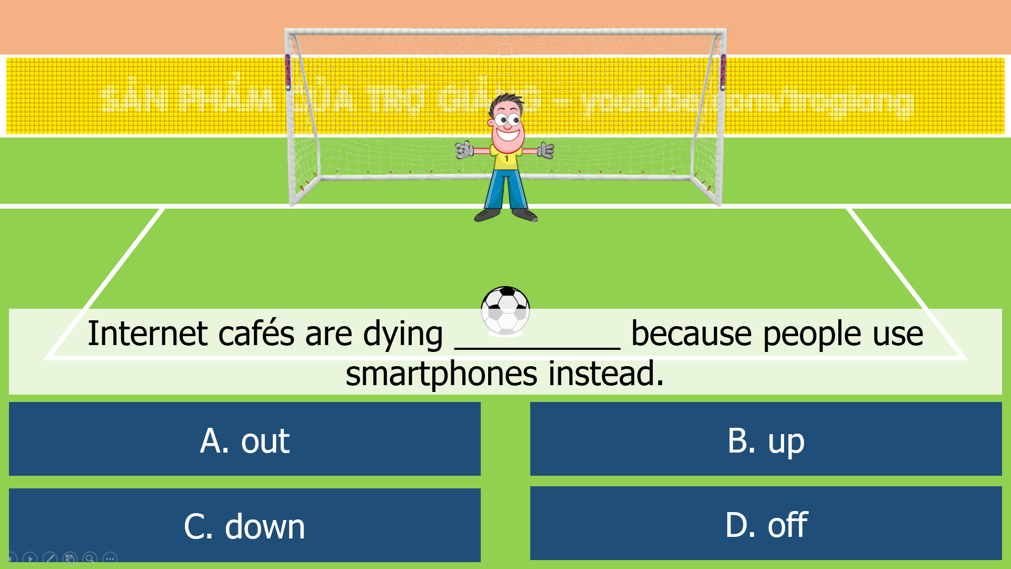
C. Consolidation (3’)
- Students learn some new phrasal verbs.
- Students can form and use phrasal verbs to discuss a problem.
D. Homework (2’)
- Review and practice using dictionary to look up words and its meaning
- Learn by heart all phrasal verbs rules
- Finish all the tasks
- Prepare: Unit 3F: Reading (page 40&41 – SB)

