Mã đề 6.1.13
ĐỀ KIỂM TRA GIỮA KỲ I – MÔN TIẾNG ANH 6
Thời gian: 60 phút – Năm học: 2022 - 2023
A. Listening (2.0 points)
Part 1. Listen and tick (√ ) under the correct picture ( 1.0 point)
1. What’s Tom doing?
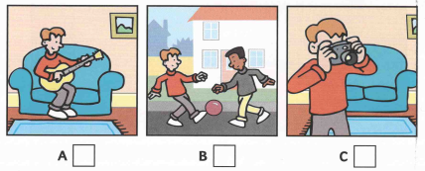
2. Where’s Mummy?
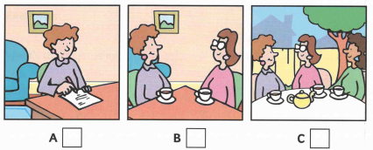
3. What’s Daddy doing?
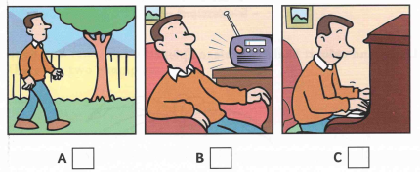
4. What games are Sam and Pat playing?
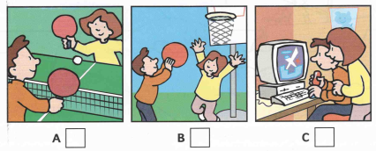
5. What’s Grandfather doing?
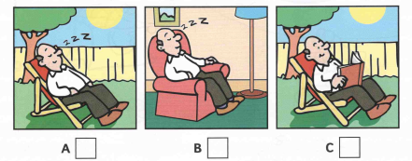
Part 2. Listen and complete the missing words/ numbers ( 1.0 point)

1. Who’s the girl in the picture ? …………………………………………
2. How many bedrooms are in the house? …………………………………………
3. What number is on the door? …………………………………………
4. What’s the name of her baby brother? …………………………………………
5. Which book is the girl reading? …………………………………………

B. Language ( 3.0 points)
1. Choose the word which has a different sound in the part underlined. ( 0.2 points)
A. come | B. class | C. study | D. mother
2. Choose Choose the word which has a different sound in the part underlined. ( 0.2 points)
A. flats | B. cups | C. pictures | D. sinks
Choose the best option to complete the sentences ( 2.0 points)
3. Nam ……… football now. He’s tired.
A. doesn’t play | B. plays | C. is playing | D. isn’t playing
4. The family photo is ……… the wall.
A. in | B. on | C. at | D. with
5. I usually ……………..books in my free time.
A. am reading | B. read | C. to read | D. reads
6. Do you know where our new …………… is? Our teacher wants to meet him.
A. poem | B. classmate | C. swimming pool | D. gym
7. Today is a great day at the………….
A. Masons' | B. Mason’s house | C. Mason's. | D. houses Mason
8. My sister always has a lot of new ideas. She’s a …………. person.
A. creative | B. hard-working | C. caring | D. careful
9. Tom ……………. football every weekend.
A. studies | B. has | C. plays | D. does
10. My brother has short…………………..hair.
A. long | B. big | C. black | D. small
11. ……… do you go out with your friends? – Every day.
A. How often | B. How old | C. How | D. How much
12. There is a bed, a bookshelf in her……………….
A. kitchen | B. garden | C. bedroom | D. bathroom
Choose the best respond ( 0.6 points)
13. An: “ How do you go to school every day ?” – Ba: “………………………..”
A. Always B. By bus
C. No, I don’t D. English is my favourite subject.
14. Mum: “ Let’s buy some pictures for your room” – Elena: “………………….”
A. That’s great! Thanks, Mum. B. See you later.
C. I’m sorry. D. I go to school every day.
15. Mum: “ What does your new friend look like?” – An: “……………”
A. She is creative. B. She is tall with long black hair.
C. She is a good student. D. She talks to me everything.
C. Reading
Part 1. Read and decide if each statement is true (T) or false (F). Tick (√) T for true or F for false. ( 1.5 pts)
Elena is a pupil of Green School. She will tell you something about her school life. She goes to school five days a week except Saturday and Sunday. Classes in her school start at 8 o’clock in the morning and end at 15.30 in the evening. She often has 6 or 7 lessons a day. She studies a lot of different subjects: English, History, Geography, Biology, Physics, Chemistry, Math, etc. Her favourite subject is English because she can learn lots of interesting things in England. This is her school. Her classroom is on the third floor. Her school has a stadium, a library, a gym and a computer room, too. She loves her school so much.
Statements | T | F
1. Elena is a pupil at Blue School.
2. She does not go to school on the weekend.
3. Her school starts at 8.00 a.m. and finishes at 3.00 p.m.
4. She learns different subjects at school.
5. Maths is her favourite subject.
Part 2. Choose the letter A, B, C or D to answer these questions ( 1.5 pts)
Tim and Tom are twin brothers. They are very similar and a lot of people don’t know who is who. They both have blond hair and blue eyes, and they always wear jeans and T-shirts.
They like doing the same things, too. For example, they both like jazz and they’re crazy about football. They go to a football match once a week. Tim doesn’t like dancing or discos and Tom doesn’t like them, either. Although they’re twins, they’re not exactly the same at everything. Tim works hard at school because he wants to go to university, but Tom is a bit lazy. Their mother is often away from home because of her job, so they all work together in the house. Most of the time it’s fine, but sometimes they fight a bit!
1. What do both Tim and Tom have?
A. grey hair and blue eyes. B. grey hair and brown eyes.
C. blond hair and blue eyes. D. blond hair and brown eyes.
2. Tim and Tom …………………………….________
A. like doing the different things B. are cousins.
C. aiways wear uniforms. D. like football very much.
3. What does the word “them” in line 4 refer to?
A. dancing or discos B. jazz
C. jeans and T-shirts D. things
4. Which of the following is not true?
A. Tim is hard-working
B. Tom is a bit lazy
C. Their mother is often away from home
D. Tim doesn’t like dancing or discos but Tom likes them.
5. What is the passage about ? _______
A. brothers | B. a pair of male twins | C. friends | D. mothers
D. Writing ( 2 pts)
Part 1. Rearrange the sentences. You cannot change the words. (0.4 point)
1. clock/ is/The/ between / picture/ and/ the/ the/ lamp.
→………………………………………………………………………………………………………
2. classmates/ My/ playing/ in/ schoolyard/ are/ now/the.
→………………………………………………………………………………………………………
Part 2. Rewrite these sentences, do not change their meaning. ( 0.6 points )
1. How about going to the cinema tonight?
→ Let’s……………………………………………………………………………………
2. This is Lan. This is her house.
-> This house………………………………………………………………………
3. The school has a computer room and a library.
→ There…………………………………………………………………
Part 3. Mi is describing her house. Use the given words to make complete sentences to describe her house. ( 1 point)
M: Hi/ everyone. Name/ Mi.
-> Hi, everyone. My name is Mi.
1. I/ live/ big/ house/ countryside.
…………………………………………………………………………………………………………
2. There/ five rooms/ the first floor/ and four rooms/ the second floor.
…………………………………………………………………………………………………………
3. The big yard/ in front of/ house/ and/ small garden/ next to/ it.
………………………………………………………………………………………………………….
4. My bedroom/ have/ two windows/,/ there/ many/ beautiful pictures/ this room.
………………………………………………………………………………………………………….
5. I/ like/ house/ so much/because/ my family/ have/ happy time/ this house.
………………………………………………………………………………………………………….

The end!

