|  |  |
| --- | --- |
| **TRƯỜNG THCS TÂN PHONG** | **ĐỀ THI HỌC SINH GIỎI**  **NĂM HỌC 2024-2025**  **MÔN THI: TIẾNG ANH 6**  *Thời gian làm bài: 120 phút;* |

**A. LISTENING (4.0 POINTS)**

**PART I: There are 5 questions in this part, for each question there are 3 pictures and a short recording. Choose the correct picture. You will listen to the audio twice. (1.0 pt)**

1.Where does her brother work?

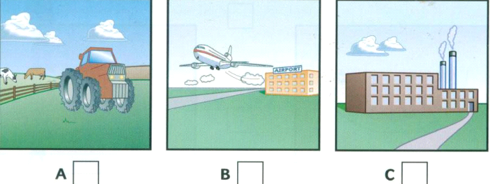

2. How does he go to work?

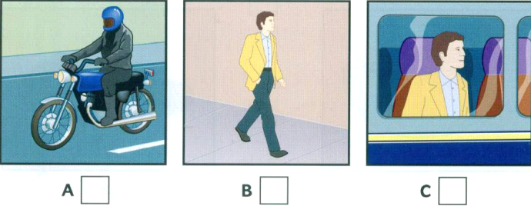

3. When does he start work?

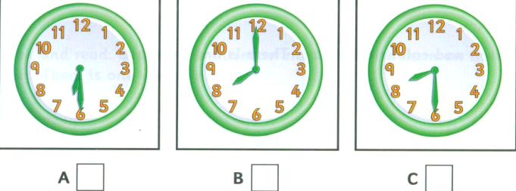

4. What does he do for lunch?

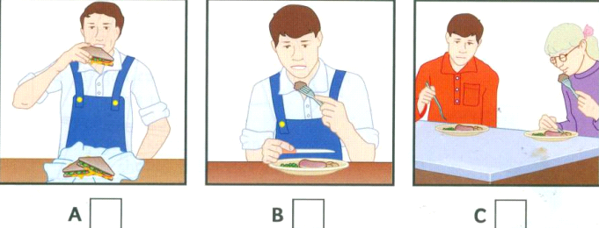

5. What did he do before he started this job?

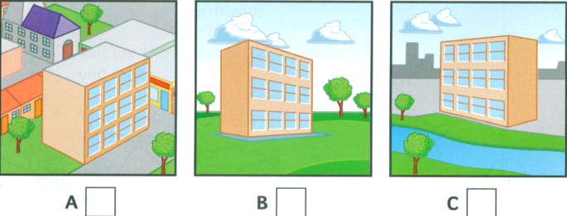

**PART II. Listen to a girl asking for information about a coach trip to Edinburgh. For questions 6-10, choose the correct answer to each question.**

6. The girl will pay……….

A. £5 B. £7 C. £9 D. £6

7. The girl will get on the coach …………..

A. outside the library B. in front of the Grand Hotel

C. in Bridge Street D. behind the restaurant

8. The coach will be at the girl’s stop at………………..

A. 8:45 am. B. 8:55 am. C. 9:05 am. D. 9:15 am

9. In Edinburgh, the girl will visit……………………………

A. the castle and shops B. the cathedral and museums

C. the castle and cathedral D. the museums and shops

10. The whole trip take……………..

A. 2 hours B. 21/4 hours C. 41/4 hours D.3 hours

**PART III . You will hear some information about a cinema. Listen and complete questions 1-5. You will hear the information twice.(5 points)**

**CINEMA**

Name of cinema: North London Arts Cinema

Next week’s film: (11)...........................Meeting

From Monday to (12).....................

Times: 6:45 p.m and (13).................

Student ticket costs: (14) £....................................

Nearest car park: (15).............................Street.

**PART IV. Listen and decide if the following statements are True (T) or False (F) (5 points)**

**16.**  Maria thinks life in the city is more interesting than that in the countryside.  T/F

**17.**David says that city is less dangerous than the countryside.  T/F

**18.**The people in the countryside aren't as open as those in the city.  T/F

**19.**  The country is quieter than the city. T/F

**20.**Maria thinks the city is more fun than the country.  T/F

**B – GRAMMAR – VOCABULARY – LANGUAGE FUNCTIONS**

**Part I. Choose the correct answer to fill in each blank.**

21. " **Lan:** “What a wonderful picture!” **Huong:** _________.

A. Of course, I think so. B. I’m very happy.

C. You’re right. D. It’s nice of you to say so.

22. A: Hello. You must be Maryam?

B: ………………

A. I must be B. I may be

C. That’s right D. You are not Maryam.

23. There are a lot of …………………… in Ha Long Bay.

A. scenery B. mountains C. beautiful caves D. rivers

24. Everest is the …………………… mountain in the world.

A. high B. higher C. highest D. most high

25. Let’s ………………… to the cinema tonight.

A. go B. going C. goes D. to go

26. It …………… me about three hours to get there.

A. gets B. does C. has D. takes

27. Ngan is not easy-going. She is ……………..

A. curious B. lazy C. serious D. smart

28. Before Tet, people often give ……………….. to show their love and respect.

A. firecrackers B. plants C. food D. presents

29. Tet is a time for family ………………

A. working B. cooking C. playing D. gathering

30. My mother cooked noodles for me ………………… I was hungry.

A. and B. but C. although D. because

31. It started to rain, ………………… we went inside and watched TV.

A. and B. although C. so D. because

32. He…………as a reporter since he……………from Boston university.

A. worked / graduated B. works / graduates

C. has worked / graduated D. worked / has graduated

**Part 2:** **Read the advertisement and choose the correct option.**

**The Bloomfield Tim is Going Online**

Here at the Bloomfield Times, we understand that 33) _____ people are using mobile devices for news these days. So, as a part of our plan 34) _____ aims to limit costs and reduce our carbon footprint, our paper 35) _____ switch to become a fully digital publication next month. To subscribe, go to bloomfieldtimes.net.

33. A. more                  B. the more                 C. more and more       D. Many and many

34. A. which                 B. where                      C. whose                     D. who

35. A. makes                 B. is making                C. has made                D. making

**Part 3: Choose the underlined part which needs correction in each of the following sentences.**

41. I (A) don’t agree (B) of you that a robot (C) will be able (D) to understand what people say.

42. Scientists (A) are working on how (B) to invent (C) a intelligent (D) robot.

43. If you (A) will help (B) me, I (C) will lend you (D) my new bike.

44. (A) How much (B) is a bowl of (C) noodles? (D) They are 20 thousand dongs.

45. (A) Electricity can be reduced if people (B) turned off all the electric (C) appliances in one (D) hour.

**Part 4: Complete the sentences with the correct form of words in brackets.**

46. The old lady hid all her……………………under floor. (save)

47. He cycled…………………and had an accident. (care)

48. William Shakespeare (1564-1616) is a famous ………..….. in the world. (play)

49. My brother dreams of living in a house …………….. by water. (surround)

50. I don’t like horror films because they are too……………… for me. (fright)

**C.READING**

**Part 1:** **Read the passage andfill in the blank with a suitable word.**

Mary lives (51)____________ a village in London. Her day starts (52)___________ 4 o’clock. She gets up, and she walks three kilometers to the river. She takes some water and she carries it back to her house. The water is very (53)_______________. It isn’t clean but there (54)________________ any water in the village. She doesn’t go to school. She can’t read or write. She (55)_________________ her mother to clean the house.

**Part 2: Read the passage and choose the correct answer A, B, C or D.**

I live in a small village called Henfield. There (56)_______ about 500 people here. I love it because it is (57) _______ and life is slow and easy. You (58) ________ have to queue in shops or banks. The village is clean. People look after it and (59) ______ their rubbish in the streets. The air is also (60) _______ because there’s not much heavy traffic. It’s much more (61) _______ here than in a city. Everyone knows everyone and if someone (62) _______ a problem, there are always people who can help. There are (63) _______ things I don’t like about Henfield. One thing is that there’s not much to do in the evening. We haven’t got any cinemas (64) _______ theaters. Another problem is that people always talk about each other and everyone knows (65) ________ everyone else is doing. But I still prefer village life to life in a big city.

|  |  |  |  |
| --- | --- | --- | --- |
| 56. A. be | B. is | C. are | D. was |
| 57. A. quite | B. quiet | C. noisy | D. noisily |
| 58. A. can’t | B. should | C. not | D. never |
| 59. A. don’t throw | B. throw | C. not throw | D. throwing |
| 60. A. dirty | B. not clean | C. clean | D. nice |
| 61. A. friendly | B. unfriendly | C. boring | D. uninteresting |
| 62. A. have | B. are | C. has | D. get |
| 63. A. much | B. a little | C. a few | D. a lot |
| 64. A. and | B. or | C. but | D. because |
| 65. A. who | B. where | C. how | D. what |

**Part 3: Read the following passage and choose the best answer to complete each sentence.**

Once a poor farmer had a daughter named Little Pea. After his wife died, the farmer married again. His new wife had a daughter, Stout Nut. Unfortunately, the new wife was very cruel to Little Pea. Little Pea had to do chores all day. This made Little Pea’s father very upset. He soon died of a broken heart.

Summer came and went. In the fall, the village held its harvest festival. That year, everyone was excited as the prince wanted to choose his wife from the village. Stout Nut’s mother made new clothes for her, but poor Little Pea had none.

However, before the festival started, a fairy appeared and magically changed Little Pea’s **rags** into beautiful clothes.

As Little Pea ran to the festival, she dropped one of her shoes and lost it. When the prince found the shoe, he decided to marry the girl who owned it. Of course the shoe fitted Little Pea, and the prince immediately fell in love with her.

66. Little Pea’s father was a___________.

A. fairy B. prince C. cruel man D. poor farmer

67. How was the new wife of Little Pea’s father? ~ She was not very_________.

A. upset B. kind C. cruel D. beautiful

68. Who made Little Pea do chores all day?

A. the prince B. her father C. Stout Nut D. Stout Nut’s mother

69. What made Little Pea’s father very annoyed?

A. Little Pea had to do chores all day.

B. His new wife was very cruel to his daughter.

C. He had a broken heart.

D. A and B

70. When did the village hold its harvest festival?

A. In the spring B. In the summer C. In the autumn D. In the winter

71. Who did Stout Nut’s mother make new clothes for?

A. herself B. Stout Nut C. Little Pea D. the prince

72. When did Little Pea have beautiful clothes?

A. Before the festival started B. After the festival began

C. During the festival D. When the prince found her shoe

73. The word ‘rags’ in line 8 could best be replaced by___________.

A. black, dirty clothes B. nice, new clothes

C. old, torn clothes D. beautiful fitted clothes

74. All of the following are false EXCEPT__________.

A. Stout Nut, the new wife was very cruel to Little Pea.

B. The village held its harvest festival in the summer.

C. The girl who owned the lost shoe was Little Pea.

D. The prince found Little Pea’s lost shoe and he decided to marry it.

75. What is the best title for the passage?

A. The Lost Shoe B. Little Pea

C. Stout Nut D. Little Pea and Stout Nut

**D – WRITING**

**Part I. Rewrite the following sentences without changing the meaning.**

81. Could you tell me how to get to the City’s Exhibition, please?

🡪 Could you show ……………………………………………………………..

82. Hang is the tallest girl in my class.

🡪 No girl …………………………………………………………………………

83. I think you should prepare carefully for your journey.

🡪 I advise you …………………………………………………………………..

84. I have never seen a more beautiful city than Da Lat.

🡪Da Lat is ……………………………………………………………………..

85. Tet holidays always excite me.

🡪 I am ………………………………………………………………………….

**Part II.** **Write an email to your friend and tell him/ her your school.**

………………………………………………………………………………………………………………………………………………………………………………………………………………………………………………………………………

………………………………………………………………………………………………………………………………………………………………………………………………………………………………………………………………………

………………………………………………………………………………………

………………………………………………………………………………………

………………………………………………………………………………………

**Part III. In about 100 – 120 words. Write a paragraph about about Tet holiday.**

………………………………………………………………………………………………………………………………………………………………………………………………………………………………………………………………………

………………………………………………………………………………………………………………………………………………………………………………………………………………………………………………………………………

………………………………………………………………………………………………………………………………………………………………………………………………………………………………………………………………………

………………………………………………………………………………………………………………………………………………………………………………………………………………………………………………………………………

………………………………………………………………………………………

**_ The End _**