School: ……………………………………….. | Date:……………………………………..
Class: ……………………………..................... | Period: …………………………….........

UNIT 7: TEENS
Lesson 2.2 - Grammar (Pages 69&70)
I. OBJECTIVES
By the end of the lesson, Ss. will be able to:
1.1. Language knowledge and skills
- practice and use Reported speech for statements correctly
1.2. Competences
- communication, critical thinking, collaboration,
1.3. Attributes
- know more about celebrities’ lives which can be a part of their dream jobs.
II. TEACHING AIDS AND LEARNING MATERIALS
1. Teacher’s aids: Student book and Teacher’s book, class CDs, Digital Book (DCR phần mềm tương tác SB, DHA (từ vựng/ cấu trúc) phần mềm trò chơi tương tác), projector/interactive whiteboard / TV (if any), PowerPoint slides, handouts.
2. Students’ aids: Student’s book, Workbook, Notebook.
III. ASSESSMENT EVIDENCE
Performance Tasks | Performance Products | Assessment Tools
- Ask Ss. discuss some questions.  - Demonstrate some activity.  - Explain the new grammar point.  - Ask Ss. some questions.  - Have Ss. listen to the audio.  - Give feedback the Students’ answers. | - Ss’ performance.  - Ss’ observation  - Ss’ observation  - Ss’ answers.  - Ss’ answers.  - Ss’ observation | - T’s feedback.  - T’s observation.  - T’s observation.  - T’s feedback.  - T’s feedback.  - T’s observation.
IV. PROCEDURES
A. Warm up: (5’)
a) Objective: Introduce the new lesson and set the scene for Ss to acquire new language; get students' attention at the beginning of the class by enjoyable and short activities as well as to engage them in the follow-up steps.
b) Content: Reviewing new vocabulary about a celebrity’s life.
c) Expected outcomes: Ss are able to use the new words correctly in appropriate situations.
d) Organization of the activity:
TEACHER’S ACTIVITIES | STUDENTS’ ACTIVITIES
- Option 1:  - Ask Ss discuss the following questions in pair:  Would you like to live like a celebrity? Why(not)?  You are a celebrity so what would you like to have?  - Check the answer with some Ss. and give feedback.  - Lead Ss. to the new lesson  - Option 2: Slap the board  - Write the following words on the board: celebrity, millionaire, mansion, home theaters, sports cars, helicopter, jet, yacht.  - Have Ss. divide into four groups; each group sends one student to the board. These stand a few steps away from the board, with hand or flyswatter. T call out a word in Vietnamese, three (or four) Ss. slap the correct word as fast as they can. The Ss. who hit the correct word first wins a point. The group with the most points at the end of the game wins.  - Ask Ss.:  You are a millionaire, what would you like to have?  - Have Ss. answer and write the word on the board  - Rewrite Ss.’s answer on the board.  - Lead Ss. to the new lesson. | - Discuss.  - Answer and take note.  - Listen.  - Answer the question.  - Look and listen.  - Play the games.  - Observe.  - Answer.  - Observe.  - Listen
B. New lesson (35’)
- Activity 1: Presentation (10’)
a) Objective: introduce Reported Speech for statements
b) Content: Tasks a, b; page 69
c) Expected outcomes: Ss. know about reported speech for statements and use them in some exercises that follow.
d) Organization of the activity:
TEACHER’S ACTIVITIES | STUDENTS’ ACTIVITIES
- Option 1:  -Point a word which is on the board and have a student say loudly by using the structure “I have…”. Do the first statement as a demonstration.  - Write down a statements on the board and rewrite the statement with reported speech for statements.  Ex. I have a jet.  Nam said he had a jet.  - Lead Ss. to the new lesson.  - Option 2:  - Point a word on the board and ask Ss.  Ex. Who has a jet?  - Write the student’s name on the board by using the new structure.  Ex. Nam said he had a jet.  - Call some more Ss. and ask them use the new structure in answering.  - Lead Ss. to the new lesson.  Task a. Read about the reported speech for statements and fill in the blanks.  - Give the explanation as on the book page 69. Lead Ss. to the form on page 70.  - Remind Ss. Past simple (if necessary)  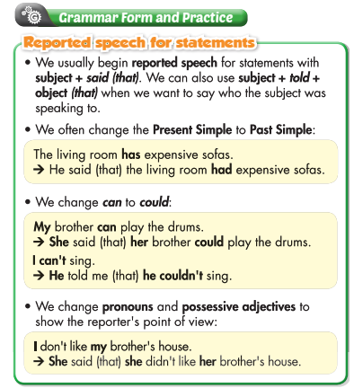  - Use some more examples to illustrate the explanation.  - Lead Ss. to the task a. and have Ss. look at the picture on page 69.  - Have Ss. fill in the blanks.  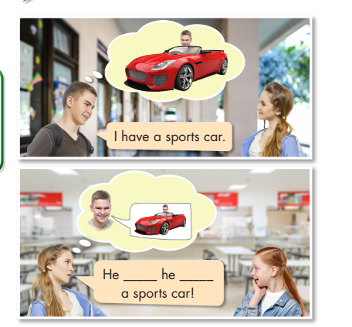  Task b. Listen and check the answers. Listen again and repeat.  - Have Ss. listen to the audio CD2 – track 21.  - Check their answers.  - Play the audio again and have Ss. listen and repeat.  - Listen and give feedback | - Observe and answer.  - Observe.  - Listen.  - Observe and answer.  - Observe.  - Observe and answer.  - Listen.  - Observe and take notes.  - Listen and take notes.  - Observe and take note.  - Observe and look at the picture on page 69.  - Fill in the blanks.  Answer.  He said he had a sports car!  - Listen.  - Listen and take notes.  - Listen and repeat.  Answer  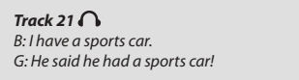
- Activity 2: Practice (15’)
a) Objective: Students can use Reported Speech for statements
b) Content: Tasks a, b; page 70
c) Expected outcomes: Students can get used to Reported Speech for statements and be able to use correctly.
d) Organization of the activity:
TEACHER’S ACTIVITIES | STUDENTS’ ACTIVITIES
Task a. Read the notes and examples on the left, then fill in the blanks.  - Remind Ss. the structure of Reported Speech of statement by writing the form on the board.  Subject + said (that) + Past Simple  Subject + told + Objective (that) + Past Simple  - Demonstrate the activity using the example from the box on the left, draw Ss. attention to the missing elements of the structure.  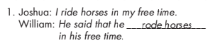  - Have Ss. fill in the blanks.  - Have pairs check each other’s work.  - Have some Ss. share their answers with class.  - Check the answers and give feedback.  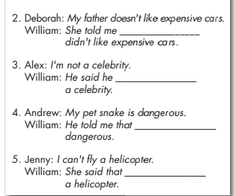  Task b. Complete the sentences to report what these people said.  - Demonstrate the activity using the first item as the example, revise Ss. Reported Speech structure.  - Have Ss. complete the sentences using reported speech  - Have pairs check each other’s answer.  - Have some Ss. share their answers with class  - Check the answers and give feedback  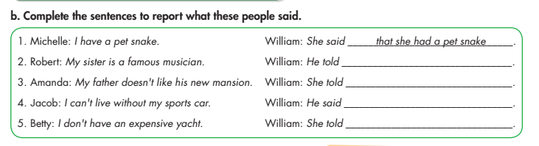 | - Listen and take note.  - Observe and take notes.  - Fill in the blanks.  - Work in pairs.  - Present.  - Listen and take note.  Answer  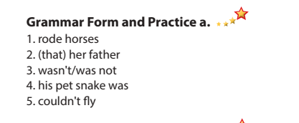  - Observe and take note.  - Complete the sentences  - Work in pairs.  - Present.  - Listen and take note.  Answer  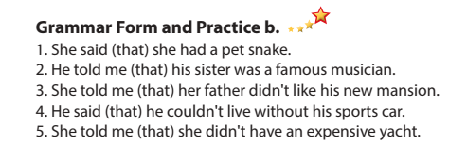
- Activity 3: Production (10’)
a) Objective: Students master the grammar point they study in the lesson.
b) Content: Tasks a, b; page 41 workbook.
c) Expected outcomes: Ss. produce the new language successfully.
d) Organization of the activity:
TEACHER’S ACTIVITIES | STUDENTS’ ACTIVITIES
Task a. Look and write the correct pronouns.  - Have some Ss. go to the board and write down the Reported Speech structure and some other Ss. write down Possessive Adjectives for he and she.  - Have Ss. read the task a carefully.  - Demonstrate the task using the first item as the example  - Have Ss. finish the task individually.  - Call some Ss read the answer.  - Check the answer and give feedback.  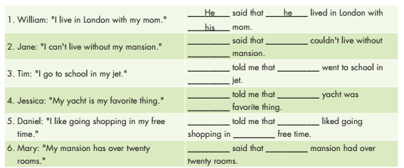  Task b. Look and tick the correct answer  - Have Ss. read the task instruction and six items carefully, ask Ss. pay attention to the new words.  - Have Ss. do the task individually.  - Call some Ss. read the answers.  - Check the answers as the whole class and give feedback.  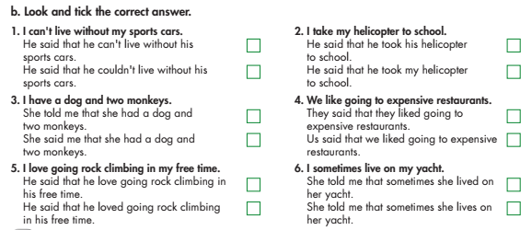 | - Write on the board or take note  - Read the task.  - Observe.  - Do the task.  - Read the answer or check the answer.  - Listen and take note  Answer  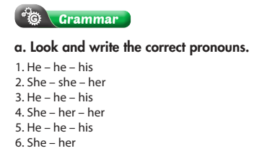  - Read.  - Do the task.  - Present.  - Listen and take note.  Answer  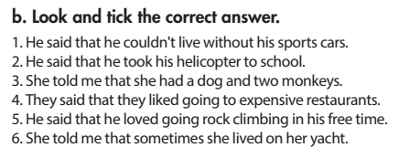

C. Consolidation. (5’)
* Consolidation: Reported Speech for statement; Pronoun, and Possessive adjective for he and she.
* Homework:
- Make 2 sentences, use Reported Speech.
- Complete the grammar notes in Tiếng Anh 8 i-Learn Smart World Notebook.
- Play consolation games in Tiếng Anh 8 i-Learn Smart World DHA App on www.eduhome.com.vn
- Prepare: Pronunciation and Speaking (pages 70 & 71 – SB).

V. REFLECTION
a. What I liked most about this lesson today:
…………………………………………………………………………………………
- What I learned from this lesson today:
…………………………………………………………………………………………
c. What I should improve for this lesson next time:
…………………………………………………………………………………………

