**TIẾNG ANH 9 FRIENDS PLUS**

**REVIEW 2 - TEST 2**

**I. Pronunciation (1-4)**

**Câu 1.** Which word has the underlined part pronounced differently from that of the others?

**A.** c**o**mputer  **B.** opp**o**rtunity  **C.** kn**o**wledge  **D.** **o**btain

**Câu 2.** Which word has the underlined part pronounced differently from that of the others?

**A.** find**s**  **B.** laugh**s**  **C.** cook**s**  **D.** help**s**

**Câu 3.** Which word has a different stress pattern from that of the others?

**A.** creature  **B.** nominate  **C.** dedication  **D.** practical

**Câu 4.** Which word has a different stress pattern from that of the others?

**A.** scientific  **B.** obligation  **C.** innovation  **D.** infrastructure

**II. Choose the answer (A, B, C or D) that best fits the space in each question. (5-14)**

**Câu 5.** Don't forget to get a _________ when you buy something. You can return the item with it later.

**A.** refusal  **B.** discount  **C.** receipt  **D.** voucher

**Câu 6.** I need to _________ this shirt for a larger size. It’s too small.

**A.** exchange  **B.** keep  **C.** stay  **D.** hold

**Câu 7.** I will have the package _________ to my house by the ExDeli tomorrow.

**A.** deliver  **B.** delivery  **C.** delivering  **D.** delivered

**Câu 8.** The sports day at school was very _________. Everyone enjoyed it.

**A.** boring  **B.** expensive  **C.** competitive  **D.** casual

**Câu 9.** The new rules will have a big _________ on students.

**A.** promotion  **B.** impact  **C.** achievement  **D.** decrease

**Câu 10.** Even though we live in different cities now, we still _________ by calling each other every week.

**A.** lose contact  **B.** stay in touch  **C.** see of  **D.** disconnect

**Câu 11.** _________ it was raining heavily, they decided to go for a walk in the park.

**A.** Despite  **B.** Because  **C.** In spite of  **D.** Although

**Câu 12.** _________ being very tired, she managed to finish all her homework before going to bed.

**A.** Despite  **B.** Although  **C.** Because  **D.** As

**Câu 13.** The train to Paris _________ at 9:00 AM every morning, and the plane to London _________ at 3:00 PM daily.

**A.** is leaving/ departs  **B.** leaves/ departs

**C.** leaves/ will depart  **D.** will leave/ will depart

**Câu 14.** How often should the windows be washed? - __________

**A.** Friday, March 3.  **B.** They are old windows.

**C.** At least twice a year.  **D.** Please pass me my glasses.

**III. Look at the signs. Choose the best answer (A, B, C or D). (15-16)**

**Câu 15.** How does Max assure Susan about the borrowed items?

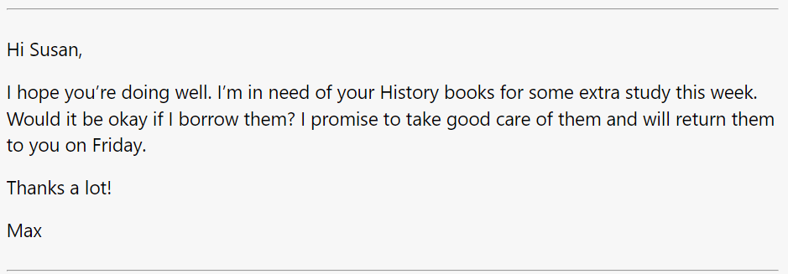

**A.** He will return them next month.  **B.** He will take good care of them.

**C.** He will replace them with new ones.  **D.** He will pay for them.

**Câu 16.** Choose the best answer for the question.

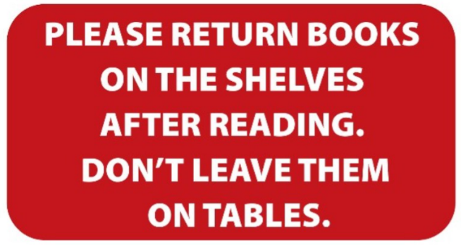

**A.** Books should be left on the tables instead of the shelves.

**B.** After you finish reading, you have to put the books back on the shelves.

**C.** You need to put the books both on the table and the shelves.

**D.** You can leave books either on the shelves or on the tables.

**IV. Read the following passage and do as direct. (17-22)**

**New Language Center Opening!**

**Exciting news! A new language center is opening in our city. This center will help people learn new languages easily. You can study English, Spanish, French, and many more. The teachers are very friendly and experienced.**

**The grand opening is this Monday at 9 AM. There will be free trial classes for the first 30 visitors. You can also talk to the teachers and learn about the courses. There are classes for all levels, from beginners to advanced learners.**

**The language center is located at 456 Maple Street, next to the library. It will be open every day from 8 AM to 8 PM. The center has modern classrooms and a nice study area. They also offer online classes if you prefer to study from home.**

**This is a great opportunity to improve your language skills. Don't miss the special discounts on the first day. Come and join us at the new language center!**

**Câu 17.** The new language center is opening this Monday at 9 AM.

**A.** True  **B.** False

**Câu 18.** The first 30 visitors will receive special discounts on their language courses.

**A.** False  **B.** True

**Câu 19.** The language center offers online classes for those who prefer to study from home.

**A.** False  **B.** True

**Câu 20.** The language center is located at 456 Elm Street, next to the library.

**A.** True  **B.** False

**Câu 21.** Which languages can you study at the new language center?

**A.** English, German, Italian  **B.** English, Spanish, French

**C.** French, German, Russian  **D.** Spanish, Chinese, Japanese

**Câu 22.** What time does the language center open every day?

**A.** 9 AM  **B.** 10 AM  **C.** 7 AM  **D.** 8 AM

**V. Choose the word (A, B, C or D) that best fits the blank space in the following passage. (23-28)**

**Hi Alice,**

**I hope you're doing great! I heard you want to ________(23) your public speaking skills, and I thought I'd share some tips that helped me.**

**________(24), practice is key. Try to speak in front of a mirror or record yourself. This can help you see your body language and hear your voice. Next, join a local club like Toastmasters. It's a great place to practice speaking in a supportive ________(25).**

**Also, prepare your speeches ________(26). Know your topic inside out and organize your thoughts clearly. Practice your speech multiple times until you feel comfortable.**

**Another tip is to focus on your audience. Make eye contact and engage ________(27) them. It makes your speech more interesting and helps you feel more confident.**

**Lastly, stay calm and breathe deeply. If you make a mistake, don't worry. Just ________(28) going.**

**I hope these tips help you. Let me know how it goes!**

**Best,**

**Nhi**

**Câu 23.** Choose the correct answer.

**A.** improves  **B.** improving  **C.** improve  **D.** improved

**Câu 24.** Choose the correct answer.

**A.** Least  **B.** Second  **C.** First  **D.** Thirdly

**Câu 25.** Choose the correct answer.

**A.** air  **B.** habitat  **C.** scene  **D.** environment

**Câu 26.** Choose the correct answer.

**A.** worse  **B.** best  **C.** good  **D.** well

**Câu 27.** Choose the correct answer.

**A.** at  **B.** for  **C.** with  **D.** to

**Câu 28.** Choose the correct answer.

**A.** save  **B.** hold  **C.** keep  **D.** retain

**VI. Supply the correct form of the word given in each sentence. (29-34)**

**Câu 29.** Be careful with that glass vase because it is very __________. (fragility)

**Câu 30.** The broken toy is now __________, so we threw it away. (value)

**Câu 31.** If a student __________ in class, the teacher will talk to their parents. (behaviour)

**Câu 32.** You don't __________ have to go if you don't want to. (necessary)

**Câu 33.** The __________ on TV last night was very funny. We admired him. (comedy)

**Câu 34.** Our __________ is very kind and always fixes things quickly. (land)

**VII. Rearrange the groups of words in a correct order to make complete sentences. (35-36)**

**Câu 35.** see / how they are / grandparents / We should visit our / doing. / this weekend to

_________________________________________________

**Câu 36.** we will stay home / If it rains / and watch movies all / tomorrow, / day.

_________________________________________________

**VIII. Rewrite each of the following sentences in another way so that it means almost the same as the sentence printed before it. (37-40)**

**Câu 37.** My written English is better than my spoken English.

I am _____________________________________________________________.

**Câu 38.** The comedy was so terrible that we didn’t want to see it again.

It _____________________________________________________________________.

**Câu 39.** I’m interested in the information about this ancient town.

I find ____________________________________________________________.

**Câu 40.** “When will you go to see this new film?”, Jack said.

Jack asked me ________________________________________________________.

**IX. Listening: listen to a dialogue and choose the correct. (41-50)**

**Câu 41.** Why is Jake upset?

**A.** He missed a class.  **B.** He lost his homework.

**C.** He didn't make it onto the basketball team.

**Câu 42.** What does Emma suggest Jake should do to cheer up?

**A.** Quit basketball  **B.** Look on the bright side

**C.** Go on a vacation

**Câu 43.** What benefit does Emma mention about not making the team?

**A.** Not having to stay late after school for practice  **B.** More free time to hang out with friends

**C.** Less homework

**Câu 44.** When does Jake plan to try out again for the basketball team?

**A.** In the summer  **B.** In the spring  **C.** In the winter

**Câu 45.** What does Emma say will be busy anyway?

**A.** The current time with school projects  **B.** The winter with holidays

**C.** The summer with family trips

**Câu 46.** Is Jake sad because he didn't make it onto the basketball team?

**A.** No  **B.** Yes

**Câu 47.** Does Emma think Jake should quit basketball?

**A.** Yes  **B.** No

**Câu 48.** Did Jake enjoy staying late after school for practice?

**A.** Yes  **B.** No

**Câu 49.** Does Jake plan to try out for the team in the autumn?

**A.** No  **B.** Yes

**Câu 50.** Does Emma believe Jake will get another chance to make the team?

**A.** No  **B.** Yes

**----HẾT---**

Mời bạn đăng ký tài khoản (chỉ 100k/ năm) tại: *Giaoandethitienganh.info*  để chủ động tự tải tài liệu khi cần!