**READING**

|  |  |  |
| --- | --- | --- |
| **1.**  **CDR_T_Test 1_A1_T25_LIS_P1_1_0** | | |
| **(A)**The boy is drawing a picture. | **(B)**The boy is taking a photo. | **(C)**The boy is talking on the phone |
| **The answer is “B”. Fill in “B” on your answer sheet.** | | |
| **2.**  **CDR_T_Test 1_A1_T25_LIS_P1_2_0**  **What does**   **the arrow show?**  **The boy with the arrow is ahead of the other boy.** | | |
| **(A)**Ahead | **(B)**Beside | **(C)**Under |
| **The answer is “A”. Fill in “A” on your answer sheet.** | | |

**3.**

****

**(A)** Apple

**(B)** Bear

**(C)** Doll

**4.**

**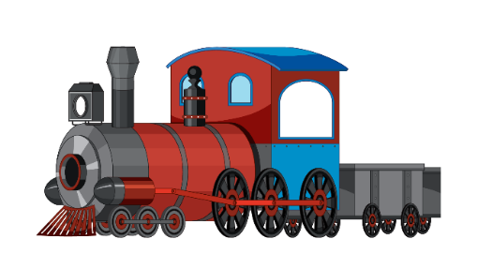**

**(A)** Car

**(B)** Bike

**(C)** Train

**5.**

**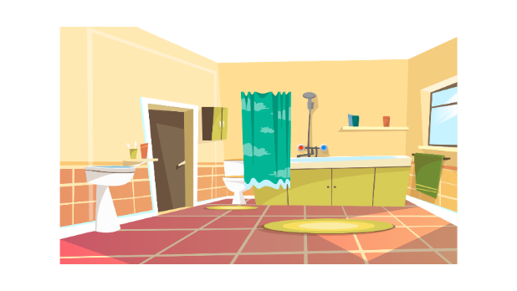**

**(A)** Bathroom

**(B)** Bedroom

**(C)** Dining room

**6.**

****

**(A)** Hospital

**(B)** Library

**(C)** Post office

**7.**

****

**(A)** sad

**(B)** happy

**(C)** tired

**8.**

****

**(A)** Star

**(B)** Moon

**(C)** Sun

**9.**

**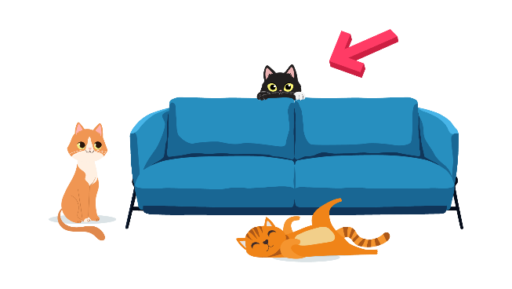**

**(A)** In front of

**(B)** Next to

**(C)** Behind

**10.**

**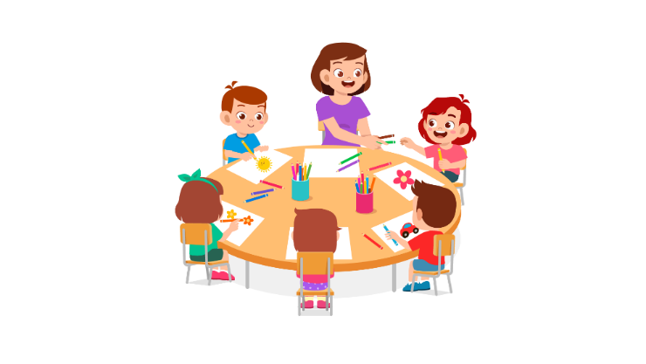**

**(A)** They are standing up.

**(B)** They are writing on the notebook.

**(C)** They are drawing pictures.

**11.**

**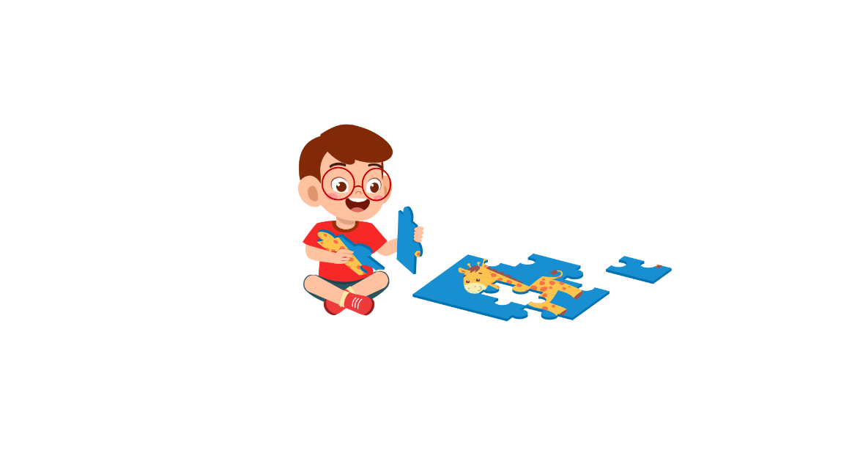**

**(A)** The boy is playing tennis.

**(B)** The boy is jumping rope.

**(C)** The boy is making a model.

**12.**

**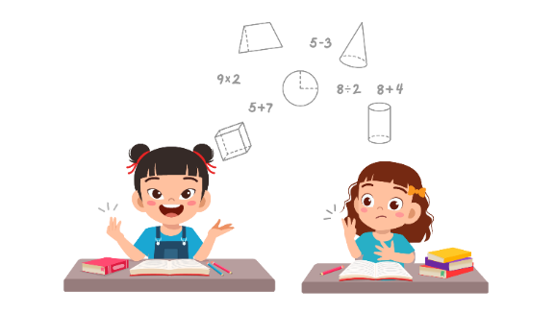**

**(A)** The girls are in the playground.

**(B)** The girls are in the I.T class.

**(C)** The girls are in the Math class.

**13. Hình ảnh các bạn đang xếp thành một hàng thẳng, tay ép sát bên người.**

**(A)** The students are lining up.

**(B)** The students are playing basketball.

**(C)** The students are waving their hands.

**14.**

**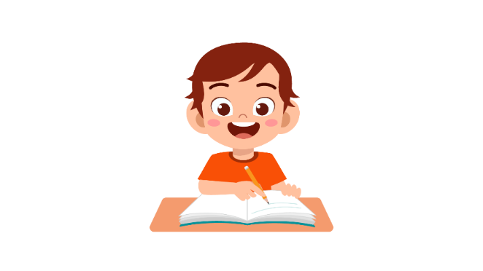**

**(A)** The boy is raising his hand.

**(B)** The boy is sitting quietly.

**(C)** The boy is taking notes.

**15.**

**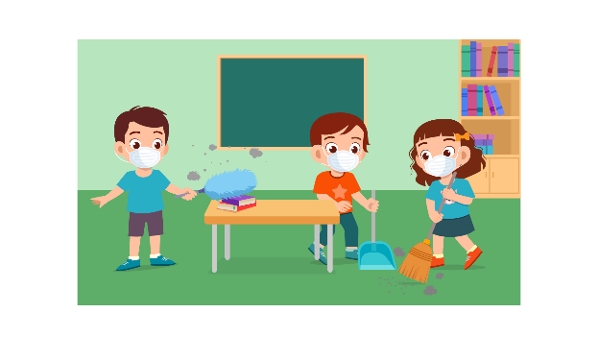**

**(A)** They are drawing pictures.

**(B)** They are cleaning the class.

**(C)** They are chatting with each other.

**16.**

**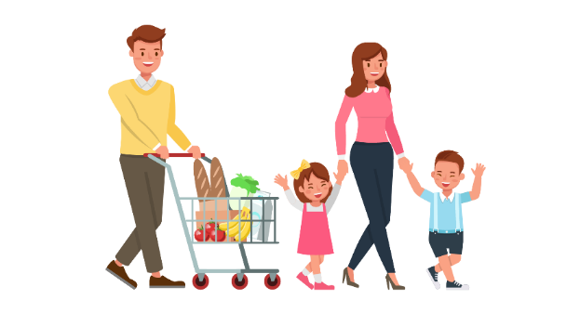**

**(A)** The family went shopping.

**(B)** The family visited the zoo.

**(C)** The family cooked dinner.

**17.**

**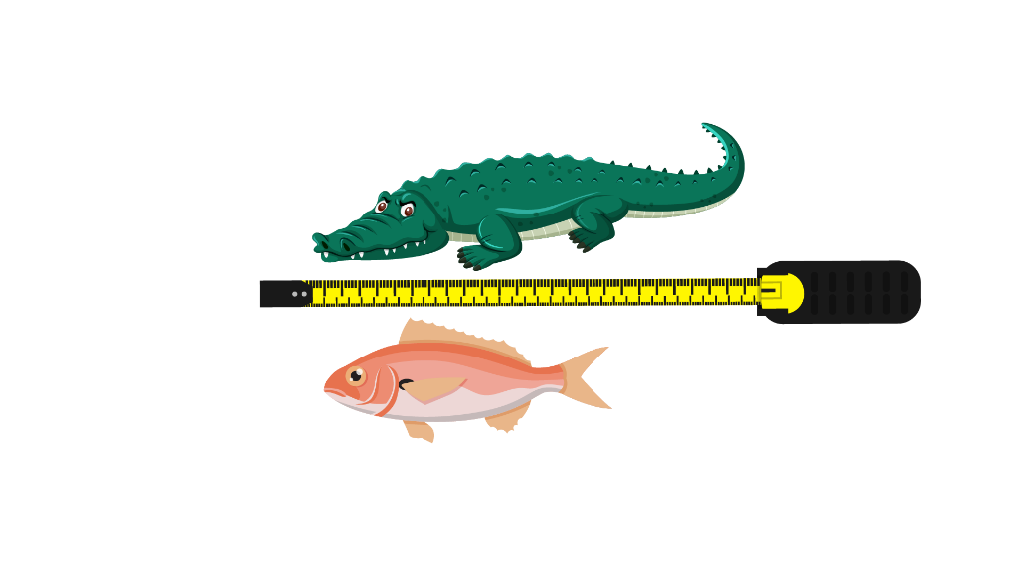**

**(A)** The crocodile is shorter than the fish.

**(B)** The fish is stronger than the crocodile.

**(C)** The crocodile is longer than the fish.

**Part 2.** **Read and find the answer.  
Fill in the correct circles on your answer sheet.**

|  |
| --- |
| **Let’s do an example.**   1. **Students go to class here. Teachers work here. It has many desks. What is it?**     1. **(A)  A house**    2. **(B)  A school**    3. **(C)  A bank**   **The correct answer is a school. Fill in "B" on your answer sheet.** |

1. **It is a big place. It has many books. It has a librarian.**

**Where is it?**

**(A)** A farm

**(B)** A factory

**(C)** A library

1. **This is a school object. You use it to create lines. It measures length.**

**What is it?**

**(A)** A pencil case

**(B)** A pencil sharpener

**(C)** A ruler

1. **This takes you from one place to another. You need tickets for it. This travels in the air.**

**(A)** A bike

**(B)** A plane

**(C)** A bus

1. **You feel sick. You can’t eat. Your mouth hurts. You have a \_\_\_\_\_\_\_\_\_.**

**(A)** fever

**(B)** toothache

**(C)** stomachache

1. **You do this when you don’t want to keep a ball. You move the ball to another place.**

**You \_\_\_\_\_\_\_\_\_ it.**

**(A)** stay

**(B)** hold

**(C)** throw

1. **You go outside and you get wet. You have an umbrella. It is \_\_\_\_\_\_\_\_\_.**

**(A)** rainy

**(B)** sunny

**(C)** snowy

1. **There are many noises. People talk a lot. It is \_\_\_\_\_\_\_\_\_\_.**

**(A)** noisy

**(B)** peaceful

**(C)** quiet

**Part 3**

**Fill in the correct circles on your answer sheet.**

**Read the menu. Answer questions 26 to 29.**

Sophie, James, Lily, Peter go to the canteen. They read this menu at the canteen.

|  |
| --- |
| **CANTEEN MENU** |

**26. Sophie wants something with soup for starter. She should buy \_\_\_\_\_\_\_\_\_\_\_\_.**

**(A)** fruit salad

**(B)** bean soup

**(C)** yoghurt

**27. James is hungry, and he wants meat. He should buy \_\_\_\_\_\_\_\_\_\_\_\_.**

**(A)** fried potato chips

**(B)** beef steak

**(C)** rice noodle soup

**28. Lily likes to use chopsticks to eat. She wants soup, too. She should buy \_\_\_\_\_\_\_\_\_\_\_\_.**

**(A)** fried potato chips

**(B)** beef steak

**(C)** rice noodle soup

**29. Peter wants some desserts. He should buy \_\_\_\_\_\_\_\_\_\_\_\_.**

**(A)** chocolate cake

**(B)** bean soup

**(C)** fruit salad

**Read the children’s extra classes timetable. Answer questions 30 to 33.**

|  |  |  |  |
| --- | --- | --- | --- |
|  | **Monday** | **Wednesday** | **Friday** |
| **John** | English | Science | Maths |
| **Mary** | Maths | English | Science |
| **Cerci** | Science | Maths | English |

**30. Which class does John have on Wednesday?**

**(A)** English

**(B)** Maths

**(C)** Science

**31. When does Mary have Science?**

**(A)** Monday

**(B)** Wednesday

**(C)** Friday

**32. Who has English class on Friday?**

**(A)** John

**(B)** Mary

**(C)** Cerci

**33. Which class does John have on Friday?**

**(A)** English

**(B)** Maths

**(C)** Science

**Read the letter. Answer questions 34 to 35.**

|  |
| --- |
| Dear Grandmother,  This is Daisy. I am writing this to tell you about my new friend – James. He just moves to my class. He is really funny and nice. The teacher asked him to sit next to me. We chatted a lot during breaktime.  Today classes were really exciting as well. We learnt to sing new songs and build paper rockets together. The classmates organized a small party to welcome James. I hope to visit you soon and tell you many things more.  Love you,  Daisy |

**34. Why does Daisy write to her grandmother?**

**(A)** To tell her about her new friend

**(B)** To talk about classes

**(C)** To visit her grandmother

**35. What does Daisy feel about the classes?**

**(A)** She feels excited.

**(B)** She feels tired.

**(C)** She feels surprised.

**Read the email. Answer questions 36 to 37.**

To: Ginny

From: Jane

Subject: My new brother

Long time no see, Ginny. This email is to inform you that my new little brother is back home now. My family loves him so much. I love him, too. He has cute black eyes with a tiny nose. He sleeps a lot. My mother tells me to be quiet so he can sleep more. I folded many paper flowers to gift him. He can’t talk yet but my mother said he would love my gifts. You can visit my house later, when you are back from your family vacation.

See you,

Jane

**36. Why does Jane write to Ginny?**

**(A)** To invite her to her house later.

**(B)** To tell her about the new little brother.

**(C)** To ask her about the gifts.

**37. What is probably true about Jane?**

**(A)** She has a new sister.

**(B)** She doesn’t love her sister.

**(C)** She is Ginny’s friend.

**Read the announcement. Answer questions 38 to 39.**

|  |
| --- |
| **THE “TINKLY” FLOWER SHOP**  **ANNOUNCEMENT**  **OUR SHOP IS CLOSED UNTIL MONDAY!**  We still sell flowers on our website: bestflowerintown.com  Contact us through the number: 999-284-732  This season’s flowers : ROSES, SUNFLOWERS, DANDELIONS |

**38. What is probably true about the flower shop?**

(A) The shop doesn’t sell flowers.

(B) The shop is closed until Monday.

(C) The shop doesn’t have a number.

**39. Which flower does the shop sell this season?**

(A) Sunflowers

(B) Lilies

(C) Tulips

*You finished the reading test.*

**LISTENING**

**Part 1**

**Listen to the words. Look at the pictures.  
Fill in the correct circles on your answer sheet.**

**Let’s do an example.**

**1.**

|  |  |  |
| --- | --- | --- |
|  |  |  |
| **A** | **B** | **C** |

**The answer is “A”. “Fill in” “A” on your answer sheet.**

**Now, you do it.**

**2.**

|  |  |  |
| --- | --- | --- |
|  |  |  |
| **A** | **B** | **C** |

**3.**

|  |  |  |
| --- | --- | --- |
|  |  |  |
| **A** | **B** | **C** |

**4.**

|  |  |  |
| --- | --- | --- |
|  |  |  |
| **A** | **B** | **C** |

**5.**

|  |  |  |
| --- | --- | --- |
|  |  |  |
| **A** | **B** | **C** |

**6.**

|  |  |  |
| --- | --- | --- |
|  |  |  |
| **A** | **B** | **C** |

**7.**

|  |  |  |
| --- | --- | --- |
|  |  |  |
| **A** | **B** | **C** |

**8.**

|  |  |  |
| --- | --- | --- |
|  |  |  |
| **A** | **B** | **C** |

**Part 2**

|  |  |  |
| --- | --- | --- |
| **9.** | | |
|  |  |  |
| **(A)** | **(B)** | **(C)** |

**10.**

|  |  |  |
| --- | --- | --- |
|  |  |  |
| **A** | **B** | **C** |

**11.**

|  |  |  |
| --- | --- | --- |
|  |  |  |
| **A** | **B** | **C** |

**12.**

|  |  |  |
| --- | --- | --- |
|  |  |  |
| **A** | **B** | **C** |

**13.**

|  |  |  |
| --- | --- | --- |
|  |  |  |
| **A** | **B** | **C** |

**14.**

|  |  |  |
| --- | --- | --- |
|  |  |  |
| **A** | **B** | **C** |

**15.**

|  |  |  |
| --- | --- | --- |
|  |  |  |
| **A** | **B** | **C** |

**16.**

|  |  |  |
| --- | --- | --- |
|  |  |  |
| **A** | **B** | **C** |

**17.**

|  |  |  |
| --- | --- | --- |
|  |  |  |
| **A** | **B** | **C** |

**Part 3**

**Fill in the correct circles on your answer sheet.**

**Look at your answer sheet. Listen to a conversation. Which conversation sounds correct?**

**Let’s do an example.**

**18.  
The answer is "C." Fill in "C" on your answer sheet.**

**Now, you do it.**

**Look at your answer sheet.**

**19.**

|  |  |  |
| --- | --- | --- |
| **(A)** | **(B)** | **(C)** |

**20.**

|  |  |  |
| --- | --- | --- |
| **(A)** | **(B)** | **(C)** |

**21.**

|  |  |  |
| --- | --- | --- |
| **(A)** | **(B)** | **(C)** |

**22.**

|  |  |  |
| --- | --- | --- |
| **(A)** | **(B)** | **(C)** |

**23.**

|  |  |  |
| --- | --- | --- |
| **(A)** | **(B)** | **(C)** |

**24.**

|  |  |  |
| --- | --- | --- |
| **(A)** | **(B)** | **(C)** |

**25.**

|  |  |  |
| --- | --- | --- |
| **(A)** | **(B)** | **(C)** |

**26.**

|  |  |  |
| --- | --- | --- |
| **(A)** | **(B)** | **(C)** |

**27.**

|  |  |  |
| --- | --- | --- |
| **(A)** | **(B)** | **(C)** |

**Part 4**

**Listen to a conversation and answer the question. Fill in the correct circle on your answer sheet.**

**Let’s do an example.  
28. When is the girl's party?**

**(A)**Tonight

**(B)**Next week

**(C)**This weekend

**The answer is "C." Fill in "C" on your answer sheet. Now, you do it.**

**29**. **Where did the girl go last weekend?**

**(A)**Water themed park

**(B)**CityMuseum

**(C)**Her uncle’s farm

**30. What do they want to buy?**

**(A)**Some apples

**(B)**Some pears

**(C)**Some oranges

**31**. **How will they go to the airport?**

**(A)**By train

**(B)**By car

**(C)**By taxi

**32**. **Who is talking to the teacher?**

**(A)**A student

**(B)**A teacher

**(C)**A nurse

**33**. **What is the girl trying to do?**

**(A)**ask to go to the birthday party

**(B)**do her homework

**(C)**have party at school

**34. What are the friends planning to do?**

**(A)**go fishing

**(B)**play badminton

**(C)**take pictures of the lake

**Part 5**

**Listen and answer the question.  
Fill in the correct circle on your answer sheet.**

**Let’s do an example.**

1. **What did Mike call about?**

(A)  Homework

(B)  A movie

(C)  A library book

**The answer is "B." Fill in "B" on your answer sheet. Now, you do it.**

**36. Why did Katherine call?**

**(A)**To tell him to return her notebooks

**(B)**To tell him to borrow books in the library

**(C)**To ask him to call her back soon

**37. Why did Helen call?**

**(A)**To talk about her friend - Alan

**(B)**To ask what to prepare for the science festival

**(C)**To ask for help with her homework

**38. Why did the neighbor call?**

**(A)**To ask a question

**(B)**To tell some news

**(C)**To explain the homework

**39. Why did the teacher call?**

**(A)**To congratulate the student’s high prize

**(B)**To speak with Lucas’ mother

**(C)**To ask Lucas about joining a competition

**40. Why did the shop assistant call?**

**(A)**To tell Duke about the new assistant

**(B)**To ask Duke to call her

**(C)**To give directions to register a member card

**41.** **Why did Tim’s father call?**

**(A)**To tell Tim to lock the door downstairs

**(B)**To ask Tim to come with him

**(C)**To advise Tim to leave the house