Full name: ……………………………………………….  Class: …………………………………………………….  School: …………………………………………………... | Mark:

SPEAKING TEST 2 (UNITS 4 – 5)

TASK 1 |  |  | Let’s talk about global warming and solutions to this problem. The following questions may help you.
 | 1. | What is global warming?
 | 2. | What are the main causes of this problem?
 | 3. | What concerns you most about global warming?
 | 4. | Which countries will be most affected by global warming? Is Viet Nam in the list?
 | 5. | What should we do to solve this problem?

TASK 2 | Work in pairs. Each of you receives a card. Use the clues on your card to make questions about your friend’s picture. Use the picture on your card to answer your friend’s questions.

CARD A
ASEAN Youth Conference
Ask your friends about his/ her picture. Listen to his/ her answers. |  | 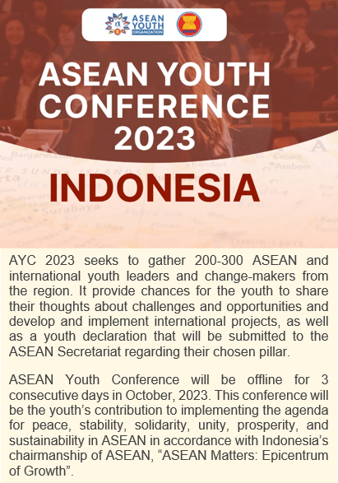
1. | What position/ leaflet/ calling for?
2. | What/ qualifications or skills/ candidates/ have?
3. | When/ programme/ start and end?
4. | Which countries/ ship/ visit?
5. | What/ common theme/ programme?
 |  | Answer your friend’s questions about this picture.

CARD B
SSEAYP’s calling for discussion facilitators
Ask your friends about his/ her picture. Listen to his/ her answers. |  | 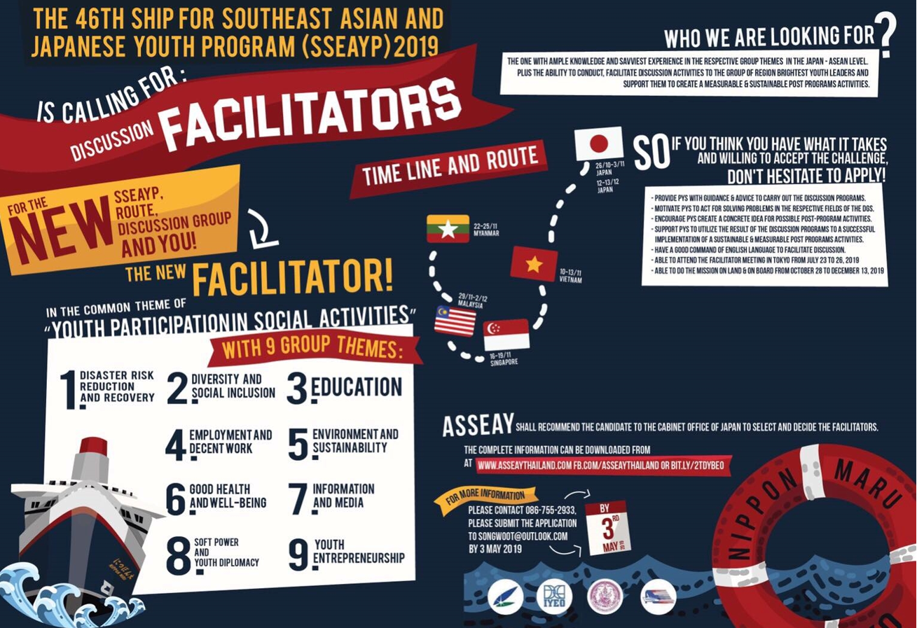
1. | Who/ main participants/ event?
2. | What/ can / do/ in the conference?
3. | When & where/ event/ take place?
4. | What/ can/ contribute?
5. | ASEAN’s events (programmes) / youth/ you know?
 |  | Answer your friend’s questions about this picture.

