UNIT 11: TRAVELLING IN THE FUTURE

Lesson 4: Communication

I. OBEJECTIVES
By the end of this lesson, Ss will be able to:
1. Knowledge
- learn how to how to make predictions.
- practise using some grammar points and vocabulary related to the topic.
2. Core competence
- Develop communication skills
- Be collaborative and supportive in pair work and team work
- Actively join in class activities
3. Personal qualities
- Be benevolent and responsible
II. PREPARATIONS
1. Teacher
- Grade 7 textbook, laptop, TV/Projector/ pictures and cards, speakers, lesson plan, sachmem.vn…
2. Students
- Grade 7 textbook, notebooks, school things….
III. TEACHING PROCEDURES
Notes
In each activity, each step will be represented as following
* Deliver the task
** Implement the task
*** Discuss
 Giving comments or feedback
ACTIVITY 1 – WARM – UP & INTRODUCTION (5’)
a) Aims:
- To revise the old lesson and introduce the new lesson.
- To lead in the lesson.
b) Contents: Chatting
c) Products: Ss’ answers
d) Teaching steps:
Teacher’s and students’ activities | Content
* Teacher checks Ss’ knowledge of the previous lessons by asking them to make sentences using The Future Simple or possessive pronouns.  ** Ss think of a sentence individually.  *** Teacher calls on some Ss to read aloud their sentences.   Teacher confirms, corrects grammar and pronunciation if needed.  - Teacher leads students into the lesson by telling what they are going to learn: “We are going to learn how to make predictions and use the grammar and the vocabulary related to our topic Travelling in the future” | Chatting  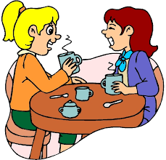
ACTIVITY 2 – PRESENTATION (10’)
a) Aims:
- To introduce to Ss how to make predictions
b) Contents:
- Teach some structures to make predictions
- Listen and read the conversation.
c) Products:
- Making predictions
- Listen and read the conversation.
d) Teaching steps:
Teacher’s and students’ activities | Content
* Teacher lets students listen to the examples in Ex. 1 in the book.  ** Teacher draws their attention to the form of ways to express disappointment.  *** Teacher and students discuss the form of ways to express disappointment, and give some other expressions.   Teacher confirms the answers and gives feedback.  * Teacher plays the record for SS to listen and read the conversation  ** Ss listen and practice saying with their partners.  *** Teacher calls some pairs to read aloud.   Teacher corrects pronunciation if needed.  * Teacher asks Ss to pay attention to the highlighted parts and asks them some questions to elicit the new structure  ** Ss answer teacher’s questions to find out new structure to express preferences.  *** Some students give the new structure to the teacher.   Teacher corrects and writes on the board | I - EVERYDAY ENGLISH  Making predictions  * Some structures to make predictions  - We certainly will/ won’t  - It probably won’t/ will  Task 1: Listen and read the conversation. (Ex 1, p. 119)  - Structure: to make predictions  - We certainly will/ won’t …  if you are sure about your predictions.  - It probably won’t/ will …  if you are not sure about your predictions.
ACTIVITY 3 – PRACTICE (20’)
a) Aims:
- To help Ss practise making predictions.
- To help Ss learn more about what information they can discover when talking about a means
of transport
– To help Ss practise asking and answering questions about a future means of transport.
b) Contents:
- Make similar conversation.
- Complete the conversation between Mark and Lan with the questions and answers from the box.
- Choose one means of transport below and make a similar conversation as in 3.
c) Products:
- Answer key
- Ss’ speakings
d) Teaching steps:
Teacher’s and students’ activities | Content
* Teacher has SS look at the situation in Ex 2 to make similar dialogue.  ** Ss work in pairs to make similar dialogue.  *** Teacher calls some pairs to present it in front of the class.   Teacher gives feedback and some comments.  * Teacher asks Ss to work in pairs to read the conversation and complete it with the questions and answers from  the box  ** Ss do the task in pairs  *** Teacher calls some Ss to give their answer and explain it.   Teacher confirms the correct answers.  * Teacher asks Ss to n pairs to ask and answer questions about which means of transport they would like to  use to travel to school. Ask them to use the example in 3. Elicit any other questions and answers they  can ask and answer about a means of transport.  ** Ss work in pairs.  *** Teacher invites some pairs to role-play, asking and answering the questions in front of the class   Teacher confirms and corrects if needed. | II – HOW WILL CHILDREN GO TO SCHOOL?  Task 2: Make similar conversation. (Ex 2, p. 119)  1. travelling long distances by hyperloop.  2. travelling to other planets for holidays.  Suggested answers:  Situation 1:  A: Do you think we will travel long distances by hyperloop?  B: We certainly / probably will.  A: Will it allow us to travel to other planets?  B: It probably / certainly won’t.  Situation 2:  A: Do you think people will travel to other planets for their holidays?  B: They certainly / probably will.  A: Will holidays on other planets be expensive / interesting?  B: They certainly will (be).  Task 3: Complete the conversation between Mark and Lan with the questions and answers from the box. (Ex 3, p, 119)  Answer key:  1. B  2. A  3. D  4. C  Task 4: Choose one means of transport below and make a similar conversation as in 3. (Ex 4, p. 119)  Suggested answer:  For the conversation about bamboo-copter, for example, T may guide Ss to ask questions:  1. So what means of transport will students use to go to school?  2. How many fans does it have?  3. How will it work?  4. What will it run on?  5. Why would you like to go to school by bamboo-copter?  – For the Solo wheel, T instructs Ss to ask similar questions.
ACTIVITY 4 – PRODUCTION (7’)
a) Aims:
- To help Ss practise talking about which means of transport they would like to use to travel to school
– To help Ss practise giving reasons
– To help Ss practise reporting.
b) Contents:
- Choose one means of transport that you would like to use to travel to school. Give reasons.
c) Products:
- Ss’ presentations
d) Teaching steps:
Teacher’s and students’ activities | Content
* Teacher asks Ss to work in group to discuss which means of transport they would like to use to travel to  school  ** Ss work in groups to take notes several means of transport for Ss to think of such as a bamboo-copter, a solowheel , a scooter or a bicycle and reasons for them to use:  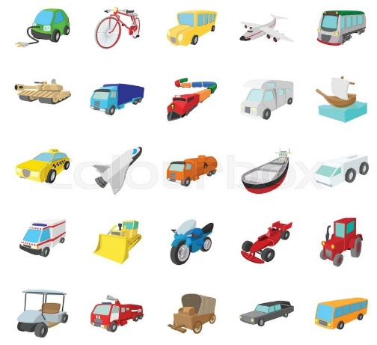  + It is safe / fast / green / fun / economical / convenient.  + It doesn’t cause noise or pollution.  + It doesn’t make fumes.  + It doesn’t pollute the environment.  - Teacher goes round the class to monitor and give support if necessary.  *** Ss from each group present their ideas to the class.   Teacher comments on their clarify, language, fluency, grammar, etc. | Task 5: Choose one means of transport that you would like to use to travel to school. Give reasons. (Ex 5, p. 119)
IV. WRAP-UP & HOMEWORK (7’)
- Teacher has Ss say what they have learnt in the lesson:
+ Vocabulary of the means of transport
+ The present simple
+ Possessive pronouns
- Teacher asks Ss to prepare the next lesson “Unit 11 – Skills 1”

V. FEEDBACK

……………………….…, ngày………….tháng…………..năm 2023
Duyệt của Tổ chuyên môn

