**LỚP HỌC THẦY (CÔ) ___________________________** **ĐỀ ÔN TẬP: READING SIGNS/ NOTICES – A2**

**Test 3**

*Thời gian làm bài: [Time]*

Họ và tên: ________________________________________________ Lớp: 9/___

**Nội dung:**

**Question 1:** What does the sign say?

**A.** Everyone can enter the area freely without needing a pass.  
**B.** You can only enter this area if you have a pass or permission.  
**C.** You do not need a pass to enter this area; it is open to all.  
**D.** Having a pass is not necessary; entry is allowed without one.

**Question 2:** What does the noticesay?

**"The dining area is closed for setup. It will be open after 1 PM"**

**A.** The dining area only opens after 1 PM.

**B.** The dining area will be closed for preparation. Please eat within 1 hour.

**C.** You can eat within 1 hour while we finish preparing.

**D.** The dining area is closed for setup and will open after 1 PM.

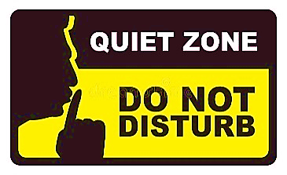**Question 3:** What does the sign say?

**A.** You can make noise and talk loudly in this area**.**  
**B.** This area is for quiet and no loud noises are allowed**.**  
**C.** Making noise is encouraged and allowed in this area**.**  
**D.** The area is not watched, so noise is not controlled**.**

**Question 4:** What does the notice say?

**"The garden is closed for planting.  Will be open to visitors next week"**

**A.** You can visit the garden any day, not just next week.

**B.** The garden is open for planting and visitors are allowed in now.

**C.** The garden is always open and is not closed for planting.

**D.** The garden will be open after planting is completed**.**

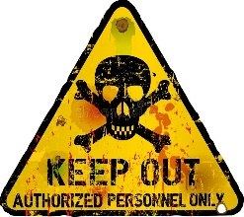**Question 5:** What does the sign say?

**A.** You are allowed to go into this area anytime you want.  
**B.** You should stay away and not enter this area**.**  
**C.** This area is used for special events or activities.  
**D.** You are allowed to enter only if you have a special pass or permission.

**Question 6:** What does the notice say?

**"Please remember to keep your receipt.**

**The staff may ask to see your receipt if you want to exchange the item."**

**A.** You need to bring your receipt. The staff may ask to see the receipt.

**B.** The staff will give you a new receipt if you need to exchange the item.

**C.** No receipt is required when shopping.

**D.** When exchanging the item, the staff will ask to check the receipt again.

**Question 7:** What does the sign say?

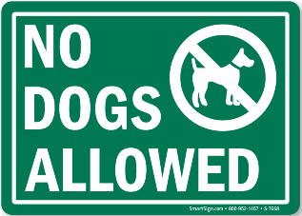**A.** Dogs are welcome everywhere and can go anywhere.  
**B.** Dogs are not allowed to enter or be in this area**.**  
**C.** You may bring dogs here if they are on a leash.  
**D.** Only small dogs are allowed in this area**.**

**Question 8:** What does the notice say?

**"Please recycle paper and plastic in the bins provided**

**."**

**A.** Throw paper and plastic in any trash can.

**B.** You should recycle paper and plastic in special bins.

**C.** Do not recycle paper and plastic**.**

**D.** Use the recycling bins only for glass.

**Question 9:** What does the sign say?

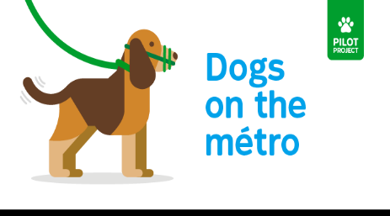**A.** Dogs are allowed to roam without any rules.  
**B.** Dogs must wear muzzles while they are in this area**.**  
**C.** Only some dogs need to wear muzzles here.  
**D.** Dogs do not need to wear muzzles in this area**.**

**Question 10:** What does the notice say?

**"Please clean up the kitchen after using it. Throw away any leftover food and wash your dishes.**

**This helps keep the kitchen clean for everyone."**

**A.** Just throw away leftovers in the trash.

**B.** Throw away leftover food and wash dishes immediately.

**C.** Only clean up if you make a mess.

**D.** You don’t need to clean up if you’re in a hurry.

**[HẾT]**