Họ và tên: ....................................................  Lớp: ............................................................. | PHIẾU GHI BÀI CHUYÊN ĐỀ HÓA HỌC 11  Bài 1: GIỚI THIỆU CHUNG VỀ PHÂN BÓN
MỞ ĐẦU
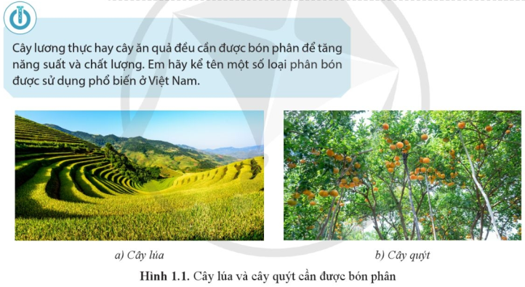
..........................................................................................................................................................................
..........................................................................................................................................................................

I. KHÁI NIỆM VÀ PHÂN LOẠI PHÂN BÓN
1) Khái niệm phân bón
..........................................................................................................................................................................
..........................................................................................................................................................................
..........................................................................................................................................................................
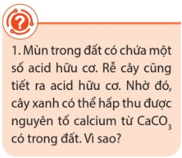 | ..................................................................................................................  ..................................................................................................................  ..................................................................................................................  ..................................................................................................................  ..................................................................................................................  ..................................................................................................................

2) Phân loại phân bón
...................................................................................................................  ...................................................................................................................  ...................................................................................................................  ...................................................................................................................  ...................................................................................................................  ...................................................................................................................  ...................................................................................................................  ...................................................................................................................  ...................................................................................................................  ...................................................................................................................  ...................................................................................................................  ...................................................................................................................  ...................................................................................................................  ................................................................................................................... | 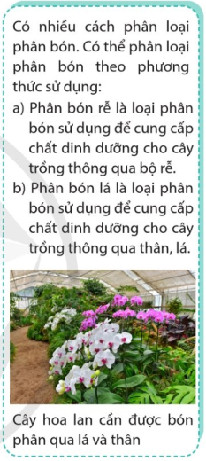
II. MỖI LIÊN HỆ GIỮA PHÂN BÓN = CÂY TRỒNG - ĐẤT
...................................................................................................................  ...................................................................................................................  ...................................................................................................................  ...................................................................................................................  ...................................................................................................................  ...................................................................................................................  ...................................................................................................................  ...................................................................................................................  ................................................................................................................... |  | 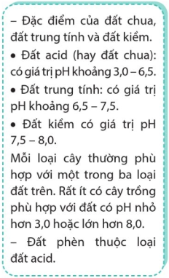
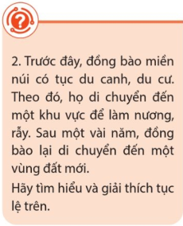 | ..................................................................................................................  ..................................................................................................................  ..................................................................................................................  ..................................................................................................................  ..................................................................................................................  ..................................................................................................................  ..................................................................................................................
III. MỘT SỐ PHÂN BÓN PHỔ BIẾN Ở VIỆT NAM
..........................................................................................................................................................................
..........................................................................................................................................................................
..........................................................................................................................................................................
..........................................................................................................................................................................
..........................................................................................................................................................................
..........................................................................................................................................................................
..........................................................................................................................................................................
..........................................................................................................................................................................
..........................................................................................................................................................................
..........................................................................................................................................................................
..........................................................................................................................................................................
..........................................................................................................................................................................
..........................................................................................................................................................................
..........................................................................................................................................................................
..........................................................................................................................................................................
..........................................................................................................................................................................
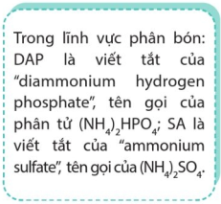 | 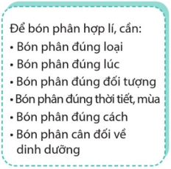 | 




