UNIT 12: ROBOTS

Lesson 1: Getting started –
At an International Robot Show

  - I. Objectives
By the end of this lesson, students will be able to:

1. Knowledge
- Use the lexical items related to the topic robots and daily activities
- Use the vocabulary and structures to talk about what a robot can do

2. Core competence
- Develop communication skills and creativity
- Be collaborative and supportive in pair work and team work
- Actively join in class activities

3. Personal qualities
- Develop self-study skills

II. Materials
- Grade 6 textbook, Unit 12, Getting started
- Computer connected to the Internet
- Projector/ TV/ pictures and cards
- hoclieu.vn

  - Language analysis
Form | Meaning | Pronunciation | Vietnamese equivalent
1. robot (n) | a machine that is made to look like a human and that can do some things that a human can do | /ˈrəʊbɒt/ | người máy
2. do the dishes (vph) | to wash plates, glasses, bowls, etc. with soap and water after a meal. | /duː ðə dɪʃiz/ | rửa bát
3. iron (v) | ​to make clothes, etc. smooth by using an iron | /ˈaɪən/ | là (ủi) quần áo
4. useful (adj) | ​that can help you to do or achieve what you want | /ˈjuːsfl/ | có ích, có tác dụng tốt
5. put st away (vph) | ​to put something in the place where it is kept because you have finished using it | /pʊt əˈweɪ/ | bỏ đi, đổ đi
6. repair (v) | to fix something that is damaged | /rɪˈpeə(r)/ | sửa chữa
7. broken (adj) | no longer whole or working correctly | /ˈbrəʊkən/ | bị hỏng

Anticipated difficulties | Solutions
1. Students may be lack of knowledge and experiences about the topic. | Prepare some handouts in which the key language is presented.
2. Students may have underdeveloped listening, speaking and co-operating skills. | - Play the recording many times if any necessary.  - Encourage students to work in pairs, in groups so that they can help each other.  - Provide feedback and help if necessary.

  - Board Plan

Date of teaching

Unit 12: Robots

Lesson 1: Getting started

*Warm-up

Guessing word
I. Vocabulary:
1. robot (n)
2. do the dishes (vph)
3. iron (v)
4. useful (adj)
5. put sth away (vph)
6. repair (v)
7. broken (adj)
II. Getting started:
Task 1: Listen and read. (p. 58)
Task 2: Complete the sentences, using the adjectives in the box. (p. 59)
Task 3: Read the conversation again and tick T (True) or F (False). (p. 59)
Task 4: Match the activities with the pictures. (p. 59)
Task 5: Game – Miming
*Homework

Procedure

Stage | Stage aim | Procedure | Interaction | Time
Warm-up | - To introduce the topic.  - To enhance students’ skills of cooperating with team mates. | * Guessing word:  - Teacher divides the class into two big groups.  - Teacher draws a 6-letter word puzzle on the board.  - Each group will take turns guessing a letter in the puzzle and get 10 points for a correct  letter.  - The group finding out the correct word before all letters are written will get 50 points.  - The group with more points will be the  winner.  Suggested answer:  R O B O T S | T-Ss | 5 mins
Lead-in | To lead in the topic of the unit. | - Teacher asks student to open the textbook and draws students’ attention to the title of the conversation and the picture in the textbook and asks them questions like:  1. Where are Nick, Phong and Dr Adams?  2. What are they talking about?  3. Have you ever been to a show before?  Suggested answers:  1. They are at a robot show.  2. They are talking about robots.  3. Yes, I have been to a motor show. / No, I  haven’t. But I want to be at a show in the future. | T-Ss | 2 mins
Presentation  (Vocab-  pre-teach) | - To introduce the vocabulary appearing in the text.  - To help students well-prepared for the listening and reading tasks. | VOCABULARY  Teacher introduces the vocabulary by:  - providing the pronunciation of the words  - providing the definition or picture of the words  1. robot (n): [picture]  2. do the dishes (vph): [picture]  3. iron (v): [picture]  4. useful (adj) that can help you to do or achieve what you want  5. put sth away (vph) to put something in the place where it is kept because you have finished using it  6. repair (v) to fix something that is damaged  7. broken (adj): [picture]  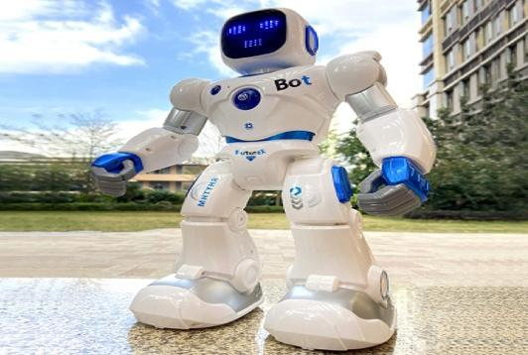  robot  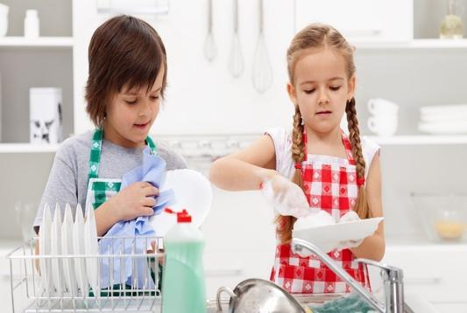  do the dishes  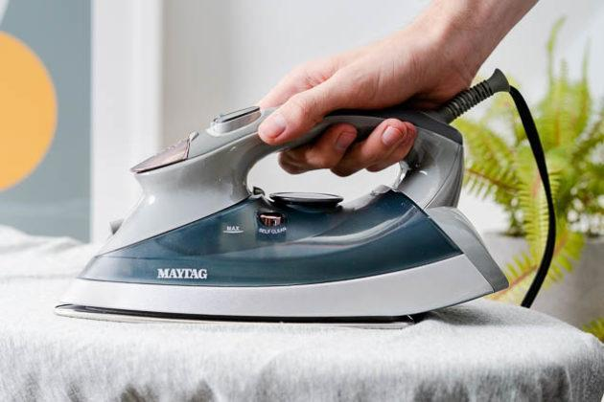  iron  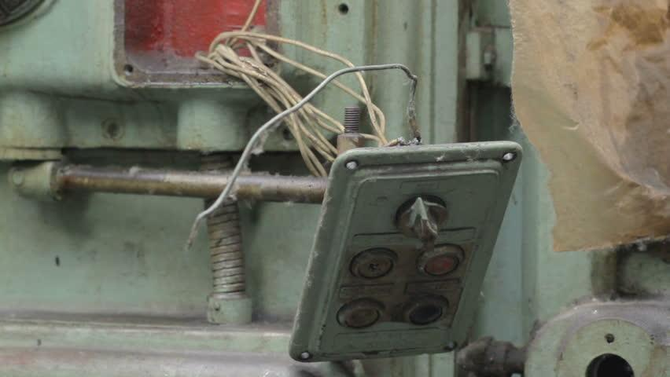  broken | T-Ss | 5 mins
Practice | To practice the  targeted language and the background knowledge of the topic Robots.  To help students understand the text.  To help students further understand the text.  To develop students’ knowledge of the  vocabulary about daily activities. | Task 1: Listen and read. (p. 58)  - Teacher plays the recording, asks students to underline the words that are related to the topic of the unit while they are listening and reading.  - Teacher can play the recording more than once.  - Students listen and read.  - Teacher invites some pairs of students to read the dialogue aloud.  Task 2: Complete the sentences, using the adjectives in the box. (p. 59)  - Teacher asks students to work independently to fill each blank with the adjective in the box from the conversation.  - Teachers may instruct them how to do the  exercise and model with the first sentence:  1. Read the sentence with the blank and try to work out the meaning of the whole sentence  2. Find the adjective in the box that can fit the blank meaningfully.  - Teacher asks students to share their answers before discussing as a class.  - Teacher checks their answers as a class.  Answer key:  - useful  - fast  - strong  - smart  - heavy  Task 3: Read the conversation again and tick T (True) or F (False). (p. 59)  - Teacher has students look at the statements in this activity and tells them how to do it by telling them the strategies to do the exercise:  1. Read the statement  2. Underline the key words  3. Read the text and pay attention to the key words  4. Decide if each sentence is true or false  - Teacher sets the time limit.  - Students work independently.  - Teacher allows students to share their answers before discussing as a class.  - Teacher invites some pairs to give their  answers and confirms the correct ones. Teacher may ask students to correct the false sentences.  Answer key:  1. T 2. F 3. T 4. F 5. T  Task 4: Match the activities with the pictures. (p. 59)  - Teacher has students quickly match each  activity with the picture in pairs  - Teacher asks some students to read out their answers and write the answers on the board.  - Teacher checks as a class.  - With weaker classes, teacher can ask for translation of the activities to make sure they understand. With stronger class, teacher may ask some additional questions, e.g. Can you iron clothes/make meals…? Who often makes meals in your family?  Answer key:  1. b 2. c 3. e 4. d 5. f 6. a | T-Ss  Ss  Ss-Ss  T-Ss  T-Ss  Ss-Ss  T-Ss  Ss-Ss  T- Ss  Ss  T-Ss  T-Ss | 25 mins
Production | To help students pratise saying phrases of human daily activities which are introduced in Task 4. | Task 5: Game – Miming  - Teacher asks students to work in group of 4.  - Teacher asks a more able student to help and demonstrates the game to the class first.  ● Choose an activity in task 4.  ● Act it out and ask the question: What am I  doing?  ● Other students respond: You’re doing the dishes.  ● Respond: Yes, that’s right. / No, try again.  - Students take turns to act and guess. | Ss-Ss | 5 mins
Wrap-up | To consolidate what  students have learnt in the lesson. | Teacher asks students to talk about what they have learnt in the lesson. | T-Ss | 2 mins
Homework | To revise what they have learnt in the  lesson. | Write about 5 sentences to describe what a robot can do. | T-Ss | 1 min

UNIT 12: ROBOTS

Lesson 2: A closer look 1
  - I. Objectives
By the end of this lesson, students will be able to:

1. Knowledge
- use the lexical items related to the topic Robots;
- use the vocabulary and structures to talk about what a robot can and cannot do;
- pronounce and recognize the falling tone in statements.

2. Core competence:
- Be collaborative and supportive in pair work and team work
- Access and consolidate information from a variety of sources
- Actively join in class activities

3. Personal qualities
- Develop self-study skills

II. Materials
- Grade 6 textbook, Unit 12, A closer look 1
- Computer connected to the Internet
- Projector/ TV/ pictures and cards
- hoclieu.vn

III. Language analysis

Form | Meaning | Pronunciation | Vietnamese equivalent
1. understand (v) | to know or realize the meaning of words, what somebody says, etc. | /ˌʌndərˈstænd/ | hiểu
2. pick (v) | to take flowers, fruit, etc. from the plant or the tree where they are growing. | /pɪk/ | nhặt, ngắt
3. water (v) | to pour water on plants, etc. | /ˈwɔːtər/ | tưới nước
4. guard (n) | a person, such as a soldier, a police officer or a prison officer, who protects a place or people. | /ɡɑːrd/ | canh giữ
5. delicious (adj) | ​given or made when people are watching, not recorded | /dɪˈlɪʃəs/ | ngon
6. helpful (adj) | able to improve a particular situation | /ˈhelpfl/ | hay giúp đỡ

Anticipated difficulties | Solutions
1. Students may lack knowledge about some lexical items. | Provide students with the meaning and pronunciation of some lexical items.
2. Students may have underdeveloped listening,  speaking and co-operating skills. | - Play the recording many times if any necessary.  - Encourage students to work in pairs, in groups so that they can help each other.  - Provide feedback and help if necessary.
3. Some students will excessively talk in the class. | - Define expectations in explicit detail.  - Have excessive talking students practise.  - Continue to define expectations in small chunks (before every activity).

  - Board Plan

Date of teaching

Unit 12: Robots

Lesson 2: A closer look 1

*Warm-up

Matching

I. Vocabulary
1. understand (v)
2. pick (v)
3. water (v)
4. guard (n)
5. delicious (adj)
6. helpful (adj)
Task 1: Match the verbs in column A to the words or phrases in column B.
(p. 60)
Task 2: Work in pairs. Tell your partner the activities in Task 1 you can or can’t do. (p. 60)
Task 3: Work in pairs. Read, ask and answer questions. (p. 60)
II. Pronunciation
Task 4: Listen and repeat the sentences. (p. 60)
III. Production
Task 5: Listen and practice saying the statements in the paragraph. (p. 60)
*Homework

Procedure
Stage | Stage aim | Procedure | Interaction | Time
Warm-up | - To activate students’ prior knowledge and  vocabulary related to the topic.  - To enhance students’ skills of cooperating with team mates. | * Matching:  - Teacher divides students into 4 groups and delivers a set of 6 pictures about daily  activities.  - Teacher asks students to work in groups and match the names of daily activity with  suitable pictures.  - The fastest group will say “Bingo” and stick their work on board.  - Teacher checks the answers, asks the class to read out loud the activities and gives a small gift to the winning group.  * SET OF PICTURES:    make meals  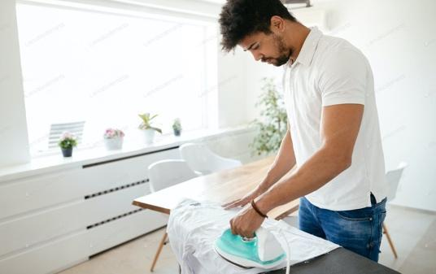  iron clothes  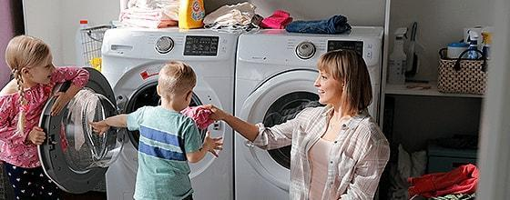  do the washing  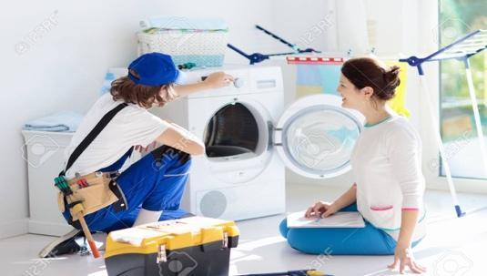  repair a broken machine  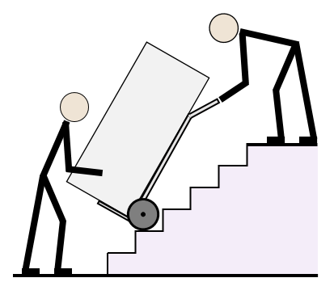  move heavy things  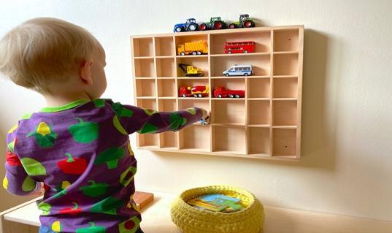  put toys away | Group work  T-Ss  Ss-Ss | 5 mins
Lead-in | - To lead in the lesson about vocabulary and  pronunciation. | - Teacher leads students into the lesson by  telling them that “In today's lesson, we are going to learn more words to describe what a robot can do and the falling tone in statements.” | T-Ss | 2 mins
Presentation  (Vocab-  pre-teach) | To teach students some more words related to the topic. | VOCABULARY  Teacher introduces the vocabulary by:  - providing the definition of the words.  - providing the synonyms of the words.  - providing the pictures of the words.  1. understand (v) to know or realize the meaning of words, what somebody says, etc.  2. pick (v): [picture]  3. water (v): [picture]  4. guard (n): [picture]  5. delicious (adj) –  [synonym]: yummy/tasty  6. helpful (adj) –  [synonym]: useful  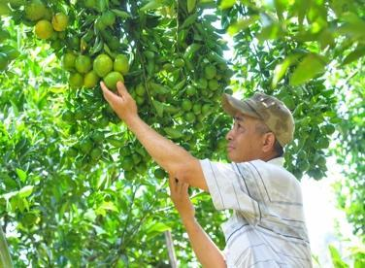  pick    water    guard | T-Ss | 5 mins
Practice | To revise/ teach the names of other human daily activities.  To help students practice telling about people’s abilities, using the modal can/can’t and the phrases they have learnt in Task 1.  To give students  further practice on asking and answering about abilities, using the modal can and daily activities. | Task 1: Match the verbs in column A to the words or phrases in column B. (p. 60)  - Teacher has students quickly match the verbs in column A to the words/phrases in  column B individually. Explain the words/ phrases if necessary.  - Teacher plays the recording for students to check their answers. Pause the recording  after each phrase and ask them to repeat chorally and correct their pronunciation if necessary.  Answer key:  1. c 2. a 3.b  4. e 5. d  Task 2: Work in pairs. Tell your partner the activities in 1 you can or can’t do. (p. 60)  - Teacher helps students remember the use of can to talk about ability in the present and have some students give examples.  - Students work in pairs do the same sharing.  - Teacher may go around to help weaker students.  - Teacher calls some pairs to share their  answers with the whole class.  - Teacher gives feedback and corrections (if  necessary).  Examples:  1. I can do the washing but I can’t work as a guard.  2. I can water plants but I can’t understand your feelings.  Task 3: Work in pairs. Read, ask and answer questions. (p. 60)  - Teacher models the activity with a more able student. Remind students that they only use the information from the table to ask and answer about what the robot V10 can or can’t do.  - Students work in pairs, ask and answer about what the robot V10 can or can’t do.  - Teacher calls some pairs to practice in front of the class and gives feedback.  Model answer:  A: Can V10 do the  washing?  B: Yes, it can.  A: Can V10 repair a  broken machine?  B: No, it can’t. | T-Ss  T-Ss  T-Ss  Pair work  T-Ss  T-Ss  Pair work  T-Ss | 15 mins
Presentation  (Pre-teach the falling tone in statements.) | To help students  indentify how to say  statements with corrects tone. | PRONUNCIATION  - Teacher briefly explains to the student that we use falling tones at the end of a statement.  - Teacher provides an example of a statement and models the falling tone of the statement.  - Teachers ask students to provide some more examples ofstatements.  Suggested answer:  1. We go to school every morning.  2. I can do the washing.  3. My father repairs a broken machine. | T- Ss | 5 mins
Practice | To help students  identify how to say  statements in the correct tone. | Task 4: Listen and repeat the sentences. (p. 60)  - Teacher plays the recording and asks  students to listen and repeat the statements. Remind students of the falling tone.  - Teacher ask some students to read out the statements and invite comments from other students. | T-Ss | 5 mins
Production | To give students a chance to apply what they have learnt. | Task 5: Listen and practice saying the statements in the paragraph. (p. 60)  - Teacher has students say the statement in the paragraph on pairs: one reads out the statements and the other gives comments.  - Teacher plays the recording for students to listen and compare with how their partners have pronounced.  - Teacher asks some students to perform in front of the class.  - Other students give comments  - Teacher gives more comments if needed. | Pair work  Ss-Ss | 5 mins
Wrap-up | To consolidate what students have learnt in the lesson. | Teacher asks students to talk about what they have learnt in the lesson. | T-Ss | 2 mins
Homework | To revise what they have learnt. | Write a text to describe V10 using the sample in Exercise 5 and information in Exercise 3. | T-Ss | 1 min

UNIT 12: ROBOTS

Lesson 3: A closer look 2

  - I. Objectives
By the end of this lesson, students will be able to:

1. Knowledge
- Use superlative adjectives: short adjectives correctly.

2. Core competence
- Develop communication skills
- Be collaborative and supportive in pair work and team work
- Actively join in class activities

3. Personal qualities
- Develop self-study skills

II. Materials
- Grade 6 textbook, Unit 12, A closer look 2
- Computer connected to the Internet
- Projector/ TV/ pictures and cards
- hoclieu.vn

  - III. Language analysis
Form | Meaning | Example
The + short adj + est | Superlative adjectives to compare three or more people or things. | This is the smartest robot I have ever met.

Anticipated difficulties | Solutions
1. Students may lack knowledge and experiences about the target grammatical points. | Prepare some hand-outs in which key grammatical points are presented.
2. Some students will excessively talk in the class. | - Define expectations in explicit detail.  - Have excessive talking students practise.  - Continue to define expectations in small chunks (before every activity).

  - Board Plan

Date of teaching

Unit 12: Robots

Lesson 3: A closer look 2
*Warm-up

Sentence racing
I. Grammar focus
Superlative adjectives: short adjectives
Form:
The + short adj + est

Task 1: Write the superlative form of the adjectives in the table. (p. 61)
II. Practice
Task 2 + 3: Complete the sentences with comparative or superlative form of the adjectives. (p. 61 + 62)
Task 4: Work in pairs. Look at the information of three robots: M10, H9 and A3 and talk about each of them, using superlative adjectives. (p. 62)
III. Production
Game: Find someone who…
*Homework

Procedure
Stage | Stage aim | Procedure | Interaction | Time
Warm-up | - To activate and  anticipate students’ knowledge of superlative adjectives.  - To enhance students’ skills of cooperating with team mates. | * Game: Sentence racing.  - Teacher divides the class into 4 groups.  - Teacher delivers a set of word cards which contains superlative adjectives of short adjectives to each group.  - Teacher models a sentence first. (e.g. Minh is the tallest in my class.)  - Students will have to work in groups to create as many correct sentences from the word cards as possible.  - The group with more correct sentences will be the winner.  Set of words:  1. the tallest  2. the shortest  3. the biggest  4. the smallest | Group work | 5 mins
Lead-in | To introduce target grammar of superlative adjectives: short adjectives. | Teacher draws students’ attention to superlative adjectives in the sentence they have made and leads in the lesson. | T-Ss | 2 mins
Presentation | To introduce the superlative of short adjectives.  To help students practice forming the correct form of superlative adjectives. | 1. Superlative adjectives: short adjectives:  - Teacher briefly explains the form and use of  superlative adjectives:  * Form:  The + short adj + est  * Use: Superlative adjectives are used to compare more than three people or things, expressing the highest degree.  - Teacher notices the way to construct the superlative of short adjectives in English:  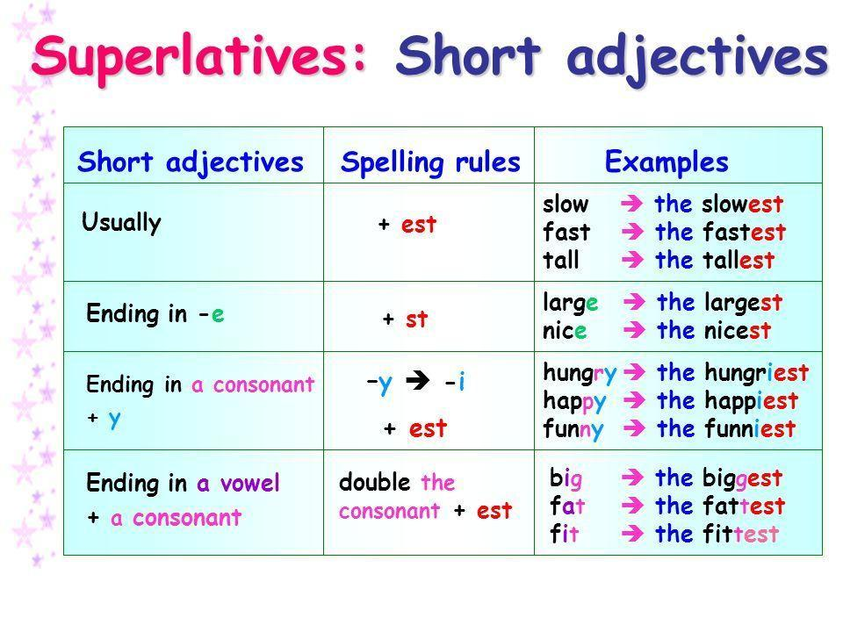  Task 1: Write the superlative form of the adjectives in the table.  (p. 61)  - Teacher asks students to read the instruction and tells them what they should do. (With a weaker class, do the first word as an example).  - Teacher asks students to do the exercise individually and then compare their answers with a classmate.  - Teacher checks the answers as a class.  Answer key:  Adjectives Superlative form  fast fastest  tall tallest  noisy noisiest  nice nicest  hot hottest  light lightest  quiet quietest  heavy heaviest  large largest | T-Ss  T- Ss  Ss  T-Ss | 10 mins
Practice | To help students practice the superlative of adjectives and revise the comparative of adjectives.  To give students further  practice on using  superlative adjectives. | Task 2 + 3: Complete the sentences with comparative or superlative form of the adjectives. (p. 61, 62)  - Teacher uses questions in Exercise 2 + 3 (p. 61, 62) to create questions in the Quizizz game.  - Teacher allows students to use their mobile devices to answer and interact with the questions online.  - Teacher gives clear instructions for students to fully understand how to play Quizizz quiz online.  → Go to joinmyquiz.com  → Enter the game CODE  → Type your name  → Use and, but and so to complete each sentence appearing on the screen  → See who will be the winner  - Teacher provides the game CODE and allows students’ access to the game.  - Students type the word and, but or so to complete each sentence appearing on the screen  - Teacher gives compliments or good marks to the winner of the game.  * Questions in the game:  1. Bonbon can move 10 tons; it’s the (strong) _________ of all.  2. This robot can understand all of what we say. It’s the (smart) __________ in the robot show.  3. He is the (tall) ____________ in our class; he is about 1.8m tall.  4. This is the (small) ___________ of all home robots; we can put it in our bag.  5. This robot is only 200 dollars. It’s the (cheap) ____________ in our shop.  6. My brother has a (tidy) ____________ room than me.  7. The (hot) _____________ desert of all is Sahara and it’s in Africa.  8. Travelling by plane is (fast) ____________ than going by car.  9. Who is the (tall) _____________ in your family?  10. I think dogs are (smart) _____________ than cats.  Answer key:  1. strongest  2. smartest  3. tallest  4. smallest  5. cheapest  6. tidier  7. hottest  8. faster  9. tallest  10. smartest  Task 4: Work in pairs. Look at the information of three robots: M10, H9 and A3 and talk about each of them,  using superlative adjectives. (p. 62)  - Teacher asks students to look at the information in exercise 4 and explains what they have to do.  - Teacher models the activity with a more able student and reminds students that they only use the information from the table to describe the three robots using superlative adjectives.  - Teacher may explain the meaning of the words age, weight, height, price and asks students to elicit the adjectives they can use to describe each row.  - Students work in pairs to say sentences comparing three robots.  - Teacher moves around to offer help if needed.  - Teacher calls some pairs to perform in front of the class.  MODEL DISCUSSION:  A: A3 is the tallest of the three robots.  B: M10 is the youngest of the three robots.  A: A3 is the heaviest of the three robots.  B: H9 is the cheapest of the three robots. | T-Ss  Ss  T-Ss  T-Ss  Pair work | 15 mins
Production | To give students a chance to use the  superlative of short  adjectives in real life  context. | * Game: Find someone who…  - First, teacher models the game Find someone who… with a more able student.  - Teacher has students work in pairs ask and answer questions to find out the student who is the shortest/ tallest/ smartest, ect. in the class.  - Teacher moves around and offers help if needed.  - Teacher calls some pairs to report their findings.  * MODELLING  A: Who is the tallest in our class?  B: Khoi is the tallest in our class.  …    Report:  In our class, Khoi is the  tallest… | Pair work | 10 mins
Wrap-up | To consolidate what  students have learnt in the lesson. | Teacher asks students to talk about what they have learnt in the lesson. | T-Ss | 2 mins
Homework | Reactivate the knowledge that students have gained in the lesson. | Write the answers of exercise 2 and 3 on your notebooks. | T-Ss | 1 min

UNIT 12: ROBOTS

Lesson 4: Communication

  - I. Objectives
By the end of this lesson, students will be able to:

1. Knowledge
- Express agreement and disagreement
- Talk about what a robot can do

2. Core competence
- Develop creativity and communication skills
- Be collaborative and supportive in pair work and team work
- Actively join in class activities

3. Personal qualities
- Develop self-study skills

II. Materials
- Grade 6 textbook, Unit 12, Communication
- Computer connected to the Internet
- Projector/ TV/ pictures and cards
- hoclieu.vn

Language analysis

Anticipated difficulties | Solutions
1. Students may lack knowledge about how to express agreement and disagreement in English; | Provide students with more structures to express agreement and disagreement.
2. Students may have underdeveloped speaking and  co-operating skills. | - Encourage students to work in pairs, in groups so that they can help each other.  - Provide feedback and help if necessary.
3. Some students will excessively talk in the class. | - Define expectations in explicit detail.  Have excessive talking students practise.  - Continue to define expectations in small chunks (before every activity).

  - Board Plan

Date of teaching

Unit 12: Robots

Lesson 4: Communication

*Warm-up

Spider web:

A ROBOT CAN

do the dishes

...

work as a guard

water plants

iron clothes

I. Everyday English:

*Expressing agreement and disagreement
Task 1: Listen and read the dialogues. Pay attention to the highlighted sentences. (p. 63)
Task 2: Work in pairs. Express your opinions about the statements. (p. 63)
II. My robot’s abilities:
Task 3: Listen to the radio programme from 4Teen News. Fill the blanks with the words you hear. (p. 63)
Task 4: Interview three friends about what abilities they want their robots to have. (p. 63)
Task 5: Report the findings (p. 63)
*Homework

Procedure
Stage | Stage aim | Procedure | Interaction | Time
Warm-up | To activate students’ knowledge of what a robot can do. | *Spider web:  - Teacher draws a spider web on the board with the word A ROBOT CAN in the middle.  - Teacher asks students to name as many  activities a robot can do as possible.  - Students give their answers.  - Teacher writes down the answers on the board.  Suggested answer:  A robot can:  - do the dishes  - iron  - water plants  - work as a guard  … | T-Ss | 5 mins
Lead-in | To lead in the lesson about communication. | Teacher leads students into the lesson by telling that what they are going to learn how to express agreement and disagreement in English. | T-Ss | 2 mins
* EVERYDAY ENGLISH
Presentation | To introduce ways to express agreement and disagreement in English. | Expressing agreement and disagreement  Task 1: Listen and read the dialogues. Pay  attention to the highlighted sentences. (p. 63)  - Teacher plays the recording and asks students to look at the dialogues and read it while listening. Ask students to pay attention to the  highlighted sentences.  - Teacher elicits the structures to express agreement and disagreement from students (I agree/ disagree with…).  - Students practice the dialogues in pairs.  - Teacher calls some pairs to practice the dialogues in front of the class.  - Teacher asks students to provide some more expressions of agreement and disagreement they know.  Agreement and  disagreement  expressions:  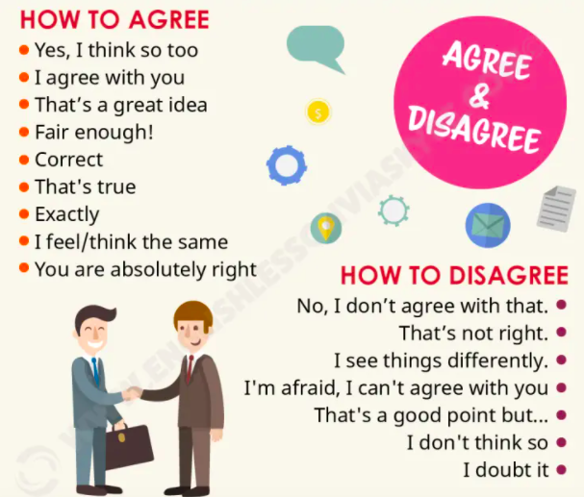 | T-Ss  Pair work | 7 mins
Practice | To help students  practice expressing  agreement and disagreement. | Task 2: Work in pairs. Express your opinions about the statements. (p. 63)  - Teacher asks students to read the instruction and given statements, decide whether they agree or disagree with the statements.  - Students work in pairs to make similar dialogues, using the structures for expressing agreement and disagreement.  - Teacher moves around to observe and provide help.  - Teacher calls some pairs to practice in front of the class and comment on their performance. | Ss  Pair work | 7 mins
* My robot’s abilities
Practice | To help students practice using some grammar points and vocabulary related to the topic.  To help students  practice asking and answering about robot’s abilities. | Task 3: Listen to the radio programme from 4Teen News. Fill the blanks with the words you hear. (p. 63)  - Teacher asks students to look at the conversation and guess words can be filled in the blanks.  - Teacher plays the recording for the first time and asks students to listen and fill in the blanks.  - Teacher asks students to share their answers in pairs and plays the recording again for students to check their answers.  - Teachers asks some students to role play the radio programme again, paying attention to the use of the words of daily activities.  Answer key:  Key:  1. understand  2. smartest  3. put  4. water  5. guard  Audio script:  Speaker: Today we ask our friends: Tom from Australia, Linh from Viet Nam and Nobita from Japan to tell about their robots. Tom, would you like to start?  Tom: My robot can understand what I say.  It can also understand my feelings. It’s the smartest robot.  Speaker: Linh?  Linh: My robot is my best friend. It does a lot for me: clean the floor, put my toys away, and…  Speaker: And Nobita?  Nobita: My robot is very useful. It help me a lot. It can water my plants and even work as a guard. | T- Ss  Ss  T- Ss | 8 mins
 |  | Task 4: Interview three friends about what abilities they want their robots to have. (p. 63)  - Teacher asks students to move around and asks three classmates what abilities they want their robots to have.  - Teacher reminds students to write the names of the people they interview and note the answers in the table.  - Students move around and interview their friends.  - When students have finished the interviews, teacher asks them to practice reporting the results of their interview in pairs. | Ss-Ss  Pair work | 5 mins
Product | To help students practice reporting the results of their interviews. | Task 5: Report the findings. (p. 63)  - Teacher calls some students to report the results of their interview in front of the whole class. After each student has finished the report, teacher invites comments from other students.  - Teacher provides further feedback and corrects the common errors. | Ss- Ss | 8 mins
Wrap-up | To consolidate what students have learnt in the lesson. | Teacher asks students to talk about what they have learnt in the lesson. | T-Ss | 2 mins
Homework | To revise what they have learnt and prepare for the next lesson Skills 1. | - Write a paragraph about 50 words to  describe a robot you want to have.  - Prepare for the next lesson (Lesson 5:  Skills 1). | T-Ss | 1 min

UNIT 12: ROBOTS

Lesson 5: Skills 1

  - I. Objectives
By the end of this lesson, students will be able to:

1. Knowledge
- Develop reading skill for general and specific information
- Identify different features of different types of robots
- Use what they have learnt to practice describing what a robot can do

2. Core competence
- Develop communication skills and creativity
- Be collaborative and supportive in pair work and team work
- Develop presentation skill
- Actively join in class activities

3. Personal qualities
- Develop self-study skills

II. Materials
- Grade 6 textbook, Unit 12, Skills 1
- Computer connected to the Internet
- Projector/ TV/ pictures and cards
- hoclieu.vn

  - III. Language analysis
Form | Meaning | Pronunciation | Vietnamese equivalent
1. literature (n) | pieces of writing that are valued as works of art, especially novels, plays and poems | /ˈlɪtrətʃər/ | văn học
2. subject (n) | an area of knowledge studied in a school, college, etc. | /ˈsʌbdʒekt/ | môn học
3. improve (v) | to become better than before | /ɪmˈpruːv/ | cải thiện, tiến bộ
4. look after (phv) | take care of | /ˈlʊk æftər/ | trông nom, chăm sóc
5. space station (nph) | a large structure that is sent into space and remains above the earth as a base for people working and travelling in space | /ˈspeɪs steɪʃn/ | trạm vũ trụ
6. planet (n) | a large round object in space that moves around a star (such as the sun) and receives light from it | /ˈplænɪt/ | hành tinh

Anticipated difficulties | Solutions
1. Students may lack knowledge about some lexical items. | Provide students with the meaning and pronunciation of words.
2. Students may have underdeveloped reading, speaking and co-operating skills. | - Let students read the text again (if needed).  - Create a comfortable and encouraging environment for students to speak.  - Encourage students to work in pairs, in groups so that they can help each other.  - Provide feedback and help if necessary.
3. Some students will excessively talk in the class. | - Define expectations in explicit detail.  - Have excessive talking students practise.  - Continue to define expectations in small chunks (before every activity).

  - Board Plan

Date of teaching

Unit 12: Robots

Lesson 5: Skills 1

*Warm-up

Task 1: Choose the best answer – Kahoot game.
I. Reading:
*Vocabulary
1.literature (n)
2. subject (n)
3. improve (v)
4. look after (phv)
5. space station (nph)
6. planet (n)
Task 2: Read the text and choose the best answer to each of the questions
(p. 64).
Task 3: Read the text again and fill the table. (p. 64)
II. Speaking
Task 4: Work in groups. Discuss what you think robots can do in the five places. (p. 64)
Task 5: Present your discussion. (p. 64)
*Homework

Procedure
Stage | Stage aim | Procedure | Interaction | Time
Warm-up | To activate students’ prior knowledge and vocabulary related to the topic and introduce the topic of reading. | * Kahoot game: Choose the best answer  - Teacher allows students to use their mobile devices to answer and interact with the questions online.  - Teacher gives clear instructions for  students to fully understand how to play Kahoot game online.  → Go to kahoot.it  → Enter the game PIN  → Type your nickname  → Choose the best option for each question appearing on the screen  → See who will be the winner  - Teacher provides the game PIN and allows students’ access to the game.  - Students choose the best option for each question appearing on the screen.  - Teacher gives compliments or a small gift to the winner of the game.  * Questions in the game:    1. What type of robot is that?  A. Home robot  B. Space robot  C. Teacher robot  D. Doctor robot    2. What type of robot is that?  A. Worker robot  B. Space robot  C. Teacher robot  D. Doctor robot    3. What type of robot is that?  A. Home robot  B. Worker robot  C. Teacher robot  D. Doctor robot  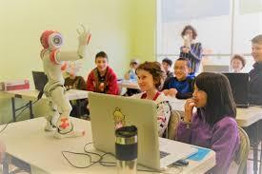  4.What type of robot is that?  A. Home robot  B. Space robot  C. Teacher robot  D. Doctor robot    5.What type of robot is that?  A. Home robot  B. Space robot  C. Teacher robot  D. Worker robot  Answer key:  1. B 2. D 3. B 4. C 5. A | Ss | 5 mins
Lead in | To lead in the lesson about Skills 1. | - Teacher leads students into the lesson by asking students the question:  1. What robots are you interested in? Why?  Suggested answers:  1. I am interested in home robots because they can help my mom do the housework. | T-Ss | 2 mins
Pre-Reading (Pre-teach  vocabulary) | To provide students with some lexical items before reading the text. | VOCABULARY  - Teacher introduces the vocabulary by:  ● providing the synonym of the words;  ● providing the pictures of the words;  ● providing the definition of the words.  - literature (n) [picture]  - subject (n) [picture]  - improve (v) [definition] to become better than before  - look after (phv)  [synonym] take care of  - space station (nph) [picture]  - planet (n) [picture]    literature    subject    space station    planet | T-Ss | 5 mins
While-  Reading | To develop reading skills for general and specific information. | Task 2: Read the text and choose the best answer to each of the questions. (p. 64)  *Keywords in multiple choice questions:  - Teacher asks students to go through the questions (1 – 4) to make sure that they understand them and know what information is being asked.  - Students underline the key word(s) in each question to locate the answer in the reading text  - Teacher asks students to read the text and answer the questions. The fastest student who gives the correct answers will get mark 10.  Answer key:  1. B 2. C 3. C 4. C  Task 3: Read the text again and fill the table. (p. 64)  - Teacher asks students to scan the text again and find the detailed information to complete the table.  - Teacher asks students to note down where they have found the  information.  - Students compare their answers with peers.  - Teacher checks students' answers as a class.  Answer key:  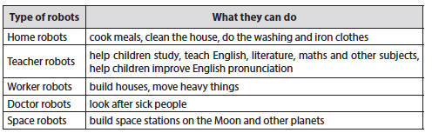 | T- Ss  Ss | 10 mins
Pre-Speaking | To help students form the ideas for their speaking. | Task 4: Work in groups. Discuss what you think robots can do in the five places. (p. 64)  - Teacher divides the class into 5 groups and assigns each group a place in Task 4.  - Teacher provides each group with a piece of A2 paper and some markers.  - Teacher asks students to work in groups, discuss what robots can do in the place they are assigned and note the ideas they have discussed on the paper.  - Teacher goes around and offers help if needed. | Group work  Ss-Ss | 5 mins
While-  Speaking | To help students use what they have learnt so far to talk about what robots can do in the place they are assigned. | Task 5: Present your  discussion (p. 64).  - Teacher invites some groups to share their discussion and makes sure they speak in full sentences.  - Students share their discussion with the whole class. | T-Ss  Ss-Ss | 10 mins
Post-Reading and Speaking | To help students improve next time. | - Teacher allows students to give comments for their friends and vote for the most interesting and informative presentation.  - Teacher gives feedback and comments. | Ss-Ss  T-Ss | 5 mins
Wrap-up | To consolidate what students have learnt in the lesson. | Teacher asks students to talk about what they have learnt in the lesson. | T-Ss | 2 mins
Homework | To prepare for the next lesson: Skills 2. | Choose a type of robot in reading text and write about what they can do. | T-Ss | 1 min

UNIT 12: ROBOTS

Lesson 6: Skills 2

  - I. Objectives
By the end of this lesson, students will be able to:

1. Knowledge
- Listen for specific information about what a robot can do
- Write a paragraph about the robot they want to have

2. Core competence
- Develop communication skills and creativity
- Be collaborative and supportive in pair work and team work
- Actively join in class activities

3. Personal qualities
- Develop self-study skills

II. Materials
- Grade 6 textbook, Unit 12, Skills 2
- Computer connected to the Internet
- Projector/ TV/ pictures and cards
- hoclieu.vn

Language analysis

Anticipated difficulties | Solutions
1. Students may lack knowledge and experiences about the topic. | Prepare some hand-outs in which key language related to the topic Robots.
2. Students may have underdeveloped listening, writing and co-operating skills. | - Play the recording many times if any necessary.  - Encourage students to work in pairs, in groups so that they can help each other.  - Provide feedback and help if necessary.
3. Some students will excessively talk in the class. | - Define expectations in explicit detail.  - Have excessive talking students practise.  - Continue to define expectations in small chunks (before every activity).

  - Board Plan

Date of teaching

Unit 12: Robots

Lesson 6: Skills 2

*Warm-up
Brainstorming
I. Listening
Task 1: Listen to the conversation and tick the phrases you hear. (p. 65)
Task 2: Listen and tick True (T) or False (F). (p. 65)
II. Writing
Task 3: Imagine a robot you would like to have and make notes about it. (p. 65)
Task 4: Write a paragraph of 50-60 words about the robot you would like to have. (p. 65)
*Homework

Procedures
Stage | Stage aim | Procedure | Interaction | Time
Warm-up | - To activate students’ prior knowledge of different types of robots.  - To enhance students’ skills of cooperating with team mates. | * Brainstorming:  - Teacher sticks 5 icons on the board, and divides the class into 5 big groups.  Space robot  Doctor robot  Worker robot  Teacher robot  Home robot  - Each group will be assigned a type of robot.  - Teacher asks students to brainstorm all abilities that the robot can have.  - The group having the most suitable answers is the winner.  Suggested answers:  ○ Space robot: build space stations, take  measurements, collect samples, take pictures of planets, ect.  ○ Doctor robot: look after sick people, do the  surgery, help the doctors, ect.  ○ Worker robot: build houses, move heavy things,  ○ Teacher robot: help children study, teach English, literature, maths and other subjects, help children improve English pronunciation, ect.  ○ Home robot: cook meals, clean the house, do the washing, iron clothes, ect. | T-Ss  Group work | 5 mins
Lead-in | To help students have the ideas of what the conversation is about. | Teacher draws students’ attention to the lesson by telling them:  “Today we are going to listen to a conversation about what robots can do and learn how to write about a robot you would like to have.” | T-Ss | 1 min
Pre-Listening | To help students have ideas of what the conversation is about. | Task 1: Listen to the conversation and tick the phrases you hear. (p. 65)  - Teacher asks students to underline key words in each of five given phrases and guess which phrases will appear in the conversation.  - Teacher plays the recording and asks  students to tick next to the phrase they hear from the conversation.  - Teacher calls some students to share their answers and confirms the correct ones.  Answer key:  - look after sick people - understand what we say - build the very high buildings - teach many subjects - move heavy things 4 | T-Ss  Ss | 5 mins
While-  Listening | To help students  develop listening skill for specific information (T / F). | Task 2: Listen and tick True or False. (p. 65)  * True – False prediction:  - Teacher asks students to go through the statements (1 – 5) to make sure that they understand and know what information they have to catch for the  answers.  - Students underline the key word(s) in each statement and guess whether they are True or False individually.  * Listen and decide True or False:  - Teacher plays the recording.  - Teacher asks students to listen and tick the answers.  - Teacher asks students to compare their answers with the predictions made previously.  - Teacher calls on some students to read aloud their answers and  correct the false one(s).  - Teacher checks students' answers as a class.  Answer key:  1. F (Robots can do quite a lot today.)  2. T  3. T  4. T  5. F (No, not everything. They can’t understand our feelings or play football.)  Audio script:  Khang: Dr Adams, please tell me something about robots.  Dr Adams: Sure. Robots can do quite a lot today. Home robots can do housework. Doctor robots can look after sick people. And …  Khang: Can robots build houses?  Dr Adams: Yes. Worker  robots can even build very high buildings.  Khang: Can they teach?  Dr Adams: Yes. Teacher  robots can teach many subjects in a classroom or online.  Khang: Can they  understand what we say?  Dr Adams: Yes, they do. They can even speak to us.  Khang: Robots can do  everything like humans?  Dr Adams: No, not  everything. They can’t  understand our feelings or play football. | T-Ss  Ss  Ss  Ss-Ss  T-Ss | 8 mins
Pre-Writing | To help students  prepare ideas for their writing. | Task 3: Imagine a robot you would like to have and make notes about it. (p. 65)  - Teacher asks students to make notes on a robot they want to design (its name, type of robot, where it can work and what it can do).  - Remind them that they do not have to write full sentences and they can use abbreviations.  - Teacher goes around and helps if needed.  - Students work in pairs and share their notes with their partners.  Model notes:  1. Name of your robot Mimi  2. Type of robot Home robot  3. Where it can work At my house  4. What it can do for you Help my Mum do the housework: clean the house, wash dishes and cook meals. | T-Ss  Ss-Ss  Pair work | 5 mins
While-Writing | To help students practice writing a  paragraph about the  robot they would like to have. | Task 4: Write a paragraph of 50-60 words about the robot you would like to have. (p. 65)  - Teacher introduces some structures to write about the robot:  *Name:  My robot’s name is…  I would like to have a robot named…  I would name my robot …  *Type:  It is a …  *Where it can work:  It can work at…  … is an ideal place for it.  *What it can do:  My robot can…  My robot is able to…  - Teacher asks student to use the given structures and the information they have noted in task three to write a paragraph about the robot they want to have. | T-Ss  T-Ss | 10 mins
Post-Listening and Writing | To peer check, cross check and final check students’ writing. | - Teacher asks students to exchange their textbooks to check their friends’ writing.  - Teacher then gives feedback as a class  discussion. | Ss-Ss  T-Ss | 2 mins
Wrap-up | To consolidate what  students have learnt in the lesson. | Teacher asks students to talk about what they have learnt in the lesson. | T-Ss | 2 mins
Homework | To allow students finalize their writings after being checked by friends and the teacher. | Rewrite the final version of students’ writing on your notebook. | T-Ss | 1 min

UNIT 12: ROBOTS

Lesson 7: Looking back & Project

  - I. Objectives
By the end of this lesson, students will be able to:

1. Knowledge
- Review the vocabulary and grammar of Unit 12
- Apply what they have learnt (vocabulary and grammar) into practice through a project

2. Core competence
- Develop communication skills and creativity
- Develop presentation skill
- Develop critical thinking skill
- Be collaborative and supportive in pair work and team work
- Actively join in class activities

3. Personal qualities
- Be more creative when doing the project
- Develop self-study skills

II. Materials
- Grade 6 textbook, Unit 9, Looking back & Project
- Computer connected to the Internet
- Pictures, A0 paper
- Projector/ TV
- hoclieu.vn

Language analysis
Anticipated difficulties | Solutions
1. Students may have underdeveloped speaking, writing and co-operating skills when doing projects. | - Encourage students to work in pairs, in groups so that they can help each other.  - Provide feedback and help if necessary.
2. Some students will excessively talk in the class. | - Define expectations in explicit detail.  - Have excessive talking students practise.  - Continue to define expectations in small chunks (before every activity).

  - Board Plan

Date of teaching

Unit 12: Robots

Lesson 7: Looking back & Project

*Warm-up
Quizizz game
I. Looking back
Task 2: Fill in the blanks with the verbs from the box. (p. 66)
Task 3: Use the correct form of the adjectives in brackets to complete the paragraph. (p. 66)
Task 4: Complete the sentences with the superlative form of the adjectives in the brackets. (p. 66)
II. Project:
Robot Design Competition
*Homework

Procedure
Stage | Stage aim | Procedure | Interaction | Time
Warm-up | To revise the vocabulary related to the topic and lead in the next part of the lesson. | * Quizizz game:  - Teacher uses questions in Exercise 1 to create questions in the Quizizz game.  - Teacher allows students to use their mobile devices to answer and  interact with the questions online.  - Teacher gives clear instructions for students to fully understand how to play Quizizz quiz online.  → Go to joinmyquiz.com  → Enter the game CODE  → Type your name  → Use and, but and so to complete each sentence appearing on the screen  → See who will be the winner  - Teacher provides the game CODE and allows students’ access to the game.  - Students type the word and, but or so to complete each sentence appearing on the screen.  - Teacher gives complements or good marks to the winner of the game.    1. _________ the clothes  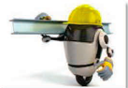  2. ________ heavy things    3. ____________ fruit    4. do the ___________    5. __________ the dishes  Answer key:  1. iron  2. move  3. pick  4. washing  5. do | T-Ss | 5 mins
Looking back | To help students  revise phrases  related to daily  activities.  To help students  revise the form and use of superlative adjectives. | Task 2: Fill in the blanks with the verbs from the box. (p. 66)  - Teacher encourages students to complete the task individually.  - Students exchange their textbook to discuss the answers.  - Teacher asks one student to write the answers on the board.  - Teacher gives feedback as a class discussion.  Answer key:  1. work  2. make  3. repair  4. understand  5. waters  Task 3: Use the correct form of the adjectives in brackets to complete the paragraph. (p. 66)  - Teacher asks students to do the task individually first.  - Teacher then allows students to check their answers with a partner.  - Teacher calls some students to write down the answers on the board.  - Teacher gives feedback as a class discussion.  Answer key:  1. smartest  2. smallest  3. lightest  4. strongest  5. cheapest  Task 4: Complete the  sentences with the  superlative form of the adjectives in the brackets. (p. 66)  - Teacher asks students to complete the task individually.  - Students exchange their textbook to discuss the reasons about their  answers.  - Students should record their original answers to guide their self-assessment later.  - Teacher gives feedback as a class discussion.  Answer key:  1. highest  2. largest  3. longest  4. widest  5. hottest | S  Ss-Ss  T-Ss  T-Ss  Ss-Ss  T-Ss | 16 mins
Project | To allow students to apply what they have learnt (vocabulary and grammar) into practice through  a project. | *Robot Design  Competition    - Teacher divides students into 4 big groups.  - Teacher asks students to discuss the robot they want to design.  - Teacher asks them to consider the following information when designing the robot:  ● Robot name  ● Appearance (weight, height, ect.)  ● Where it can work  ● What it can do  - Students summarize the information and design A0 size posters about the robot they want to design.  - Teacher asks the class to listen to the reports and ask questions if they would like to.  - Students will critically evaluate all the posters, then give 1 vote for the most attractive robot  - Teacher gives comments and feedback to all 4 posters and awards a special prize to the group which has the most votes. | T-Ss  Group work  T-Ss | 20 mins
Wrap-up | To consolidate what  students have learnt in the lesson. | Teacher asks students to talk about what they have learnt in the lesson. | T-Ss | 3 mins
Homework | To prepare for the next lesson. | Prepare for the next  lesson: Review 4 (Units 10-11-12). | T-Ss | 1 min
*Pictures' source: From Internet

