Đề thi Tiếng Anh lớp 3 giữa kì 2 Chân trời sáng tạo
Bản quyền thuộc về VnDoc nghiêm cấm mọi hành vi sao chép vì mục đích thương mại
Choose the odd one out
- A. skirt | - trousers | - badminton | - dress
- A. drum | - dance | - talk | - watch
- A. sing | - song | - listen | - eat
- A. bus | - car | - plane | - bike
Look and write
 | 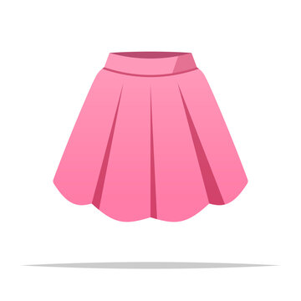
- ________________ | - ________________
 | 
- ________________ | - ________________
Choose the correct answer
- He can play _____________.
- sports
- guitar
- a horse
- a ride
- I can draw. What _____________ you do?
- are
- is
- does
- can
- Can you skip, Khoa?
- No, I _____________. I never skip.
- can
- cant
- can’t
- cans
- What’s your hobby?
I like _____________ computer games
- play
- plays
- playing
- played
- My sister is _____________ to music in her room.
- listen
- listens
- listening
- listened
Read and choose the correct answer
Hi, I’m John. I lkie going shopping with mu mum. I wear a blouse and a skirt. I wear a blouse and a skirt. I also like goinf skating with my friend. On those days, I wear a T-shirt, jeans and a pair of shoes. Sometimes, on hot days, I wear a cap and a pair of sandals. They are my favourite sandals. They are black. They are eighty-five thousand dong.
- John likes ……………… with his mum
- go for a walk
- going shopping
- go fishing
- He wears ……………….. and a skirt.
- a blouse
- a jacket
- a jumper
- He wears jeans when going …………………
- skating
- fishing
- walking
- His favourite sandals’ colour are ………………
- blue
- black
- Brown
Reorder these words to have correct sentences
- wearing/ pink/ a/ my/ dress/ sister/ is/ ./
__________________________________________
- can/ she/ soccer/ play/ ./
__________________________________________
- wearing/ What/ you/ are/ today/ ?/
__________________________________________
-The end-
Đáp án đề thi Tiếng Anh lớp 3 giữa kì 2 Chân trời sáng tạo
Choose the odd one out
- C | - A | - B | - C
Look and write
- read | - skirt | - truck | - take photos
Choose the correct answer
- B | - D | - C | - C | - C
Read and choose the correct answer
- B | - A | - A | - B
Reorder these words to have correct sentences
- My sister is wearing a pink dress.
- She can play soccer.
- What are you wearing today?
Mời các bạn tham khảo thêm nhiều tài liệu Tiếng Anh lớp 3 Family and Friends hay và miễn phí tại: https://vndoc.com/tieng-anh-lop-3-ctst

