|  |  |  |
| --- | --- | --- |
| UBND QUẬN _________ PHÒNG GIÁO DỤC VÀ ĐÀO TẠO ĐỀ CHÍNH THỨC | ĐỀ KIỂM TRA __________ Năm học: 20__ - 20__ Tiếng Anh - Lớp 8 Thời gian làm bài: 45 phút | |
| Trường: ________________________ Họ tên: _______________________ Lớp: _____________ | Điểm | Nhận xét của giáo viên |

|  |
| --- |
| **Tiếng Anh 8 i-Learn Smart World_Unit 7 Time allotted: 45** |

|  |  |
| --- | --- |
| **PART 1** | **PRONUNCIATION (5 questions)** |

**Choose the word whose underlined part differs from the other three in pronunciation in the following question.**

|  |  |  |  |  |
| --- | --- | --- | --- | --- |
| 1. | A. measure | B. theater | C. idea | D. fear |

**Choose the word whose underlined part differs from the other three in pronunciation in the following question.**

|  |  |  |  |  |
| --- | --- | --- | --- | --- |
| 2. | A. designer | B. attendant | C. dentist | D. education |

**Choose the word whose underlined part differs from the other three in pronunciation in the following question.**

|  |  |  |  |  |
| --- | --- | --- | --- | --- |
| 3. | A. mansion | B. yacht | C. parrot | D. travel |

**Choose the word whose primary stress is NOT placed on the second syllable.**

|  |  |  |  |  |
| --- | --- | --- | --- | --- |
| 4. | A. engineer | B. celebrity | C. director | D. musician |

**Choose the word whose primary stress is NOT placed on the third syllable.**

|  |  |  |  |  |
| --- | --- | --- | --- | --- |
| 5. | A. volunteer | B. millionaire | C. journalist | D. electricity |

|  |  |
| --- | --- |
| **PART 2** | **USE OF ENGLISH (12 questions)** |

**Choose the option that best completes the following sentence.**

**Question:**

6. ______________ care for the health of animals and work to protect public health.

|  |  |  |  |
| --- | --- | --- | --- |
| A. Journalists | B. Engineers | C. Veterinarians | D. Dentists |

**Choose the option that best completes the following sentence.**

**Question:**

7. Reporter: What problems do many students have to face these days?   
Student: ______________

|  |  |  |  |
| --- | --- | --- | --- |
| A. You can do lots of things in an English-speaking club. | B. I think students suffer stress from studying and bullying from their mates. | C. Students should have a friendly environment to develop. | D. I think doing yoga is a good idea for teenagers to reduce stress. |

**Choose the option that best completes the following sentence.**

**Question:**

8. Some teenagers volunteer to help the elderly ______________ their household chores.

|  |  |  |  |
| --- | --- | --- | --- |
| A. with | B. on | C. at | D. for |

**Choose the option that best completes the following sentence.**

**Question:**

9. Lily said that her son ______________ 3 languages including English, French, and German.

|  |  |  |  |
| --- | --- | --- | --- |
| A. speaks | B. can speak | C. couldn’t speak | D. could speak |

**Choose the option that best completes the following sentence.**

**Question:**

10. On the first day at school, Thomas could find his classroom, but Susan and Mary couldn’t find ______________.

|  |  |  |  |
| --- | --- | --- | --- |
| A. hers | B. theirs | C. ours | D. his |

**Choose the option that best completes the following sentence.**

**Question:**

11. She dreamt to be a famous ______________ at an early age.

|  |  |  |  |
| --- | --- | --- | --- |
| A. music | B. musical | C. musically | D. musician |

**Choose the option that best completes the following sentence.**

**Question:**

12. Mary said that she ______________ her brother’s car.

|  |  |  |  |
| --- | --- | --- | --- |
| A. doesn’t like | B. didn’t like | C. likes | D. don’t like |

**Choose the option that best completes the following sentence.**

**Question:**

13. They sailed around the harbor in their ______________ all Saturday afternoon.

|  |  |  |  |
| --- | --- | --- | --- |
| A. yacht | B. sports car | C. helicopter | D. jet |

**Choose the option that best completes the following sentence.**

**Question:**

14. Many pupils have ______________ in the evenings or at weekends.

|  |  |  |  |
| --- | --- | --- | --- |
| A. problems | B. families | C. relationships | D. extra classes |

**Choose the option that best completes the following sentence.**

**Question:**

15. My dream is to be a professional flight attendant. What’s ______________?

|  |  |  |  |
| --- | --- | --- | --- |
| A. yours | B. mine | C. your | D. my |

**Choose the option that best completes the following sentence.**

**Question:**

16. Louis: What’s Judy’s dream? – Nick: ______________

|  |  |  |  |
| --- | --- | --- | --- |
| A. Her favorite actor is Leonardo DiCaprio. | B. Hers is to be a police officer. | C. She is a police officer. | D. She likes taking care of animals. |

**Choose the option that best completes the following sentence.**

**Question:**

17. He told me that he ______________ a new mansion the following year.

|  |  |  |  |
| --- | --- | --- | --- |
| A. buys | B. bought | C. had bought | D. was going to buy |

|  |  |
| --- | --- |
| **PART 3** | **WORD FORMATION (3 questions)** |

**Write the correct form of the given word.**

18. Her dream is to be a ______________.

***(MILLION)***

**Write the correct form of the given word.**

19. All her close and distant ______________were invited to the wedding.

***(RELATE)***

**Write the correct form of the given word.**

20. She ______________a special school for children with learning difficulties when she was young.

***(ATTENDANCE)***

|  |  |
| --- | --- |
| **PART 4** | **ERROR RECOGNITION (2 questions)** |

**Find the underlined part that needs correction in the following question.**

**Question:**

21. Kelly said me that she had won the lottery.

|  |  |  |  |
| --- | --- | --- | --- |
| A. said me | B. she | C. had won | D. lottery |

**Find the underlined part that needs correction in the following question.**

**Question:**

22. A veterinarian is coming to repair our phone tomorrow morning.

|  |  |  |  |
| --- | --- | --- | --- |
| A. veterinarian | B. is | C. to repair | D. tomorrow |

|  |  |
| --- | --- |
| **PART 5** | **READING (5 questions)** |

**Read the website article about teenagers and choose the best answer for each question. (5 questions)**

|  |
| --- |
| What do teenagers need? Perhaps the most important thing is enough sleep. Between the ages of 13 and 19, our brains and bodies change a lot. Sleep helps those changes to happen, so teenagers need more sleep than 12-year-olds. Teens sometimes sleep for 11 or 12 hours on the weekend, but scientists say about nine hours is the correct amount, up from about eight hours at a younger age.    Unfortunately, teenagers cannot normally go to sleep before 11 p.m. because of the changes in their bodies. In most countries, they then have to get up most of the year at 6.00 or 7.00 to be in time for school. It would be better if high schools in countries around the world started at 11.00 or 12.00, but **they** do not, so parents must find other ways to make sure their teenagers get enough sleep.    Firstly, teenagers could sleep for half an hour as soon as they get home or after dinner. **This** is better than letting them sleep late on the weekend. If a teenager wakes up at a later time on two days a week, it will be much harder to go back to the earlier time on school days.    Secondly, teenagers should not use laptops or cell phones late in the evening for games or social media. The light from these devices makes it harder for the body to feel tired. |

**Questions:**

23. What is the right amount of sleep for a 14-year-old?

|  |  |  |  |
| --- | --- | --- | --- |
| A. 8 hours | B. 9 hours | C. 11 hours | D. 12 hours |

24. According to the article, how much sleep does the average teenager get during the week?

|  |  |  |  |
| --- | --- | --- | --- |
| A. 6 hours | B. 7 hours | C. 8 hours | D. 7 or 8 hours |

25. In the second paragraph, ***they*** means ______________.

|  |  |  |  |
| --- | --- | --- | --- |
| A. all schools | B. high schools | C. teenagers | D. countries |

26. What does ***this*** mean in the third paragraph?

|  |  |  |  |
| --- | --- | --- | --- |
| A. Sleeping for half an hour | B. Half an hour | C. Home | D. Sleeping after dinner |

27. What happens to teenagers if they use an electronic device late in the evening?

|  |  |  |  |
| --- | --- | --- | --- |
| A. They spend too long on social media. | B. They play games late into the night. | C. They don’t want to turn the device off. | D. The screen light stops the body getting ready for sleep. |

|  |  |
| --- | --- |
| **PART 6** | **LISTENING (5 questions)** |

**You will hear an announcement by the headteacher of a school. Complete the summary. Write ONE WORD AND/OR A NUMBER in each numbered space. (5 questions)**

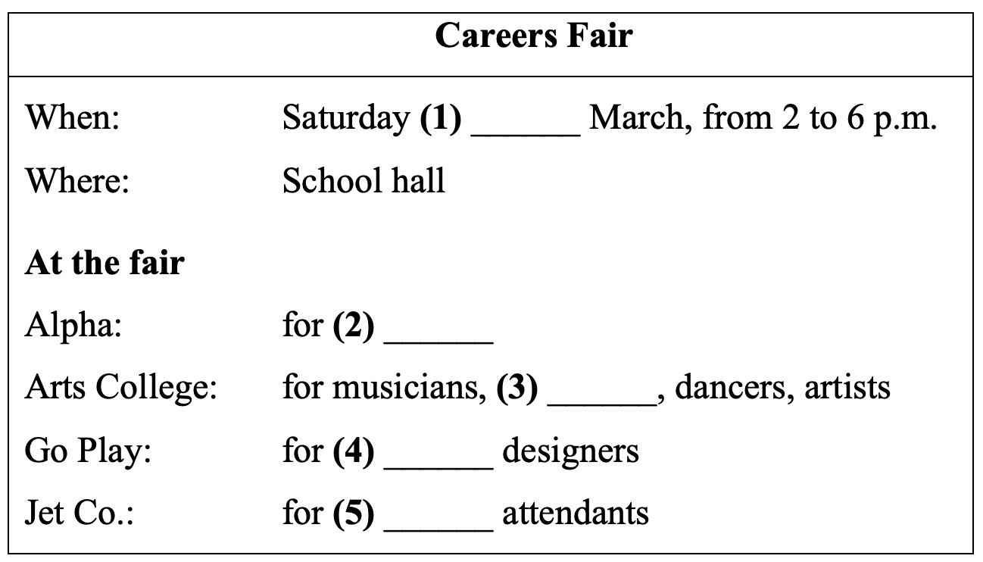

(28)___________________  
(29)___________________  
(30)___________________  
(31)___________________  
(32)___________________

|  |  |
| --- | --- |
| **PART 7** | **WRITING (8 questions)** |

**Rewrite the following sentence without changing its meaning. Use the given word(s) if any.**

33. Her dream is to become a ballerina and mine is to be a singer.

→ HERS___________

**Rewrite the following sentence without changing its meaning. Use the given word(s) if any.**

34. My mom told me, “You must finish your homework before playing games.”

→ (HAD TO)___________

**Rewrite the following sentence without changing its meaning. Use the given word(s) if any.**

35. James said to me, “I will fly around the world in my jet.”

→ James told me___________

**Rewrite the following sentence without changing its meaning. Use the given word(s) if any.**

36. Participating in a dancing class is a good idea for teenagers if they want to reduce stress.

→ It’s a___________

**Use the given words or phrases to make a complete sentence.**

37. He / tell me / his dream / is / be / famous soccer player / .

→ ___________

**Use the given words or phrases to make a complete sentence.**

38. It / difficult / students / focus / their school work / if they / not have / enough time / sleep /.

→ ___________

**Put the words in the correct order to make a correct sentence.**

**Question:**

|  |  |
| --- | --- |
| 39. | Keywords: she had/that/in journalism/ten-year experience/She told/the interviewer/.  → ....................................... |

**Put the words in the correct order to make a correct sentence.**

**Question:**

|  |  |
| --- | --- |
| 40. | Keywords: sports car/My dream is/to buy a/is to own/./and his/a car-making company  → ....................................... |

**---THE END---**