Họ tên thí sinh: .................................................................
Số báo danh: ......................................................................
Mã Đề: 028.
Câu 1. What is Peter asking Helen to bring to the barbecue?
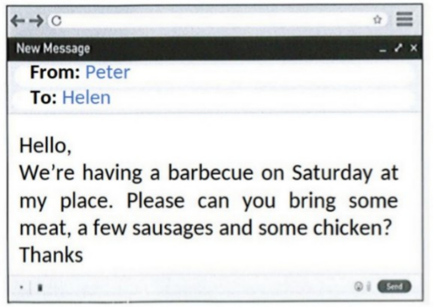
A. Dessert and side dishes B. Bread and condiments
C. Meat, sausages, and chicken D. Drinks and salad
Câu 2. Look at the signs. Choose the best answer for the question.

A. You don’t need to litter in this place. B. Littering is not good for the environment.
C. Waste is not available in this place. D. You mustn’t throw trash on the ground.
Câu 3. Which of the following statements is true?
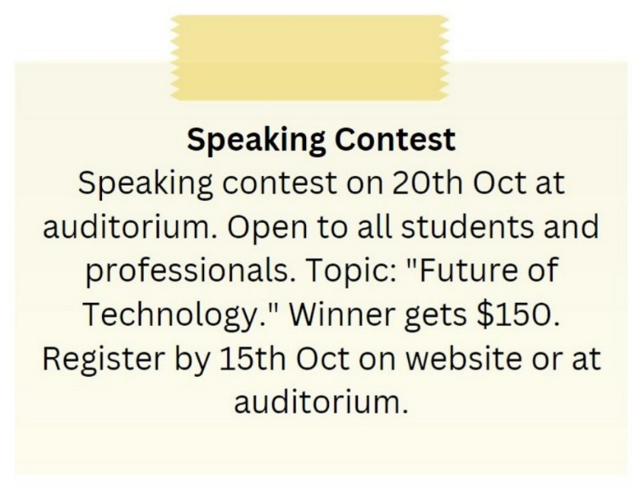
A. The topic of the speaking contest is "Future of Technology."
B. The winner of the speaking contest gets $100.
C. The speaking contest is on 15th October.
D. The speaking contest is only open to students.
Câu 4. What is the main offer of this Happy Hour promotion?
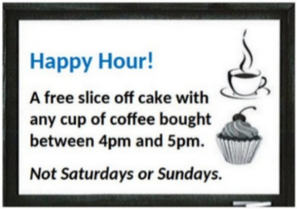
A. Free coffee B. Discounted cupcakes
C. A free slice of cake with coffee purchase D. Half-price cake
Câu 5. Look at the signs. Choose the best answer for the question.
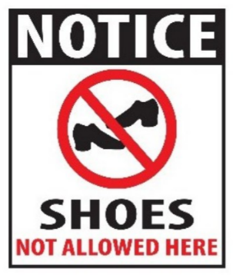
A. You don’t have to wear shoes in this place.
B. Please put on your shoes when entering this place.
C. You can’t buy any shoes in this place.
D. Please take off your shoes when entering this place.
Câu 6. When does the science club meet?
Science Club Notice:
Science club opening soon! Meets Tues/Thurs after school in room 205. First meeting on Sept. 14th at 3:30 pm.
A. Sunday afternoon B. Tuesday and Thursday after school
C. Monday and Wednesday after school D. Saturday morning
Câu 7. What are the things that Mom asked her kid to pick up?
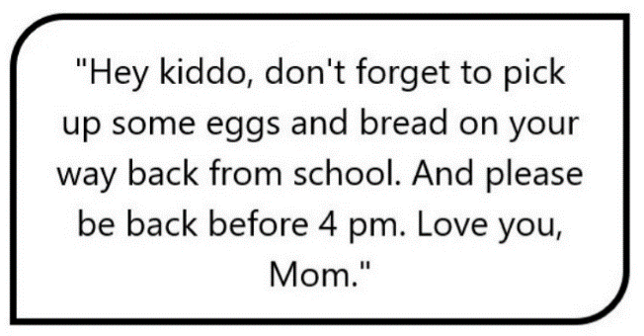
A. Eggs and bread B. Eggs, bread, and milk
C. Eggs and milk D. Bread and milk
Câu 8. Look at the signs. Choose the best answer for the question.
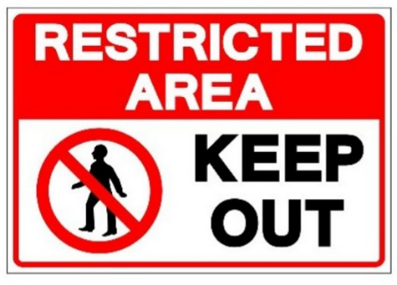
A. We should keep this area out. B. People aren’t allowed to enter this area.
C. This area is open to everyone. D. This area is kept open.
Câu 9. Why does Chloe want Susie to move her work stuff?
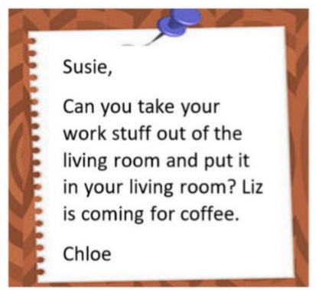
A. Because the living room is messy B. Because Susie needs to work in her bedroom
C. Because Chloe wants to use the living room D. Because Liz is coming for coffee
Câu 10. Look at the signs. Choose the best answer for the question.

A. You can buy burgers and chips today only.
B. Chips and burgers are free - today only.
C. If you buy a burger today, you will get chips for free.
D. Every burger is served with chips in this restaurant.
----HẾT---

