SPEAKING TEST ENGLISH 7
UNIT 6: A VISIT TO A SCHOOL
PART 2
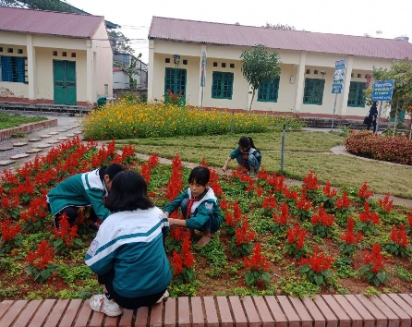  1 | 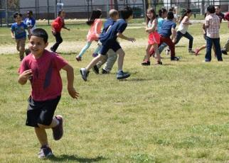  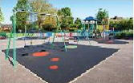  2 | 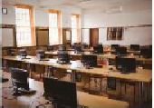  3 | 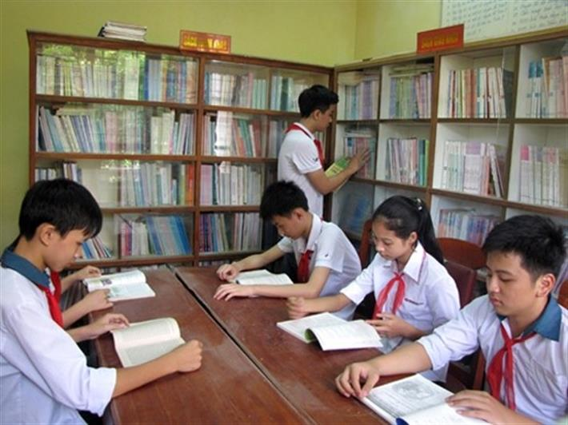  4
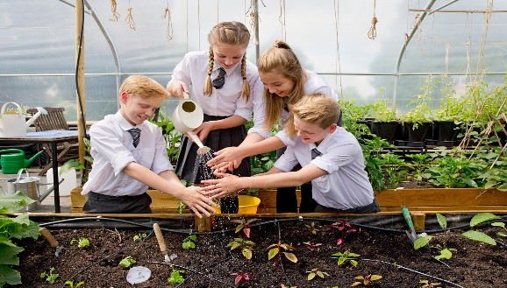  12 | 1. What is this/that? (1/2/3/8)  2. Where are the students? (4/5)  Where do the students water the flowers? 12  3. What does he/she often do after school? (2,6)  4. Where is the boy writing ? (11)  5. They’re extra activities that students do outside. (9)  6. They’re tables, desks, chairs, boards,... at school. What are they? (3/7/10) |  | 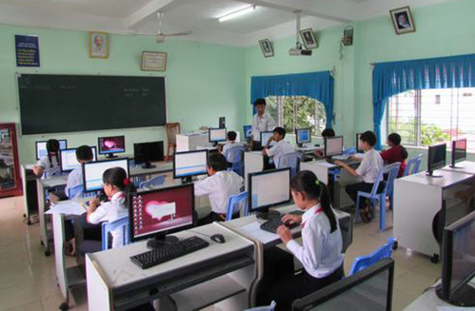  5
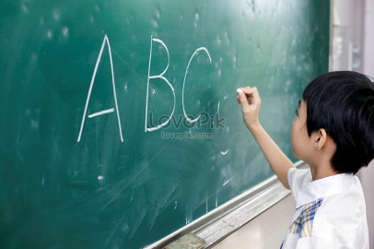  11 |  |  |   6
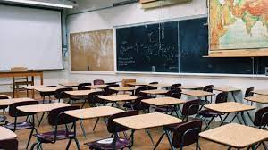  10 | 9 | 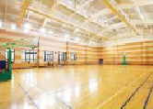  8 | 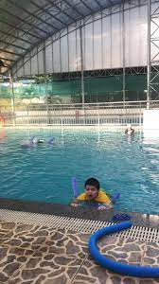  7
PART 3



1. What’s the full name of your school?
2. Where is your school?
3. What are the students in your school like?
4. What facilities does your school have?
5. What outdoor activities do you take part in at school?
6. Which outdoor activity do you like best?

KEY FOR SECTION 2:
- (school) garden
- playground
- computer room
- school library
- computer room
- hard-working / doing homework….
- Swimming pool
- gym
- outdoor activities
- school facilities
- black board
- in the (school) garden

