**LỚP HỌC THẦY (CÔ) ___________________________** **ĐỀ ÔN TẬP: READING SIGNS/ NOTICES – A2**

**Test 15**

*Thời gian làm bài: [Time]*

Họ và tên: ________________________________________________ Lớp: 9/___

Question 1: What does this sign mean?

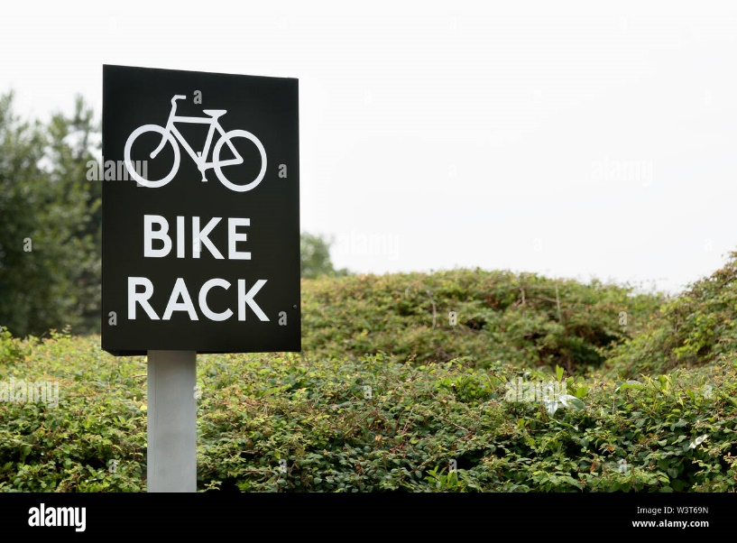

A. You can park your bike here.  
B. Bicycles are not allowed here.  
C. You must carry your bicycle.  
D. Parking bikes is not encouraged.

Question 2: What is the message about?

We are hosting a family picnic at the park this Saturday from 11am to 3pm. Everyone is invited to bring food and enjoy.

A. A family gathering at a cafe. B. A family dinner at a restaurant.

C. A picnic at the park next Saturday. D. A family picnic at the park this Saturday.

Question 3: What does this sign mean?

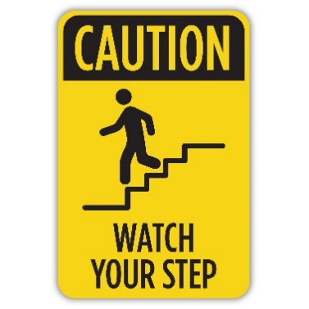

A. The path is safe to walk on.  
B. Be careful; the ground may be uneven.  
C. The path is clear of obstacles.  
D. The area is being repaired.

**Question 4:** What should you do according to the notice?

*Please remember to lock the door when you leave*

*the office. This is*

*important for security.*

**Door**

A. Leave the door unlocked. B. Lock the door when leaving the office.  
C. Only lock the door if someone is inside. D. The door will be locked automatically.

Question 5: What does this sign mean?

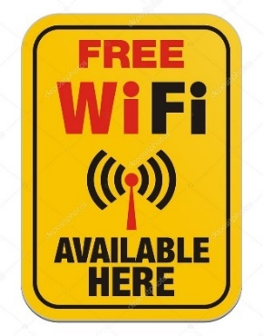 A. There is no Wi-Fi here.  
B. You can use Wi-Fi for free here.  
C. You have to pay to use the Wi-Fi.  
D. Wi-Fi is only available in some places.

**Question 6:** What is the purpose of the announcement?

*Join us for a cooking class this Tuesday at 6pm. Learn to make delicious Italian dishes! Contact Amy at 0801234567 to register.*

A. Sign up for a sporting event. B. Learn how to cook Italian food in a class.

C. Join a language class. D. Advertise an Italian cooking course.

Question 7: What does this sign mean?

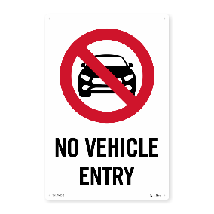

A. Vehicles can enter this area without any restriction.  
B. Vehicles are not encouraged to enter this area.  
C. Vehicles can enter this area only during certain times.  
D. Vehicles are not allowed to enter this area at all.

**Question 8:** Choose the correct answer from the announcement.

Free!!

Used books support poor students to overcome difficulties. Only for hard-working students, receive books from 2pm - 5pm every day.

A. All students can receive books. B. Only for hard-working students.

C. Only for poor students within 3 hours. D. For everyone from 2pm to 5pm.

Question 9: What does this sign mean?

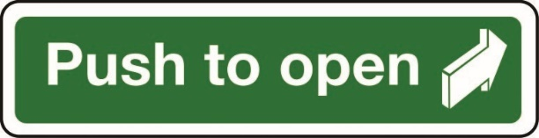

A. You need to pull the door to open it.

B. The door is always open and does not need to be opened.

C. The door will open by itself.  
D. You need to push the door to open it.

**Question 10:** What should you do according to the notice?

The swimming pool will be closed for maintenance on Friday. Please check for reopening updates.

A. Visit the swimming pool on Friday.

B. Check for reopening updates.

C. The swimming pool will be open on Friday.

D. The swimming pool is closed only on Sundays.

**[HẾT]**