**LỚP HỌC THẦY (CÔ) ___________________________** **ĐỀ ÔN TẬP: READING SIGNS/ NOTICES – A2**

**Test 11**

*Thời gian làm bài: [Time]*

Họ và tên: ________________________________________________ Lớp: 9/___

**Nội dung:**

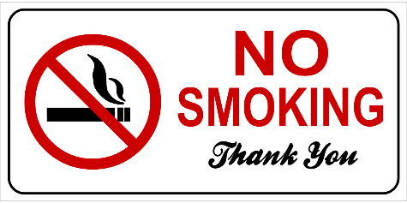**Question 1:** What does the sign suggest?

**A.** Smoking is allowed anywhere you like without restrictions.

**B.** Smoking is not permitted in this area.

**C.** Only certain types of smoking are allowed in this area.

**D.** Smoking is only permitted in special rooms designed for it.

**Question 2:** What does the notice advise?

Keep your personal belongings in your locker. Do not leave them in common areas.

**A.** Leave your belongings in common areas **B.** Leave your belongings in your locker

**C.** Share your locker with others **D.** Take your belongings home every day

**Question 3:** What does the sign suggest?

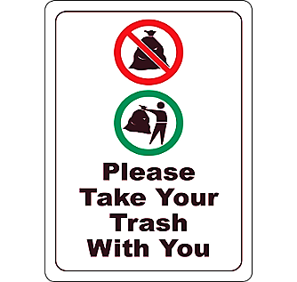

**A.** Leave your trash in the designated bins provided in the area**.**

**B.** Take your trash with you when you leave this place.

**C.** Only take your trash with you if it is recyclable.

**D.** You can leave your trash in any area around here.

**Question 4:** What does the notice ask you to do?

Please keep the noise to a minimum in the library. This helps others study and read

**A.** Do not listen to music in the library to keep it quiet.

**B.** Keep the noise level low in the library

**C.** Watch movies with the volume at its highest.

**D.** Play music in the library

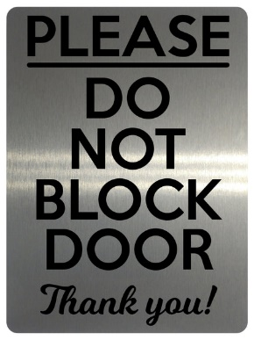**Question 5:** What does the sign suggest?

**A.** It is okay to block the door if it is open.

**B.** Only block the door during the night if needed**.**

**C.** You should block the door if it is too cold outside.

**D.** Ensure that the door is always kept clear and not blocked**.**

**Question 6:** What does the notice require?

Please do not feed the birds in the park. It may make them sick

**A.** Feed the birds without letting others know **B.** Play with the birds

**C.** Do not feed the birds any food **D.** Only give the birds water, do not feed the birds

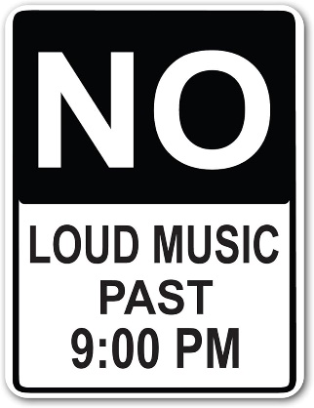Question 53: What does the sign suggest?

**A.** Loud music can be played at any time during the night.

**B.** Only classical music is permitted to be loud after 9 PM.

**C.** You are allowed to play loud music only before 9 PM.

**D.** Make sure to keep the music quiet after 9 PM.

**Question 7:** What should you do with your ID card?

Remember to bring your ID card when you enter the building. You will need it to go through security.

**A.** Leave your ID card at home **B.** No ID card required

**C.** Show your ID card upon entry **D.** Bring your ID card for security check

**Question 8:** What does the sign suggest?

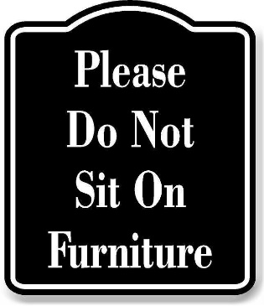

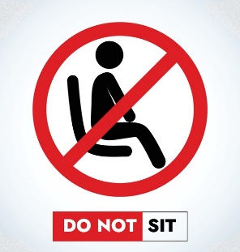

**A.** You can sit on the furniture if you want.

**B.** Only some pieces of furniture can be used for sitting.

**C.** Sitting on the furniture is not allowed here.

**D.** You may sit on the furniture only during designated breaks.

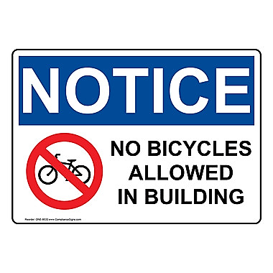**Question 9:** What does the sign suggest?

**A.** You are allowed to bring your bicycle into the building whenever you want.

**B.** All bicycles must be left outside and not brought into the building.

**C.** Only smaller bicycles are not allowed in the building, larger bicycles are allowed**.**

**D.** All bicycles must be left outside the building and not brought inside.

**Question 10:** What is true about the announcement from the library?

"Attention all students: Please note that our library will now open at 10:00 AM and close at 6:00 PM, Monday through Friday. Our weekend hours remain the same. Thank you for your cooperation."

**A.** Change in the library's hours on weekends.

**B.** Change in the library's location.

**C.** Change in the library's opening and closing times on weekdays.

**D.** Change in the library's phone number.

**[HẾT]**