|  |  |
| --- | --- |
| **UBND HUYỆN CẨM GIÀNG** | **ĐỀ KHẢO SÁT HỌC SINH GIỎI CẤP HUYỆN**  **NĂM HỌC 2024 - 2025**  **MÔN:TIẾNG ANH 9**  **Thời gian làm bài: 150 phút**  **Đề thi gồm 06 trang** |

**A. LISTENING (20pts)**

**I. You will hear FIVE short conversations. Listen and choose the correct answer. (5 pts)**

1. How will they travel to the pop concert?

A. by bus B. by private car C. by train D. by taxi.

2. What was the weather like on Beth's birthday?

A. cloudy B. Cloudy and sunny C. Sunny D. Rainy

3. Where must has the teacher put the dictionaries?

A. on the shelf in class B. on the shelf in the library

C. on the shelf in the cafe. D. on the shelf in staff room.

4. Where did Paul go running yesterday?

A. by the river B. through the field C. in the park D. through the woods.

5. What does Karen still need to get for the school play?

A. an umbrella B. a hat C. sungglasses D. a long coat

**II. You will hear the manager of a cycling club giving some information about a bike race. For each question, choose the correct answer. (5 pts)**

6. The race is _____.

A. on 7th September B. on 27th September

C. on 27th October D. on 27th November

7. Racers will wear _____.

A. blue T-shirt and shorts B. black T-shirt and shorts

C. blue suits D. black suits

8. There will be 3 people _____.

A. in 4 teams B. on a day.

C. at the race D. on each team

9. At 8.30, racers must _____.

A. get up and have breakfast. B. be ready to start.

C. be ready for breakfast. D. prepare for the race.

10. At 20 kilometres, there will be a place for_____.

A. some snack. B. orange juice.

C. snacks, cakes, orange juice. D. snack and orange juice.

**III. You will hear a radio programme about some historic places to visit. For each question, fill in the missing information in the numbered space. (5 pts)**

**BLACK ROCK CAVES**

Over two million years old

For half a million years, people and animals, especially (11)__________ lived there.

**SALTER HOUSE**

Built in the year (12) __________.

All visitors want to visit Dorothy's (13) __________.

**THE OLD PORT**

Have a ride on an old tram to the (14) __________ village.

In the factory find out how people used to make (15) __________.

**IV. Look at the five sentences for this part. You will hear a woman talking about a singing course she attended. Decide if each sentence is True or False. If it is correct, write T. If it is not correct, write F. (5 pts)**

16. Lena Phipps runs these three-day courses for people with experience of singing.

17. She used to be a pop singer.

18. She never takes more than ten students on a course.

19. Every class begins with some exercises to reduce stress.

20. Students learn around twenty songs on a day.

**B. GRAMMAR-VOCABULARY (25 pts)**

**I. Choose the word or phrase A, B, C or D that best fits the blank space in each sentence. (9 pts)**

21. The police stated that the accident ______________ soon.

A. will be investigated  B. had investigated  C. is being investigated  D. would be investigated

22. I think he will join us, ______________?

A. doesn’t he  B. won’t he  C. will he  D. do I

23. Your hair needs ______________. You’d better have it done tomorrow.

A. cut  B. to cut  C. being cut  D. cutting

24. ______________ finds the treasure is entitled to twenty five percent of it.

A. Who  B. The person who  C. Whoever  D. Man who

25. The passage ______________ that the first settlers were Spanish.

A. refers  B. instills  C. implies  D. infers

26. Can you give me the ______________ for tomato soup?

A. formula  B. recipe  C. order  D. method

27. You should pay ______________ to what the instructor is saying.

A. attendance  B. intention  C. convention  D. attention

28. The jokes Jack tell are as old as ______________.

A. the earth  B. the mountains  C. the hills  D. the oceans

29. We think they are living in that ______ on the corner.

A. modern villa brick big B. brick big modern villa

C. big modern brick villa D. villa brick big modern

**II. Read and choose the correct option to complete the announcement. (3 pts)**

Feeling stressed? Here are some simple ways to (30) ______________ better. First, take deep breaths and relax your muscles. Exercise regularly, even if it (31) ______________just a short walk. Get enough sleep, aiming for 7-8 hours each night. Eat healthy foods, like fruits and vegetables, and drink plenty of water. Finally, take time for hobbies you enjoy. Remember, small changes can (32) ______________ a big difference in reducing stress.

30. A. feel B. make C. look D. seem

31. A. has been B. is C. was D. had been

32. A. do B. have C. take D. make

**III. Read and choose the correct option to complete the advertisement. (3 pts)**

**A new Hi-Tech Fridge!**

Designed to make your life easier! With smart cooling technology, it (33) ______________ your food fresher for longer. The touchscreen lets you control everything (34) ______________ a simple tap, and the built-in camera shows you what’s inside, even when you’re shopping. Plus, it’s energy-efficient, saving you money. (35) ______________ your kitchen with the Hi-Tech Fridge and experience convenience like never before!

33. A. keeps B. has kept C. is keeping D. will keep

34. A. at B. with C. for D. on

35. A. Update B. Upload C. upraise D. Upgrade

**IV. Find 05 errors in the following passage. Write the errors and write the correction in your paper. (5 pts)**

|  |  |
| --- | --- |
| Line |  |
| 1  2  3  4  5  6  7  8  9 | Obviously, English, in our globalization world, has been considered as the international passport to enable us to be the globe citizen. That means the good demand of English helps us live or work well in any corner of the world. English is an international language that is speak everywhere, so if you are able to use English, you can communicate with people all around the world. It is the English language that used in aviation, international sports, music, commerce, newspapers, periodicals, radio and television stations and other. We can learn almost all things with the help of English. If your English is good enough, you can make full advantages of the internet – the mass media storage and sources of knowledge and entertainments. |

|  |  |  |  |
| --- | --- | --- | --- |
|  | **Line** | **Error** | **Correction** |
| **36** |  |  |  |
| **37** |  |  |  |
| **38** |  |  |  |
| **39** |  |  |  |
| **40** |  |  |  |

**V. Give the correct form of the words in brackets. (5 pts)**

|  |  |
| --- | --- |
| 41. Traditional _________ are a good source of fun and entertainment. | CELEBRATE |
| 42. Athletes take part in ten _________ running, jumping and throwing events. | DIFFER |
| 43. There is a _________ lot near my house. | PARK |
| 44. The meeting finished without a single _________. | AGREE |
| 45. Women nowadays have more _________ to participate in social activities. | FREE |

C. READING (25 pts)

**I. The text below has five spaces. Put a given sentence A, B, C, D, E, F or G into its correct space. There are two sentences that you do not need to use. ( 5 pts)**

|  |
| --- |
| **A.** she worked as a researcher  **B.** she learnt to be a jet pilot and a flight engineer.  **C.** to get on to more important things.  **D.** They cannot function without English.  **E.** but she is not always serious  **F.** Physics will also help make the planet a better place.  **G.** when she was 25 |

**Salley Ride**

People who know Salley Ride say she is intelligent and confident. She also thinks deeply about things, (46) _________. She is fun and enjoys humor but she is in a hurry (47) _________ .

At high school she became interested in science. At university she studied English and Physics. After completing her studies at Stanford University, (48) _________. In 1977, she was one of the 1,000 women and 7,000 men who applied for the astronaut training program (49) _________. She was one of the 35 women who were accepted to start the program in 1978. As part of her training, (50) _________. She married during her training. Her husband, Havley, is also an astronaut. They do not plan to have any children yet.

**II. Read the passage and decide which option A, B, C or D best fits each space. (10 pts)**

Easter is one of the most popular celebrations of Christians. Have you ever stopped (51) _________ why people give each (52) _________ eggs at Easter? The Christian festival of Easter celebrates the return of Christ from the dead, but the festival is actually name (53) _________ the goddess of the sun, Eostre, whose name is taken from the East where she (54) _________. In very ancient times, Easter was a celebration that winter was (55) _________ and that a new life was about to begin. The rabbit, (56) _________ to the number of young it produces, it the symbol of life. In some parts of the world, the rabbit leaves large (57) _________ of eggs (another symbol of new life ) in the garden and children have to find as many as they can. This is very (58) _________ Christmas when Santa Claus leave presents for individual children. At Easter children have to be independent and (59) _________ after themselves. In this (60) _________ the hunt for Easter eggs presents the need for young people to go out in to the world and make their own fortune.

|  |  |  |  |
| --- | --- | --- | --- |
| 51. A. to wonder | B. wondering | C. wonder | D. wander |
| 52. A.else | B. person | C. others | D.other |
| 53. A.for | B. about | C. after | D. with |
| 54. A. goes | B. sets | C . rises | D. raises |
| 55. A. finish | B.conclusion | C. up | D. over |
| 56. A. as | B.since | C. due | D. because |
| 57. A. numbers | B. sums | C. fingures | D. totals |
| 58. A. like | B.unlike | C.different | D.similar |
| 59. A.take | B.get | C.look | D. carry |
| 60. A day | B. way | C.habit | D.time |

**III. Read the following passage and choose the best answer from A, B, C or D. (10 pts)**

**HUNGRY POP STARS**

*Valerie Jones runs a company called Peanuts whose job is to look after pop stars and pop groups when they go on tour. She is the person who feeds the stars and she’s been doing it for the past ten years.*

When the stars are playing at a festival, Valerie may have to cook for up to a thousand people which includes all the crew and the people who work backstage. She erects a marquee-a huge tent-and the food is served buffet style from a central serving area. She has to cater for different tastes, so there are normally four or more choices of menu. She also has to look after people who may be on special diet or some singers don’t eat dairy food before a concert.

She drives an enormous truck full of kitchen equipment and hires at least three walk-in refrigerators, a dishwashing unit and portable cabins which act as storerooms and office.

All the bands have to queue up to be served and everyone has to have a meal ticket. The stars are usually more relaxed when they are eating as no one is bothering them for autographs, although Valerie says that sometimes the security men and the stars’ managers are more trouble than the stars themselves.

There are certain things which she always has to keep in stock like herbal teas and her own particular mixture of honey, lemon and ginger which singers like to keep in flasks on stage with them when they are singing. Years ago bands used to drink quite a lot of alcohol, but these days they’re much healthier. Most bands drink fresh fruit juice and prefer to eat salads.

A lot of people in the bands are quite young and they’re not used to very expensive food, so Valerie prepares plain food unless a band sends her a “rider”. This is a list of special requirements. When people are tired, unwell or homesick they like to have familiar” *comfort*” food so she keeps a stock of people’s requirements **just in case**. As a result of all this Valerie says she has become an expert shopper and in less than an hour in a supermarket she can spend £1000.

A lot of bands won’t eat before a concert because they’re too nervous, so Valerie and her staff can end up working very long hours as they have to be around to provide what people want at two or three in the morning. One thing Valerie has noticed is that the more mad a band is on stage, the more normal they are when they are off it. She says she is amazed at the change in behaviour. A really wild singer can turn out to be really quiet and polite off stage.

***61. Peanuts is the name of _________.***

A. a pop band B. a pop star C. a pop concert D. a company

***62. Valerie has to provided a range of food because***

A. people are very fussy about what they eat

B. people are used to eating in restaurants

C. there is such a wide variety of preferences

D. there is such a demand for special menus

***63. The singers are less nervous when they are eating because***

A. their security men are with them B. there are no fans hanging around

C. their managers fuss over them D. the bands enjoy eating together.

***64. Why does Valerie have to keep a supply of certain drinks?***

A. the bands really rely on a special recipe B. the bands like to drink alcohol

C. the bands prefer herbal tea to coffee D. the bands take fruit juice on stage

***65. What do most bands like best to eat?***

A. rich food B. cheap food C. junk food D. simple food

***66. What does* “just in case” *in paragraph 5 refer to?***

A. Valerie’s supply of more expensive food

B. Valerie’s list of “riders” from the different bands

C. Valerie’s supply of special food for various people

D. Valerie’s understanding of people feeling sick

***67. Why do you think Valerie has become an “expert shopper”?***

A. She has a lot of money to spend each week

B. She has learnt to find what individuals want

C. she has to buy as much as possible for £ 1000

D. She has to shop very quickly in a supermarket

***68. Why is a band likely to be hungry after playing?***

A. They feel more relaxed after the concert

B. They work long hours with little food

C. They only have a snack before a concert

D. They like to wait until they eat together

***69. What does Valerie think about the singers?***

A. They are completely crazy on and off stage.

B. They behave differently on and off stage

C. They are less rude when they are off stage

D. They are normally more noisy on stage

***70. How does Valerie feel about the behaviour of the singers***

A. surprised B. angry C. uncomfortable D. pleased

**D. WRITING (30 pts)**

**I. Finish each of the following sentences in such a way that it means exactly the same as the sentence printed before it. (5 pts)**

71. The bridge was so low that the bus couldn't go under it.

=> It was ____________________________________________________________.

72. “Why don’t we go out for a while?” Minh said to me.

=> Minh suggested _____________________________________________________.

73. There hasnot been any tea left.

=> We ___________________________________________________________.

74. Happiness depends on your optimistic thoughts.

=> The more __________________________________________________________.

75. People in my village earn their living by farming.

=> People in my village live _________________________________________________.

**II. This is part of a letter you have received from your friend, Daisy. In about 100 -120 words, write a letter to answer her question. (10 pts)**

***I often feel stressed because of my parents' expectation. They hope I will pass the entrance exam to High school at high grades. Do you have any suggestions for me to feel more relaxed?***

***You are required to begin and end your letter as followed:***

*Dear Minh,*

*…………………………………………………………………………………………………………………*

*…………………………………………………………………………………………………………………*

*Love,*

*Manh*

**III. (15 pts) In about 150-170 words, write a paragraph to express your opinion on the topic:**

***Smartphones have more and more negatvive aspects. Do you agree with this idea? Why? Or why not?***

**----------- THE END -----------**

|  |  |
| --- | --- |
| **UBND HUYỆN CẨM GIÀNG** | **HDC ĐỀ KHẢO SÁT HỌC SINH GIỎI CẤP HUYỆN**  **NĂM HỌC 2024-2025**  **MÔN:TIẾNG ANH 9**  **Thời gian làm bài: 150 phút**  HDC **gồm 03 trang** |

***From question 1 to question 75: 1point on a correct answer***

**1.A 2.B 3.B 4.D 5.C**

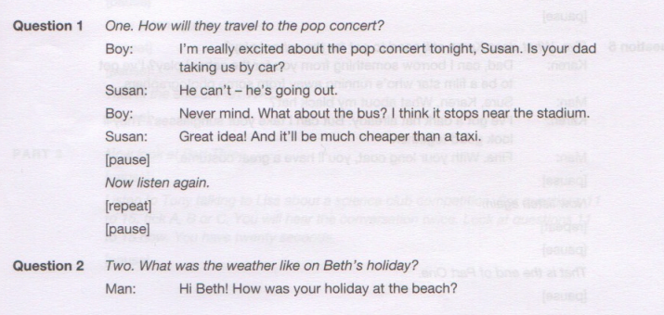

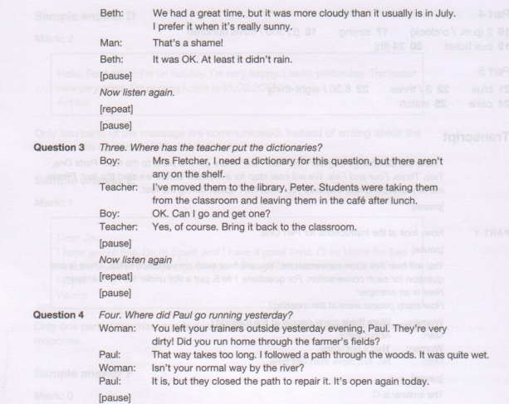

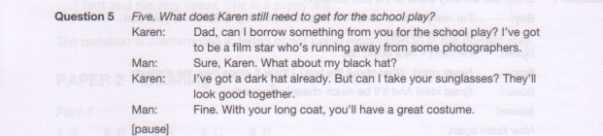

**6.B 7.A 8.D 9B 10C**

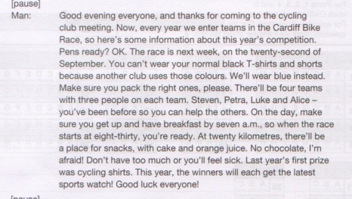

**11. tigers 12. 1765 13. kitchen(s) 14. Fishing 15. sweet(s)/ candy(ies)**

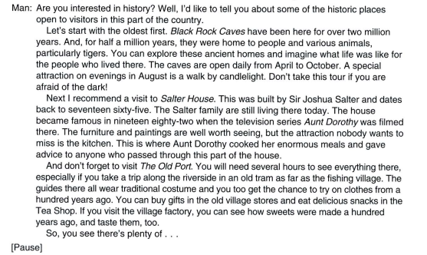

16.F 17.F 18.T 19.T 20.F

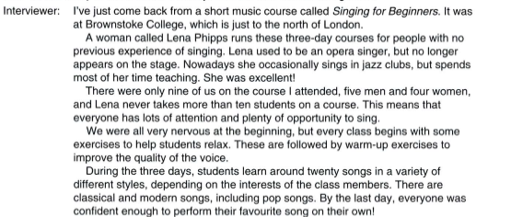

21.D 22.B 23.D 24.B 25.C 26.B 27.D 28.C 29.C

30.A 31.B 32.D

33.A 34.B 35.D

|  |  |  |  |
| --- | --- | --- | --- |
|  | **Line** | **Error** | **Correction** |
| **36** | **2** | globe | global |
| **37** | **3** | or | and |
| **38** | **4** | speak | spoken |
| **39** | **5** | used | is used |
| **40** | **8** | make | take |

**41. celebrations 42. different 43. parking 44. disagreement 45. freedom**

**46-E 47-C 48-A 49-G 50-B**

51.A 52.D 53.C 54.C 55.D 56.C 57.A 58.A 59.C 60.B

61.D 62.C 63.B 64.A 65.D 66.C 67.B 68.A 69.B 70.A.

71. => It was such a low bridge that the bus couldn't go under it.

72. => Minh suggested going out for a while.

73. => We has run out of tea.

74. Happiness depends on your optimistic thoughts.

=> The more optimistic thoughts you have, the more happy you are.

Hoặc: The more optimistically you think, the more happy you are.

75. => People in my village live on farming.

**II. This is part of a letter …………**

**Tổng 10 điểm.**

Đúng mẫu.

Đủ nội dung

Đúng ngữ pháp, sử dụng từ vựng hợp lý.

GV chấm lỗi ngữ pháp và từ vựng linh hoạt. Thêm điểm khi có sự sáng tạo, ý tưởng độc đáo.

**III. (15 pts) In about 150-170 words, write a paragraph to express your opinion on the topic:**

**Tổng 15 điểm.**

Đúng mẫu.

Đủ nội dung

Đúng ngữ pháp, sử dụng từ vựng hợp lý.

GV chấm lỗi ngữ pháp và từ vựng linh hoạt. Thêm điểm khi có sự sáng tạo, ý tưởng độc đáo.

**----------- THE END -----------**