Period
LESSON PLAN
TIẾNG ANH 10 FRIENDS GLOBAL
UNIT 1: FEELINGS
LESSON 1F: READING - PAINLESS
I. OBJECTIVES:
By the end of the lesson, Ss will be able to:
1. Knowledge:
- know some new words and expressions about accidents and injuries
- read an usual medical condition
2. Ability:
- main skills: reading and writing skills
- sub skills: listening and speaking skills
- Talk about accidents and injuries
3. Quality:
- have positive attitude in English language learning so that they can participate enthusiastically in all classroom activities, especially with the topic conducted by the teacher
- keen on reading English
II. TEACHER AIDS AND LEARNING MATERIALS:
Lesson plan, PPT slides, student’s book, workbook, notebook, personal computer (if any), projector/TV, speakers, IWB software.
III. PROCEDURES:
A. Warm-up (5’)
a) Objective: Introduce the new lesson and set the scene for Ss to acquire new language; get students' attention at the beginning of the class by means of enjoyable and short activities as well as to engage them in the steps that followed.
b) Content: Game ‘Choosing Right Rocket’ Guess the signs
c) Outcomes: Students can gain more confidence and interest in the lesson.
d) Competence: communication, collaboration, guessing
e) Organisation of the activity:
TEACHER’S ACTIVITIES | STUDENT’S ACTIVITIES | CONTENTS
WARM-UP. T-Ss/ S-S  Game ‘Choosing Right Rocket  - Divide class into groups to choose the correct answer. Invite some students to guess the signs. If the students get the correct answer, the rocket won’t disappear. If the students get it wrong, the rocket will disappear for students to choose the correct one.  - Have students read aloud and give bonus to them.  - Lead in the lesson ‘Painless’ | - Play in groups.  - With one correct answer, students will get one point.  - Read aloud.  - Open book page 16. | 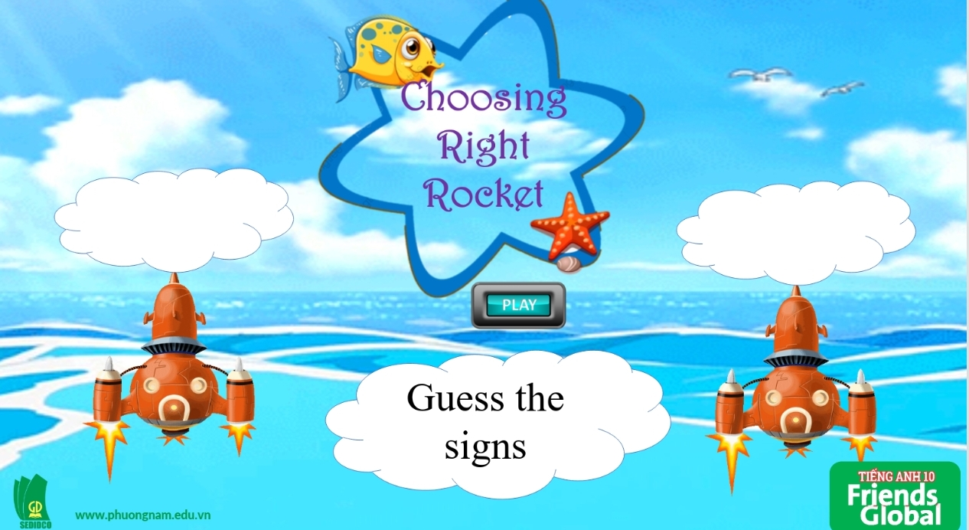  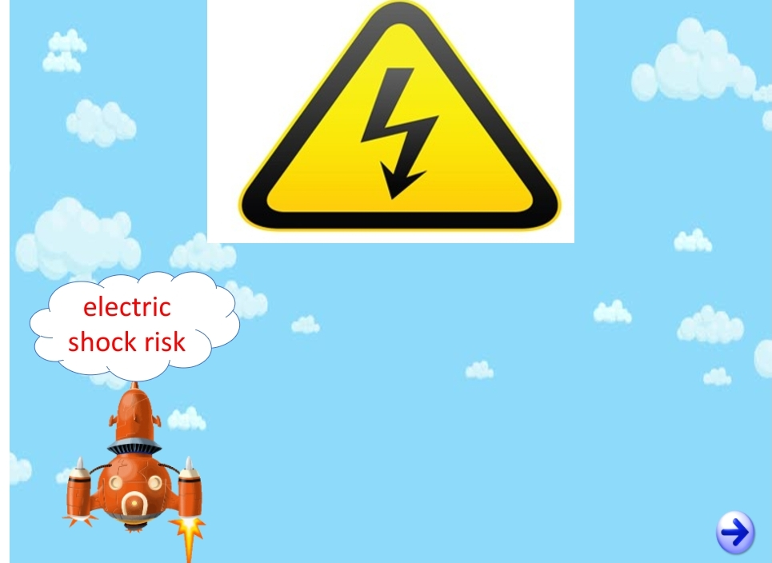  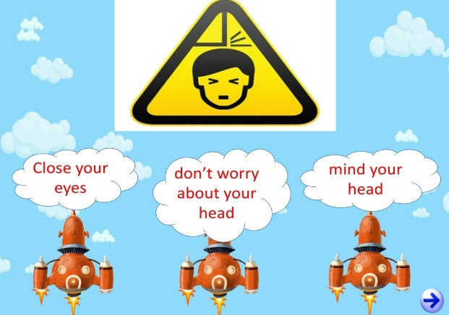

B. New lesson (35’)
- Activity 1: Presentation (10’)
a) Objective: Students get to know some words about accidents and injuries.
b) Content:
Vocabulary study
Speaking
c) Outcomes: Students know how to pronounce words correctly.
d) Competence: communication, presentation, guessing
e) Organisation of the activity:

TEACHER’S ACTIVITIES | STUDENT’S ACTIVITIES | CONTENTS
PRESENTATION. T-Ss/ S-S/ Indiv.  Activity 1 (8’): Teach new words.  - Present new vocabulary with explanations and pictures.  - Ask students to practice their pronunciation drills.  New words:  - Injury (n)  - Injure (v)  - Blood (n)  - Bleed (v)  - Bruise (n)  - Sprain (v,n)  - Burn (v, n)  - Fall/ trip/ slip over (phrasal verb)  - Sprain your ankle/ wrist (phrase)  Activity 2 (2’): Task 1 page 16. Look at the title of the text and the four warning signs (A-D). What is the connection? What do you think the text will be about?  - Ask students to look at the tittle of the text on page 17 and four signs on page 16. Encourage students to give some ideas.  - Check the answers. | - Look, listen and repeat in chorus and individuals.  - Do as what teacher said.  - Check the answer with the teacher. | 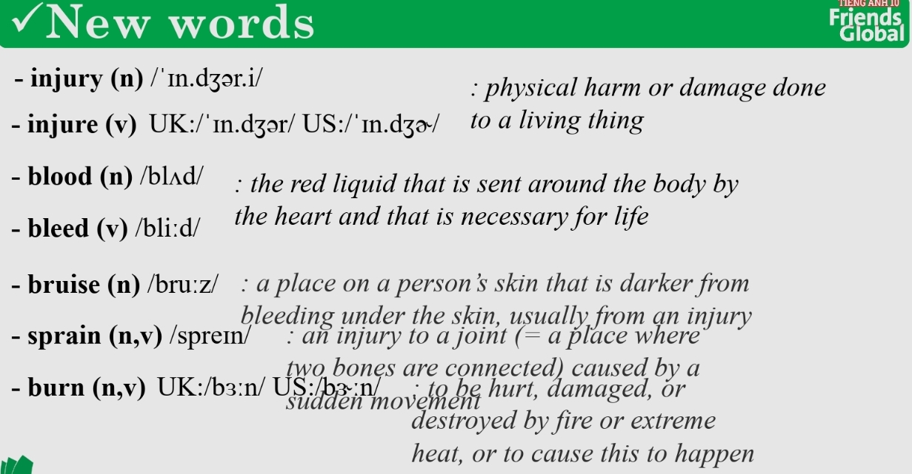  fall/ trip/ slip over: to trip or stumble and almost fall as a result of bumping into someone or something with one’s feet.  Sprain your ankle/ wrist: when your ankle/ wrist is forced to move out of its normal position.  Suggested answer:  The text is about the life of a girl who cannot feel pain.
- Activity 2 Practice (20’)
a) Objective: Students can answer the questions to critical thinking, and they can finish the tasks in the textbook. Critical thing skills (guessing/ reasoning) and communication can also be practiced.
b) Content: Students choose the correct answers. Then, complete the sentences with words in the brackets.
c) Outcomes: Students read and write, and they can apply the useful language in everyday conversations.
d) Competence: communication, collaboration, presentation
e) Organisation of the activity:
TEACHER’S ACTIVITIES | STUDENT’S ACTIVITIES | CONTENTS
PRACTICE. T-Ss/ S-S/ Indiv  Activity 1 (5’): Read the Reading Strategy and then read the text quickly to get a general idea of the meaning. Check if their ideas in exercise 1 correct.  - Ask students to read the Reading Strategy box and read the text quickly. And check if their guesses correct.  Activity 2 (2’): Task 5 page 16. Find words in the text to do with accidents and injuries. Then complete gaps 1-7.  - Ask students to find words to fill in the blanks.  - Give the answers to the class.  Activity 3 (5’): Task 3 page 16. Read the text again and match the questions with paragraph A-E of the text.  - Ask students to read the text again and match.  - Check the answers.  Activity 4 (2’): Task 4. Complete the questions using the question words below.  - Ask students to complete the task with the correct question word.  - Give the answers to the class.  Activity 5 (6’): Task 4. Work in pairs. Take turns to ask and answer the questions.  - Ask students to work in pairs to ask and answer about the questions in the exercise.  - Have students show the answers on which paragraph, line.  - Call out some pairs to ask and answer.  - Check the answers. | - Read the box and read the text quickly to get general idea.  - Complete the task.  - Check the answers with the teacher.  - Read the text again and match.  - Check the answers with the teacher.  - Read and complete the task.  - Check the answers with the teacher.  - Work in pairs. Take turns to ask and answer the questions.  - Point out where to get the answers.  - Volunteer to present their ideas.  - Check the answers with the teacher. | 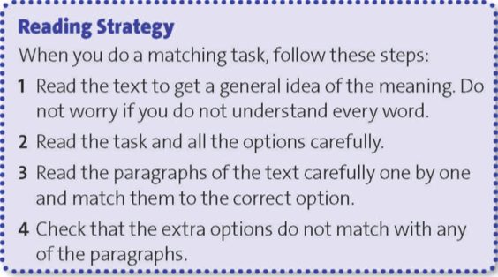  Answers:  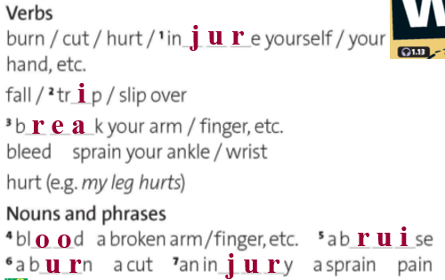  Answers:  1. B  2. E  3. A  4. C  5. D  Answers:  2. Why  3. Who  4. When  5. What  Answers:  1. (paragraph B, line 4)  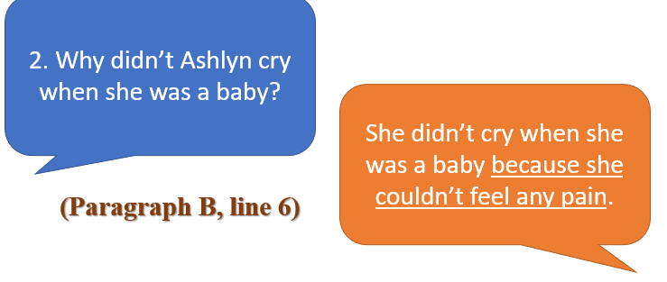  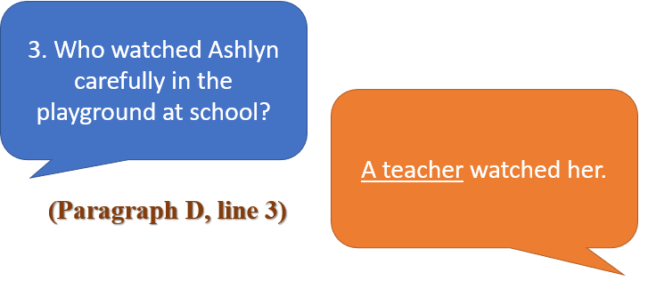  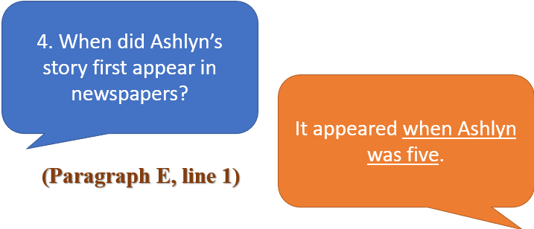  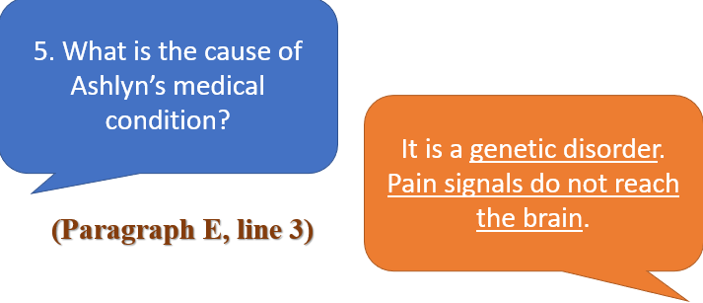

- Activity 3: Outcomes (5’)
a) Objective: Ss work in groups to talk about a time when they hurt or injured themselves and use new vocabulary.
b) Content: Game ‘Mining game’
c) Outcomes: Ss speak and listen mutually, they can apply new words and phrases they have learnt in their daily conversations.
d) Competence: Collaboration, communication, guessing
e) Organisation of the activity:
TEACHER’S ACTIVITIES | STUDENT’S ACTIVITIES | CONTENTS
PRODUCT. T-Ss/ S-S  Game ‘Mining Game’  - Ask students to work in groups and pick the amount of money they want. The harder situation comes with higher points. Click on the screen to show the situation. Press on the man to go back the main screen. | - Work in groups and pick the amount of the money they like.  - Volunteer to present their ideas. | 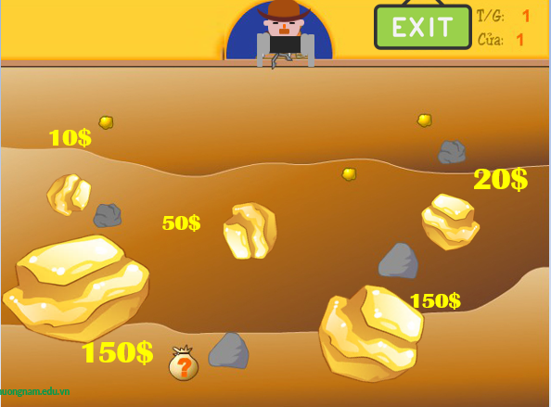  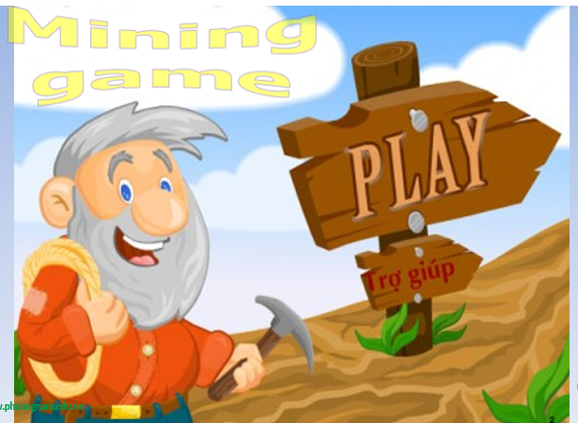  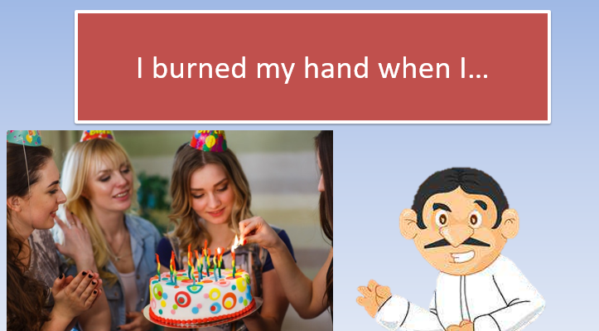  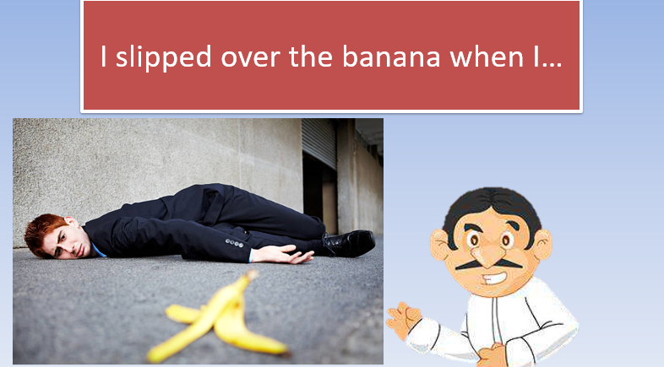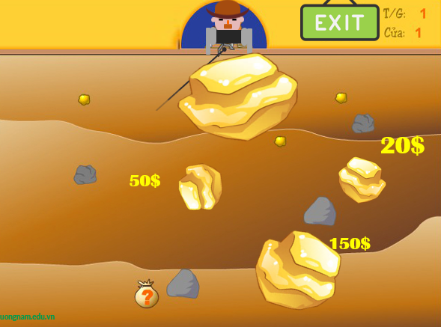
C. Consolidation (3’)
a) Vocabulary: injury, injure, blood, bleed, bruise, sprain, burn, fall/ trip/ slip over, sprain your ankle/ wrist.
b) Ways to do matching tasks
D. Homework (2’)
- Learn by heart the vocabulary about accidents and injuries
- Do exercise
- Prepare: Unit 1 – G- Speaking (page 17 – SB)

