Week 27 – Period 79  Date of planning: …./…../2021  Date of teaching: …/…../2021 | THE MID-TERM 45-MINUTE TEST
A. Objectives
1. Knowledge: By the end of the lesson, SS can review knowledge from unit 7 to unit 9. They will be able to realize their studying result and know how to learn to improve it.
Listening : - Listen and tick √ the correct picture.
- Listen and fill in the correct information.
Language focus: Choose the best answers to complete each sentence.
Reading: - Read the sentences 1-5 and match with the information in the notices A-H.
- Read the passage and circle A, B or C to complete the sentences.
Writing : - Rewrite the following sentences, using the given words.
- Write a paragraph about negative effects of tourism.
2. Competence: SS will develop some competences such as working independently and being determined, using language in the right ways.
3. Behavior: Students are hardworking and serious.
B. Teaching aids
1. Teacher: loud speaker, paper tests
2. Students: Notebooks, pens.
C. Procedures:
I. Matrix

Chủ đề | Nhận biết |  |  | Thông hiểu |  |  |  |  |  | Vận dụng |  |  |  | Céng
 |  |  |  |  |  |  |  |  |  | Thấp |  | Cao
 | TNKQ | TL |  | TNKQ |  |  |  | TL |  | TNKQ | TL | TNKQ | TL
Listening | - Listen and tick the correct picture  - Listen and complete the information
Số câu hỏi |  |  |  | 10 |  |  |  |  |  |  |  |  |  | 10
Số điểm |  |  |  | 2,5 |  |  |  |  |  |  |  |  |  | 2.5
Language focus | Choose the best answer to complete each following sentence
 | Relative clause , conditional sentences type 2, article |  |  |  | Vocabulary, V-ing
Số câu hỏi | 6 |  |  | 4 |  |  |  |  |  |  |  |  |  | 10
Số điểm | 1,5 |  |  | 1 |  |  |  |  |  |  |  |  |  | 2,5
Reading | 1. Reading sentences and do the matching with the signs.
Số câu hỏi |  |  |  | 5 |  |  |  |  |  |  |  |  |  | 5
Số điểm |  |  |  | 1 |  |  |  |  |  |  |  |  |  | 1
 | 2. Read the passage then Choose the answer for each question.
Số câu hỏi |  |  |  | 5 |  |  |  |  |  |  |  |  |  | 5
Số điểm |  |  |  | 1,5 |  |  |  |  |  |  |  |  |  | 1,5
Writing | 1. Write the sentences using the words given.
Số câu hỏi |  |  |  |  |  |  |  |  |  |  | 5 |  |  | 5
Số điểm |  |  |  |  |  |  |  |  |  |  | 1,5 |  |  | 1,5
 | 2. Write a paragraph to talk about negative effects of tourism.
 |  |  |  |  |  |  |  |  |  |  |  |  | 1 | 1
 |  |  |  |  |  |  |  |  |  |  |  |  | 1 | 1
TS câu hỏi | 6 |  |  |  |  | 24 |  |  |  | 6 |  |  |  | 36
TS điểm  Tỉ lệ % | 1,5  15% |  |  |  |  | 6  60% |  |  |  | 2,5 25% |  |  |  | 10

II. Content of the test

Teacher’s and students’ activities | The main contents
- LISTENING
Listen and tick the correct picture.(1,5p)
1. When did Gary start his new job?
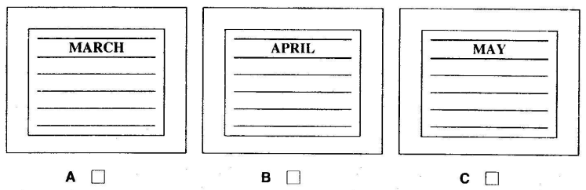
2. What time does the film start?
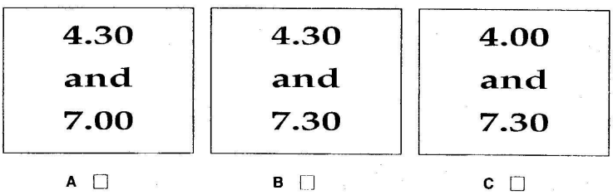
3. What was the weather like on Saturday?
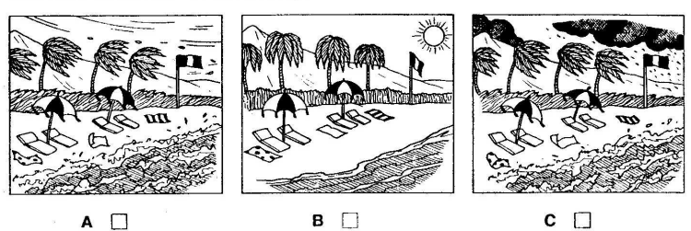
4. Which motorway will they take?
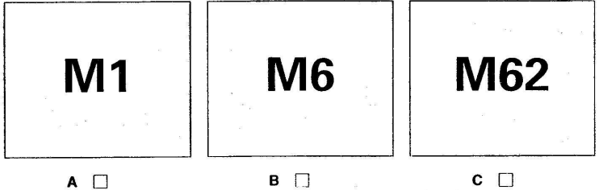
5. Which book does Lorna want?
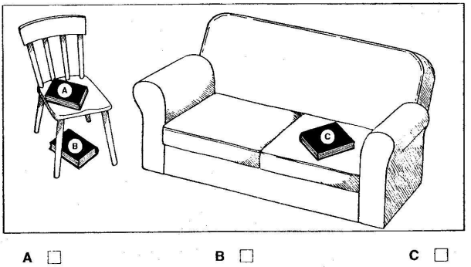
Listen and write . There is one example. (1pt)
TELEPHONE MESSAGE
To: Mr Brown
From: | 1. David ..…………………..
Not in school because he has: | 2. a bad …………………….
Students should read pages: | 3. …………… to ……………..
David will return school on: | 4. ….…………… afternoon
At: | 5. …….……………… p.m.

- GRAMMAR – VOCABULARY – LANGUAGE FUNCTION
Circle the best answer A, B or C to complete each sentence below. (2,5pts)
1. The paintings …………Mr.Brown has in his home worth about $100.000.
A. who | B. whom | C. which
2. The language that you learn to speak from birth is .……………….language.
A. official | B. first | C. second
3. Tuan: “ I’ve passed my exam. ” - Loan: “…………………. ”
A. Congratulations! B. It’s nice of you to say so C. That’s a good idea.
4. The children ………………..attend that English school receive good education.
A. who | B. whom | C. whose
5. If I had more time, I………………..a business English course.
A. will take | B. would take | C. took
6. I have ……………older brother and …………..younger sister.
A. an/a | B. a/an | C. an/an
7. All ………………must complete a visa form upon arrival the Singapore airport.
A. tourists | B. customers | C. passengers
8. If you want to keep fit , you ……………….eat less meat and do more exercises.
A. should | B. shouldn’t | C. will
9. The hotel where we are ……………….is quite luxurious.
A. living | B. staying | C. existing
10. Tom: “ Would you like to have dinner with me?” Jerry: “ …………”
A. Yes, I’d love to B. I’m very happy C. Yes, It is
C. READING
I.Read the sentences 1-5 and match with the information in the notices A-H. (1p)

1. You can’t leave your car here all day.
2 .You pay less to eat at this time.
3. If you are staying here, you may leave your car in
this place.
4. Bring a friend here for lunch and you will pay for
only one meal.
5 .You cannot drive here at the moment.

1- 2- 3- 4-

5-

II. Read the passage and choose the answer the following questions. (1,5ps)
There are about 3000 living languages in the world, but only six of them are the most important ones. Two-thirds of the world’s population speaks those languages. More than 400 million people speak English as their mother tongue. The same number of people speak it as a second language. No one knows how many people speak it as a foreign language. Chinese is the language with more speakers than English, but it is only the language for more than one billion Chinese people. English is the official language on one-fifth of the land area in the world. It is spoken in North America, Great Britain, Australia, and New Zealand. In South Africa and India it is one of the official languages. In many countries, the textbooks in universities are written in English. More than three-fourths of the world’s mail is composed in English. More than three-fifths of the radio stations broadcast programs in English. More than half of the scientific and research journals are in English. English is the language of international communication.
1. How many people speak English as a second language in the world?
A. 3000 B. 400 C. No one knows
2. How many people speak English as a foreign language?
A. 3000 B.one billion C. No one knows
3. Where is English the official language?
A. North America and Great Britain B. Australia and New Zealand C. Both are correct
4. Is English the language of national or international communication?
A. international B. national C. Yes, it is .
5. Which language has more speakers, English or Chinese?
A.English B. Chinese C. Both language have the same speakers.
D. WRITING
I. Rewrite the sentences using the suggested words given. (1,5pts)
1. Spend more time improving your pronunciation or you will get bad mark.
-> If ………………………………………………………………………………
2. He doesn’t drive carefully , so he can have an accident.
-> If he ……………………………………………………………………………..
3. I gave him a book on his birthday. It was bought from oversea. (which)
-> ……….. ………………………………………………………………………………
4. She started learning English in 1999.
-> She has ……………………………………………………………………………
5. I suggest having spaghetti and pizza tonight.
-> Let’s ………………………………………………………………………………...
II. Use the following ideas to write a paragraph of around 100 words about the negative effects of tourism(1p)
Negative effect : quality of life of the local community is changed.
Changes in lifestyle change.
Changes in cultural and traditional practices.
Changes in physical structure.
……………………………………………………………………………………………………………………………………………………………………………………………………………………………………………………………………
……………………………………………………………………………………………………………………………………………………………………………………………………………………
-----------------*********---------------
ANSWER KEY
LISTENING
Listen 1 : 1,5pts – 0,25p for each correct answer. Part 1 – Test 1 – KET 3
1C 2B 3B 4B 5A
Listen 2 : 1,0 pts – 0,2p for each correct answer. Part 4 – Test 1 – KET 3
1.Graham 2.back 3.58 to 73 4. Tuesday 5. 2.15
B. VOCABULARY – GRAMMAR – LANGUAGE FUNCTION
2,5pts – 0,25p for each correct answer.
1-A 2-B 3-C 4-A 5-B 6-A 7-C 8-A 9-B 10-A
C. READING
I. Read 1 - Part 1 : 1,0pts – 0,2p for each correct answer.
1–C 2 -G 3- E 4 -D 5- A
II. Read 2 - 1,5pts – 0,25p for each correct answer.
1-B 2-C 3-C 4-A 5-B
D. WRITING
I. Rewrite the sentences using the suggested words given. (1,5pts)
1,5pts – 0,3p for each correct answer.
1. Spend more time improving your pronunciation or you will get bad mark.
-> If you spend more time improving your pronunciation, you won’t get bad mark.
2. He doesn’t drive carefully , so he can have an accident.
-> If he drove carefully, he couldn’t have an accident.
3. I gave him a book on his birthday. It was bought from oversea. (which)
-> I gave him a book which was bought from oversea on his birthday.
4. She started learning English in 1999.
-> She has learnt English since 1999.
5. I suggest having spaghetti and pizza tonight.
-> Let’s have spaghetti and pizza tonight.
II. Use the following ideas to write a paragraph of around 100 words about the negative effects of tourism(1p)

Correct form : 0,2
Fullfil task/content : 0,2
Correct grammar : 0,2
Good punctuation , correct word : 0,2
Good creativeness : 0,2p
Listen ad remember. | III. SUMMARY & HOMEWORK  Prepare next lesson :  Unit 10– A CLOSER LOOK 1
-------------------------------------------------/
Week 27 – Period 80  Date of planning: …./…../2021  Date of teaching: …/…../2021 | UNIT 10: SPACE TO TRAVEL  Lesson 2: A closer look 1

I. OBJECTIVES:
1. Knowledge: By the end of this lesson, students will be able to:
- use the lexical items related to astronomy and space travel
- identify continuing or finishing tones and say sentences with the correct intonation
a. Vocabulary: vocabulary related to astronomy and space travel
b. Grammar: Past simple and past perfect(review)
c. Pronunciation: continuing or finishing tones
d. Skills: Filling the gaps with the verbs provided, choosing a word/ phrase in the box to fill each blank, matching practicing saying, playing game, asking and answering.
2. Competence development: Groupwork, independent working, pair work, linguistic competence, cooperative learning and communicative competence.
3. Behavior: Ss will be more responsible for and be more aware of discovering and developing space to travel.
II. TEACHING AIDS
1. Teacher: Textbooks, computer, projector, plan.
2. Students: Textbooks.
III. PROCEDURE
1. Checking: During the lesson
2. New lesson:

Teacher’s and students’ activities | Content
- Warm up- 7’
a. Aim: Play game about the denitions to guess the planets to warm up the class
b. Content : Play a game.
c. Outcome: Ss can attract to the lesson and have knowledge about the planets.
d. Performance:
Groupwork: (Activity 4)  This game can be played in small groups in two rounds.  In the first round, all groups will read the denitions to guess the planets.  The game will be timed.  The group who is quickest to have all correct answers is the winner. | GAME: Which planet of our solar system is being describle in each sentence? Guess the planets, and write their names.  1.Venus  2. Mercury  3. Jupiter  4. Mars  5. Neptune  6. Earth  7. Saturn  8. Uranus
- Presentation – 8’
a. Aim: Ss can know some vocabulary related to astronomy and space travel
b. Content : Learn some vocabularies.
c. Outcome: Ss can know some vocabulary related to astronomy and space travel
d. Performance:
T elicit some vocab in part 1  Check vocabulary : what and where  -T asks Ss to work individually to do this exercise (remind them to modify the verbs where necessary) and then compare their answers with a classmate. | I. VOCABULARY  -orbit (v) : xoay quanh  (n) :đi theo quỹ đạo  -launch (v) : phóng (vệ tinh)  -a flight suit (n) : trang phục cho phi công(guessing)  -space suit (n) : trang phuc du hành vũ trụ

3. Practice- 18’
a. Aim: Ss can practice doing exercises
b. Content : Do the following tasks:
+ Fill the gaps with the verbs provided
+ Choose a word/ phrase in the box to fill each blank.
+ Match these space – related idioms to their meanings then practice saying them with a partner.
+ Pronunciation
c. Outcome: Ss can use the lexical items related to astronomy and space travel and they can identify continuing or finishing tones and say sentences with the correct intonation.
d. Performance:
Activity 1:  Have Ss work individually to complete the exercise. Remind them to modify the verbs where necessary.  They then compare their answers in pairs.  For a more able class, after Ss have finished, ask them which word(s) can be used as a noun as well. Give feedback: orbit, experience, launch. Ask Ss to make sentences with these nouns.  Activity 2:  For this exercise, remind Ss of some words about space they have learnt earlier, for example: astronaut, jet pilot, weightlessness, water tank laboratory, microgravity.  Then have Ss work individually to complete the exercise. Ask Ss to pay attention to the key words to understand the text, as well as to the part of speech of the missing words.  Activity 3:  a/ As a class, ask Ss to cover the boxes on the right so that they can attempt to guess the meaning of the idioms first. Then they uncover the boxes and do the matching exercise. Check the answers as a class, and make sure the idioms are understood before moving on to  b/ Have Ss then work in pairs to make short dialogues using the idioms they have learnt.  T explains the way to use: Continuing or finishing tones and then gives examples  Ss listen and remmember and then give examples  T asks Ss to listen and to work in pairs to practise saying the statements and short dialogues in activity 5. Play the recording and have Ss check their pronunciation.  Ss listen and practice in pairs | 1. Fill the gaps with the verbs provided  - Orbit  2. Experienced  3. Launched  4. Landed  5. Trained  2. Choose a word/ phrase in the box to fill each blank.  1. good health  2. A flight suit  3. Parabolic flights  4. operate  5. spacewalks  3a. Match these space – related idioms to their meanings  - over the moon : delighted  - once in a blue moon : occasionally  - out of this world: amazing  - The sky’s the limit: almost without limit  3b. Now practice saying them with a partner.  Eg:  A: How often do you play football?  B: Oh, once in a blue moon  II. Pronunciation  Continuing or finishing tones  When we say a list of things, we raise our voice on each item on the list to show that the list has not finished, and lower our voice at the end of the last thing to show we have finished.  Activity 5: Listen and practise
4. Application – 10’
a. Aim: Ss can practise about the real situations
b. Content : List the names of the planets in the solar system.
c. Outcome: Ss can list the names of the planets in the solar system with their partner.
d. Performance:
T has Ss work in pairs to do the task: ask them to think of other situations when they tell other people lists of things. Ask Ss to work in pairs to play out the situations.  Ss work in pairs | Eg:  I’d learnt about the planets, the stars, satellites, rockets and stuff.

3. Guides for homework- 2’
- Write new words then learn them by heart.
- Copy the exercise into notebooks.
- Prepare A CLOSER LOOK 2
-----------------------------------------------------/
Week 27 – Period 81  Date of planning: …./…../2021  Date of teaching: …/…../2021 | UNIT 10: SPACE TO TRAVEL  Lesson 3: A CLOSER LOOK 2

I. OBJECTIVES:
1. Knowledge: By the end of this lesson, students will be able to:
- Use Past simple and past perfect correctly with confidence
Use defining relative clauses correctly and appropriately
a. Vocabulary: vocabulary related to astronomy and space travel
b. Grammar: Past simple and past perfect(review)
c. Skills: Look at the timeline and put the verbs in brackets into the correct tense, asking and answering, sentences completion, combining each pair of sentences into one using the prompts provided, practising the dialogue.
2. Competence development: Groupwork, independent working, pairwork, linguistic competence, cooperative learning and communicative competence.
3. Attitude: Ss will be more responsible for and be more aware of discovering and developing space to travel.
II. TEACHING AIDS
1. Teacher: Textbooks, computer, projector, plan.
2. Students: Textbooks.
III. PROCEDURE
1. Checking: During the lesson
2. New lesson:

Teacher’s and students’ activities | Content
- Warm up- 5’
a. Aim: To warm up the class and lead in the new lesson
b. Content : Review the past perfect.
c. Outcome: Ss can attract to the lesson and remind the past perfect.
d. Performance:
* Checking up: When we use the Past perfect? | The Past perfect is used to describe an action before a stated time in the past or an action that happened before another action in the past.  Form: S + had + PP
- Presentation- 10’
a. Aim: Ss can review the past simple & past perfect and relative clause
b. Content : Grammar:
+ Review the past simple and past perfect.
+ Defining relative clauses
c. Outcome: Ss can remind the past simple & past perfect and relative clause and their using.
d. Performance:
T asks Ss to retell the past simple and past perfect.  Ss retell the past simple and past perfect and give examples.  T explains the way to use A defining relative clause  Ss listen and remember | I. PAST SIMPLE & PAST PERFECT: REVIEW  II. DEFINING RELATIVE CLAUSES  A defining relative clause gives essential information about someone or something we are talking about. This is the information that we need in order to understand What or Who is being referred to.  Eg:  - The relative clause is used to define a subject:  The student who won the competition is my cousin.  - The relative clause is used to define an object.  The rock that they found last week may have landed on Earth from the moon.
- Practice- 18’
a. Aim: Ss can do exercises about the past simple & past perfect and relative clause
b. Content : Do the following tasks:
+ Look at the timeline and put the verbs in brackets into the correct tense.
+ Add the missing add of birth to the box, choose an event from the timeline. Ask and answer the Qs.
+ Fill in the blank with a word/ phrase in the box
+ Combine each pair of sentences into one, using the prompts provided.
c. Outcome: Ss can remind the past simple & past perfect and relative clause and their using.
d. Performance:
Activity 1:  1 Remind Ss of how to use the past simple and past perfect.  Have Ss then work individually to complete the exercise. Tell Ss to pay attention to the position of already in the sentences.  Activity 2:  Ask Ss to complete the box with T’s year of birth and their own year of birth. Then ask Ss to check where the dates fit into the timeline. Ss can write out the dates and events from the timeline along a line drawn on a piece of paper. They can then add in this task four additional dates.  Have Ss now work in pairs to talk about these events. Remind them to use the word already. Walk around the class and provide help if necessary. Call on some pairs to give their questions and answers in front of the class.  Defining relative clauses  Activity 3:  - Draw Ss’ attention to the grammar box and Look out! box. Give more examples if necessary. Ensure Ss have understood the rules before moving on.  Have Ss work individually to complete the exercise and then compare their answers with a partner. Remind Ss that a relative pronoun may not be required to complete the sentences (indicated in the key with a cross).  Activity 4:  - Have Ss work individually to complete the exercise and then compare their sentences with a partner.  Remind Ss that a relative pronoun may not be required to complete the sentences – this is indicated in the key with a cross (x). | 1. Look at the timeline and put the verbs in brackets into the correct tense.  Key :  - Had been sent; made  - Became ; had (already) been launched  - Had flown; flew; walked  - Put; had already sent  - Was established; had (already) travelled  2/. Add the missing add of birth to the box, choose an event from the timeline. Ask and answer the Qs.  3a/ Fill in the blank with a word/ phrase in the box  *Key:  1. Who/ that  2. Where  3. Which/ that/x  4. which/ that  5. Which/ that/x  6. when  4/ Combine each pair of sentences into one, using the prompts provided.  Key:  - The film which/ that/x the class watched yesterday was about the Apollo 13 space mission.  - We read an astronaut who travelled into space 1961.  - This is the man who works for NASA.  - The team who/ that plays on the left has never won the championship.  - The ground – breaking space mission which/ that/x this article describes is called Rosetta.  - The task which/ that/x the Rosetta mission has is comparable to fly trying to land on a speeding bullet.
- Application – 10’
a. Aim: Ss can practise talking about someone, something or some moments in space exploration history
b. Content : In pairs, use the information from the timeline to talk about someone, something or some moments in space exploration history. Don’t mention their exact name so that the other has to guess.
c. Outcome: Ss can talk about someone, something or some moments in space exploration history.
d. Performance:
- This activity can be done as pair work or a game between two big groups. One student or group describes  the object/person/event using defining clauses for the other student or group to guess.  - Ss work in pairs/ groups, one student in the group describes the object/ person/ event using defining clauses for the other student or group to guess  Ex: It’s the dog that was the first dog ever fly into space  - That’s Laika!  Question for the good students:  Have you ever met an Astonaut? If you met his or her, what would you want to know?  Question for the bad students:  Do you want to become a Pilot? | In pairs, use the information from the timeline to talk about someone, something or some moments in space exploration history. Don’t mention their exact name so that the other has to guess.

3. Guides for homework- 2’
- Write new words then learn them by heart.
- Copy the exercise into notebooks.
- Do Ex 6 at home.
- Copy the answers into your notebooks
- Review the grammar notes
- Do exercises in workbook.
- Prepare COMMUNICATION
=======================================/
Date of checking……../………/2021
……………………………………..
……………………………………..
……………………………………..
Vũ Thị Đua

