|  |  |
| --- | --- |
| **Tiếng Anh 8 Friends Plus** | **FP 8 - UNIT 3 - TEST 1**  **Test for Unit**  *Thời gian làm bài: 40 phút (Không kể thời gian giao đề)*  *-------------------------* |

**I. Pronunciation (1-4)**

**Câu 1.** Which word has the underlined part pronounced differently from that of the others?

**A.** adventure  **B.** lasagne  **C.** carry  **D.** yoga

**Câu 2.** Which word has the underlined part pronounced differently from that of the others?

**A.** pay  **B.** cave  **C.** valley  **D.** sensation

**Câu 3.** Which word has a different stress pattern from that of the others?

**A.** surprise  **B.** amaze  **C.** inspire  **D.** desert

**Câu 4.** Which word has a different stress pattern from that of the others?

**A.** kayaking  **B.** rainforest

**C.** opponent  **D.** skydiving

**II. Choose the answer (A, B, C or D) that best fits the space in each question. (5-14)**

**Câu 5.** Have you ever been on an adventure?

**A.** My favourite colour is green.

**B.** It's a rainy day today.

**C.** Yes, I have been on a few adventurous trips, such as hiking and camping in the mountains.

**D.** I have a pet cat. She is very adventurous.

**Câu 6.** I _____ my keys. Can you help me look for them?

**A.** have lost  **B.** lost

**C.** was losing  **D.** had lost

**Câu 7.** We _____ our project yet.

**A.** haven't finished  **B.** hadn't finished

**C.** didn't finish  **D.** weren't finishing

**Câu 8.** We explored a ___________ on our hike and it was amazing!

**A.** opponent  **B.** adventure  **C.** cave  **D.** desert

**Câu 9.** I went ___________ in the river for the first time and it was so much fun!

**A.** inspiration  **B.** sail

**C.** skydiving  **D.** kayaking

**Câu 10.** We're going to ___________ at a convenience store to grab some food.

**A.** leave behind  **B.** stop off

**C.** carry on  **D.** inspire

**Câu 11.** She _____ to Paris three times.

**A.** was  **B.** has been  **C.** were  **D.** had been

**Câu 12.** I love going on ___________ with my friends.

**A.** adventure  **B.** valley  **C.** dune  **D.** yacht

**Câu 13.** Even though it's tough, I'm going to ___________ with my studies.

**A.** inspire  **B.** stop off

**C.** leave behind  **D.** carry on

**Câu 14.** They _____ each other for 10 years.

**A.** knew  **B.** have known

**C.** were knowing  **D.** had known

**III. Look at the signs. Choose the best answer (A, B, C or D). (15-16)**

**Câu 15.**

What is true about the Costa Rica advertisement?

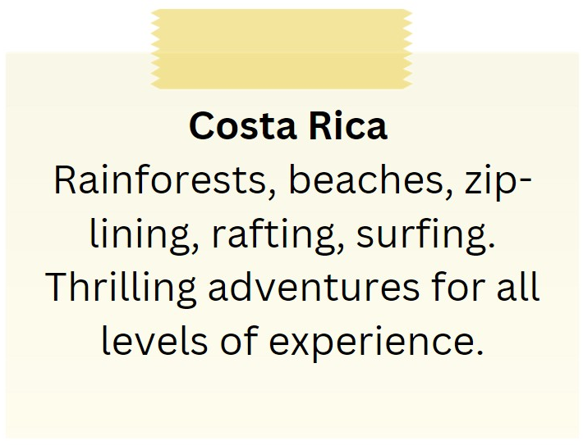

**A.** It focuses on relaxation and scenic beauty.

**B.** It offers thrilling adventures only for experienced individuals.

**C.** It features rainforests, beaches, zip-lining, rafting, and surfing.

**D.** It is a destination exclusively for nature lovers.

**Câu 16.**

What is true about the New Zealand advertisement?

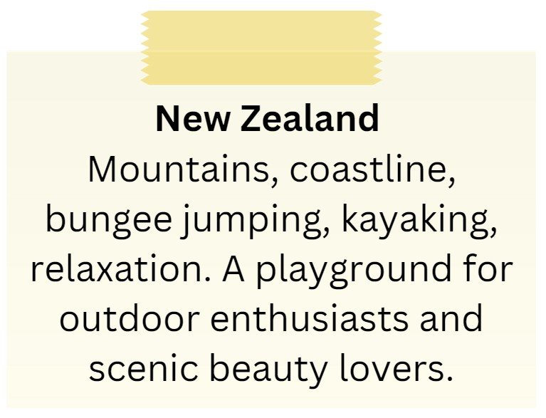

**A.** It highlights mountains, coastline, bungee jumping, and kayaking.

**B.** It is a destination for indoor activities and cultural experiences.

**C.** It is not suitable for outdoor enthusiasts.

**D.** It primarily appeals to relaxation enthusiasts.

**IV. Read the following passage and do as direct. (17-22)**

Ha Giang is a mountainous province located in the far north of Vietnam, bordering China. It is a place of breathtaking natural beauty, with towering limestone cliffs, winding rivers, and steep, terraced fields that are a vivid green in the summer months. Ha Giang is also home to a number of ethnic minority groups, including the Hmong, Tay, and Dao, who have preserved their traditional way of life for centuries.

One of the most popular attractions in Ha Giang is the Dong Van Karst Plateau, which was declared a UNESCO Global Geopark in 2010. Visitors can explore the area on foot or by motorbike, taking in the stunning scenery and learning about the geological history of the region. Other popular activities in Ha Giang include trekking, homestays with local families, and visiting the lively Sunday markets in towns like Dong Van and Meo Vac.

Despite its remote location, Ha Giang is becoming an increasingly popular destination for travellers seeking an authentic cultural and outdoor experience in Vietnam. With its rugged landscapes and rich cultural heritage, Ha Giang is a must-visit destination for anyone looking to explore the beauty and diversity of northern Vietnam.

**Câu 17.** Ha Giang is a province in central Vietnam.

**A.** False  **B.** True

**Câu 18.** The Dong Van Karst Plateau in Ha Giang is a UNESCO World Heritage Site.

**A.** False  **B.** True

**Câu 19.** Ha Giang is home to only one ethnic minority group.

**A.** False  **B.** True

**Câu 20.** Ha Giang is an unpopular destination for travellers.

**A.** False  **B.** True

**Câu 21.** What is the Dong Van Karst Plateau in Ha Giang?

**A.** A popular beach destination  **B.** A historic temple complex

**C.** A wildlife sanctuary  **D.** A UNESCO World Heritage Site

**Câu 22.** What is one popular activity to do in Ha Giang?

**A.** Trekking  **B.** Scuba diving

**C.** Shopping  **D.** Skiing

**V. Choose the word (A, B, C or D) that best fits the blank space in the following passage. (23-28)**

What is badminton?

Badminton is a racket sport that is **_____23____** around the world. It involves hitting a shuttlecock over a net and trying to make it land in your opponent's court.

How long has it been a sport?

Badminton has **____24_____** for centuries, with roots in ancient games and sports played in Asia and Europe.

Do I need to be in good **_____25____** to play badminton?

Badminton is a great sport for anyone looking to **_____26____** their fitness and agility. It can be played at a leisurely pace or at a high level of intensity.

What equipment do I need?

To play badminton, you will need a **_____27____** and shuttlecocks. You should also wear comfortable athletic clothing and shoes with good traction.

What are the best places for badminton?

Badminton can be played indoors or outdoors, but it is usually played in a gym or on a badminton court. Many gyms and community centres offer badminton facilities, and there are also dedicated badminton **_____28____** and leagues in many areas.

**Câu 23.** Badminton is a racket sport that is _____ around the world.

**A.** played  **B.** watched  **C.** ignored  **D.** disliked

**Câu 24.** Badminton has _____ for centuries.

**A.** been watched  **B.** been disliked

**C.** been ignored  **D.** been played

**Câu 25.** Do I need to be in good _____ to play badminton?

**A.** clothes  **B.** shape  **C.** location  **D.** mood

**Câu 26.** Badminton is a great sport for anyone looking to _____ their fitness and agility.

**A.** increase  **B.** ignore  **C.** reduce  **D.** decrease

**Câu 27.** To play badminton, you will need a _____ and shuttlecocks.

**A.** bat  **B.** stick  **C.** racket  **D.** ball

**Câu 28.** Many gyms and community centres offer badminton facilities, and there are also dedicated badminton _____ and leagues in many areas.

**A.** courts  **B.** rinks  **C.** fields  **D.** pools

**VI. Supply the correct form of the word given in each sentence. (29-34)**

**Câu 29.** Please review and make any ____________ to your essay before submitting it. (correct)

**Câu 30.** The motivational speaker's speech has ____________ the audience to chase their dreams. (inspiration)

**Câu 31.** Tom is ____________ and loves to try new things. (adventure)

**Câu 32.** Many students ____________ in extracurricular activities like sports and music. (participant)

**Câu 33.** This job requires someone who is ____________ in the field of finance. (experience)

**Câu 34.** Harry Potter is one of the most ____________ book series in the world. (populous)

**VII. Rearrange the groups of words in a correct order to make complete sentences. (35-36)**

**Câu 35.** before, but I am / on a solo adventure / for next month. / planning one / I have never been

…

**Câu 36.** adventure to / went on an / climb a mountain. / Last summer, I

…

**VIII. Rewrite each of the following sentences in another way so that it means almost the same as the sentence printed before it. (37-40)**

**Câu 37.** She last went to Phu Quoc Island 3 years ago.

She hasn’t …

**Câu 38.** When did you start writing this book?

How long …

**Câu 39.** This is the first time I have seen this movie.

I haven’t ……

**Câu 40.** They started studying English when they were in grade 3.

They have………

**IX. Listening: listen and do as direct.**

**Câu 41.** Friend 1 is planning a trip to Europe this summer.

**A.** True  **B.** False

**Câu 42.** Friend 2 has visited Europe before.

**A.** True  **B.** False

**Câu 43.** Friend 1 is thinking about visiting Paris, Amsterdam, and Rome.

**A.** False  **B.** True

**Câu 44.** They are planning to stay in Europe for a month.

**A.** True  **B.** False

**Câu 45.** Friend 2 is excited to have a travel buddy for the trip.

**A.** True  **B.** False

**Câu 46.** What is Friend 1's plan for the summer?

**A.** Spend time with family  **B.** Go to the beach

**C.** Visit Europe  **D.** Stay at home

**Câu 47.** Has Friend 2 ever been to Europe before?

**A.** Yes  **B.** Can't say

**C.** Not mentioned  **D.** No

**Câu 48.** Which cities is Friend 1 considering visiting?

**A.** Copenhagen, Stockholm, and Oslo  **B.** Berlin, Madrid, and Prague

**C.** London, Barcelona, and Vienna  **D.** Paris, Amsterdam, and Rome

**Câu 49.** How long are they planning to stay in Europe?

**A.** Two weeks  **B.** One week

**C.** Six months  **D.** One month

**Câu 50.** Is Friend 2 excited to have a travel buddy?

**A.** Yes  **B.** No

**C.** Not mentioned  **D.** Not really

**----HẾT---**