School: ……………………………………….. | Date:…………………………………..
Class: ……………………………..................... | Period: ………………………….........

UNIT 6: EDUCATION
Lesson 1.2 - Grammar (page 45)

I. OBJECTIVES
By the end of the lesson, Ss will be able to:
1.1. Language knowledge and skills
- listen to 2 people asking and answering about making a plan.
- use “have to”, “has to” for obligation expression.
- talk about things they have to / don’t have to do at home or at school.
1.2. Competences
- improve speaking, listening skills.
- improve the use of English.
1.3. Attributes
- be responsible for school work and housework.
- have a balance between studying and relaxing.

II. TEACHING AIDS AND LEARNING MATERIALS
1. Teacher’s aids: Student book and Teacher’s book, class CDs, Digital Book (DCR phần mềm tương tác SB, DHA (từ vựng/ cấu trúc) phần mềm trò chơi tương tác), projector/interactive whiteboard / TV (if any), PowerPoint slides, handouts.
2. Students’ aids: Student’s book, workbook, notebook, handouts.

III. ASSESSMENT EVIDENCE
Performance Tasks | Performance Products | Assessment Tools
- Listen and repeat. | - Ss’ performance. | - T’s feedback.
- Write sentences with have to using the prompts. | - Ss’ answers. | - T’s feedback/Peers’ feedback.
- Fill in the blanks with have to, has to, don't have to, or doesn't have to. | - Ss’ answers. | - T’s feedback/Peers’ feedback.
- Speak: What things do/don't you have to do at home or at school? | - Ss’ answers/ presentation. | - T’s observation, T’s feedback/Peers’ feedback.

IV. PROCEDURES
A. Warm up: (5’)
a) Objective: Introduce the new lesson and set the scene for Ss to acquire new language; get students' attention at the beginning of the class by enjoyable and short activities as well as to engage them in the follow-up steps.
b) Content: Review words about school tasks.
c) Expected outcomes: Ss review old vocabularies which are very useful for them in the new lesson.
d) Organization of the activity:
TEACHER’S ACTIVITIES | STUDENTS’ ACTIVITIES
- Option 1: Phone code  - Have Ss close books and notebooks.  - Have Ss look at the phone code and write the correct words.  - Call Ss to give answers.  - Check Ss’ answers, give feedback.  *Codes:  1. 33 7777 7777 2 999  2. 8 33 7777 8  3. 44 666 6 33 9 666 777 55  4. 7 777 666 5 33 222 8  5. 44 2 888 33 8 666    - Have Ss make sentences, using the words they have just made.  - Lead to the new lesson.  - Option 2: Matching  - Have Ss close all books and notebooks.  - Have Ss do the matching activity.  - Call Ss to give answers, tell the meaning of the phrases again.  - Check Ss’ answers, give feedback.  - Lead to the new lesson.  *Illustration  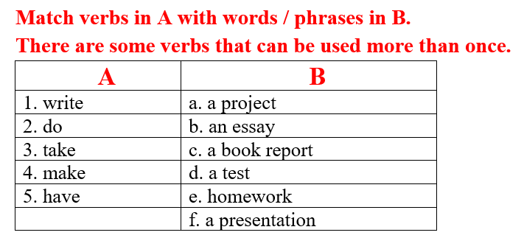 | - Close books and notebooks.  - Work in pairs.  - Give answers.  Answers keys  1. essay  2. test  3. homework  4. project  5. have to  - Make sentences.  - Close books and notebooks.  - Work in pairs to match.  - give answers, tell the meaning of the phrases.  - Listen and write the new lesson.  Answers keys  1. write: an essay, a book report  2. do: a project, a test, homework  3. take: a test  4. make: a presentation  5. have: a project, an essay, a book report, a test, homework, a presentation

B. New lesson (35’)
- Activity 1: Presentation (10’)
a) Objective: Introduce: “have to” and “has to”.
b) Content:
- Listen and repeat.
- Introduce the grammar points.
c) Expected outcomes: Ss know the new grammar points (“have to” and “has to”) and use them in some exercises that follow.
d) Organization of the activity:
TEACHER’S ACTIVITIES | STUDENTS’ ACTIVITIES
Task a. Listen and repeat  - Have Ss look at the picture using DCR.  - Play audio (CD1 – Track 61) and have Ss listen and read the speech bubbles.  - Play the audio again and have Ss listen and repeat.  Grammar box  - Option 1:  - Have Ss look at the grammar explanation and read.  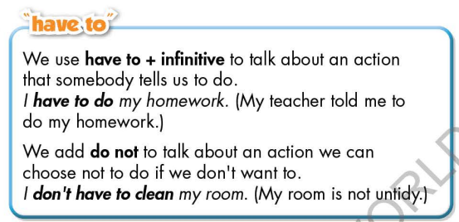  - Have Ss look at the box and read examples of different forms.  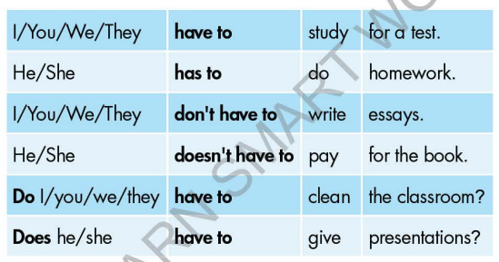  - Explain more about “have to”, “has to” to express obligation.  - Ask Ss to make more sentences using “have to”, “has to” to express obligation.  - Give feedback and evaluation.  - Option 2:  - Have Ss look at the sentences in the speech bubbles in Task a and read them again.    - Have Ss make comments on the verb in bold.  - Give feedback.  - Have Ss look at the examples, read and answer the question: Does teacher often ask you to do these activities at school?  - Then, lead to the grammar box, briefly explain the way to use “have to” and “has to”.  - Have Ss read the grammar box again.  - Ask Ss to make more sentences using “have to”, “has to” to express obligation.  - Give feedback and evaluation. | - Look.  - Listen, then read.  - Listen and repeat.  - Look and read.  - Read examples of different forms.  - Listen.  - Give more examples.  - Look and read.  - Comment.  - Read.  - Give more examples.  - Listen.
- Activity 2: Practice (19’)
a) Objective: Students can use “have to”, “has to” to do the given exercises.
b) Content:
- Write sentences with have to using the prompts.
- Fill in the blanks with have to, has to, don't have to, or doesn't have to.
c) Expected outcomes: Students can get used to the form and usage of use “have to”, “has to” and use them correctly.
d) Organization of the activity:

TEACHER’S ACTIVITIES | STUDENTS’ ACTIVITIES
Task b. Write sentences with “have to” using the prompts.  - Demonstrate the activity on DCR, using the example.  - Have Ss write sentences with “have to” using the prompts.  - Have Ss work in pairs to check each other’s work.  - Have some Ss share their answers with the whole class.  - Give feedback, correct Ss’ answers if necessary.  Task c. Fill in the blanks with have to, has to, don't have to, or doesn't have to.  - Demonstrate the activity on DCR using the example.  - Have students fill in the blanks with have to, has to, don't have to, or doesn't have to.  - Have pairs check each other's work.  - Have some students share their answers with the class. | - Look and listen.  - Work individually.  - Work in pairs.  - Write answers.  Answer keys  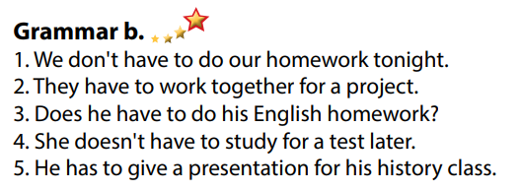  - Look and listen.  - Work individually.  - Work in pairs.  - Read answers, explain.  Answer keys  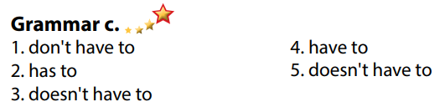

- Activity 3: Production (6’)
a) Objective: Students master the grammar points they study in the lesson.
b) Content: Speaking: What things do/don't you have to do at home or at school?
c) Expected outcomes: Ss produce the new language successfully, and they can use the grammar point in the lesson in everyday speaking and writing.
d) Organization of the activity:
TEACHER’S ACTIVITIES | STUDENTS’ ACTIVITIES
Task d. In pairs: What things do/don't you have to do at home or at school?  - Divide class into pairs.  - Have Ss take turns asking their partner about what things do/don't they have to do at home or at school?  - Have some pairs demonstrate the activity in front of the class.  - Give feedback and evaluation. | - Have conversation in pairs.  - Present.  - Listen.  Suggested answers  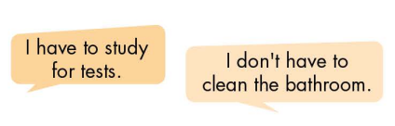

C. Consolidation and homework assignments (5’)
* Consolidation:

* Homework:
- Make 4 sentences using have to / has to / don’t have to / doesn’t have to.
- Do the exercises in WB: Grammar (page 33).
- Complete the grammar notes in Tiếng Anh 7 i-Learn Smart World Notebook (page 37).
- Play consolation games in Tiếng Anh 7 i-Learn Smart World DHA App on www.eduhome.com.vn
- Prepare: Lesson 1.3 – Pronunciation and Speaking (page 46 – SB).

D. Reflection
a. What I liked most about this lesson today:
…………………………………………………………………………………………
- What I learned from this lesson today:
…………………………………………………………………………………………
c. What I should improve for this lesson next time:
…………………………………………………………………………………………

