UNIT 2: LIFE IN THE COUNTRYSIDE
I.Vocabulary:
Word | Meaning | Picture | Examples
Beehive(n)  /’bi:haiv/ | Tổ ong | 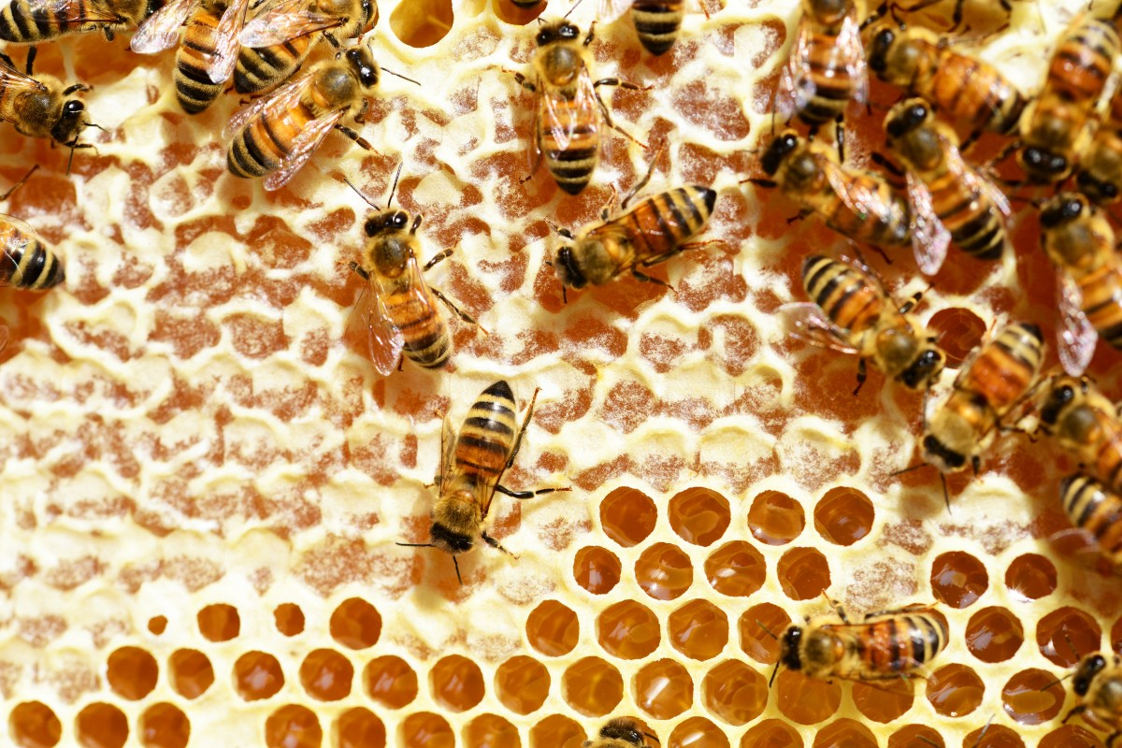 | Look! There is a beehive on the tree.
Cattle(n)  /ˈkætl/ | Gia súc | 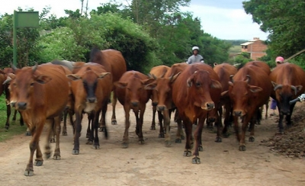  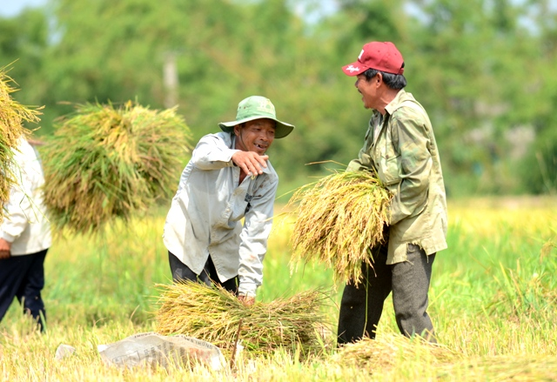 | There is a herd of cattle over there.
Crop(n) /krop/ | Vụ mùa |  | We are looking forword to  a bumper crop
Dairy product/ˈdeəriˈprɒdʌkt/ | Sản phẩm từ sữa  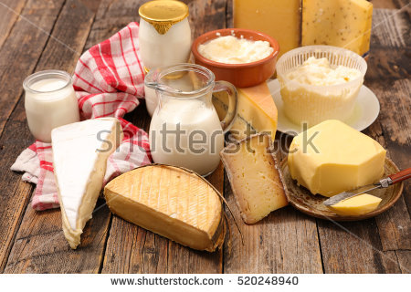 |  | The doctor advised me to eat more dairy products.
Densely(adv) /densli/ | Dày đặc   | 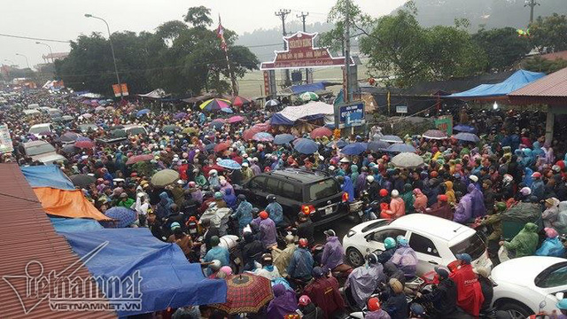 | I don’t want to live in a densely populated area.
Disturbing(adj) /dɪˈstɜːbɪŋ/ | Gây khó chịu  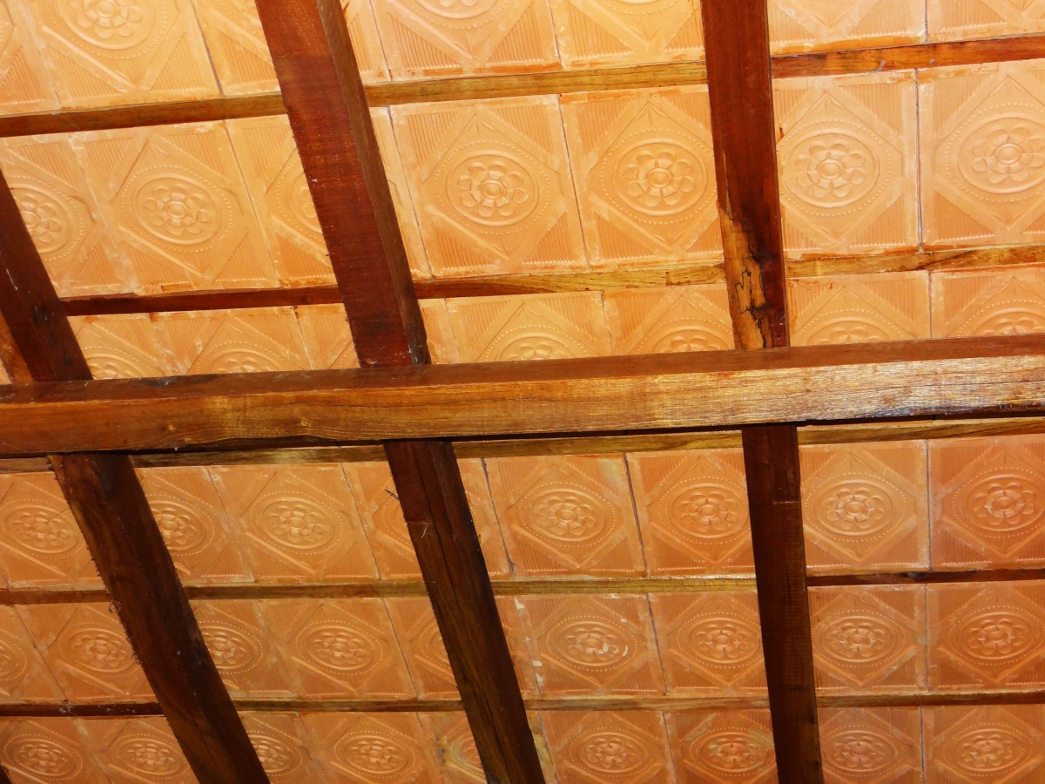 |  | Don’t make such disturbing noise
Earthen(adj) /ˈɜːθn/ | Bằng đất nung | 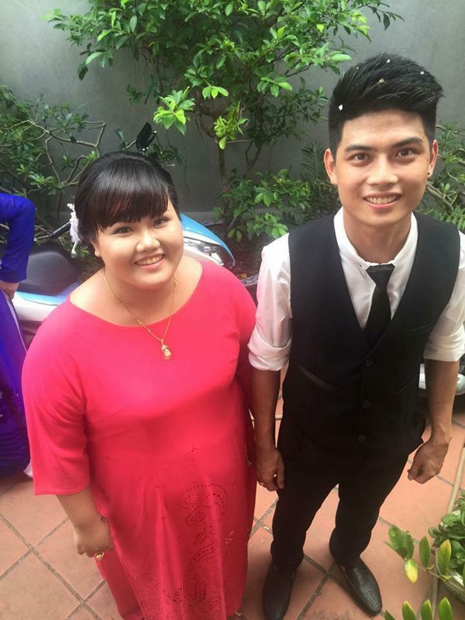 | The locals used to live in earthen houses
Envious(adj) /ˈenviəs/ | Ghen tị |  | Everyone is envious of him
Harvest(n) /ˈhɑːvɪst/ | Vụ thu hoạch  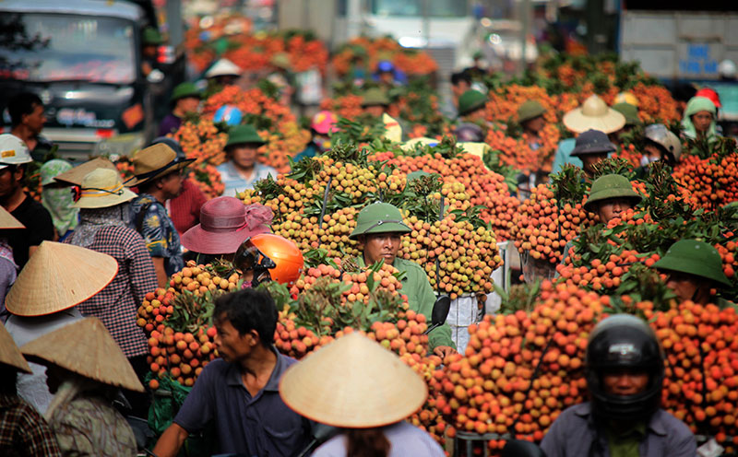  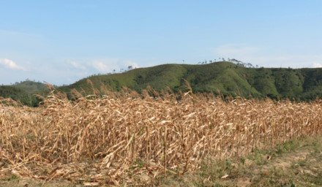 |  | Farmers often work very hard during  harvest time
Hay(n) /hei/ | Cỏ khô |  | These farm workers are making hay to feed the cattle in the winter
Herd(v) /hɜ:d/ | Chăn, dắt | 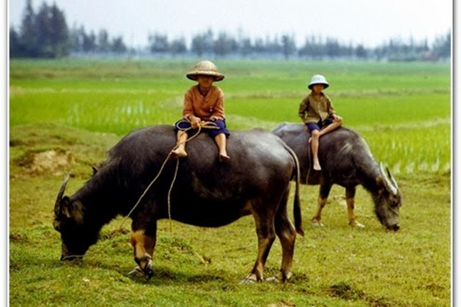 | I used to go herding buffaloes when I was  small.
Inconvenient  (adj)  /ˌɪnkənˈviːniənt/ | Bất tiện  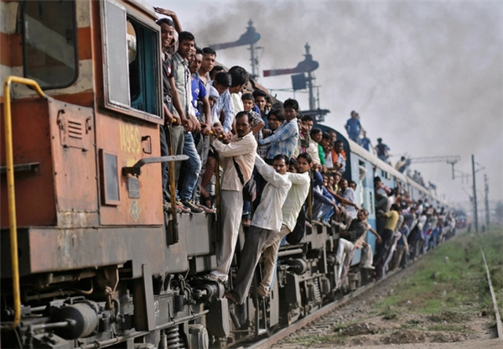 |  | This place is a bit inconvenient for  a formal meeting
Kite(n)  /kait/ | Con Diều  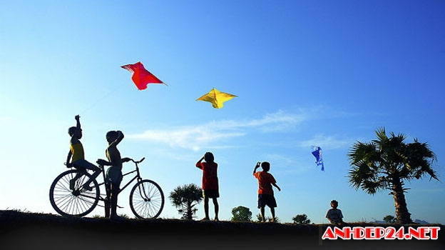  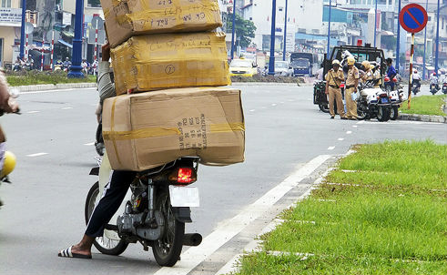 |  | My brother wants to fly his new kite
Load(v)  /ləʊd/ | Chất, chở |  | They loaded the boxes into the trucks
Nomadic(adj)  /nəʊˈmædɪk/ | Thuộc về du mục | 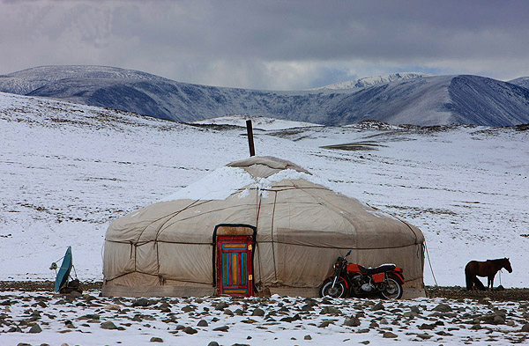  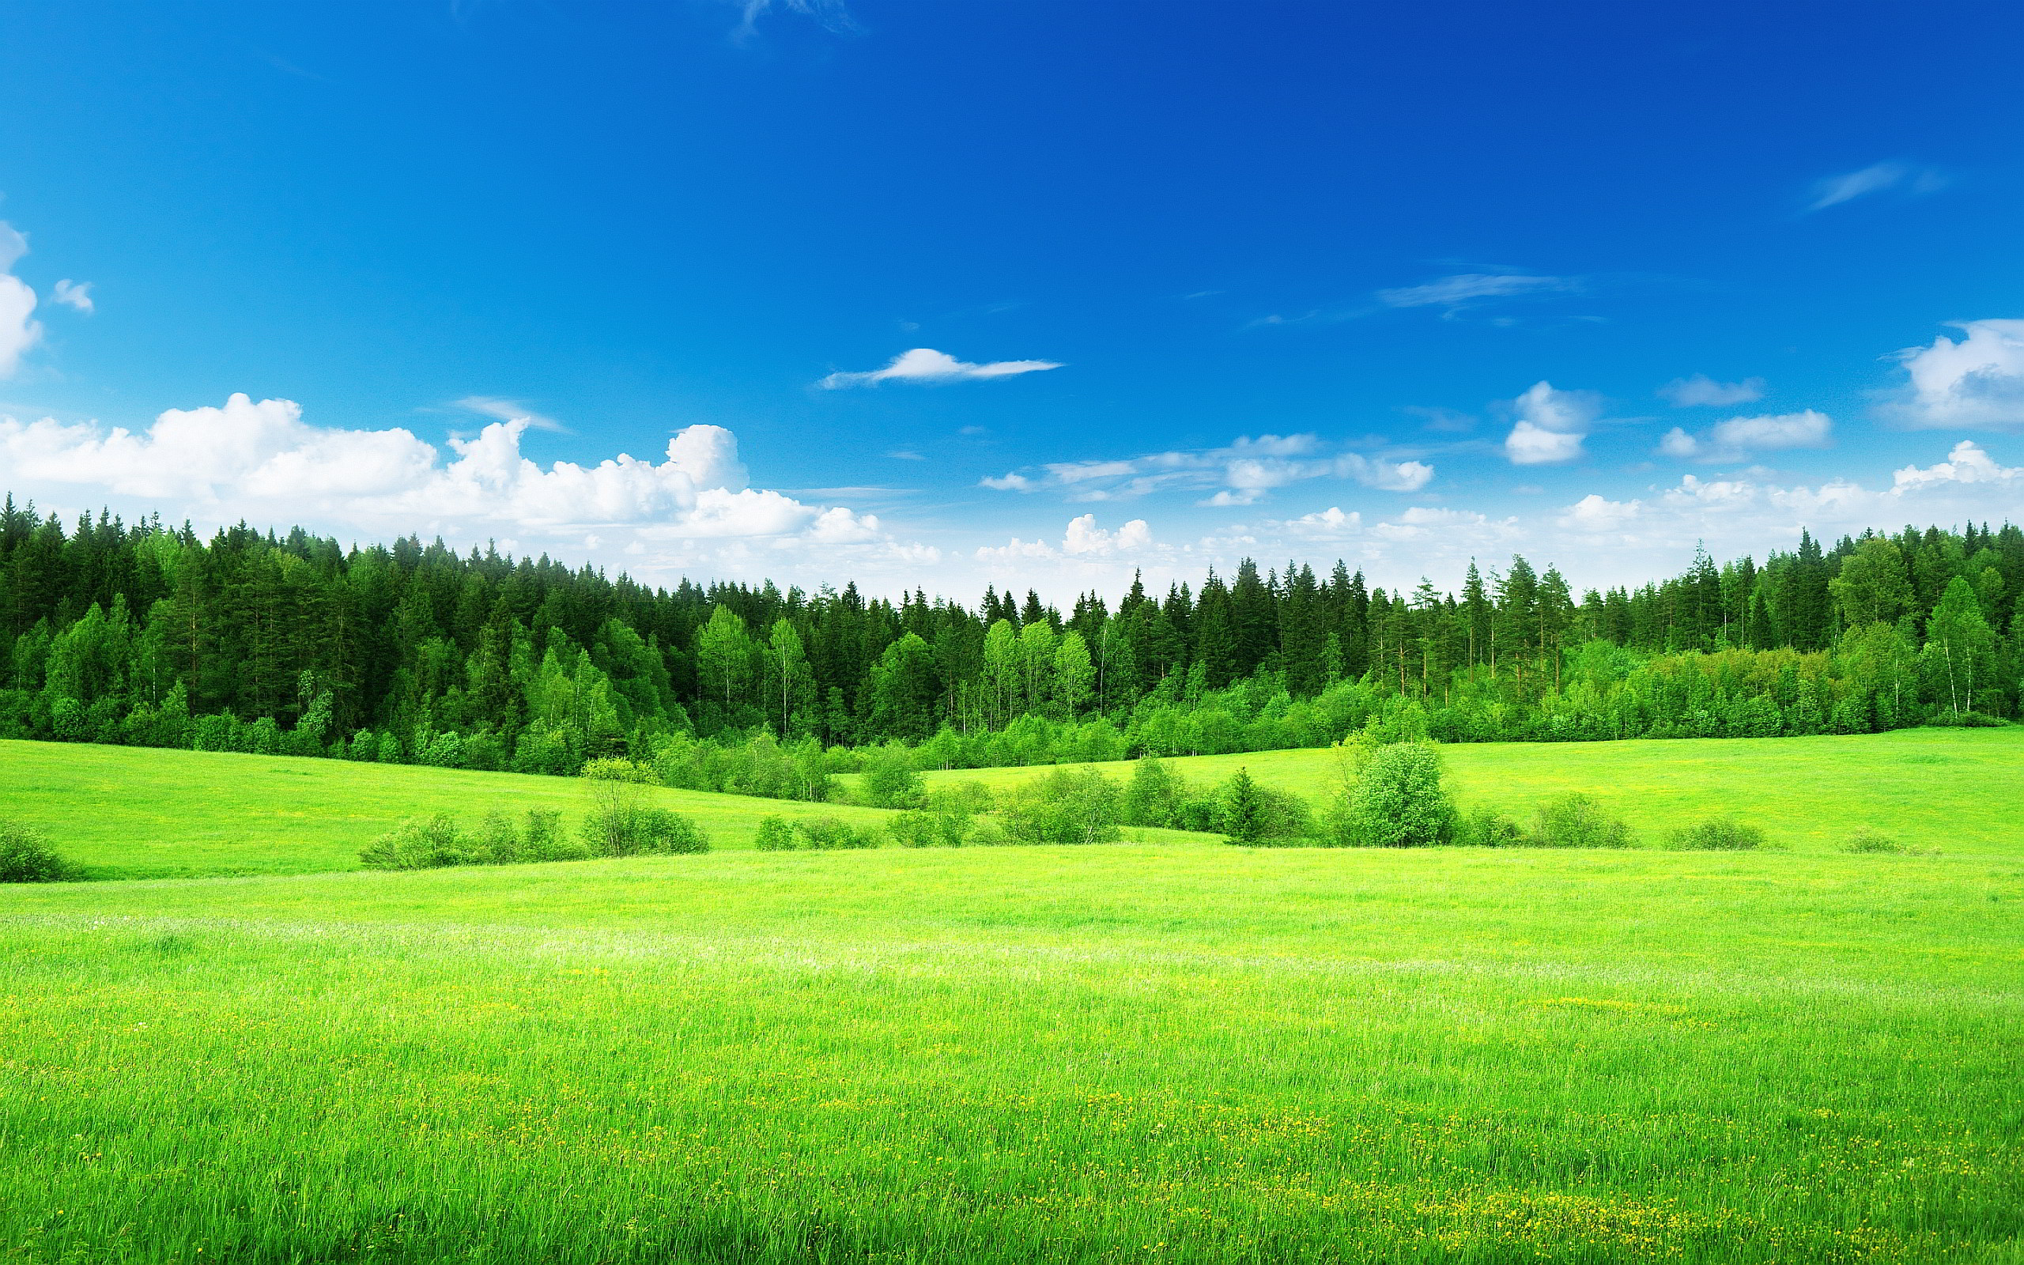 | Many groups of people gave up their nomadic life to settle down
Pasture(n) /ˈpɑːstʃə(r)/ | Đồng cỏ |  | People often raise cattle in areas of rich pasture

B. GRAMMAR:
I.Ôn tập so sánh hơn với tính từ( comparative forms of adjectives)
Ta sử dụng so sánh hơn của tính từ để so sánh giữa người(hoặc vật) này với người(hoặc vật) khác. Trong câu so sánh hơn, tính từ sẽ được chia làm 2 loại là tính từ dài và tính từ ngắn, trong đó:
- Tính từ ngắn là tính từ có 1 âm tiết : Ví dụ : tall, high, big………..
- Tính từ dài là tính từ có từ 2 âm tiết trở lên : Ví dụ : expensive, intelligent……..
II. Cấu trúc câu so sánh hơn:
Đối với tính từ ngắn | Đối với tính từ dài
S1 + to be + adj +er + than + S2
Với tính từ ngắn, thêm đuôi “er” vào sau tính từ | Với tính từ dài, thêm đuôi “more” vào trước tính từ
Ví dụ:  China is bigger than India  Lan is shorter than Nam  My house is bigger than your house  His pen is newer than my pen | Ví dụ:  Gold is more valuable than silver  Hanh is more beautiful than Hoa  Your book is more expensive than my book  Exercise 1 is more difficult than exercise 2
Lưu ý: Để nhấn mạnh ý trong câu so sánh hơn, ta thêm “much” hoặc “far” trước hình thức so sánh
Ví dụ: Her boyfriend is much/ far older than her
III. Cách sử dụng tính từ trong câu so sánh hơn:
1.Cách thêm đuôi –er vào tính từ ngắn
Tính từ kết thúc bởi 1 phụ âm →thêm đuôi -er | Old-older, near-nearer
Tính từ kết thúc bởi 1 nguyên âm “e” →thêm đuôi -r | Nice-nicer
Tính từ kết thúc bởi 1 nguyên âm(ueoai) +1 phụ âm → gấp đôi phụ âm cuối và thêm đuôi -er | Big-bigger, hot-hotter, fat-fatter
Tính từ kết thúc bởi “y” dù có 2 âm tiết vẫn là tính từ ngắn →bỏ “y” và thêm đuôi “ier” | Happy-happier,  Pretty-prettier

Lưu ý: Một số tính từ có hai âm tiết kết thúc bằng “et, ow, er, y” thì áp dụng như quy tắc thêm er ở tính từ ngắn
Ví dụ: quiet →quieter clever → cleverer
Simple → simpler narrow →narower
2.Một vài tính từ đặc biệt:
Với một số tính từ sau, dạng so sánh hơn của chúng không theo quy tắc trên.
Tính từ | Dạng so sánh hơn
Good | Better
Bad | Worse
Far | Farther/ further
Much/ many | More
Little | Less
Old | Older/ elder
BÀI TẬP VẬN DỤNG CƠ BẢN:
Bài 1: Cho dạng so sánh hơn của các tính từ trong bảng sau:
Tính từ | So sánh hơn | Tính từ | So sánh hơn
Bad |  | Modern
Clever |  | Old
Convenient |  | Peaceful
Far |  | pretty
Fresh |  | Quiet
Friendly |  | Smart
Generous |  | Soon
Good |  | Strong
Happy |  | Ugly
High |  | Warm
Little |  | Wonderful
Long |  | Young

Bài 2:Khoanh tròn vào đáp án đúng:
1.Living in this small town is (moree peaceful/ peaceful more) than I expected.
2.Nowadays people are (more anxious/ anxious more) about pollution than before.
3.Today you look ( happier/ more happy) than usual.
4.This year I will move to a (bigger/ biggest) city.
5.This experience is (more exciting/ most exciting) than I expected.
6. Who is (more intelligent/ most intelligent) between two of them.
7. This song is (catcher/ more catchy) than that song.
8. The new sofa is (costlier/ more costly) than the old one
9.Our family will move to a (more comfortable/ more comfortable than) place next year.
10. I hope you will get (best/ better) the next time I see you.
11.James has (many/ more) books than Paul.
12.She is (more independent/ most independent) than the last time I saw her.
13. Today my sister (is more quiet/ quieter) than usual.
14.Jane is(more pretty/ prettier) than Ann.
15.The weather is (hotter/ hottest) than yesterday.

Bài 3 :Hoàn thành các câu sau với dạng so sánh hơn của tính từ trong ngoặc:
1.Living in the city is________than living in the country(convenient).
2.Mrs.Smith is_________than I thought.(young).
3.Houses in big cities are much_________than those in my hometown(tall).
4.No one in my class is_________than Jim (smart).
5. The senior prom would be_________than any other proms(exciting).
6. I have__________courage than my brother(little).
7. His health condition is getting__________(bad).
8.You are_________than you think(clever).
9.This computer is much_________than mine(expensive)
10.I always dream of a__________house to live in(modern).
11.They are__________than they used to be(skillful).
12.Life in this village is_________than anywhere else.(peaceful).
13.I think people in the countryside are________than city dwellers.(friendly)
14.This year, the prize for the winner is______than last year.(valuable)
15.Which dress is__________for me?(suitable)
16.You should be__________and show your best.(confident).
17.They said that the conference was________than usual(interesting).
18.Jane is so pretty but her sister is even__________(pretty).
19.They work hard to have________life(good).
20.John is__________than the rest of the class.(intelligent)

Bài 4: Biết câu so sánh hơn dùng từ gợi ý:
0.Bob / strong /Jim. →Bob is stronger than Jim.
1.My current job / demanding/ my last one.
2.Today/ Jane/ beautiful/ usual.
3.Yesterday / it/ cold/ taday.
4.Fruits and vegetables / healthy / fast food.
5. Life in the countryside / peaceful/ life in the city.
6.Your sister/ good/ you think.
7.Who / intelligent/ you/ in your class?
8. Ann/ short / you?
9. Last year/ his salary / low/ this year.
10. Bob/ look / strong/ his brother.

Bài 5: Sắp xếp các từ sau thành câu hoan chỉnh:
1.London /think/ is/ than/ more/ I/ New York/ expensive.
2.Important/ is/ Health/ than/ money/ more.
3.in / in/ city/ better/ the / is/ in /than / country/ convenient / than / is.
4.in / health care/ city/ better/ the / is/ in / than / countryside/ the service/ the.
5.living/ is/ than / in /rural/ more/ areas / living/ urban /in / comfortable/
6.in/ pasture / this/ that/ area / richer / is / area.
7. Peter/ better / Math/ than / at/ is / Tom.
8.crowded/ cities/ often / than / more/ are/ the / countryside.
9.this /cake/ is /that/ more/ one/ delicious/ than?
10.Who/ more/ than / Tom / can /in / intelligent / class/ his?
IV. SO SÁNH HƠN VỚI TRẠNG TỪ (COMPARATIVE FORMS OF ADVERBS)
Tương tự như với tính từ, trang từ chia thành 2 loại:
-.Trạng từ ngắn là những trạng từ có 1 âm tiết.
Ví dụ: hard, near, far, right, wrong…………
-Trạng từ dài là những từ có từ 2 âm tiết trở lên.
Ví dụ: slowly, responsibly, quickly, interestingly, tiredly……
1.Cấu trúc câu so sánh hơn với trạng từ:
Đối với trạng từ ngắn | Đối với trạng từ dài
S1 +V +adv +er +than+ S2 | S1 +V +more / less +adv +than+ S2
Với các trạng từ ngắn, thường là trạng từ chỉ cách thức có hình thức giống tính từ, ta thêm “er” vào sau trạng từ | -Với trạng từ dài, hầu hết là các trạng từ chỉ cách thức có đuôi “ly” ta thêm “mỏe”(nhiều hơn) hoặc “less”(ít hơn) vào các trước trang từ  -“Less” là từ phản nghĩa của “more” ,được dùng để diễn đạt sự không bằng nhau ở mức độ ít hơn.
Ví dụ:  They work harder than I do.  She runs faster than he does  My mother gets up earlier than me.  I go to school later than my friends do | Ví dụ:  My friend did the test more carefuly than I did.  My father talks more slowly than my mother does.  Hanh acts less resposibly than anyone

2.Một vài trạng từ có dạng từ đặc biệt:
Tính từ | Dạng so sánh hơn
well | Better
Badly | Worse
Far | Farther/ further
Early | Earlier

Ví dụ:
The little boy ran farther than his friends
You’re driving worse today than yesterday.

BÀI TẬP VẬN DỤNG CƠ BẢN:
Bài 6: Cho dạng so sánh hơn của các trạng từ trong bảng sau:

Trạng từ | So sánh hơn | Trạng từ | So sánh hơn
Badly |  | Late
Conveniently |  | Smartly
Early |  | responsibly
Far |  | Patiently
Fast |  | Generously
Fluently |  | Cleverly
Happily |  | Quickly
Hard |  | Suitable
Slowly |  | Beautifully
well |  | Strongly

Bài 7: Khoanh tròn vào đáp án đúng:

1.The teacher asked me to speak___________.
A.loud B.louder C.more loud
2.Today you looks________than usual.
A.more confident B.more confidently C. confidently
3.Your house is_______decorated than me.
A.more beautiful B.more beautifully C.beautifully.
4.No one in my class runs__________than Peter.
A.more fastly B.more better C.faster.
5.This time you did much________!
A.better B.more better C.more well
6.You have to work_________If you want to succeed.
A.more hardly B.hardlier C.harder
7.Today I come to class_________than usual
A.more early B.earlier C. early
8.You need to work___________, or you will make a lot of mistakes.
A.more careful B. more carefully C. carefully
9.She walks__________than other people.
A.slower B.slowlier C.more slowier
10.The blue skirt suits you_______than the black one.
A.better B.more better C.more well
Bài 8: Hoàn thành các câu sau với dạng so sánh hơn của các trạng từ trong ngoặc:
1.I speak English__________now than last year.(fluently).
2.They smiled________than before(happily).
3.Tom arrived_________than I expected(early).
4.We will meet ________in the afternoon(late).
5.Mary dances__________than anyone else(gracefully)
6.Could you speak_________?(loud)
7.Jim could do the tast_________Jane(well).
8.We walked_______than other people(slowly).
9.Planes can fly__________than birds(high).
10.I can throw the ball__________than anyone else in my team(far).
11.James drives_______than his wife(carefully).
12.I visit my grandmother_______than my brother.(often)
13.No one can run_______than John(fast).
14.My sister cooks________than I(badly).
15. Everyone in the company is working________than ever before(hard).

Bài 9:Hoàn thành các Câu sau với dạng so sánh hơn của các trang từ trong ngoặc:
1.I/ play/ tennis/ badly/ Tom.
2.The Australian athlete/run/ slowly/ the Korean athlete.
3.Cats/ walk/ quiet/ dogs.
4.James/ reply/ swiftly/ Peter.
5. The tiger/ hunt/ ferociously/ the wolf.
6.Your idea/ work/ well/ mine.
7.I/ eat/ vegetables/ often/ I used / to.
8.Today/ you/ perform/ badly/ yesterday.
Bài 10:Viết lại câu sau cho nghĩa không đổi, sử dụng cấu trúc so sánh hơn “more /less”
0.Ann speaks French more fluently than James.
→James speaks French less fluently than Ann.
1.Today the sun shines more brightly than yesterday.
2.This cake is more freshlt made than that one.
3.Jim behaves more politely than his younger brother.
4.Teenagers act more violently these days than in the past.
5.The doctor treats his patiently than he should.
6.My sister speaks more quickly than I.
7.Now Mary drives more carefully than she used to.
8.This summer I go to the beach more often than the last summer.
BÀI TẬP TỔNG HỢP NÂNG CAO
Bài 11:Hoàn thành câu, sử dụng dạng so sánh hơn của các tính từ hoặc trạng từ cho sẵn
Angrily | large | soft | Cleverly | Warm
comfortably | hard | rich | costly | beautifully

1.Her voice is_________than mine.
2.James can sing________than many singer.
3.We can live_________in the countryside than in the city.
4.We hoped we would own a _________apartment.
5.This mordern computer is_________thann that old-fashioned one.
6.My new house is__________designed than my old one.
7.My father reacted_________to my misbehaviors than my mother.
8.John studies__________than anyone else in the class.
9.It is getting_________today so we can go out.
10. People in the city are________than people in the countryside.
Bài 12; Gạch chân lỗi sai trong mỗi câu sau và sửa lại cho đúng:
1.Their life has been more comfortably since they moved to the city.
2.She looks more pretty in this white dress.
3.The manager wants us to work more hardly.
4.This week you looks more healthily than last week.
5.Everyone in my town is looking for more better crop this year.
6.Jim runs more fastly than his friends.
7.I think a settle life is more better than a nomadic life.
8.Today Jim performs less confident than usual.
9.The heavy rain makes it more difficultly to drive.
10.Their team preformed much more well than our team.
Bài 13; Viết lại câu bằng từ đã cho sao cho nghĩa câu không thay đổi theo mẫu:
0.This exercise is easier than that one.
→That exercise is more difficult than that one.
1.Mr Smith is wealthier than Mr.Brown.
→Mr Brown___________________________________
2.My house is smaller than my parent’s house.
→My parent’s house____________________________
3.The black dress is more expensive than the red one.
→The red dress _____________________________
4.Today it is colder than yesterday.
→Yesterday______________________________
5.I don’t think you are taller than me.
→I don’t think I_________________________________
6.Is Jim worse at Math than John?
→Is John______________________________________
7. Jim looks much younger than his classmates.
→Jim’s classmates____________________________
8.Your hair is longer than mine.
My hair_________________________
Bài 14: Khoanh tròng vào đáp án đúng:
Benefit of living in the countryside.
While many people prefer city life, a lot of people want to send their life in a rural area. The countryside are often(1) _________than the city because there are not as many factories and traffic as in big cities. The country folk can be (2) _________and they often live(3) _________than city dwellers. Besides, life in the countryside is(4) _________and peaceful because the crime rate is much(5) _________. The rural areas are(6) _________populated than the urban area but the neighbors are(7) _________and more helpful. Life in the countryside is(8) _________for old people than the energetic youngsters.
1.A.less polluted B.more polluted C.less pollutedly D.more pollutedly
2.A.more healthy B.healthier C.more healthily D.helthily.
3.A.longly B.longer C.shortly D.shorter
4.A.more simple B.simpler C.simply D.more simply
5.A.higher B.highly C.lower D.lowly
6.A.more densely B.more dense C.less D.less dense
7.A.more friendly B.friendlier C.friendly D.less friendly
8.A.more suitable B.more suitbly C.less suitably D.suitably.
Bai15: Đọc đoạn văn sau và trả lời câu hỏi: The nomadic life of Mongolian
Mongololian people nowadays still maintain their tradition of a nomadic life. About half of mongolian population do not settle down but travel from place to place every season. When you think of Mongolian nomads, you think of animal farmers. Their most valuable possessions are their tents and cattle. Mongolian has severe weather. There are dramatic changed in weather condotions between seasons. That is the reason why Mongolian have to move location throughout the year to the most appropriate spots. In winter, they often move in front of a mountain for shelter. In spring, it’s closer to a river, in summer right next to a river for water supply, and in autumn up a hill to collect hay for winter time. Most nomads move at least four times a year but some might move up to 30 times in a year ,especially if they have a lot of animals that eat through the vaibable food quickly.
The number of namads has, however, significantly decreased over last years. More and more of its citizens move to Ulaanbaatar because they want to look for an education and a professional job.Mongolia is in a period of rapid change.
1.Is it true that about 50% of Mongolian population still lead a nomadic life?
2.What are the most valuable possessions of Mongolian nomads?
3.Why do Mongolian have to move location throughout the year?
4.Where do Mongolian nomads often move to in fall?
5.How often most nomads move their locations?
6.Why more and more Mongolian move to Ulaanbaatar?

