ĐỀ ÔN TẬP
TIẾNG ANH 5 – GLOBAL SUCCESS
( UNIT 1 => UNIT 5 – CÓ FILE NGHE + KEY)

UNIT 1: ALL ABOUT ME!
Name:____________________
Class: ____________________

- LISTENING

Task 1. Listen and put the stressed syllable of the following words. There is one example. (2)
- ˈdolphin
- giraffe 5. England
- behind 6. Vietnamese
- Japan 7. tennis
- July 8. goodbye
Task 2. Listen and number. There is one example. (1)
-  b. 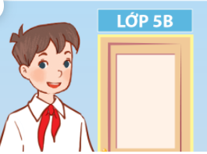 c. 

d. 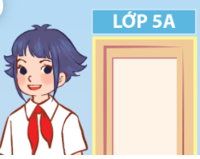 e. 
0

Task 3. Listen and complete. There is one example.
- What's your favorite sport? It's table tennis.
- What's your favorite color? It's ____________________.
- What's your favorite animal? It's ____________________.
- What's your favorite food? It's ____________________.
- What's your favourite sport? It’s ____________________.

PART 2: VOCABULARY AND GRAMMAR
Task 1: Look, read and write.
chicken color city
table tennis countryside peacocks

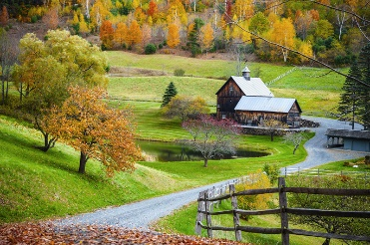
- city 1. _______________ 2. ____________

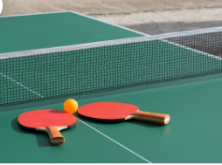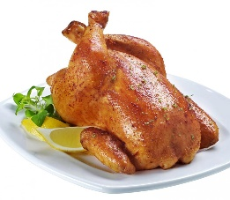

3. _______________ 4. ______________ 5. ______________

Task 2. Circle the correct answer. There is one example.
- My name is Phong. I live _____________ the city.

A. in B. on C. at
- I’m _____________ class 5A.
- in B. on C. at
- I live in the _____________. 
- city B. mountains. C. countryside
- Where _____________ she live? - She lives in the city.
- do B. does C. is
- Can you tell me about _____________?
- myself B. yourself C. himself
- What _____________ your favourite sport? - It’s tennis.
- be B. is C. are
- ___________ are you going? - I’m going to the sports centre.
- What B. When C. Where
Task 3: Fill in the blanks with the given words.
animal | Street | class 5A
countryside | birthday | big

- Hoa lives in Ngo Quyen _____________.
- He is in _____________.
- I live in a quiet village in the _____________.
- My _____________ is in July.
- What is your favourite _______________.
- Ho Chi Minh city is _______________ and busy.
Task 4. Read and match. There is an example.
A | B | Answer
- Where do you live? | - I’m in class 5A. | - c
- What class are you in? | - It’s table tennis. | 1.
- What’s your favourite color? | - I live in the city. | 2.
- What’s your favourite sport? | - It’s lion. | 3.
- What’s your favourite animal? | - It’s a sandwich. | 4.
- What’s your favourite food? | - It’s blue. | 5.

PART 3: READING AND WRITING
Task 1: Read the passage and answer the questions. There is an example.
Linh is my pen friend. She lives with her parents in Ha Noi. Her address is 79, Nguyen Du Street. There are two floors in her house. There are three bedrooms, three bathrooms, a kitchen, and a sitting room. She likes her house because it is pretty and comfortable. Her house is near her school so she usually walks to school. Her favourtie sport is basketball. She often plays basketball with her brother after school.
- Where does Linh live? => She lives in Ha Noi.
- What is her address?
    - …………………………………………………………………..........................
- Who does she live with?
    - …………………………………………………………………...........................
- What is her house like?
    - …………………………………………………………………..........................
- What’s her favourite sport?
    - …………………………………………………………………........................
- Does she often play football with her brother after school?
    - …………………………………………………………………........................
Task 2: Make the question for underlined part in each sentence.
0. I live in a big city.
    - Where do you live?
  - I like sports very much. My favourite sport is basketball.
- ……………………………………………………………………..
  - My birthday is in July.
- ……………………………………………………………………..
  - I’m going to the sports centre.
- ……………………………………………………………………..
  - I like parrots because they are cute.
- ……………………………………………………………………..
  - I’m in class 5B in Nguyen Du primary school.
- ……………………………………………………………………..
Task 3: Reorder the words to make correct sentences.
- is/ your/ address?/ What
- What is your address?
- is/ What/ animal/ your/ favourite/ ?
- ……………………………………………………………………..
- dolphin/ favourite/ is/ My/ animal/.
- ……………………………………………………………………..
- in/ Nam/ a/ and/ big/ lives/ city. / busy
- ……………………………………………………………………..
- is/ It/ 25/ Street/ Balloon/.
- ……………………………………………………………………..
- swimming/ I / every day/ go/ .
- ……………………………………………………………………..

Task 4. Write about you!
- Your name
- Your class
- Your age
- Where you live
- Your favourite sport, colour, animal and food

Giaoandethitienganh.info có rất nhiều tài liệu tiếng anh file word hay, chất lượng, mời bạn đăng ký tài khoản ( chỉ 100k/ năm) để chủ động tự tải tài liệu khi cần!

