Full name: .............................................................
School: ..................................................................
Class: .....................................................................
Mark:

End-of-term Test 2 (Semester 2)

Time: 45 minutes
A. WRITTEN TEST (45 minutes; 8 point)
I. LISTENING

(2 points)
Task 1. Listen to Peter talking about his dream house. Circle the correct answer A, B, or C. You will listen TWICE.
- How will Peter move through his house?
  - On foot.
  - By car.
  - By train.
- What will Peter do in his living room?
  - Watch films.
  - Play computer games.
  - Sing a song.
- How many swimming pools will there be in Peter’s house?
  - One.
  - Two.
  - Three.
- What will be special about Peter’s car?
  - It can cook.
  - It can swim.
  - It can fly.

Task 2. Listen to Mr. Wilson talking about tips for three R’s. Fill in each gap with NO MORE THAN TWO WORDS. You will listen TWICE.

3R’s | Actions
Reduce | - (1) toys with friends  - borrow or rent books and movies  - buy (2) items
Reuse | - bring along a reusable water bottle  - use (3) of the paper
Recycle | - (4) presents with used papers

(2 points)
II. READING

Task 1. Read the text about e-sports. Circle the correct answer A, B, or C.
Millions of people play games for fun. However, there are professional gamers. They practise for ten or more hours a day, five or six days a week. They earn money by playing competitive computer games, or e-sports!

Then, are e-sports really sports? Some say no. E-sports players don’t need to run, jump, throw or do big physical actions. At the moment, the UK government classifies e-sports as kinds of games, not as sports. But others say yes: e-sports are sports. Players do need some physical skills, especially hand–eye coordination, quick reaction. They also need to be accurate and good at timing. In fact, the governments of China and South Korea classify e-sports as sports, and they will be an official medal sport in the Asian Games starting from 2022.
How about you? Do you think e-sports are real sports?
- What is TRUE about professional gamers?
  - They play games for fun.
  - Playing games is their job.
  - They compete with computers.

- Why do some people think e-sports are not sports?
  - Because e-sports players are not physically strong.
  - Because the government says that e-sports are games.
  - Because e-sports don’t require much body movement.

- What skill does an e-sports player need?
  - Throwing a dart accurately.
  - Being good at timing.
  - Running fast.

- Which country classify e-sports as real sports?
  - South Korea.
  - The UK.
  - Germany.

Task 2. Read the description of three robotics competitions. Tick the correct competition.
B.E.S.T Robot Contest
What can high school students do with a box of materials and six weeks? The
B.E.S.T Robot Contest is a great way to find out. Teams must design a robot that can successfully complete a set of tasks within a time limit, and they’ll compete against each other.

F.I.R.S.T: Tech Challenge
Teams for the F.I.R.S.T: Tech Challenge can have up to 15 high schoolers. There’s a reusable robot kit. They must use this kit to create a robot that will be able to compete in an alliance format challenge. Teams work with adult coaches and mentors to help them.

National Robotics Challenge
The National Robotics Challenge doesn’t require specific materials or a kit. Stu- dents get to build a robot that can compete in challenges like a maze and rescue. Plus, the contest isn’t just for school students; college and graduate students can participate, too.

 |  | B.E.S.T  Contest | F.I.R.S.T  Challenge | National Robotics Challenge
1. | Students use their own materials or robot kits.
2. | There are coaches to work with each team of students.
3. | Students design a robot in six weeks.
4. | There is no age limit in this contest.

(2 points)
III. WRITING

Task 1. For each question, complete the second sentence so that it means the same as the first. Use the word in brackets. You can’t change the word. Write NO MORE THAN THREE WORDS.

Here is an example:
- The bookshop is opposite the library.
a bookshop opposite the library. (THERE) Answer: 0. There is
- We bring reusable water bottles. We don’t bring plastic bottles. (INSTEAD)
→ We bring reusable water plastic bottles.

- No one in my family cooks better than my dad. (THE)
→ My dad is in my family.

- This is a present for you. (YOURS)
→ This .

- The show was interesting. It was too long. (BUT)
→ The show was interesting, too long.

Task 2. Write an email to Linda and tell her about your house in the future. (40-60 words).
You can use the following ideas as cues.
- What type of house will it be?
- Where will it be?
- How many rooms will it have
- What appliances might it have?

……………………………………………………………………………………………………………………………………………

……………………………………………………………………………………………………………………………………………

……………………………………………………………………………………………………………………………………………

……………………………………………………………………………………………………………………………………………

……………………………………………………………………………………………………………………………………………

……………………………………………………………………………………………………………………………………………

……………………………………………………………………………………………………………………………………………

……………………………………………………………………………………………………………………………………………

……………………………………………………………………………………………………………………………………………

(2 points)
IV. LANGUAGE FOCUS

Task 1. Choose the word with a different way of pronunciation in the underlined part. Circle A, B or C.
1. A. equipment | B. exercise | C. everyday
2. A. congratulation | B. marathon | C. place
3. A. pagoda | B. crowded | C. postcard
4. A. around | B. found | C. famous

Task 2. Put the verbs in brackets in the correct form.
- If we don’t protect the environment, Mother Nature (be) angry.
- I might (go) to Da Nang next week. I’m not sure yet.
- It is likely that Tim (arrive) late.
- you (send) an email to John yesterday?

Task 3. Choose the best option to complete each sentence. Circle A, B or C.
- I want to buy many modern home .
  - apply B. appliance C. appliances
- My dreamhouse will be by big trees.
  - surround B. surrounded C. surrounding
- My is peaceful and quiet.
  - neighbour B. neighbouring C. neighbourhood
- Using energy can help save the environment.
  - sun B. sunny C. solar
- You should the amount of salt in your diet.
  - reduce B. reuse C. recycle
- a kind-hearted man!
  - How B. What C. Who
- The first Olympic Games took in Greece in 776 BC.
  - part B. place C. time
- Mr Bean has old car. car is blue.
  - an/ The B. an/ A C. a/ The

  - SPEAKING TEST (2 points, approximately 3-5 minutes/ one pair of students)
* Notes: Teacher doesn’t need to ask all questions in task 1.

Task 1. Now let’s talk about sports and exercise. Are you ready?
    - Are you good at sports?

    - What sports do you watch? And what sports do you play?
    - Do you like team sports or individual sports? Why?
    - What are some benefits of doing sports and exercise?

Task 2: Each of you will now receive a card. On the card there is a picture and clues for five questions. You should use the words to make questions and ask your friends. Your friend will answer the questions based on the picture he/ she has.
Card A  Use the words given below to make questions. Ask your friend about his/ her picture and listen to the answers.  - Where/they?  - How many/people?  - What/on/wall?  - What/they/watching?  - Do you like to play sports or watch it on TV? Why/Why not? | 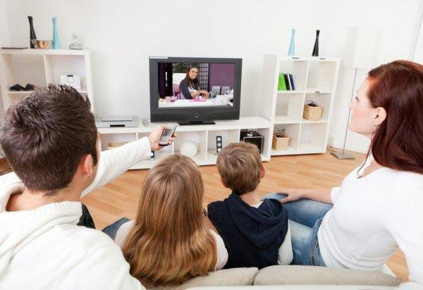  Now, your friends will ask you questions about your picture. Answer his/her questions.
Card B  Use the words given below to make questions. Ask your friend about his/ her picture and listen to the answers.  - Where/they?  - How many/people?  - What/father/holding?  - you/ like cooking shows? Why/ Why not?  - What is the most popular TV program in your country? | 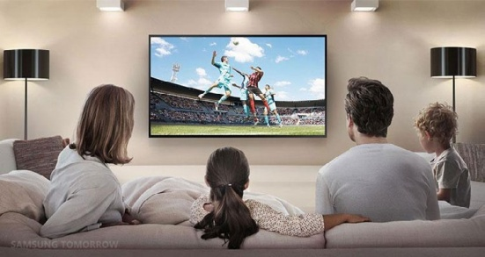  Now, your friends will ask you questions about your picture. Answer his/her questions.

