PHÒNG GD&ĐT TP HẢI DƯƠNG  TRƯỜNG THCS NGÔ GIA TỰ  MÃ ĐỀ: NGT-HSG-TA7 | ĐỀ THI HỌC SINH GIỎI  NĂM HỌC 2017-2018  MÔN: TIẾNG ANH; LỚP: 7  Thời gian làm bài: 150 phút  Đề gồm: 08 trang

A.LISTENING (20 poits)

Part 1: Listen and tick

Example:

How many people were at the meeting?

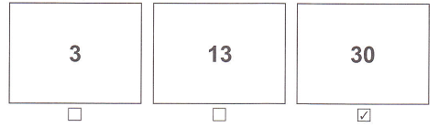

1. What must the man turn off?

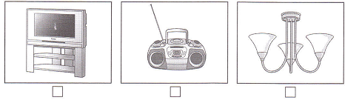

2. Where’s the girl’s pen?

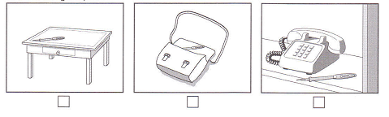

3. What will the boy do this evening?

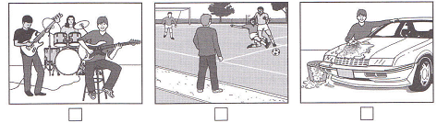

4. What animals did they see on their holiday?

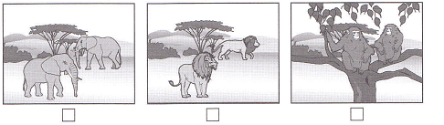

5. What does the man want to buy?

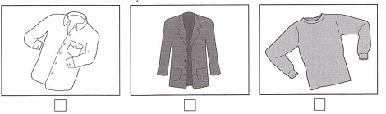
Part 2: You will hear a telephone message about a trip to the theatre. Listen and complete questions 6- 10. (5 points)
Telephone message
To: | Jamie
From: | Michael
Name of play: | (6) The…………………………….Party
Date: | (7)……………………………..August
The theatre is opposite: | (8)…………………………….
Meet Michael at: | (9)……………………………p.m.
Mobile number: | (10)…………………………….

Part 3: Listen to Joe asking about French language course. (5 points)
For questions 11 - 15, circle A, B, or C.
You will hear conversation twice.
11. The best class for Joe is ……………
A. French Conversation B. Business French C. French for Tourists
12. Joe’s class begins at ……
A. 6.30 B. 7.15 C. 8.30
13. How many other students will be in Joe’s class?
A. 9 B. 14 C. 15
14. What should Joe take to his first class?
A. a dictionary B. a course book C. a notebook
15. Joe will pay………
A. £25 B. £145 C. £170

Part 4
You will hear a woman phoning for information about a boat trip. (5 points)
Listen and complete questions from 1-5
You will hear conversation twice.

Boat trip on the River Dee

Days of the boat trip | Friday and Sunday
Get on boat at the: | (16) ……………………………
Time boat leaves | (17) …………………………… pm
Boat goes to: | (18)…………………………….
On boat, you can buy | (19) ……………………………
Cost of adult ticket | (20) £…………………………

B. Grammar – Vocabulary – Language functions.
I. Circle A, B or C for the following sentences. (20 points)
21. We often organise concerts to ....................funds for poor people.
A. donate B. raise C. volunteers D. grow
22. Vietnamese people have had the......................... of helping one another since the early days of the country.
A. custom B. legend C. tradition D. religion
23. A volunteer always helps other people willingly and ....................payment.
A. for B. within C. about D. without
24. The movie on TV last night made me ......................
A. bore B. boring C. bored D. boredom
25. I ................. thrillers to action films.
A. like B. prefer C. would rather D. enjoy
26. Trung finds horror films really...............................
A. disgust B. disgusts C. disgusting D. disgusted
27. The film has a silly plot. ..................., many people enjoyed it.
A. Though B. Moreover C. Because D. Nevertheless
28. Tet is a time for Vietnamese families to clean and................... their houses.
A. hang B. decorate C. enjoy D. prepare
29. Burning Man is a ................... festival which is celebrated in many countries.
A. music B. musical C. musician D. musician's
30. During Tet holiday the......................atmosphere is felt around the country.
A. local B. ethnic C. thankful D. festive
31. The roof of the building .......................... in a storm a few years ago.
A. damaged B. was damaged
C. have damaged D. has been damaged
32. Hello, my name’s John. ____________ to meet you
A. Please B. I am very well C. Pleased D. Thank you
33. Several animals are in danger of extinction. We should find ways to protect ........
A. us B. them C. ourselves D. themselves
34. ____________? He’s OK now.
A. What is he B. How is he
C. How tall is he D. What’s he like
35. Peter: “Thanks a lot for your wonderful gift.” – Mary: “____________”
A. You are welcome. B. Thank you.
C. Cheers. D. Have a good day!
36. Dona: “ What’s your name?” – Helen: “____________”
A. Really? B. Pardon? C. OK D. Forgive me
37. Look at the photo! You're .................................... a horse.
A. driving B. flying C. riding D. walking
38. A: “Thank you for a lovely evening.” – B: “____________”
A. Don’t mention it. B. I’m glad you enjoy it.
C. Yes, I’d like that. D. Yes, that would be very nice.
39. “The football match was exciting” means
A. They were exciting too. B. The football match excited them.
C. They excited the football match. D. The football match made them exciting.
40. A: “I hope to see you again.” – B: “____________”
A. I hope so, too. B. Good enough.
C. Thank you. D. I really enjoy meeting you, too.

II. Find a mistake in the four underlined parts of each sentence and correct it. (5 points)
41. Lots of people enjoy Titanic despite it has an unhappy ending.
A B C D
42. This is Mr and Mrs Evers' house and those are theirs children.
A B C D
43. Last summer I went to Nha Trang and buy a lot of souvenirs.
A B C D
44. You must taking off your shoes before you enter this room.
A B C D
45. The author of this novel is the same like that one.
A B C D

III. Give the correct form of the word given to complete the sentences. (5 points)
46. Tom rode his bike...................................... and had an accident. | CARE
47. There are many modern …………………… in HCM city. | BUILD
48. Many streets will be ...................... at the beginning of next year. | WIDE
49. Merlion is a ………………..with the head of a lion and the body of a fish | CREATE
50. William Shakespeare (1564-1616) is a famous ………………... in the world. | PLAY

C. READING (30 points)
I. Which notice (A-H) says this (1-5)? Write the correct answer in your paper.
(10 points)

51. You shouldn’t go in through the front entrance of the shop.  52. Extra staffs are needed here for the weekend work.  53. Please ask the shop assistants if you need any help.  54. You cannot buy a pet here on Saturday or Sunday afternoon.  55. These are cheaper at the moment. | A | 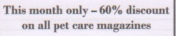
 | B | 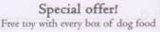
 | C | 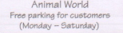
 | D | 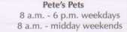
 | E | 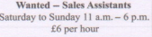
 | F
 | G | 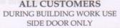
 | H

II. Read the passage and then choose the best answer A, B, C, or D. (10 points)

The world’s first film was shown in 1895 by two French brothers. Although it only (56) ............. of short, simple scenes, people loved it, and films have (57)............ popular ever since. The first films were silent, with titles on the screen to (58)............. the story.

Soon the public had (59) .............. favourite actors and actresses and, in this (60) ..............., the first film stars appeared. In 1927, the first “talkie”, a film with sound, was shown and from then on, the public (61)............. only accept this kind of film.

Further improvements continued, particularly in America, (62).......... produced 95% of all films. With the arrival of television in the 1950s, (63) ................. people went to see films, but in (64)................. years cinema audiences have grown again. More countries have started to produce films that influence film making and there are currently (65).................national film industries.
56. A. consisted B. contained C. belonged D. held
57. A. gone B. been C. made D. kept
58. A. join B. read C. explain D. perform
59. A. your B. his C. our D. their
60. A. reason B. way C. method D. result
61. A. should B. would C. might D. will
62. A. who B. where C. when D. which
63. A. other B. each C. fewer D. any
64. A. recent B. now C. modern D. present
65. A. many B. lots C. much D. plenty

III. Read the following passage and choose the best answer for each question.
(10 points)
BOOKS IN YOUR LIFE
It is often said that books are always a good friend and reading is an active mental process. Unlike TV, books make you use your brain. By reading, you think more and become smarter. Reading improves concentration and focus. Reading books takes brain power. It requires you to focus on what you are reading for long periods. Unlike magazines, Internet posts or e-emails might contain small pieces of information. Books tell the whole story. Since you must concentrate in order to read, you will get better at concentration. Many studies show if you do not use your memory; you lose it. Reading helps you stretch your memory muscles. Reading requires remembering details, facts and figures and in literature, plot lines, themes and characters.
Reading is a good way to improve your vocabulary. Do you remember that when you were at elementary school you learned how to infer the meaning of one word by reading the context of the other words in the sentence? While reading books, especially challenging ones, you will find yourself exposed to many new words.
Reading is a fundamental skill builder. Every good course has a matching book to go with it. Why? Because books help clarify difficult subjects. Books provide information that goes deeper than just classroom discussions By reading more books you become better informed and more of an expert on the topics you read about. This expertise translates into higher self-esteem. Since you are so well-read, people look to you for answers. Your feelings about yourself can only get better.
Books give you knowledge of other cultures and places. The more information you have got, the richer your knowledge is. Books can expand your horizons by letting you see what other cities and countries have to offer before you visit them.
66. What do you use when you read books?
A. eyes B. ears C. hands D. brain
67. What media helps you be smarter in the text?
A Books B. Internet C. Television D. Radio
68. It is said that if you don't use your memory you will ____________.
A. hide it in your mind B. lose it C. enrich it D. waste it
69. Why is reading most good for you?
A. You can relax. B. You must use most of senses and skill
C. You can only use eyes to read. D. You can have lot of fun
70. By reading you can____________.
A. enrich your vocabulary B. know a few words
C. get tired D. do the same as you were in elementary school.
71. Why does every course have a matching book to go with it?
A. For students to read. B. To clarify difficult subjects
C. For teachers to teach easily D. To support vocabulary
72. What activity in class gives more information?
A. Discussions B. Listening C. Writing D. Reading
73. What feeling does reading books help you?
A. more confident B. more comfortable
C. more relaxing D. more active
74. According to the writer, the main benefit of reading is____________.
A. supporting vocabulary.
B. building a fundamental skill.
C. supporting information about the cities and countries.
D. A, B and C
75. According to the text, reading books is ____________.
A. the most useful way for practise the brain
B. not as good as surfing the internet
C. the same as watching television
D. not suitable today anymore

IV. Reading the following passage and write T (True) or F (False) for each statement. (5 points)
Air pollution is a serious problem in many cities. Motor cycles, factories and other sources create so much air pollution that it may hang in the air like dirty fog. Air pollution threatens the health of people who live in the cities. City wastes cause water pollution when they are poured into the waterways. These wastes kill fish and make some areas unfit for swimming. In addition, many large cities have difficulties in disposing of their garbage. The amount of garbage grows each year, but places to put it are quickly filling up. Citizens, governments, industries, scientists, and business people must work together in different ways to gradually reduce pollution. For example, most cities have introduced recycling programmes.
 |  | T | F
76. | Motor vehicles and factories are among some sources of air pollution.
77. | Air pollution doesn't endanger people's health in some cities.
78. | Air pollution is the only problem of the environment mentioned in this passage.
79. | Garbage disposal is a problem in many large cities.
80. | Everyone must cooperate to reduce pollution.

C. WRITING (20 points)
I. Rewrite the sentences with the same meaning (5 points)
81. Eating healthy foods is very important.
→ It is............………………………………………………..…….....
82. I found the trip to the craft village quite interesting.
→ I felt quite ………………………………………………………………………
83. It is two years since she went back to her home village.
→ She hasn’t ………………………………………………………………………
84. People invented the wheel thousands of years ago.
→ The wheel …………………………………………………….………………...
85. He couldn’t find a cheaper computer.
→ That was the …………………………………………………………………….

II. Write a short paragraph about 120-140 words to answer the question (1.5pts)
What should you do to save energy and protect the environment?
....................................................................................................................................
....................................................................................................................................
....................................................................................................................................
....................................................................................................................................
....................................................................................................................................
....................................................................................................................................
....................................................................................................................................
....................................................................................................................................
....................................................................................................................................
....................................................................................................................................
....................................................................................................................................
....................................................................................................................................
....................................................................................................................................
....................................................................................................................................
- The end -

