WEEK 29
Class | Date of teaching
4A | Apri1 1 ^{st}, 2025
4B | Apri11 ^{nd}, 2025
4C | April 1 ^{st}, 2025
PERIOD 113
UNIT 17: IN THE CITY
LESSON 1 (4-6)
A. OBJECTIVES:
By the end of the lesson, pupils will be able to:
1. Knowledges:
- Use the words and phrases go, go straight, stop, turn left, turn right in relation to the topic “In the city”;
- Use What does it say? – It says ʽ_____ʼ. ask and answer questions to identify road signs;
- Listen to and demonstrate understanding of simple communicative contexts in relation to the topic “In the city”.
2. Skills: Listening and reading
3. Attributes:
- Raise pupils’ awareness about their neighborhood and traffic safety.
4. Digital Competency (2.5CB2a - Choosing simple behavioral standards - Urban Civility): Pupils can identify and choose correct behaviors (civility) when interacting with digital simulations of traffic situations (choosing the "civil" action on a digital platform/game).
B. INSTRUCTIONAL RESOURCES
- Student’s book: Page 47
- Audio tracks 65, 66
- Teacher’s guide: Pages 221, 222, 223
- Flash cards/ pictures and posters (Unit 17)
- Hoclieu.vn
- Computer, projector
C. LEARNING PLAN:
Teacher’s activities | Student’s activities
1. Warm up (5’)  Greet the class.  - Use flashcards to revise the words and phrases in period 1.  - Get pupils to open their books at page 47 and look at Unit 17, Lesson 1, Activity 4.  2. Practice (25’)  Activity 1-4. Listen and tick or cross.  * Goal: To listen to and understand four communicative contexts in which pupils ask and answer questions about the road signs and tick or cross the pictures.  * Procedure:  - Draw pupils’ attention to the pictures and elicit the meaning of the road signs. Play Yes or No with each road sign. Point at a road sign, say a phrase or a word to have pupils decide if it is correct or not by saying Yes or No.  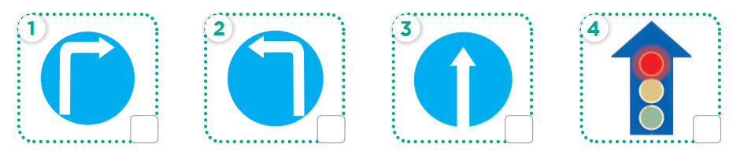  - Play the recording all the way through. Then play the recording again for pupils to listen and tick or cross the pictures.  - Get pupils to swap books with a partner and check their answers before checking as a class. Correct the answers where necessary.  Extension: If time allows, play the recording, sentence by sentence, for pupils to listen and repeat individually and in chorus. Correct their pronunciation where necessary.  Picture cues:  a. a road sign for turn right  b. a road sign for turn left  c. a road sign for go straight  d. a red traffic light  Audio script:  1. A: What does it say?  B: It says ʽturn rightʼ.  2. A: What does it say?  B: It says ʽstopʼ.  3. A: What does it say?  B: It says ʽgo straightʼ.  4. A: What does it say?  B: It says ʽturn leftʼ.  Key: 1. ✓ 2. x 3. ✓ 4. X  Activity 2-5. Look, complete and read.  * Goal: To complete four gapped exchanges with the help of picture cues.  * Procedure:  - Model gapped Exchange 1 as an example. Have pupils read the exchange and guess the missing word in the answer. Then draw pupils’ attention to the picture and elicit the answer to fill in the gap (stop).  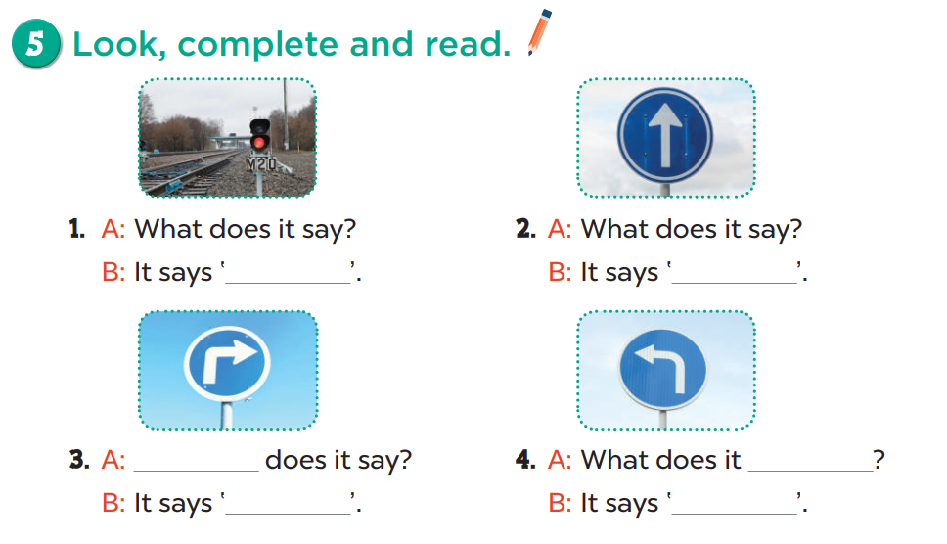  - Give pupils time to do the task independently. Go around the classroom to offer help where necessary.  - Get pupils to swap books with a partner and check their answers before checking as a class. Nominate a pupil to write the answers on the board. Give further support to those pupils who find it difficult to do the task.  - Invite four pairs of pupils to act out four completed exchanges in front of the class. Correct their pronunciation where necessary.  Key:  1. Stop  2. Go straight  3. What/Turn right  4. say/Turn left  Activity 3-6. Let’s sing.  * Goal: To sing the song Cross the road with the correct pronunciation, rhythm and melody.  * Procedure:  - Draw pupils’ attention to the title and lyrics of the song. Encourage them to point at the picture to reinforce their understanding.  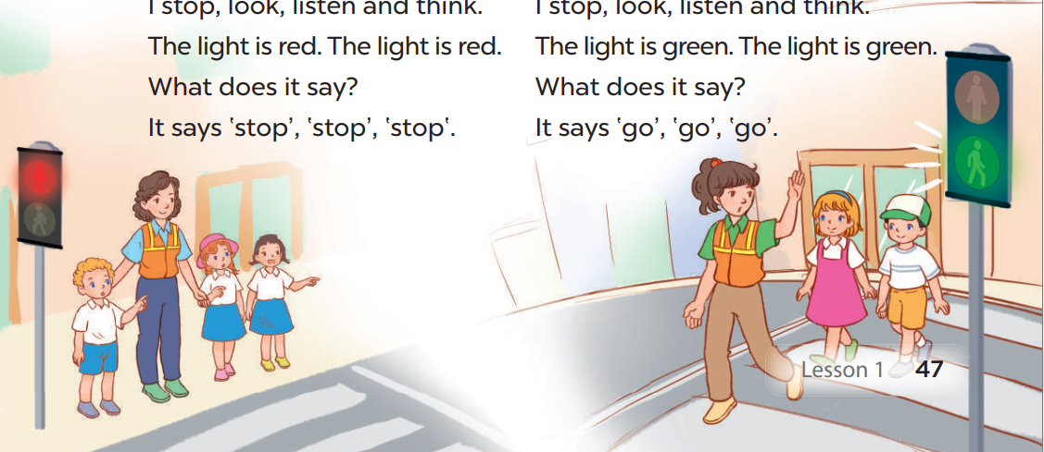  - Have pupils read the first verse of the lyrics. Explain that the first verse is about crossing the road. Have pupils listen to the first verse, drawing their attention to the pronunciation, rhythm and melody.  - Play the recording of the first verse once or twice for pupils to listen and repeat, line by line, while doing actions for cross the road, stop, look, listen and think and stop or clap their hands. Repeat the same procedure with the second verse. Check comprehension and give feedback.  - Ask pupils to listen to and sing the whole song while doing actions or clapping their hands. Go around the classroom and offer help where necessary.  - Invite a few groups to the front of the class to sing the song. The class may sing along to reinforce the activity  Game: Play the Angry bird (PPT)  Develop Competency 2.5CB2a.  - Divide the class into 2 teams.  - The "Civility" Twist: When a student chooses a number, a digital scenario appears (e.g., A boy sees a red light. What should he do?).  - Choosing Behavioral Standards: Students must choose the "Civil" answer on the screen (e.g., "He should stop" instead of "He should run").  - After 8 numbers, the team with the most points is the winner.  3. Consolidation (3’)  - Ask students to answer the following questions:  1. What have you learnt from the lesson today?  2. What are the core values of the lesson?  4. Homework (2’)  - Redo Ex.4, 5 and do the parts A, B in the workbook at home.  - Prepare the new lesson: Unit 17-Lesson 2 (1, 2, 3). | - Listen to the techer  Whole class/ Individual work  -Whole class/  Individual  work  -Listen to the T's instruction  - Listen to the recording  - Individual work  - Check  - Listen to the T's instruction  - Individual work  - Listen to the teacher  Whole class/ Individual work  - Check their answers before checking as a class  - Listen to the teacher  - Listen and repeat  - Listen to and sing the whole song while doing actions or clapping their hands  - Listen to the T's instruction.  - Play in group  - Ss evaluate and choose the correct behavioral standard on the PPT.  - Whole class/ Individual work
D. Recommendation:
…………………………………………………….….……………………………
…………………………………………………………………………………………
WEEK 29
Class | Date of teaching
4A | Apri1 1 ^{st}, 2025
4B | Apri11 ^{nd}, 2025
4C | April 1 ^{st}, 2025
PERIOD 114
UNIT 17: IN THE CITY
LESSON 2 (1-3)
A. OBJECTIVES:
By the end of the lesson, pupils will be able to:
1. Knowledges:
- Use the words and phrases get, go straight, left, right, stop, tell, turn left, turn right, turn round in relation to the topic “In the city”;
- Use What does it say? – It says ʽ_____ʼ. ask and answer questions to identify road signs;
- Use How can I get to the _____? – _____. to ask for and give directions;
- Listen to and demonstrate understanding of simple communicative contexts in relation to the topic “In the city”;
- Read and write about road signs and directions;
2. Skills: Listening and speaking
3. Attributes:
- Raise pupils’ awareness about their neighborhood and traffic safety.
4. Digital Competency (2.3CB2a): Use simple digital services (online maps) to identify locations and determine directions in a simulated or real environment.
B. INSTRUCTIONAL RESOURCES
- Student’s book: Page 148
- Teacher’s guide: Pages 223,224,225
- Flash cards/ pictures and posters (Unit 17)
- Hoclieu.vn
- Computer, projector
C. LEARNING PLAN:
Teacher’s activities | Student’s activities
1. Warm up (5’)  Greet the class.  - Greet the class, then have pupils sing the song Cross the road.  - Get pupils to open their books at page 48 and look at Unit 17, Lesson 2, Activity 1. Tell pupils what they will learn in this lesson.  2. Presentation (10’)  Activity 1-Vocabulary  * Goals: Ss will be able to know the vocab about the road signs, before starting the new lesson.  * Procedure:  - T elicits the new words  + turn around : quay vòng (picture)  - T models (3 times).  - T writes the words on the board.  - Checking: Rub out and remember  - The disabled: Practice reading vocab.  Activity 2-1. Look, listen and repeat.  * Goal: To understand and correctly repeat the sentences in two communicative contexts (pictures) focusing on asking for and giving directions.  * Procedure:  - Ask pupils to look at Pictures a and b and identify the characters and predict what they want to buy, where they can buy it (e.g. buy some books, bookshop).  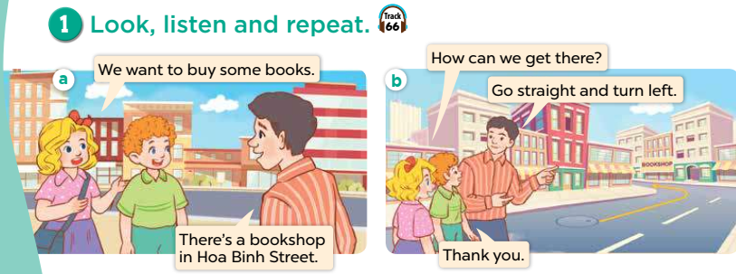  - Ask pupils to look at Picture a. Play the recording for them to listen and check the prediction. Play the recording again, sentence by sentence, for pupils to listen and repeat individually and in chorus. Correct their pronunciation where necessary. Repeat the same procedure with Picture b.  - Invite a few pairs to the front of the classroom to listen to and act out the conversations.  Activity 2. Listen, point and say.  Goal: To correctly say the phrases and use How can I get to the _____? – _____. to ask for and give directions.  * Procedure:  - Ask pupils to look at Pictures a, b, c, and d and identify the places in the pictures and directions. Have pupils describe what they can see in each picture.  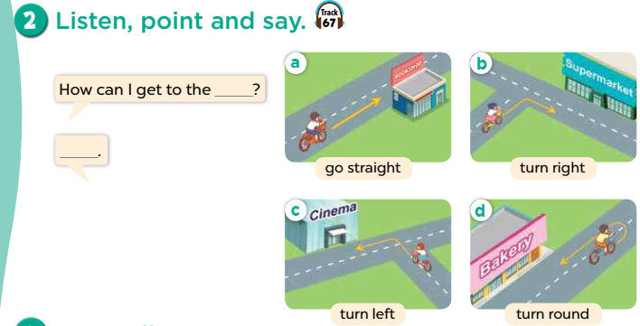  - Play the recording for pupils to listen to and repeat the phrases in chorus and individually until they feel confident.  - Draw pupils’ attention to the speech bubbles and elicit the missing words in the question and answer by pointing at Picture a. Play the recording for pupils to listen to and repeat the sentences in both bubbles a few times. Repeat the same procedure with Pictures b, c, and d.  - Let pupils point at the pictures and say the sentences in pairs. Go around the classroom to offer help where necessary.  - Invite a few pairs to act out the exchanges in front of the class.  – Picture cues:  a. go straight to the bookshop b. turn right to the supermarket  c. turn left to the cinema d. turn round to the bakery  – Speech bubbles: How can I get to the _____? – _____.  Audio script:  a. go straight b. turn right  c. turn left d. turn round  a. A: How can I get to the bookshop?  B: Go straight.  b. A: How can I get to the supermarket?  B: Turn right.  c. A: How can I get to the cinema?  B: Turn left.  d. A: How can I get to the bakery?  B: Turn round.  Activity 4-3. Let’s talk.  * Goal: To enhance the correct use of How can I get to the _____? – _____. to ask for and give directions in a freer context  * Procedure:  (Integrated with Digital Competency 2.3CB2a)  - Step 1: T opens an online map (e.g., Google Maps) of the local area or a famous city.  - Step 2: T shows how to use the map: Identify the "Start point" and "Destination" (the cinema, the bakery, etc.).  - Step 3: Ask pupils to work in pairs. One pupil points to a destination on the digital map, and the other asks: How can I get to the [place]?.  - Step 4: Pupils observe the route on the map and give directions (Go straight/Turn left...).  - Invite pairs to perform using the projected map.  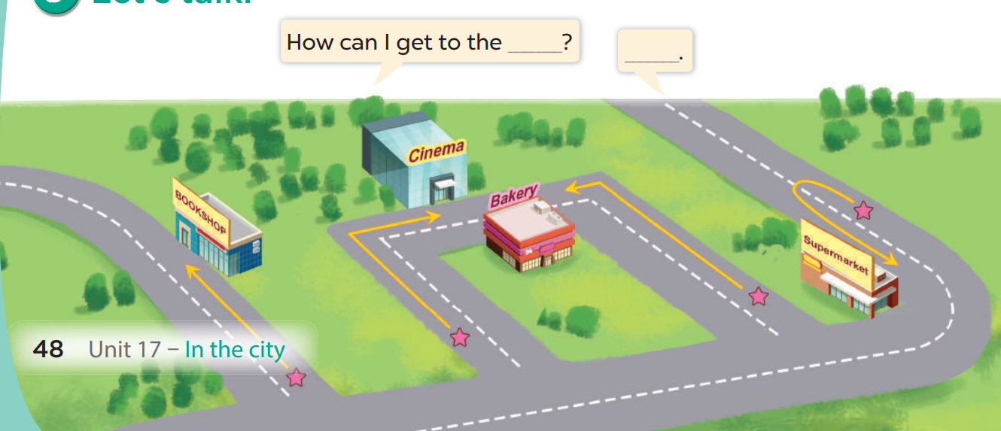  Game: “Miming game”  -Teacher divides the class into teams.  -One student in each team stands in front of the board and faces his/her team.  - Teacher writes/shows a phrase (stop).  - The rest students mime the action written on the board while their teammate guesses the action and gives the answer. The team that gives the correct answer first gets one point. The team with the most points is the winner.  4. Consolidation (3’)  - Ask students to answer the following questions:  1. What have you learnt from the lesson today?  (use the words and phrases get, go straight, left, right, stop, tell, turn left, turn right, turn round in relation to the topic “In the city”; and use How can I get to the _____? – _____. to ask for and give directions)  2. What are the core values of the lesson?  (Raise pupils’ awareness about their neighborhood and traffic safety.)  5. Homework (2’)  - Review the structure at home.  - Prepare the new lesson: Unit 17-Lesson 2 (4,5,6). | - Listen to the techer  Whole class/ Individual work  - Ss listen and answer  - Ss listen and repeat  + Choral repetition (3 times).  + Individual repetition (3 ss)  - Ss take note  - Ss look, remember and write  - Listen to the T's instruction  - Individual work  - Listen and repeat  - Practice in front of the class  - Listen to the T's instruction  - Listen to and repeat the phrases in chorus and individually until they feel confident  - Listen to the teacher  - Say the sentences in pairs  - Interact with the online map service to find locations.  - Listen to the teacher  - Pair work  - Listen to the T's instruction.  - Play in group  - Whole class/ Individual work
D. Recommendation:
…………………………………………………….….……………………………
…………………………………………………………………………………………
WEEK 29
Class | Date of teaching
4A | Apri1 3 ^{rd}, 2025
4B | April 4 ^{th}, 2025
4C | April 3 ^{rd}, 2025
PERIOD 115
UNIT 17: IN THE CITY
LESSON 2 (4-6)
A. OBJECTIVES:
By the end of the lesson, pupils will be able to:
1. Knowledges:
- Use the words and phrases get, go straight, left, right, stop, tell, turn left, turn right, turn round in relation to the topic “In the city”;
- Use What does it say? – It says ʽ_____ʼ. ask and answer questions to identify road signs;
- Use How can I get to the _____? – _____. to ask for and give directions;
listen to and demonstrate understanding of simple communicative contexts in relation to the topic “In the city”.
2. Skills: Listening and reading
3. Attributes:
- Raise pupils’ awareness about their neighborhood and traffic safety.
4. Digital Competency 1.2CB2a (Detecting the reliability of directions): Pupils can evaluate whether the direction heard matches the visual map/cues provided in the book to ensure the information is reliable before choosing the answer.
B. INSTRUCTIONAL RESOURCES
- Student’s book: Page 49
- Audio tracks 28
- Teacher’s guide: Pages 173, 174
- Flash cards/ pictures and posters (Unit 17)
- Hoclieu.vn
- Computer, projector
C. LEARNING PLAN:
Teacher’s activities | Student’s activities
1. Warm up (5’)  Greet the class.  - Use the flashcards to revise the words and phrases on page 48.  - Get pupils to open their books at page 49 and look at Unit 17, Lesson 2, Activity 4.  2. Presentation (25’)  Activity 1-4. Listen and tick.  * Goal: To listen to and understand two communicative contexts in which pupils ask and answer questions about directions and tick the correct pictures.  * Procedure:  - Draw pupils’ attention to the pictures and ask questions to elicit the places and directions to the places in the pictures. Remind them to look at each pair of pictures to contrast.  - Focus on 1.2CB2a: Tell Ss: "Before you tick, listen carefully and check if the voice in the audio 'matches' the arrow in the picture. If it says 'Turn left' but the picture shows 'Turn round', is it reliable? No."  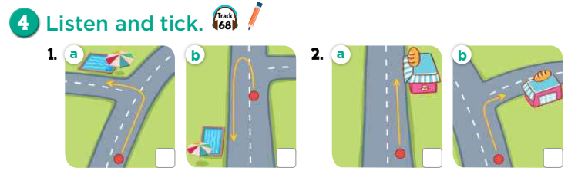  - Play the recording all the way through. Then play the recording again for pupils to listen and choose the places that the speakers are talking about.  - Get pupils to swap books with a partner and check their answers before checking as a class. Correct the answers where necessary.  Extension: If time allows, play the recording, sentence by sentence, for pupils to listen and repeat individually and in chorus. Correct their pronunciation where necessary.  - The disabled: Do Ex.4, following the teacher’s guide.  Picture cues:  1a. a direction to the swimming pool: turn left  1b. a direction to the swimming pool: turn round  2a. a direction to the bakery: go straight  2b. a direction to the bakery: turn right  Audio script:  1. A: How can I get to the swimming pool?  B: Turn left over there.  A: Thank you.  2. A: I want to buy a cake.  B: There’s a bakery in Park Street.  A: How can I get there?  B: Turn right.  A: Thank you.  Key: 1. a 2. b  Activity 2-5. Look, complete and read.  * Goal: To complete two gapped dialogues with the help of picture cues.  * Procedure:  - Model the first gapped dialogue. Have pupils read the dialogue and guess the missing words. Then draw pupils’ attention to the picture and elicit the place and the direction to complete the sentences.  - Integrate 1.2CB2a: Encourage Ss to "double-check" the map on the screen/book to ensure the word they fill in provides a reliable/correct direction to the destination.  - Give pupils a time limit to read the gapped dialogues, look at the pictures and fill in the gaps independently. Go around the classroom and give further support to pupils who find it difficult to do the task.  - Get pupils to swap books with a partner and check their answers before checking as a class. Invite one pupil to write the answers on the board.  Extension: Invite two pairs of pupils to act out the completed dialogues in front of the class. Check pronunciation where necessary  Key: 1. The shopping centre; left 2. How; right  Activity 3-6. Let’s play.  * Goal: To review the target vocabulary related to the topic “In the city” by playing Memory game.  * Procedure:  - Invite two or three teams of four pupils to the front of the class. Each team makes a line.  - Stick four flashcards for turn left, turn right, turn round and go straight on the board.  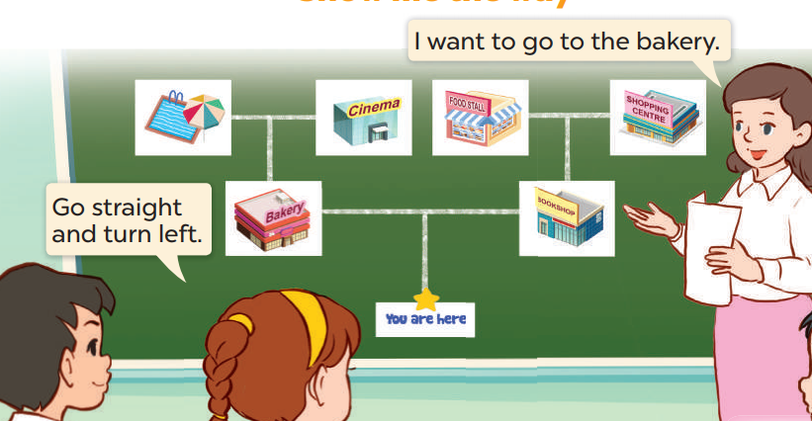  - Have pupils look at the flashcards to memorise. Take a flashcard out quickly. Have the pupils at the front of the lines can hand up to say what flashcard is missing. If it is correct, the team gets one star. The first pupil of each line goes to the end of the line. The team gets most stars wins.  - Play the game with other teams in the class  Game: Play the Lucky Number game (PPT)  - Divide the class into 2 teams.  - Pupils from each team choose a number, then choose the correct answer. If the pupils answer correctly, they get the points for that question.  - After 10 numbers, the team with the most points is the winner.  3. Consolidation (3’)  - Ask students to answer the following questions:  1. What have you learnt from the lesson today?  (use the words and phrases get, go straight, left, right, stop, tell, turn left, turn right, turn round in relation to the topic “In the city”; and use How can I get to the _____? – _____. to ask for and give directions)  2. What are the core values of the lesson?  (Raise pupils’ awareness about their neighborhood and traffic safety.)  4. Homework (2’)  - edo Ex.4, 5 and do the parts C, D at home.  - Prepare the new lesson: Unit 17-Lesson 2 (4,5,6). | - Listen to the techer  Whole class/ Individual work  - Listen to the T's instruction  - Individual work  - Listen and choose the places that the speakers are talking about  - Listen to the T's instruction  - Whole class/ Individual work  - Pair work  - Listen to the teacher  - Whole class  - Listen to the T's instruction.  - Play in group  - Whole class/ Individual work
D. Recommendation:
…………………………………………………….….……………………………
…………………………………………………………………………………………
WEEK 29
Class | Date of teaching
4A | Apri1 3 ^{rd}, 2025
4B | April 4 ^{th}, 2025
4C | April 3 ^{rd}, 2025

PERIOD 116
UNIT 17: IN THE CITY
LESSON 3 (1-3)
A. OBJECTIVES:
By the end of the lesson, pupils will be able to:
1. Knowledges:
- Correctly pronounce of the words 'bookshop and 'campsite with the stress on the first syllable in isolation and in the sentences How can I get to the 'bookshop? and How can I get to the 'campsite?;
- Use the words and phrases get, go straight, left, right, stop, tell, turn left, turn right, turn round in relation to the topic “In the city”;
- Use What does it say? – It says ʽ_____ʼ. ask and answer questions to identify road signs;
- Use How can I get to the _____? – _____. to ask for and give directions;
listen to and demonstrate understanding of simple communicative contexts in relation to the topic “In the city”.
3. Attributes:
- Raise pupils’ awareness about their neighborhood and traffic safety.
4. Phonological Competency 1.1CB2d (Sound Search Strategies - Word Stress): Use visual cues (stress marks) and auditory cues (pitch/loudness) to identify the primary stress in multi-syllabic words.
B. INSTRUCTIONAL RESOURCES
- Student’s book: Page 50
- Audio tracks 70, 71, 72
- Teacher’s guide: Pages 227, 228
- Flash cards/ pictures and posters (Unit 17)
- Computer, projector
- Hoclieu.vn
C. LEARNING PLAN:
Teacher’s activities | Student’s activities
1. Warm up (5’)  Greet the class.  - Greet the class, then have the class play Memory game with the vocabulary such as turn left, turn right, go straight, turn round, bakery, bookshop, campsite, library.  - Get pupils to open their books at page 50 and look at Unit 17, Lesson 3, Activity 1. Tell them what they will learn in this lesson.  2. Presentation (10’)  Activity 1-1. Listen and repeat.  * Goal: To correctly repeat the words 'bookshop and 'campsite with the stress on the first syllable in isolation and in the sentences How can I get to the 'bookshop? and How can I get to the 'campsite? with the correct pronunciation and intonation.  * Procedure:  Direct Instruction (1.1CB2d): T explains the "Stress Search Strategy": Look for the stress mark ( ' ) before the syllable. When speaking, that syllable is "LOUDER, HIGHER, and LONGER."  - T models: BOOK-shop (clapping loudly on the 1st syllable and softly on the 2nd).  - Play the recording (Track 70).  - Invite a few pupils to listen to and repeat the word and the sentence in front of the class. Praise them when their pronunciation is good.  - Repeat Steps 1 and 2 for the word 'campsite and the sentence How can I get to the 'campsite?. Go around the classroom and correct their pronunciation when necessary.  - Let pupils work in pairs or groups, saying the words and reading the sentences.  - The disabled: Correctly pronounce of the words 'bookshop and 'campsite with the stress on the first syllable in isolation, following the teacher’s guide.  3. Practice (15’)  Activity 2. Listen and circle.  * Goal: To identify the target words bookshop and campsite while listening.  * Procedure:  - Tell pupils the goal of the activity. Explain that they have to listen to the recording and circle the correct options. Check comprehension.  - Get pupils to read the questions, the options and guess the option they may hear in the recording.  - Play the recording, once or twice, for pupils to listen and circle the correct options. Get pupils to swap books with a partner and check their answers before checking as a class. Play the recording again for pupils to double-check their answers.  - Invite a few pupils to read aloud all the two completed questions in front of the class. Go around the classroom and correct their pronunciation and word stress if necessary.  Audio script:  1. How can I get to the bookshop?  2. How can I get to the campsite?  Key: 1. c 2. a  Activity 3-3. Let’s chant.  * Goal: To say the chant with the correct pronunciation, word stress and rhythm.  * Procedure:  - Have pupils look at the picture and tell the places they can see in the picture, and how to get there.  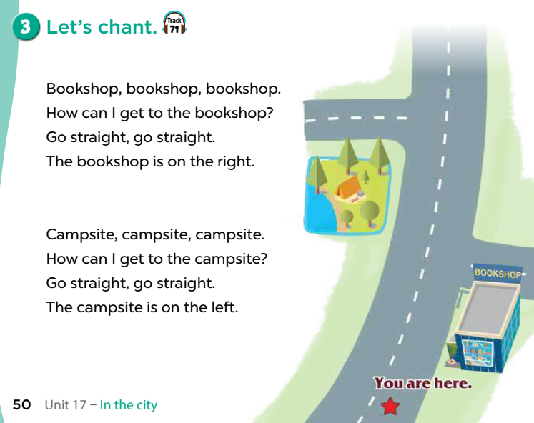  - Strategy application: Use the beat of the chant to "find" the stress. The stress of 'bookshop should fall on the beat.  - Have pupils read the first verse of the chant and draw their attention to the word bookshop. Check comprehension.  - Play the recording of the first verse. Play the recording again, line by line, for pupils to listen and repeat. Draw their attention to the rhythm, word stress and pronunciation. Encourage them to clap and do actions while chanting.  - Repeat Steps 2 and 3 for the second verse of the chant.  - Play the recording all the way through for pupils to chant and clap their hands.  Game: Play “Show me the way”  - Divide class into pairs.  - Give each pair a map and have them play in pairs. One pupil chooses a place and sy “I want to go to the ___”, the other pupil gives instructions to go to that place.  4. Consolidation (3’)  - Ask students to answer the following questions:  1. What have you learnt from the lesson today?  (correctly pronounce the words 'bookshop 'and 'campsite 'with the stress on the first syllable in isolation and in the sentences How can I get to the 'bookshop? and How can I get to the campsite?)  2. What are the core values of the lesson?  (Raise pupils’ awareness about their neighborhood and traffic safety.)  5. Homework (2’)  - Practice pronouncind of the words 'bookshop and 'campsite with the stress on the first syllable in isolation and in the sentences How can I get to the 'bookshop? and How can I get to the 'campsite?  at home.  - Prepare the new lesson: Unit 17-Lesson 3 (4,5,6). | - Listen to the techer  Whole class/ Individual work  - Whole class  - Listen to the T's instruction  - Individual work  - Listen and repeat  - Listen to the T's instruction  - Pair work  - Listen to the teacher  - Whole class/ Individual work  - Listen to the teacher  - Read the first verse of the chant and draw their attention to the word bookshop  - Whole class  - Listen to the T's instruction.  - Play in group  - Whole class/ Individual work
D. Recommendation:
…………………………………………………….….……………………………
…………………………………………………………………………………………
WEEK 30
Class | Date of teaching
4A | Apri1 11 ^{th}, 2025
4B | April 12 ^{th}, 2025
4C | April 11 ^{th}, 2025
PERIOD 117
UNIT 17: IN THE CITY
LESSON 3 (4-6)
A. OBJECTIVES:
By the end of the lesson, pupils will be able to:
1. Knowledges:
- Read and show the understanding of the text by deciding if the statements are true or false.
- Complete a gapped text about giving directions.
- Draw a map and present it by giving directions in class at Project time.
2. Skills: Readinging and writing
3. Attributes
- Raise pupils’ awareness about their neighborhood and traffic safety.
B. INSTRUCTIONAL RESOURCES
- Student’s book: Page 51
- Teacher’s guide: Pages 229, 230
- Flash cards/ pictures and posters (Unit 17)
- Hoclieu.vn
- Computer, projector
4. Digital Competency (2.4CB2a - Selecting digital tools for collaboration): Pupils discuss and choose a suitable digital tool (e.g., Google Maps, Canva, or Padlet) to collaborate with peers in designing and labeling a digital neighborhood map.
C. LEARNING PLAN:
Teacher’s activities | Student’s activities
1. Warm up  Greet the class.  - Invite one or two groups of pupils to the front of the class to say the chant in Lesson 3, Activity 3. The rest of the class may chant, clap and do actions along.  - Ask pupils to open their books at page 51 and look at Unit 17, Lesson 3, Activity 4.  2. Practice (25’)  Activity 1-4. Read and tick True or False.  * Goal: To read and show the understanding of the text by deciding if the statements are true or false.  * Procedure:  - Tell pupils the goal of the activity and explain that they should read the text and tick if the Sentences 1- 4 are true or false. Check comprehension.  - Do Statement 1 as an example. First, have pupils read Statement 1 and find what the statement is about (It’s about the bakery) and where it is (in Nguyen Hue Street). Then, find the information about the bakery in the text. Read carefully to decide if the statement is true or false.  - Set a time limit for pupils to do the task independently. Go around the classroom and offer help where necessary.  - Get pupils to swap their books with a partner and check their answers before checking as a class. Correct the answers where necessary.  - The disabled: Do Ex.4, following the teacher’s guide.  Key: 1. True 2. False 3. False 4. True  Activity 2-5. Let’s write.  * Goal: To complete a gapped text about giving directions.  * Procedure:  - Tell the class the goal of the activity and explain that they should read the gapped text and fill in the gaps with their own information. Check comprehension.  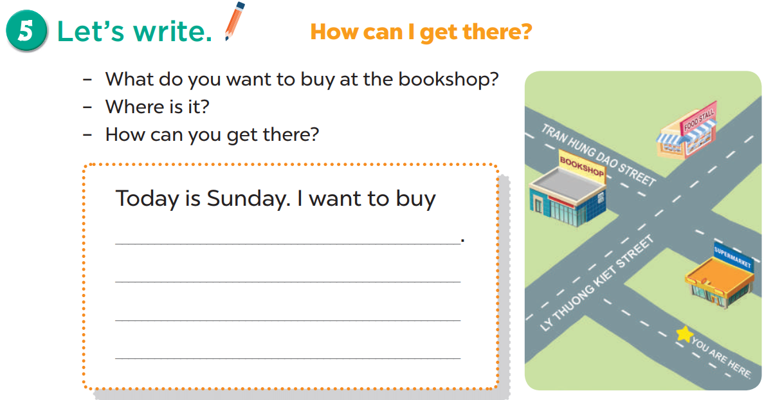  - Have pupils do the first gapped sentence together as an example. Ask them to read the first sentence and elicit the words (e.g. books, cakes, pencils). Then have them write it in the gap.  - Give pupils time to complete other gaps independently. Go around the classroom and offer help where necessary.  - Get pupils to swap their books with a partner and check their answers before checking as a class.  Extension: Invite one or two pupils to read their completed texts in front of the class.  Suggested answer:  Today is Sunday. I want to buy some comic books. The bookshop is in Tran Hung Dao Street. I can go straigh ahead and take the second turn of the left. The bookshop is on the left.  Activity 3-6. Project.  * Goal: To draw a map and present it by giving directions to three places with visual aids.  * Procedure:  - Selecting Digital Tools (2.4CB2a): T introduces 2-3 digital options for collaboration (e.g., Option A: Google Maps to pin real locations; Option B: Canva to design a creative city layout).  - Tell pupils the goal of the activity. Explain again that they are making a map of their neighbourhood to give directions from their house to at least three different places. Draw a map, mark the directions from their house to at least three places on the map, and prepare how to present it at home. Make a presentation to a group. Ask pupils to show their map.  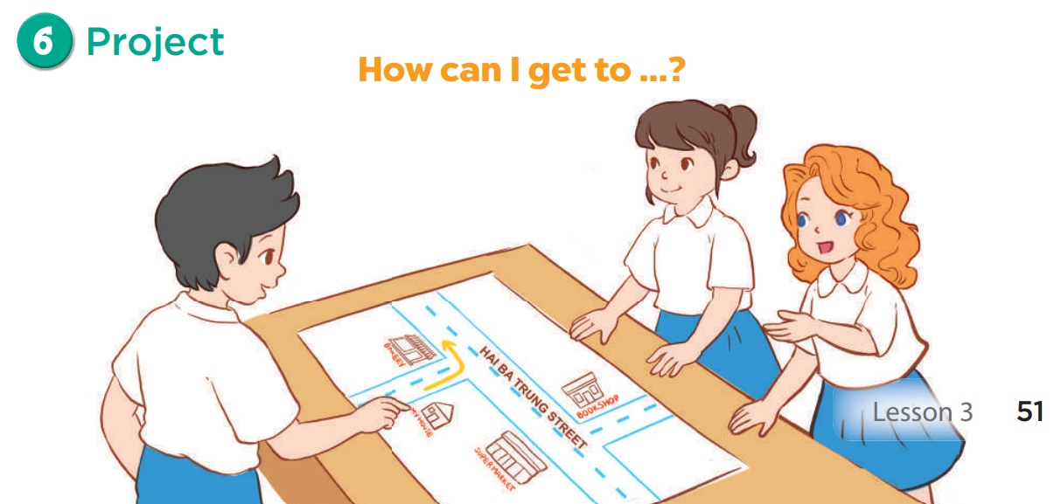  - Use Nam’s map and his presentation as an example. Act as Nam to make a presentation.  - Have pupils work in their groups. Each pupil shows his / her map and gives the directions from their house to three places. Go around the classroom and offer help where necessary.  - Invite a few pupils to show the map and make a presentation in front of the class. Praise pupils when they do the task well.  Game: Play the Who wants to be the Millionaire (PPT)  - Divide the class into 3 groups.  - Have pupils read the questions, then invite a pupil to answer (or have them raise answer cards A, B, C or D).  3. Consolidation (3’)  - Ask students to answer the following questions:  1. What have you learnt from the lesson today?  (draw a map and present it by giving directions in class at Project time.)  2. What are the core values of the lesson?  (Raise pupils’ awareness about their neighborhood and traffic safety.)  4. Homework (2’)  - Redo Ex.4, 5 and do the parts E, F at home.  - Prepare the new lesson: Unit 18-Lesson 1 (1,2,3). | - Listen to the techer  Whole class/ Individual work  - Whole class/Individual work  - Listen to the T's instruction  - Individual work  - Tick T/F  - Whole class/Do the task independently  - Listen to the T's instruction  - Individual work  - Complete other gaps independently  - Read their completed texts in front of the class.  - Listen to the teacher  - Make a presentation  - Play in group  - Listen to the T's instruction.  - Whole class/ Individual work
D. Recommendation:
…………………………………………………….….……………………………
…………………………………………………………………………………………

WEEK 30
Class | Date of teaching
4A | Apri1 11 ^{th}, 2025
4B | April 12 ^{th}, 2025
4C | April 11 ^{th}, 2025
PERIOD 118
UNIT 18: AT THE SHOPPING CENTRE
LESSON 1 (1-3)
A. OBJECTIVES:
By the end of the lesson, pupils will be able to:
1. Knowledges:
- Use the words behind, between, near, opposite, gift shop, skirt, T-shirt, dong and thousand in relation to the topic “At the shopping centre”;
- Use Where’s the bookshop? – It’s . to ask and answer questions about locations;
- Listen to and demonstrate understanding of simple communicative contexts in relation to the topic “At the shopping centre”;
2. Skills: Listening and speaking
3. Attributes:
- Use appropriate gestures and intonation when talking about locations of some places in a shopping center.
4. Digital Competency (1.1CB2b): Search for data on goods and prices. (Pupils can use digital tools to look up the price of items like skirts/T-shirts and identify which shop sells them).
B. INSTRUCTIONAL RESOURCES
- Student’s book: Page 52
- Teacher’s guide: Pages 253, 254
- Flash cards/ pictures and posters
- Hoclieu.vn
- Computer, projector
C. LEARNING PLAN:
Teacher’s activities | Student’s activities
1. Warm up (5’)  - Greet the class.  Option 1: Say the chant on page 50  - Ask pupils to open their books at page 50 and look at Activity 3.  - Ask pupils to chant and do the actions in Unit 17, Lesson 3 in groups.  - Give points to the groups and encourage them.  Option 2: Game: Game: Pass the ball  - Divide the class into 3 teams.  - Each team has 1 sticky ball.  - Play the music, pupils in each team take turns passing the ball. After the music ends, 3 pupils who have the balls will stand up and say the model sentences.  2. Presentation (10’)  Activity 1-Vocabulary  * Goals: Ss will be able to know some prepositions of place, before starting the new lesson.  * Procedure:  - T elicits the new words  + near : gần kề (picture)  + opposite : đối diện (picture)  + behind : đằng sau (picture)  + between A and B: ở giữa (picture)  - T models (3 times).  - T writes the words on the board.  - Checking: Rub out and remember  - The disabled: Practice reading vocab.  Activity 2-1. Look, listen and repeat.  * Goal: To understand and correctly repeat the sentences in two communicative contexts focusing on asking and answering questions about locations of some shops at the shopping centre.  * Procedure:  - Ask pupils to look at Pictures a and b, and identify the characters in the pictures.  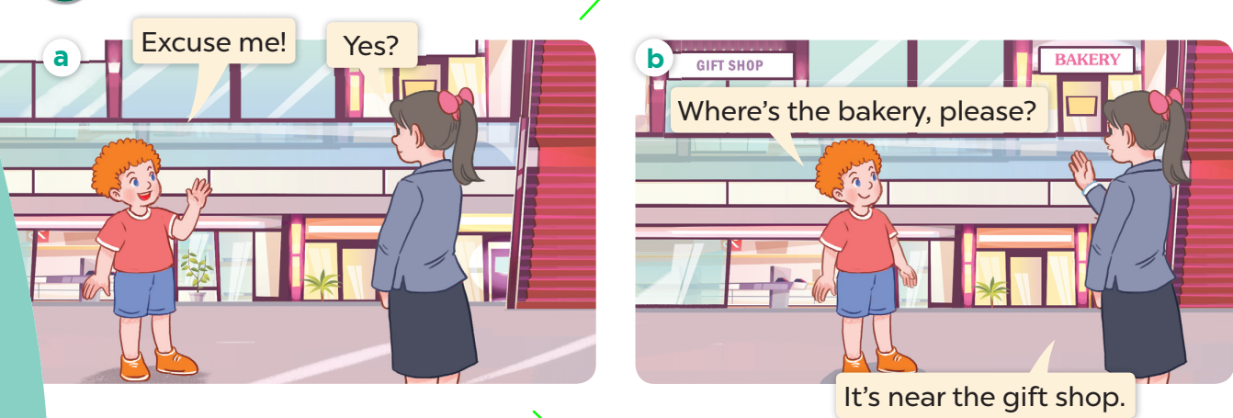  - Encourage pupils to talk about details in the backgrounds of the pictures.  - Ask pupils to look at Picture a. Play the recording for them to listen to the conversation a few times.  - Play the recording again, sentence by sentence, for pupils to listen and repeat individually and in chorus. Correct their pronunciation where necessary. Repeat the same procedure with Picture b.  - Invite a few pairs to the front of the classroom to listen to and repeat the sentences in the recording. Give corrections and feedback where necessary.  - Draw pupils’ attention to the question Where’s the bakery, please? and the answer It’s near the gift shop. Tell pupils that they are used to ask and answer questions about locations.  3. Practice (15’)  Activity 3-2. Listen, point and say.  * Goal: To correctly say the words and use Where’s the bookshop? – It’s _____.  * Procedure:  - To ask and answer questions about locations of a bookshop.  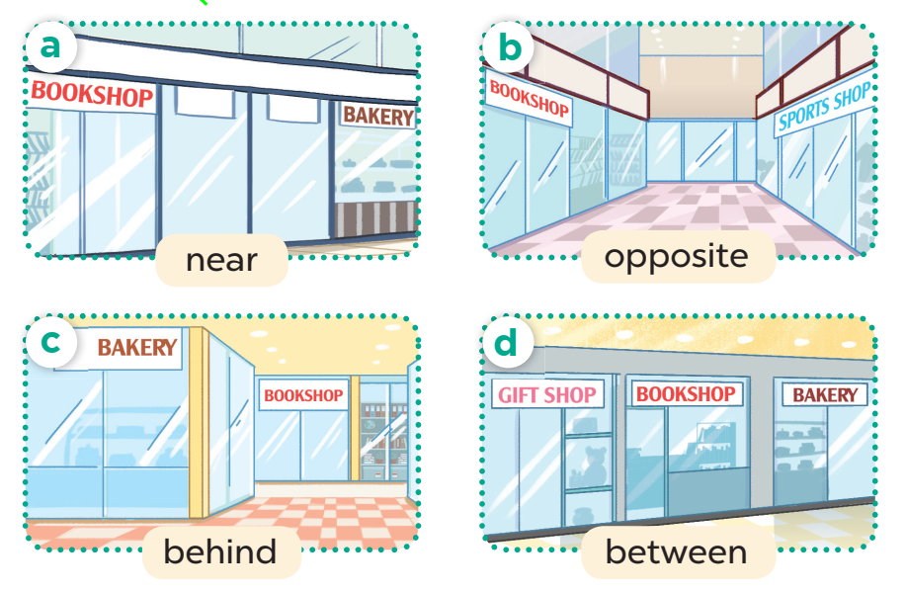  - Have pupils point at Picture a, listen to the recording and repeat the word near. Repeat the same procedure with Pictures b, c and d. Have the class repeat the words a few times and correct their pronunciation where necessary.  - Draw pupils’ attention to the speech bubbles and elicit the missing words in the answer by pointing at Picture a. Play the recording for pupils to listen to and repeat the sentences in both bubbles a few times (Where's the bookshop? – It's near the bakery.).  Repeat the same procedure with Pictures b, c and d.  - Divide the class into two groups to take turns repeating the question and the  answer for Picture a until they feel confident. Repeat the same procedure with Pictures b,  c and d.  - Have pairs practise asking and answering the questions using the pictures. Invite  a few pairs to point at the pictures and say the questions and answers in front of the class.  Give corrections and feedback where necessary.  – Picture cues:  a. a bookshop that is near a bakery  b. a bookshop that is opposite a sports shop  c. a bookshop that is behind a bakery  d. a bookshop that is between a gift shop and a bakery  – Speech bubbles: Where’s the bookshop? – It’s _____.  Audio script:  a. near b. opposite c. behind d. between  a. A: Where’s the bookshop?  B: It’s near the bakery.  b. A: Where’s the bookshop?  B: It’s opposite the sports shop.  c. A: Where’s the bookshop?  B: It’s behind the bakery.  d. A: Where’s the bookshop?  B: It’s between the gift shop and the bakery  Activity 3-3. Let’s talk  * Goal: To enhance the correct use of Where’s the _____? – It’s _____. to ask and answer questions  about locations in a freer context.  * Procedure:  - Draw pupils’ attention to the picture and elicit the words or phrases to describe locations.  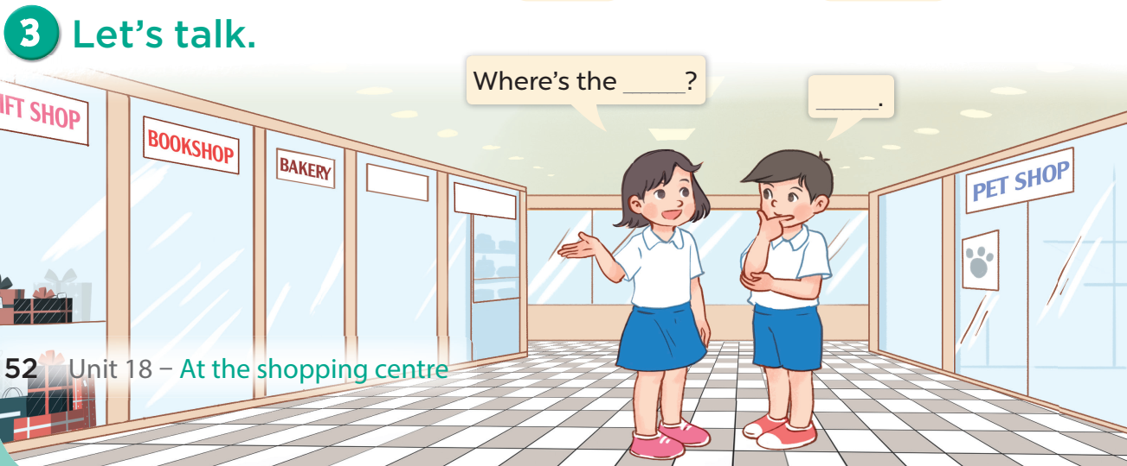  (Integrated with Digital Competency 1.1CB2b)  - Step 1: T shows a digital "Shopping Mall Catalog" on the screen.  - Step 2: T asks: "I want to buy a T-shirt. How much is it? Where can I buy it?".  - Step 3 (Data Searching): Pupils look at the digital screen/ tablet to search for the price (e.g., 50,000 dong) and the shop name.  - Step 4 (Communication): After finding the info, pairs practice:  A: Where's the sports shop? (The shop selling T-shirts).  B: It's opposite the bookshop.  Game: Lucky number  - Divide the class into 2 teams (boys and girls). Each team takes turns to choose a number. They need to ask and answer with the picture corresponding to that number to get points.  - The group with more points at the end of the game will be the winner.  - Praise the winner, encourage the other team.  4. Consolidation (3’)  - Ask students to answer the following questions:  1. What have you learnt from the lesson today?  2. What are the core values of the lesson?  Preparation for the project: Ask pupils to prepare for the project on page 57 by making a shopping list as homework so that they can give a short presentation in front of the class at Project time in Lesson 3, Activity 6.  5. Homework (2’)  - Learn by heart vocab and structure at home.  - Prepare the new lesson: Unit 18-Lesson 1 (4,5,6). | - Listen to the techer  Whole class/ Individual work  - Whole class/Group work  - Ss listen and answer  - Ss listen and repeat  + Choral repetition (3 times).  + Individual repetition (3 ss)  - Ss take note  - Ss look, remember and write  - Listen to the T's instruction  - Listen and repeat  - Repeat  - Listen to the T's instruction  - Listen to the teacher  Whole class/ Individual work  - Listen and repeat  - Group work  - Pair work  - Listen to the teacher  - Observe the teacher's digital demonstration.  - Search for specific goods and price data on the digital catalog.  - Work in pairs to ask and answer about shop locations.  - Play game in group  - Whole class/ Individual work
D. Recommendation:
…………………………………………………….….……………………………
…………………………………………………………………………………………
WEEK 30
Class | Date of teaching
4A | Apri1 13 ^{th}, 2025
4B | April 14 ^{th}, 2025
4C | April 13 ^{th}, 2025
PERIOD 119

UNIT 18: AT THE SHOPPING CENTRE
LESSON 1 (4-6)
A. OBJECTIVES:
By the end of the lesson, pupils will be able to:
1. Knowledges:
- Use the words behind, between, near, opposite, gift shop, skirt, T-shirt, dong and thousand in relation to the topic “At the shopping centre”; use Where’s the bookshop? – It’s . to ask and answer questions about locations; listen to and demonstrate understanding of simple communicative contexts in relation to the topic “At the shopping centre”; read and write about locations;
2. Skills: Listening and read
3. Attributes:
- Use appropriate gestures and intonation when talking about locations of some places in a shopping center.
4. Digital Competency 4.1CB2b (Distinguishing simple risks - shopping safety): Identify potential risks at a shopping centre (e.g., getting lost, keeping personal belongings safe) and understand that knowing the exact location of shops helps minimize these risks.
B. INSTRUCTIONAL RESOURCES
- Student’s book: Page 53
- Teacher’s guide: Pages 256, 257
- Flash cards/ pictures and posters
- Hoclieu.vn
- Computer, projector
C. LEARNING PLAN:
Teacher’s activities | Student’s activities
1. Warm up (5’)  Greet the class.  Game: Lucky number  - Divide the class into 2 teams (boys and girls). Each team takes turns to choose a number. They need to ask and answer with the picture corresponding to that number to get points.  - The group with more points at the end of the game will be the winner.  - Praise the winner, encourage the other team.  2. Practice (25’)  Activity 1-4. Listen and tick.  * Goal: To listen to and understand two communicative contexts in which pupils ask and answer questions about the locations of shops at the shopping centre and tick the correct pictures.  * Procedure:  - Have pupils look at Activity 4. Ask them How many pairs of pictures are there? and What can you see in each picture? Draw pupils’ attention to the boxes in the corners of the pictures. Check their comprehension.  - Focus on 4.1CB2b: Ask Ss: "Why do we need to know if the gift shop is opposite or near the bookshop?" -> Answer: To find our way and not get lost.  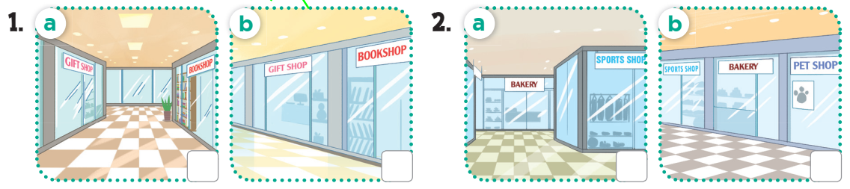  - Have pupils look at Pictures 1a and 1b. Get them to talk about the differences between the two pictures. Play the recording of the first dialogue. Then play the recording again for pupils to listen and tick the correct picture.  - Repeat Step 2 with Pictures 2a and 2b. Have pupils swap their books with a partner and check the answers. Correct the answers as a class.  Extension: If there is enough time, play the recording, sentence by sentence, for pupils to listen and repeat individually and in chorus. Correct their pronunciation if necessary.  Picture cues:  1a. a gift shop that is opposite a bookshop  1b. a gift shop that is near a bookshop  2a. a bakery that is behind a sports shop  2b. a bakery that is between a sports shop and a pet shop  Audio script:  1. A: Excuse me. Where’s the gift shop?  A: Yes. I can see it now. The gift shop is opposite the bookshop.  B: Go straight and turn right. It’s between the sports shop and the pet shop.  Key: 1. a 2. b  Activity 2-2. Look, complete and read.  * Goal: To complete four gapped exchanges about locations with the help of picture cues.  * Procedure:  - Ask pupils to look at the pictures and identify the locations of shops in them.  - Integrate 4.1CB2b: While modeling Exchange 4 (bakery is behind the sports shop), T asks: "If you go behind a shop where it's dark or quiet, is it safe?" -> Help Ss distinguish safe/unsafe areas in a shopping mall.  - Ask pupils to look at the incomplete exchanges. Draw their attention to the missing words in the sentences.  Encourage pupils to guess the missing words.  - Model Exchange 1. Have them look at the picture and identify the location. Have pupils look at the exchange. Ask them what is missing in the answer (near). Then have them complete the gap with the word (near). Repeat the same procedure with Pictures 2, 3 and 4.  - Get pupils to complete the exchanges individually, then ask a few pairs to read them aloud. Check their answers, and give corrections and feedback where necessary.  Key: 1. near 2. between 3. bookshop; opposite 4. Where’s; behind  Activity 3-3. Let’s sing  * Goal: To sing the song Where’s the bookshop? with the correct pronunciation, rhythm and melody.  * Procedure:  - Have pupils read the lyrics to familiarise themselves with the questions and answers. Check comprehension and give feedback.  - Have pupils listen to the whole song, drawing their attention to the pronunciation, the rhythm and the melody.  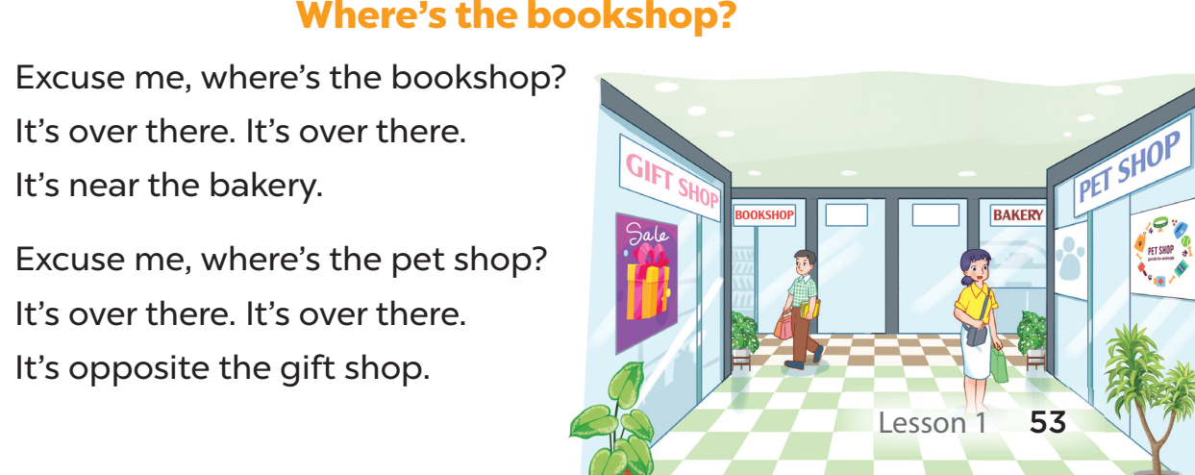  - Play the recording of the song once or twice for pupils to listen and repeat, line after line, and do related actions.  - When pupils feel confident and are familiar with the tune and melody, ask them to sing the whole song while doing actions or clapping their hands.  - Invite a few groups to the front of the class to sing the song. The class may sing along to reinforce the activity.  Game: Look and choose!  - Divide the class into teams. Each team will place a question with an image and a color.  - The teacher will open the corresponding box.  3. Consolidation (3’)  - Ask students to answer the following questions:  1. What have you learnt from the lesson today?  2. What are the core values of the lesson?  - Safety Focus (4.1CB2b): T asks: "What should you do if you get lost at the shopping centre?" (Go to a known location like the gift shop or information desk).  4. Homework (2’)  - Redo Ex.4, 5 and do the parts A, B at home.  - Prepare the new lesson: Unit 18-Lesson 2 (1,2,3). | - Listen to the techer  Whole class/ Group work  - Listen to the T's instruction  - Listen to the recording  - Individual work  - Listen and repeat  - Listen to the teacher  - Whole class/  - Individual work  - Listen and repeat  - Listen to the T's instruction.  - Play in group  - Whole class/ Individual work
  B: It’s over there. Can you see it?
  B: That’s right.
  2. A: I want to buy some cakes. Where’s the bakery?
D. Recommendation:
…………………………………………………….….……………………………
…………………………………………………………………………………………
WEEK 30
Class | Date of teaching
4A | Apri1 13 ^{th}, 2025
4B | April 14 ^{th}, 2025
4C | April 13 ^{th}, 2025
PERIOD 120

UNIT 18: AT THE SHOPPING CENTRE
LESSON 2 (1-3)
A. OBJECTIVES:
By the end of the lesson, pupils will be able to:
1. Knowledges:
- Use the words behind, between, near, opposite, gift shop, skirt, T-shirt, dong and thousand in relation to the topic “At the shopping centre”;
- Use How much is the ____? – It’s ____. to ask and answer questions about prices;
- Listen to and demonstrate understanding of simple communicative contexts in relation to the topic “At the shopping centre”;
2. Skills: Listening and speaking
3. Attributes:
- Use appropriate gestures and intonation when talking about prices.
4. Communication Competency 2.1CB2a: Interact effectively by identifying, reading, and communicating price calculations using "thousand" and "dong" in a shopping context.
B. INSTRUCTIONAL RESOURCES
- Student’s book: Page 54
- Teacher’s guide: Pages 258, 259, 260
- Flash cards/ pictures and posters
- Hoclieu.vn
- Computer, projector
C. LEARNING PLAN:
Teacher’s activities | Student’s activities
1. Warm up (5’)  Greet the class.  - Spend a few minutes revising Lesson 1 by singing the song Where’s the bookshop?  - Number Review (Prep for 2.1CB2a): T shows numbers (20, 50, 80, 90) and asks Ss to add the word "thousand" to practice large number recognition.  - Ask pupils to open their books at page 54 and look at Unit 18, Lesson 2, Activity 1. Tell pupils what they will learn in this lesson.  2. Presentation (10’)  Activity 1-Vocabulary  * Goals: Ss will be able to know the vocab, before starting the new lesson.  * Procedure:  - T elicits the new words  + T-shirt : áo phông (picture)  + skirt : váy (picture)  + thousand : nghìn (meaning)  - T models (3 times).  - T writes the words on the board.  - Checking: Rub out and remember  - The disabled: Practice reading vocab.  Activity 2-1. Look, listen and repeat.  * Goal: To understand and correctly repeat the sentences in two communicative contexts focusing on asking and answering questions about prices.  * Procedure:  - Ask pupils to look at Pictures a and b, and identify the characters in the pictures. Ask them to tell what they can see in the backgrounds of the pictures.  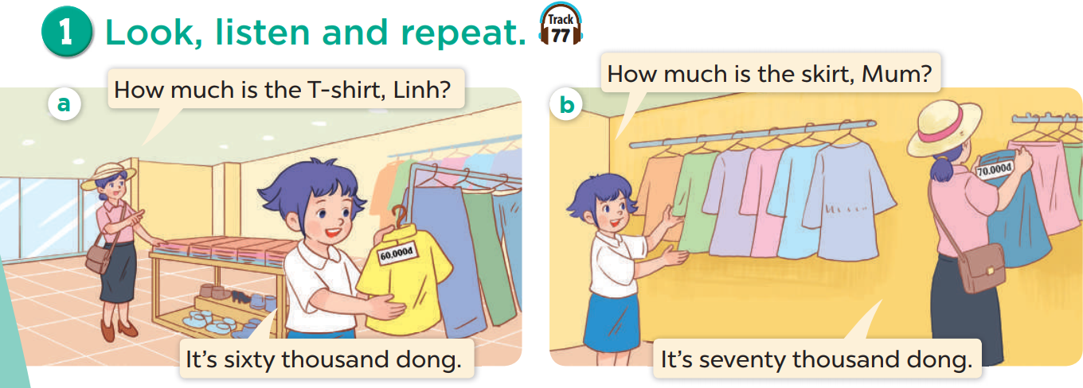  - Ask pupils to look at Picture a. Play the recording for them to listen to the conversation a few times.  - Contextualization (2.1CB2a): T asks, "If you want to buy that T-shirt, what is the first thing you need to know?" (The price).  - Play the recording again, sentence by sentence, for pupils to listen and repeat individually and in chorus. Correct their pronunciation where necessary. Repeat the same procedure with Picture b.  - Invite a few pairs to the front of the classroom to listen to and repeat the sentences in the recording. Give corrections and feedback where necessary.  - Draw pupils’ attention to the questions How much is the T-shirt? and How much is the skirt?, and the answers It’s sixty thousand dong. and It’s seventy thousand dong. Tell pupils that they are used to ask and answer questions about prices.  3. Practice (15’)  Activity 2. Listen, point and say.  * Goal: To correctly say the words and phrases and use How much is the_____? – It’s _____. to ask and answer questions about prices.  * Procedure:  - Have pupils point at Picture a, listen to the recording and repeat the word and phrase pen / twenty thousand dong. Repeat the same procedure with Pictures b, c and d. Have the class repeat the words and phrases a few times.  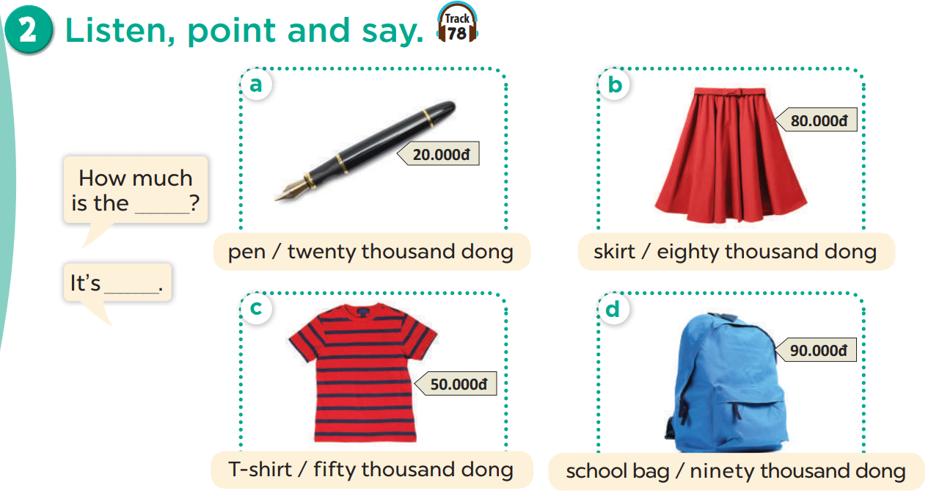  - Point at the speech bubbles and Picture a again and have pupils listen to and repeat after the recording (How much is the pen? – It’s twenty thousand dong.). Have the class repeat the question and answer a few times. Repeat the same procedure with Pictures b, c and d.  - Divide the class into two groups to take turns repeating the questions and the answers until they feel confident.  - Have pairs practise asking and answering the questions and answers with the pictures. Then, invite a few pairs to point at the pictures and say the questions and answers in front of the class. Give corrections and feedback where necessary.  – Picture cues:  a. a pen with its price tag of twenty thousand dong  b. a skirt with its price tag of eighty thousand dong  c. a T-shirt with its price tag of fifty thousand dong  d. a school bag with its price tag of ninety thousand dong  – Speech bubbles: How much is the _____? – It’s _____.  Audio script:  a. pen / twenty thousand dong  b. skirt / eighty thousand dong  c. T-shirt / fifty thousand dong  d. school bag / ninety thousand dong  a. A: How much is the pen?  B: It’s twenty thousand dong.  b. A: How much is the skirt?  B: It’s eighty thousand dong.  c. A: How much is the T-shirt?  B: It’s fifty thousand dong.  d. A: How much is the school bag?  B: It’s ninety thousand dong.  Activity 4-3. Let’s talk.  * Goal: To enhance the correct use of How much is the _____? – It’s _____. to ask and answer questions about prices in a freer context.  * Procedure:  - Draw pupils’ attention to the picture and elicit the words or phrases used to describe prices.  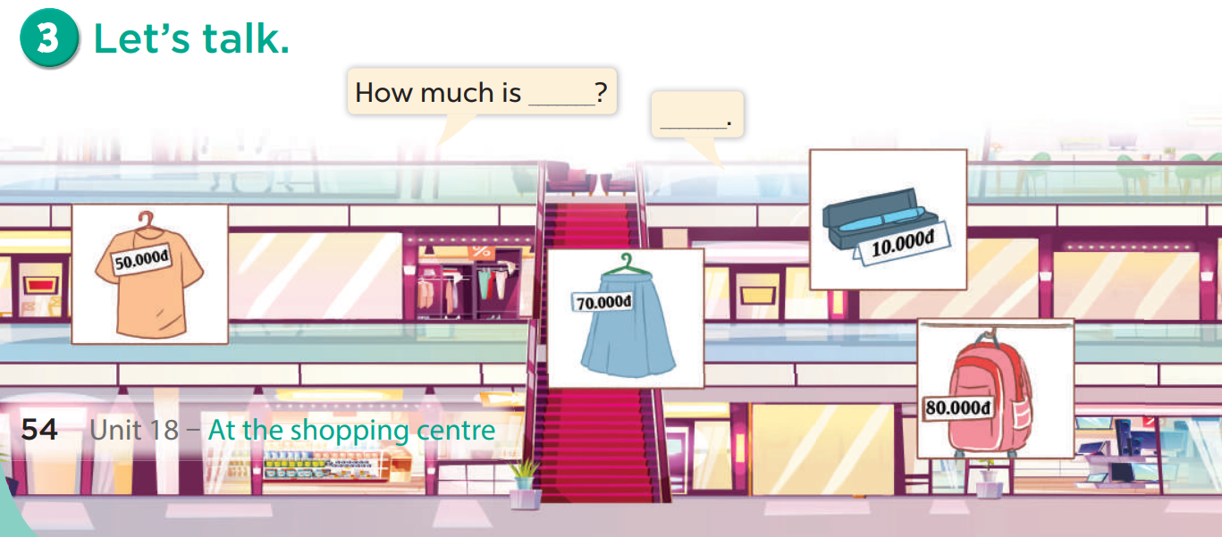  - Role-play (2.1CB2a): T encourages Ss to use real money gestures (handing over a bill) while saying the price to make the interaction authentic.  - Elicit the missing words in the first bubble. Ask pupils to look at the second bubble and identify what the answer should be. Give an example conversation, e.g. How much is the T-shirt? – It’s fifty thousand dong. Get pupils to repeat the question and the answer several times.  - Have pairs practise asking and answering the questions about the prices of the items in the picture. Go around the classroom to observe and provide help.  - Invite a few pairs to practise asking and answering questions in front of the class. Give corrections and feedback where necessary.  Game: Play the Let’s go shopping game (PPT)  - Divide the class into 2 teams.  - Pupils from each team choose an object they want to buy, then answer the question. If the pupils answer correctly, they get the points (coins) for that question to buy that object.  - After 6 numbers, the team with the most points is the winner.  4. Consolidation (3’)  - Ask students to answer the following questions:  What have you learnt from the lesson today?  (use the words behind, between, near, opposite, gift shop, skirt, T-shirt, dong and thousand in relation to the topic “At the shopping centre”).  5. Homework (2’)  - Practice reading vocab and structure at home.  - Prepare the new lesson: Unit 18-Lesson 2 (1,2,3). | - Listen to the techer  Whole class/ Individual work  - Whole class/Individual work  - Ss listen and answer  - Ss listen and repeat  + Choral repetition (3 times).  + Individual repetition (3 ss)  - Ss take note  - Ss look, remember and write  - Listen to the T's instruction  - Listen to the conversation a few times  - Pair work  - Listen and repeat  - Listen to the T's instruction  - Listen to and repeat  - Whole class/ Group work  - Ask and answer  - Listen to the teacher  - Pair work  - Listen to the T's instruction.  - Play in group  - Whole class/ Individual work
D. Recommendation:
…………………………………………………….….……………………………
…………………………………………………………………………………………
Duyệt của TT Chuyên môn Người thực hiện

NguyễnThị Thu Hiền
Nguyễn Thị Thu Hà

