**LỚP HỌC THẦY (CÔ) ___________________________** **ĐỀ ÔN TẬP: READING SIGNS/ NOTICES – A2**

**Test 1**

*Thời gian làm bài: [Time]*

Họ và tên: ________________________________________________ Lớp: 9/___

**Nội dung:**

**Question 1:** What does the sign say?

**A.** Anyone is allowed to enter without restrictions.  
**B.** Only authorized personnel are permitted to enter.  
**C.** No one is allowed to enter the area**.**  
**D.** You should keep your dog on a leash while in the are**a.**

**Question 2:** What does the noticesay?

**"Please keep your bus ticket with you at all times. The transport officers might ask to see it during your journey"**

**A.** You need to keep your bus ticket with you. Officers might check it.

**B.** Transport officers will give you a bus ticket.

**C.** You do not need a bus ticket for the journey.

**D.** You can get your bus ticket from the transport officers.

**Question 3:** What does the sign say?

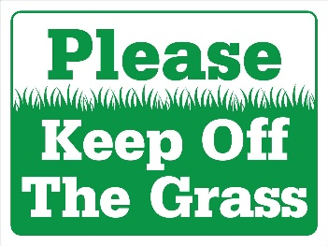

**A.** You can walk on the grass and play games there.  
**B.** The grass should be kept clean and free of trash.  
**C.** You should not walk on the grass to help keep it healthy.  
**D.** The grass is for sitting and relaxing only.

**Question 4:** What does the notice say?

**"No entry allowed without a valid pass.**

**You must show your pass to enter the building"**

**A.** You need a valid pass to enter. Show it to get in.

**B.** You can enter the building without a pass.

**C.** Passes are not needed for entering the building.

**D.** The building is open to everyone.

**Question 5:** What does the sign say?

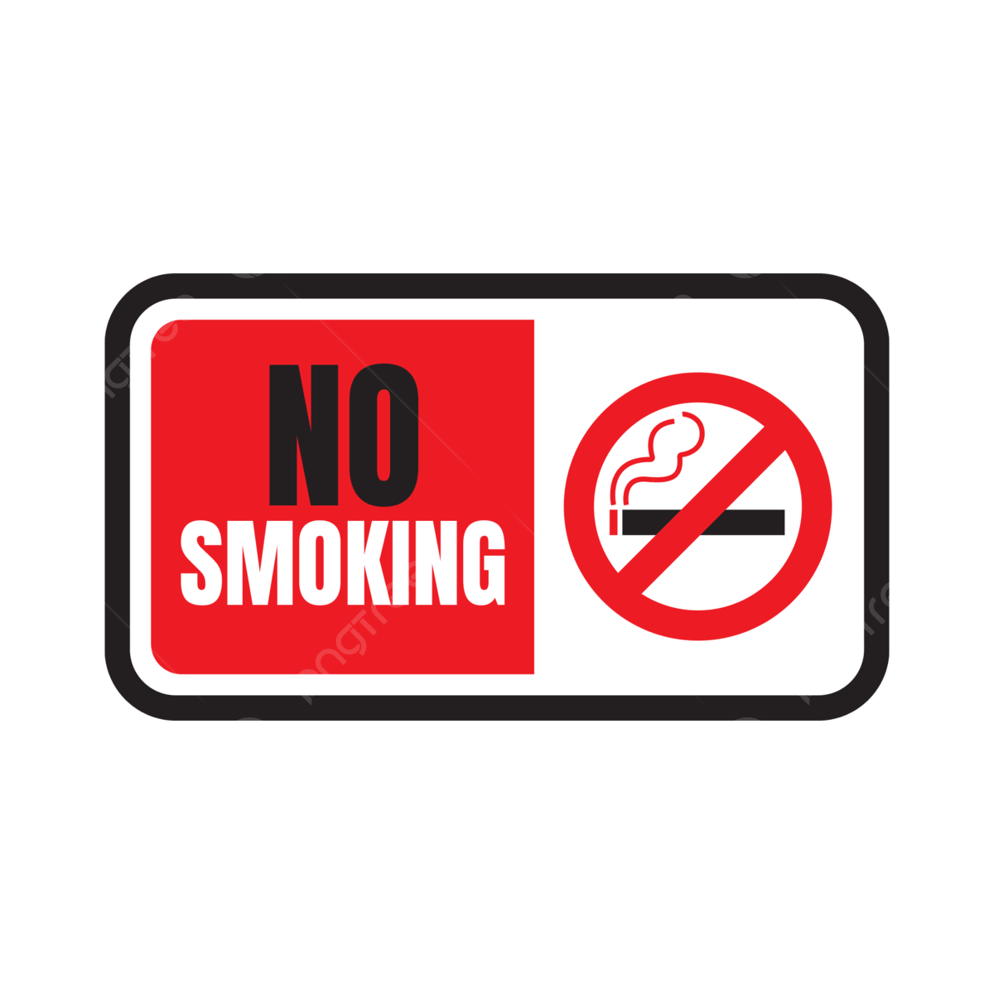**A.** You can smoke anywhere, including in this area**.**  
**B.** Smoking is only allowed in specific areas that are marked for it.  
**C.** Smoking is not allowed at all in this area to keep it clean and safe.  
**D.** Smoking is encouraged and welcome in this area**.**

**Question 6:** What does the noticesay?

**"No smoking is allowed inside this building.**

**Please use the designated smoking areas outside"**

**A.** Do not smoke inside. Use smoking areas outside.

**B.** Smoking is allowed in any part of the building.

**C.** You can smoke anywhere inside the building.

**D.** Smoking is only allowed in specific rooms inside.

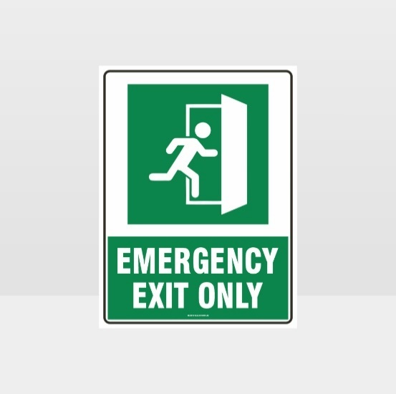**Question 7:** What does the sign say?

**A.** You can use this door anytime you want to enter.

**B.** This door is only for use in emergencies when you need to leave quickly.

**C.** Everyone should use this door to enter the building.

**D.** This door is locked and cannot be opened at all.

**Question 8:** What does the noticesay?

**"Dogs must be leashed at all times in this area.**

**Please keep your dog on a leash to ensure safety"**

**A.** Dogs need to be leashed here. It is for safety.

**B.** Dogs can run free without a leash.

**C.** Leashes are not necessary for dogs.

**D.** Only some dogs need leashes.

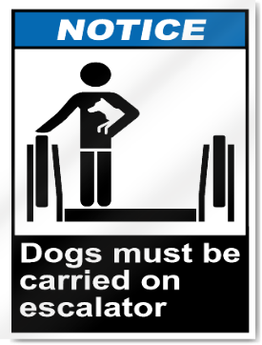**Question 9:** What does the sign say?

**A.** Dogs are allowed to walk on the escalator.  
**B.** Dogs should be carried when using the escalator.  
**C.** Dogs are not allowed to use the escalator at all.  
**D.** Dogs can ride the escalator without any restrictions.

**Question 10:** What does the notice say?

**"The restroom is temporarily closed for maintenance.**

**It will open as soon as the work is finished"**

**A.** The restroom is closed for maintenance and will open later.

**B.** The restroom is open but being cleaned**.**

**C.** The restroom is always open.

**D.** You can use the restroom in a different building.

**[HẾT]**