READING
PART 1
Look at the picture. Read the words. Which words go with the picture? Fill in the correct circles on your answer sheet.
1.

(A) The boy is drawing a picture. | (B) The boy is taking a photo. | (C) The boy is talking on the phone
The answer is “B”. Fill in “B” on your answer sheet.
2.
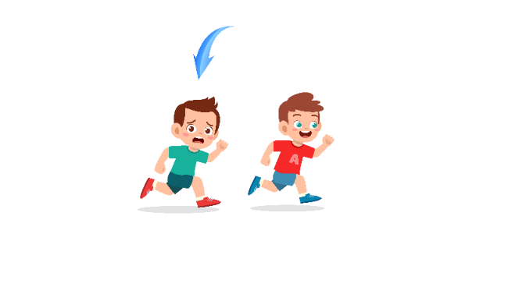
What doew the arrow show?
The boy with the arrow is ahead of the other boy.
(A) Ahead | (B) Beside | (C) Under
The answer is “A”. Fill in “A” on your answer sheet.

3.


(A) Book | (B) Notebook | (C) Computer
4.

(A) Truck | (B) Tram | (C) Plane
5.
 | 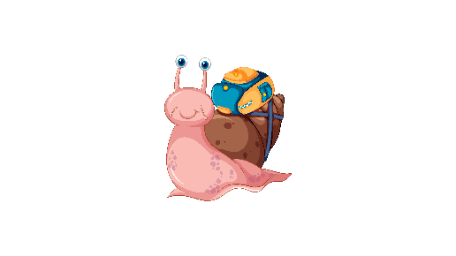
(A) Kangaroo | (B) Squirrel | (C) Snail
6.
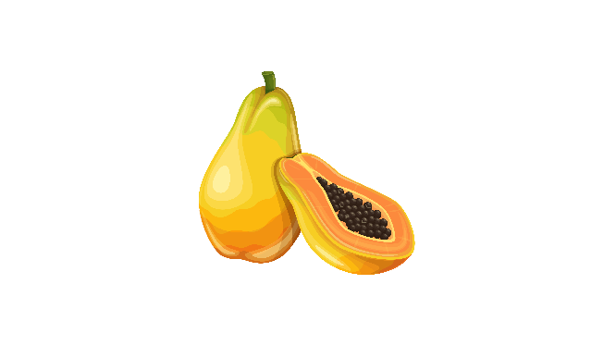
(A) Pomelo | (B) Papaya | (C) Plum
7.
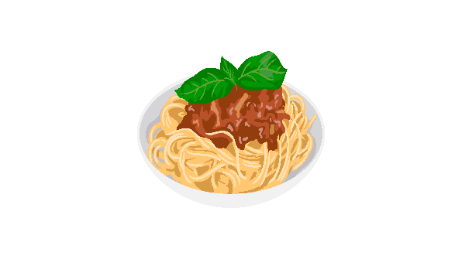
(A) Noodles | (B) Sausage | (C) Rice
8.
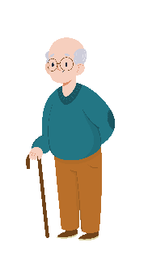
(A) straight | (B) curly | (C) bald
9.
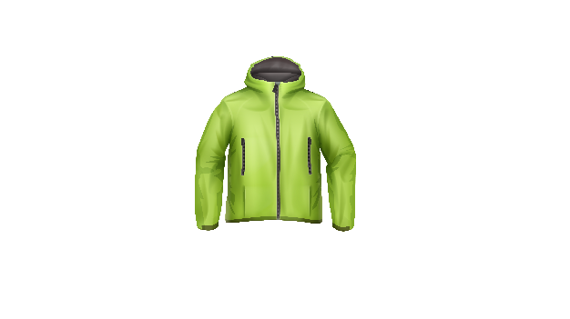
(A) Shirt | (B) Jacket | (C) Jeans
10.

(A) They are playing soccer. | (B) They are riding bikes. | (C) They are playing basketball.
11.
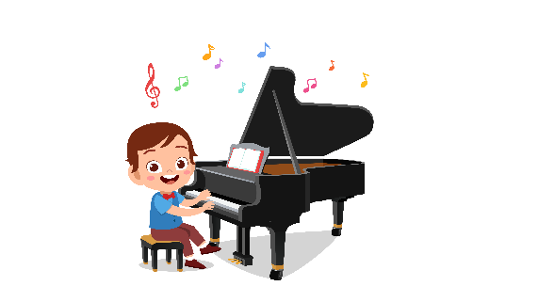

(A) The boy is playing the piano. | (B) The boy is playing the violin. | (C) The boy is playing the guitar.
12.
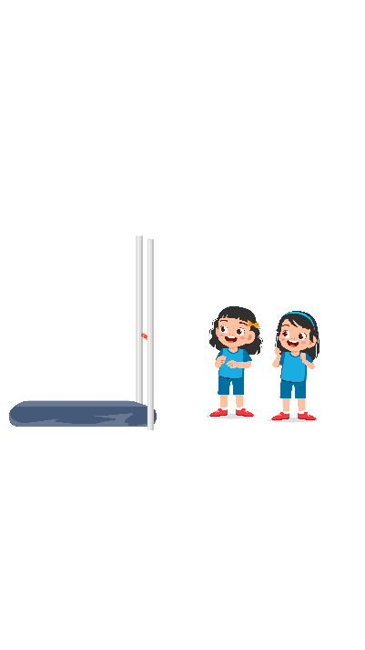
(A) The girls are in the P.E class. | (B) The girls are in the Chemistry class. | (C) The girls are in the Geography class.
13.
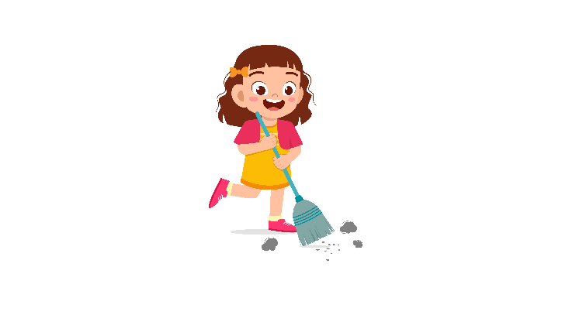
(A) She is sweeping the floor. | (B) She is emptying the bin. | (C) She is washing dishes.
14.
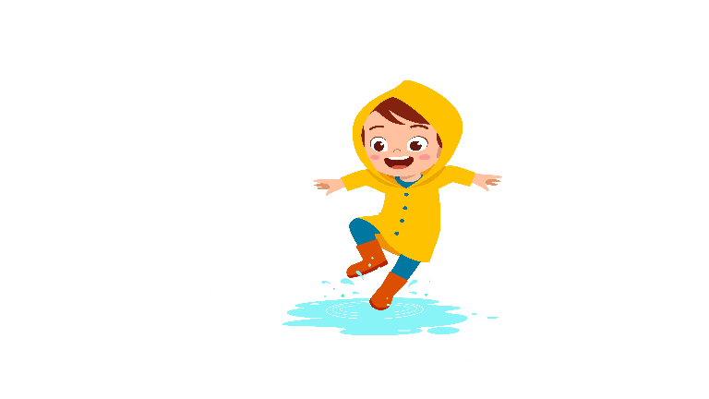
(A) The boy wears a raincoat. | (B) The boy takes a hat. | (C) The boy wears boots.
15.


(A) She is eating ice cream. | (B) She is eating bread. | (C) She is eating fries.
16.
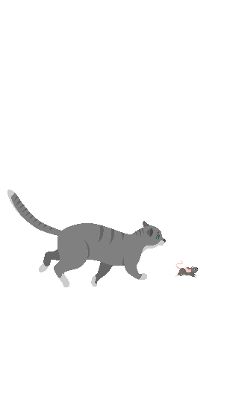
(A) The cat is chasing a mouse. | (B) The cat is climbing tree. | (C) The cat is eating fish.
17.
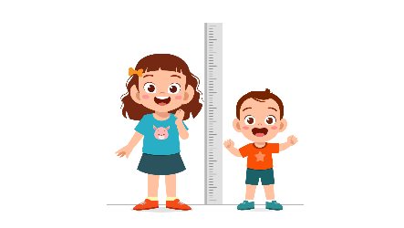

(A) The girl is shorter than the boy. | (B) The girl is taller than the boy. | (C) The boy is taller than the girl.

PART 2
Read and find the answer.
Fill in the correct circles on your answer sheet.
Let’s do an example.
- Students go to class here. Teachers work here. It has many desks. What is it?
  - (A) A house
  - (B) A school
  - (C) A bank
The correct answer is a school. Fill in "B" on your answer sheet.

- It is a place. Chemists do experiments there. Where is it?
(A) A laboratory
(B) A restaurant
(C) An office

- This is a kitchen equipment. It uses electricity to preserve food at a cold temperature. What is it?
(A) A trash bin
(B) A fridge
(C) An oven

- Peter has a beautiful voice. He wants to be ________________ in the future.
(A) a singer
(B) an artist
(C) a pianist

- Your body is at a low temperature. You may have a/an _________.
(A) eyesore
(B) cold
(C) stomachache

- When playing football, a boy forcibly hits the ball with his foot. He ________ the ball.
(A) kicks
(B) holds
(C) throws

- Musa is going out. She wears sunglasses. It is ______________ outside.
(A) sunny
(B) cold
(C) cool

- Rosie is _________________ and she needs something to eat.
(A) hungry
(B) happy
(C) thirsty

PART 3
Read the sign. Answer questions 26 to 29.
Fill in the correct circles on your answer sheet.
Jay, Alex, Ellen, Kelly and Ana go to the park. They read this sign at the park

Guide to the park
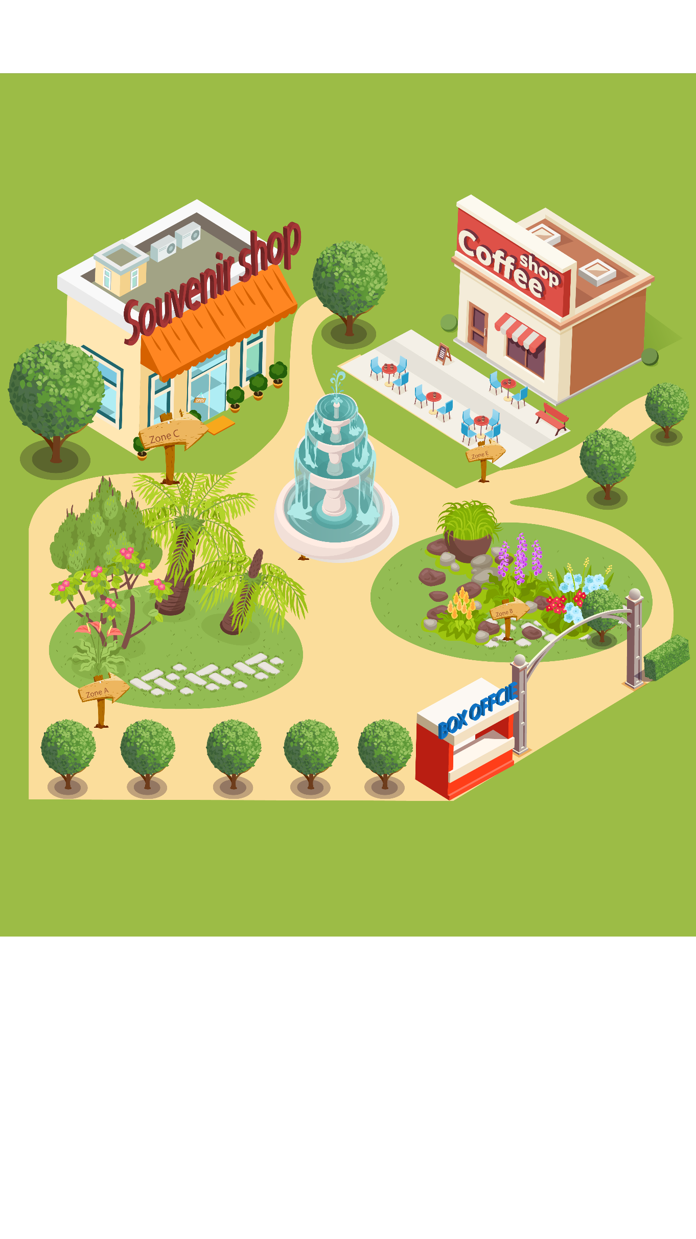

- Peter Ellen wants to buy ticket. She goes to ____________.
(A) zone D
(B) zone A
(C) the gate

- Ana needs to see some plants. She goes to ____________.
(A) zone A
(B) zone B
(C) zone C

- Jay wants to buy some gifts. He goes to ____________.
(A) zone C
(B) zone D
(C) zone E

29. Kelly wants to explore the flowers. She goes to ____________.
(A) the gate
(B) zone B
(C) zone D

Read the timetable of Isabella. Answer questions 30 to 33.
 | Tuesday | Wednesday | Thursday
Maths | x | x | v
English | v | x | x
History | x | v | x
30. What subject does Isabella have on Tuesday?
(A) Maths
(B) English
(C) History

31. When does Isabella have History?
(A) Tuesday
(B) Wednesday
(C) Thursday

32. What subject does Isabella have on Wednesday?
(A) Maths
(B) English
(C) History

33. When does Isabella have Maths?
(A) Tuesday
(B) Wednesday
(C) Thursday

Read the letter. Answer questions 34 to 35.

Dear Evie,

It’s been so long since your last visit, so I thought I should write to you to see how everything is. So how are you doing? Hope you started your new job last week. It must be really exciting. I’d love to hear about your new job.

Mila is getting ready for the new school year. She mentioned you the other day while talking about this new restaurant. The food there is delicious, and you would love it. She wants to know when you are going to visit us again. We are all looking forward to seeing you. I hope you are getting a small holiday in December. Do try to visit us if you have time. We all miss you very much.

Hoping to hear from you soon
Love,
Maria

34. Why does Maria write to Evie?
(A) To catch up with each other
(B) To show her love to Evie
(C) To ask Evie to pay a visit
35. What is true about Evie?
(A) She is having a vacation in December.
(B) She used to work in a restaurant.
(C) She had a new job.

Read the letter. Answer questions 36 to 37.
Dear Jack,

I am writing this letter to thank you for coming to my birthday party last night. Thank you so much for spending your time coming to my party. Also, thanks for the wonderful gift that you brought. It was so pretty.

I hope you liked the food, the music and the activities at the party. I hope that you enjoy all of these. I am sorry if anything was not as good as you want.

Thank you again for coming and making my day more special. Give my love to uncle and aunty.

Yours Lovingly,
Rose

36. Why does Rose write to Jack?
(A) To thank him for joining the party
(B) To talk about childhood memories
(C) To ask whether he liked the party

37. According to the letter, what is true about the birthday party?
(A) Something went wrong.
(B) Rose prepared for the party carefully.
(C) Jack gave Rosie a gift.
Read the letter. Answer questions 38 to 39.
Dear Tom,

This is to tell you that August 20 is the date of my marriage. Of course, we sent the invitation to you already. But I think, it is my duty to write to a close friend like you to join us on this occasion. Please come soon two days before the marriage as I have to talk to you about a certain important issue. My parents are also eagerly waiting for you.

Please come soon.
With best wishes-
Your friend,
Will
38. Why does Will write to Tom?
(A) To invite him to one engagement ceremony
(B) To mention one important matter
(C) To talk about his wedding
39. What does Will talk about the occasion?
(A) Tom can take his parents there.
(B) It may take place two days earlier.
(C) The guest may also receive the invitation.

You finished the reading test.
LISTENING
PART 1
Listen to the words. Look at the pictures.
Fill in the correct circles on your answer sheet.
1.
 | 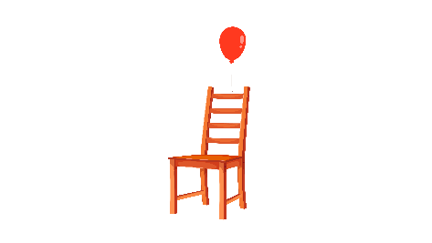 | 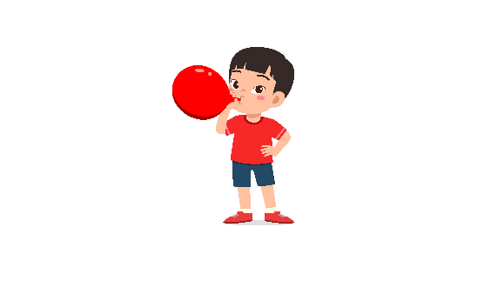
(A) | (B) | (C)
2.
 |  | 
(A) | (B) | (C)
3.
 | 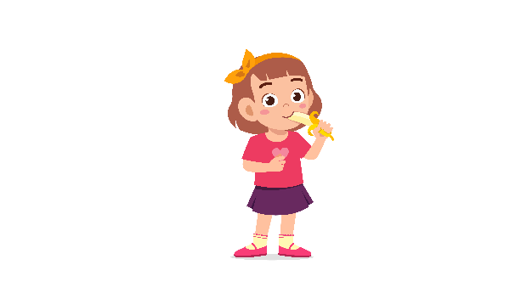 | 
(A) | (B) | (C)
4.
 |  | 
(A) | (B) | (C)
5.
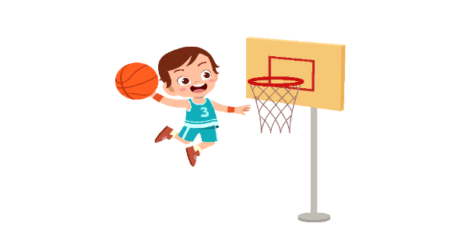 | 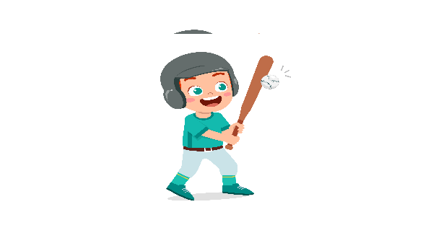 | 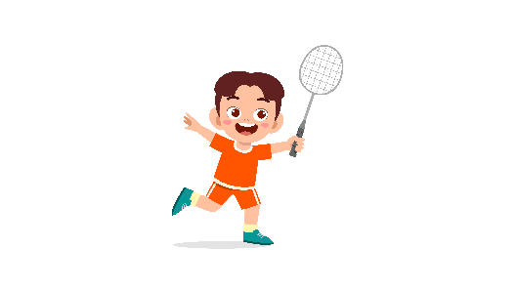
(A) | (B) | (C)
6.
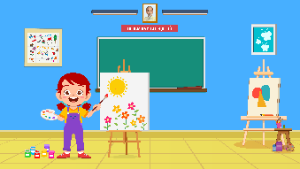 | 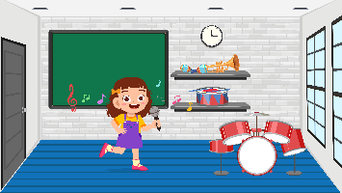 | 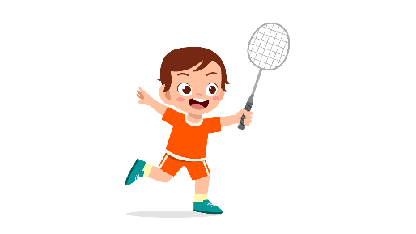
(A) | (B) | (C)
7.
 | 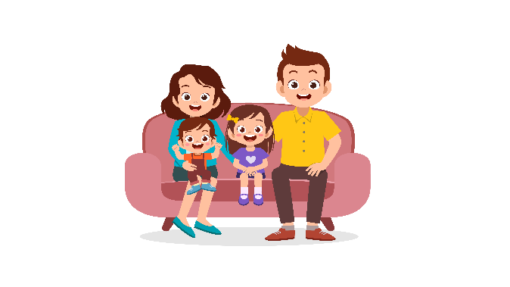 | 
(A) | (B) | (C)
8.
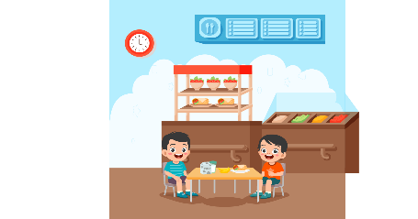 | 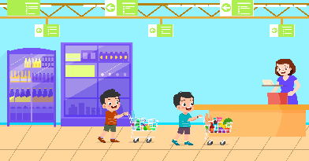 | 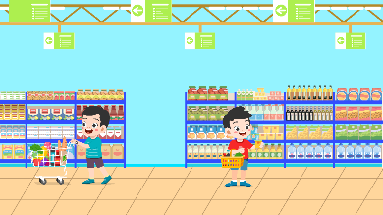
(A) | (B) | (C)

PART 2
Fill in the correct circles on your answer sheet.

9.
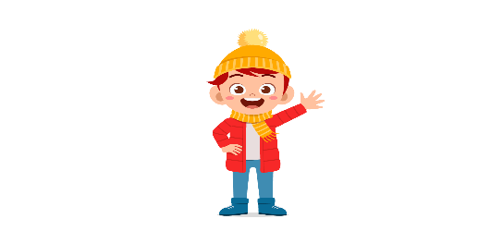 | 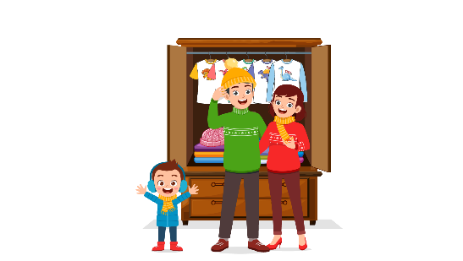 | 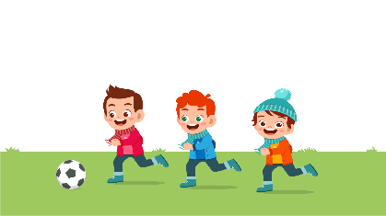
(A) | (B) | (C)
10.
 | 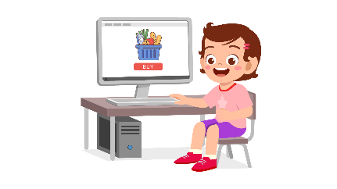 | 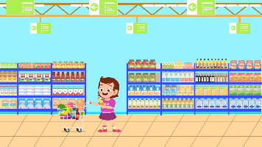
(A) | (B) | (C)
11.
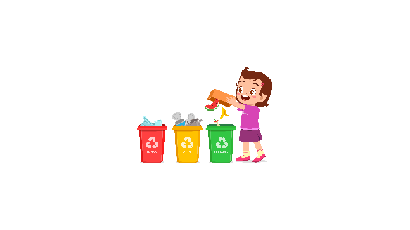 | 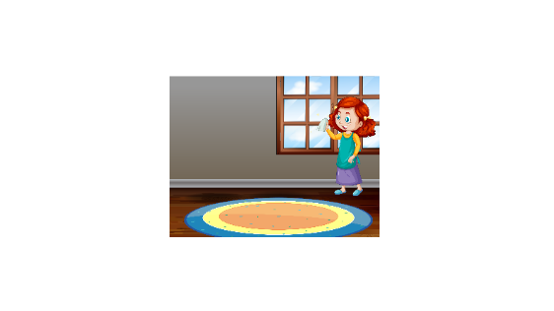 | 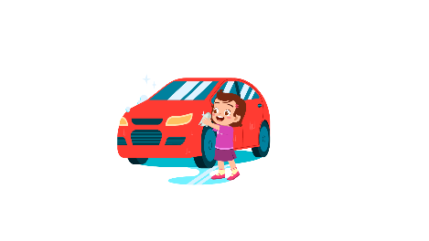
(A) | (B) | (C)
12.
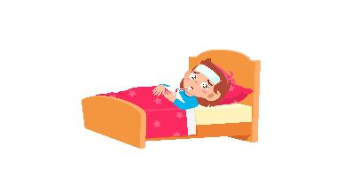 | 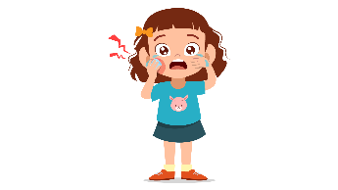 | 
(A) | (B) | (C)
13.
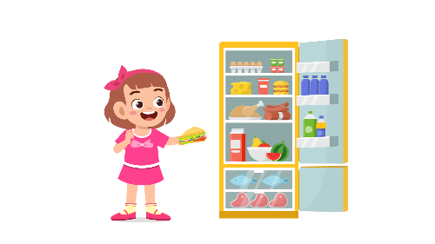 | 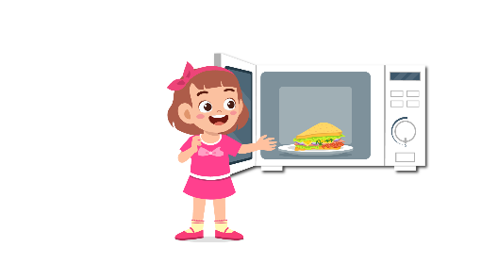 | 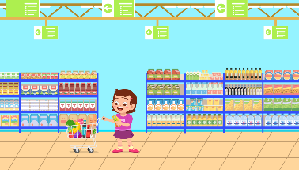
(A) | (B) | (C)
14.
 |  | 
(A) | (B) | (C)
15.
 |  | 
(A) | (B) | (C)
16.
 | 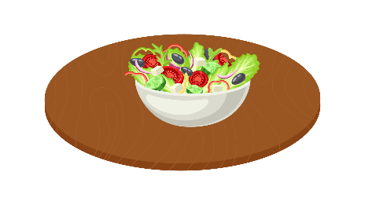 | 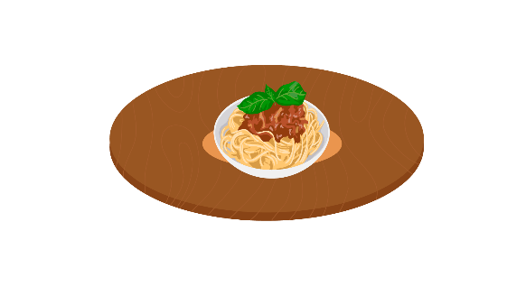
(A) | (B) | (C)
17.
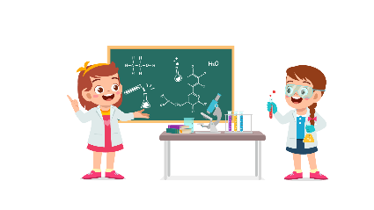 | 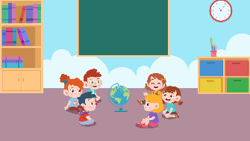 | 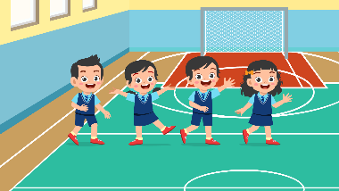
(A) | (B) | (C)
PART 3
Fill in the correct circles on your answer sheet.
Look at your answer sheet. Listen to a conversation. Which conversation sounds correct?
Let’s do an example.
(Narrator): A
(Boy): Hello. What’s your name?
(Girl): I’m fine, thanks.
(Narrator): B
(Boy): How are you today?
(Girl): I’m six years old.
(Narrator): C
(Boy): Nice to meet you!
(Girl): Nice to meet you, too!
The answer is "C." Fill in "C" on your answer sheet. Now, you do it.
18.
(A) | (B) | (C)
19.
(A) | (B) | (C)
20.
(A) | (B) | (C)
21.
(A) | (B) | (C)
22.
(A) | (B) | (C)
23.
(A) | (B) | (C)
24.
(A) | (B) | (C)
25.
(A) | (B) | (C)
26.
(A) | (B) | (C)
27.
(A) | (B) | (C)

PART 4
Listen to a conversation and answer the question. Fill in the correct circle on your answer sheet.
Let’s do an example.
28. When is the girl's party?
(A) Tonight
(B) Next week
(C) This weekend
The answer is "C." Fill in "C" on your answer sheet. Now, you do it.
29. What did the boy do last weekend?
(A) Go to the cinema
(B) Play tennis
(C) Go camping
30. What does the customer buy?
(A) A dress
(B) A jumpsuit
(C) A jacket
31. What will the boy do this summer holiday?
(A) go to the beach
(B) go to the zoo
(C) go camping
32. What does the teacher tell the boy to do?
(A) write an essay
(B) make a presentation
(C) add some pictures
33. What does the girl need to do?
(A) cook food
(B) learn about Italian food
(C) prepare some tomatoes
34. What do the friends want to do?
(A) go to the cinema
(B) go skiing
(C) go skateboarding

PART 5
Listen and answer the question.
Fill in the correct circle on your answer sheet.
Let’s do an example.
- What did Mike call about?
(A) Homework
(B) A movie
(C) A library book
The answer is "B." Fill in "B" on your answer sheet. Now, you do it.

36. Why did Lisa’s mother call?
(A) To ask her to cook dinner
(B) To ask her to check the quantity of one ingredient
(C) To tell her to buy some food
37. Why did Clara call?
(A) To remind about the homework
(B) To ask for cooperation in the homework
(C) To tell about her visit
38. Why did Camilla call?
(A) To confirm one previous decision
(B) To tell about her class schedule
(C) To suggest another plan
39. Why did the teacher call?
(A) To invite Lucy to the gallery
(B) To talk about the pictures
(C) To ask Lucy to draw pictures
40. Why did the shop assistant call?
(A) To ask Dan to send message
(B) To ask about Dan’s available time
(C) To confirm the order
41. Why did Ariel call?
(A) To get feedbacks for an essay
(B) To ask for advice on one writing part
(C) To change the role in group work

