Period
LESSON PLAN
TIẾNG ANH 10 FRIENDS GLOBAL
UNIT 3: ON SCREEN
LESSON 3H: WRITING – AN INFORMAL LETTER
I. OBJECTIVES:
By the end of the lesson, Ss will be able to:
1. Knowledge:
- learn how to write an informal letter
- practice making invitations using phrases
2. Ability:
- main skills: listening and speaking skills
- sub skills: reading and writing skills
- plan and write an informal letter
3. Quality:
- have positive attitude in English language learning so that they can participate enthusiastically in all classroom activities, especially with the topic conducted by the teacher
- keen on studying English
II. TEACHER AIDS AND LEARNING MATERIALS:
Lesson plan, PPT slides, student’s book, workbook, notebook, personal computer (if any), projector/TV, speakers, IWB software.
III. PROCEDURES:
A. Warm-up (5’)
a) Objective: Introduce the new lesson and set the scene for Ss to acquire new language; get students' attention at the beginning of the class by means of enjoyable and short activities as well as to engage them in the steps that followed.
b) Content: Game “MOVIE QUIZ” and task 1 page 43
c) Outcomes: Students can gain more confidence and interest in the lesson.
d) Competence: communication, collaboration, guessing
e) Organisation of the activity:
TEACHER’S ACTIVITIES | STUDENT’S ACTIVITIES | CONTENTS
WARM-UP. T-Ss/ S-S/ Indiv  Activity 1 (3’): Game “MOVIE QUIZ”  - Divide class into 2 groups  - Ask students to choose the correct word for each sentence  Activity 2 (2’): Task 1 page 43  - Ask students to look at the photo and answer the questions  - Lead in the lesson: An informal letter | - Play in groups  - With each correct answer, that group get one point.  - Volunteer to answer  - Open the course book page 43 | 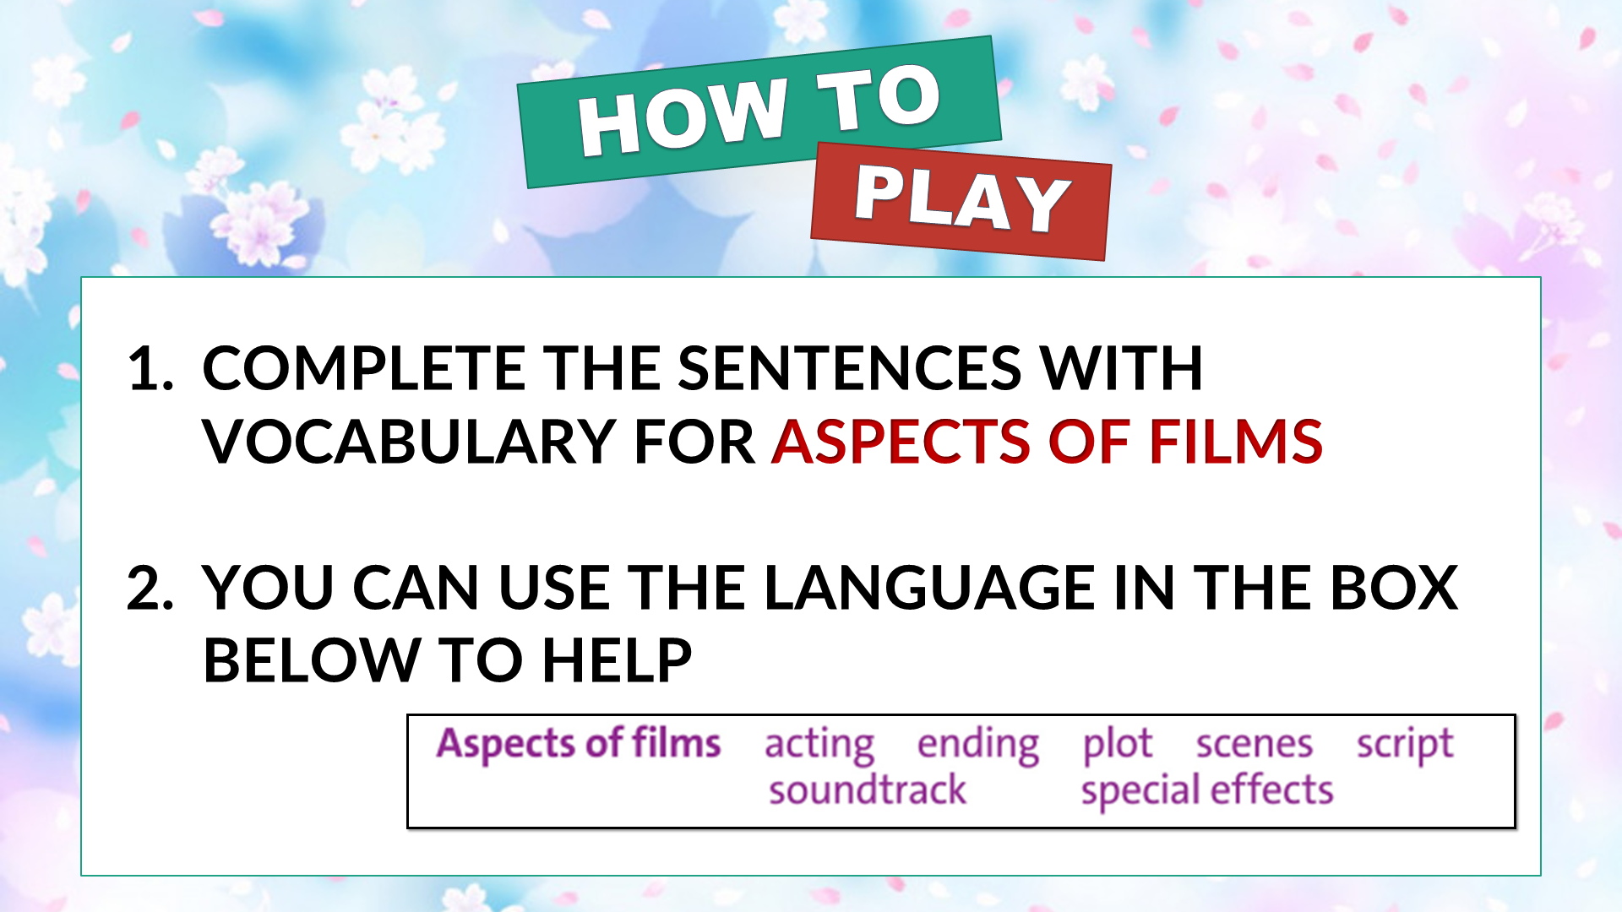  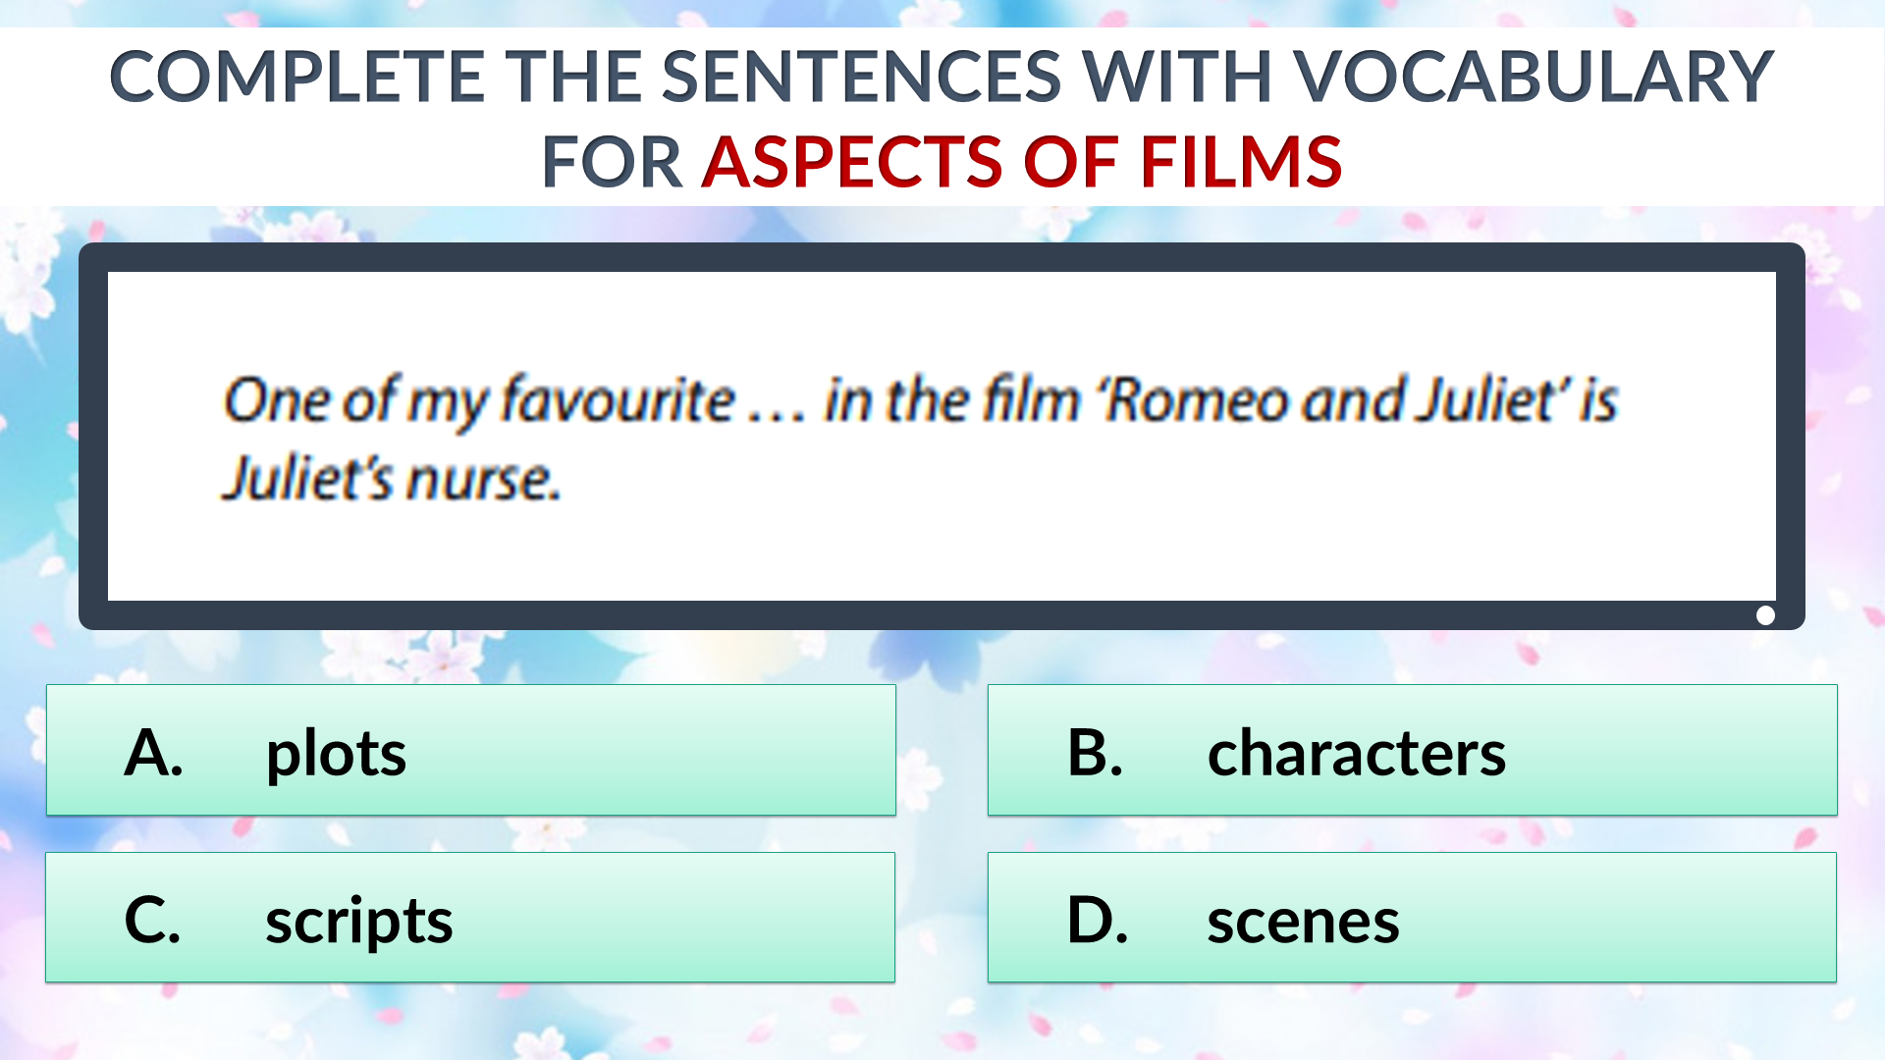  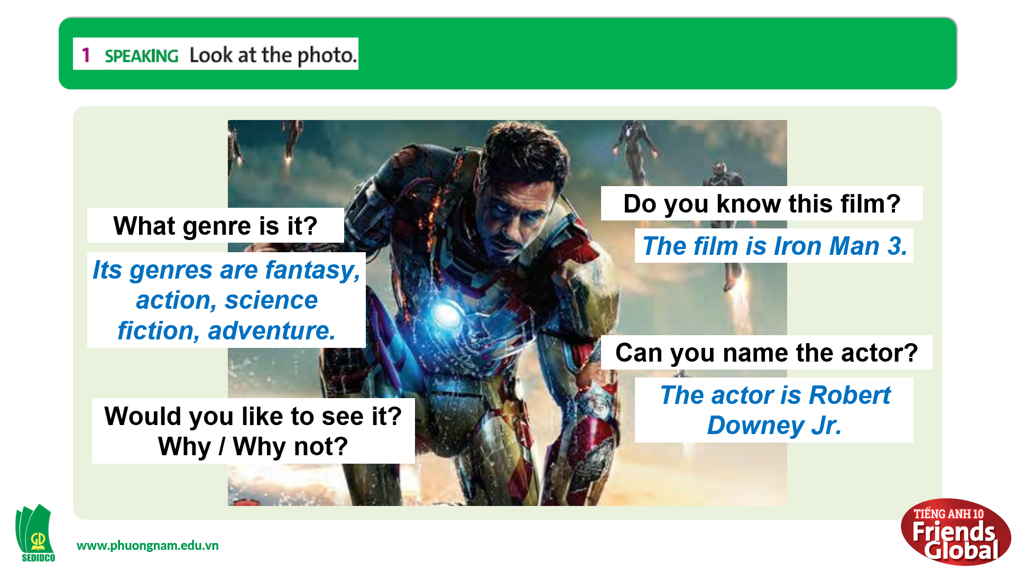  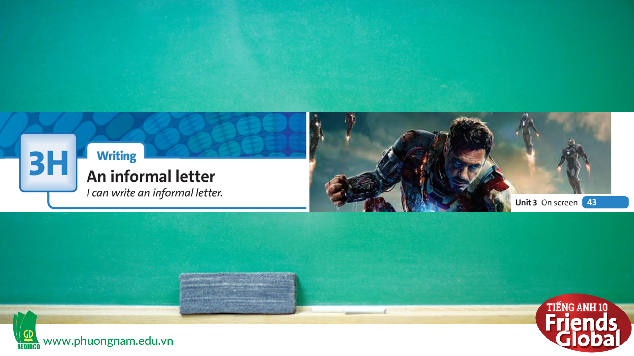

B. New lesson (35’)
- Activity 1: Presentation (3’)
a) Objective: Students get to know some new words in the lesson.
b) Content:
Speaking
Listening
c) Outcomes: Students know how to pronounce the new words precisely and use them in appropriate contexts.
d) Competence: communication, presentation, guessing
e) Organisation of the activity:
TEACHER’S ACTIVITIES | STUDENT’S ACTIVITIES | CONTENTS
PRESENTATION. T-Ss/ S-S/ Indiv.  Teach new vocabulary:  - Use pictures and explanation to present new words  - Have students practice their pronunciation drills  New words:  twist (n)  worth adjective (IMPORTANCE)  be worth having/doing sth  noodle bar (n) | - Look, listen, and repeat in chorus and individuals | 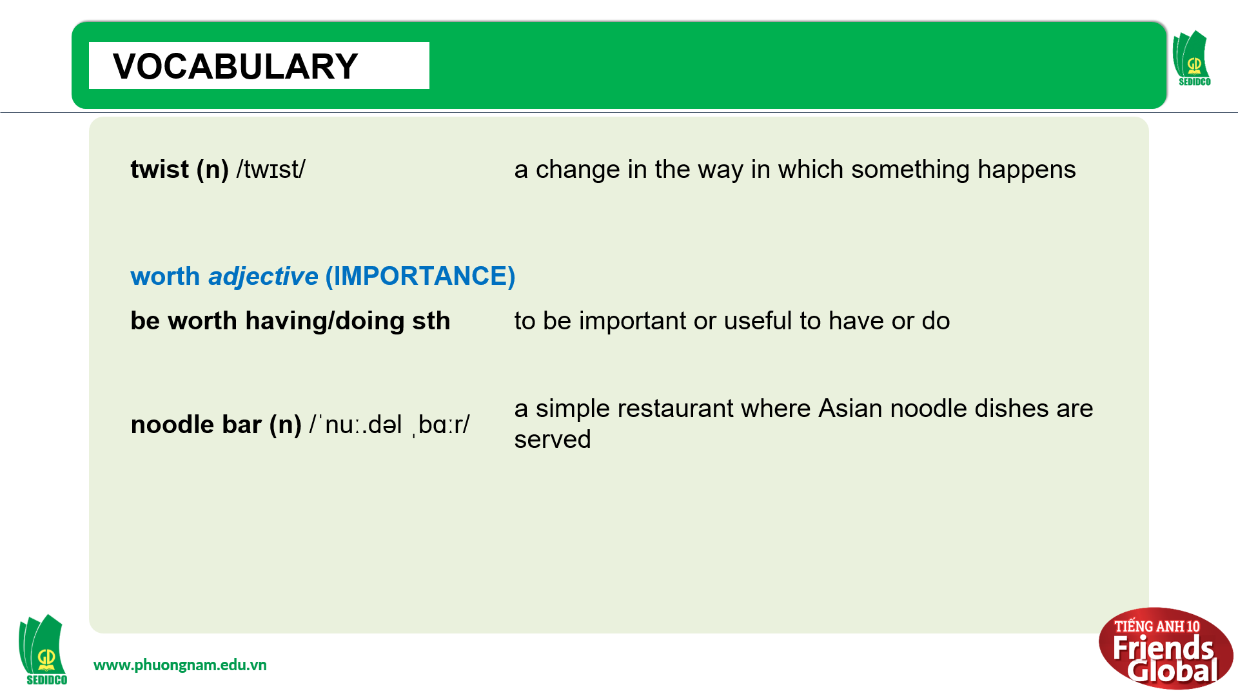
- Activity 2: Practice (18’)
a) Objective: Students can answer the questions to critical thinking, and they can finish the tasks in the textbook. Critical thing skills (guessing/ reasoning) and communication can also be practiced.
b) Content:
Reading
Speaking
c) Outcomes: Students learn how to plan and write an informal letter.
d) Competence: communication, collaboration, presentation
e) Organisation of the activity:
TEACHER’S ACTIVITIES | STUDENT’S ACTIVITIES | CONTENTS
PRACTICE. T-Ss/ S-S/ Indiv.  Activity 1 (5’): Task 2 page 43  - Ask students read the letter and find the parts on the letter that match elements 1-4  - Check the answer  Activity 2 (3’): Task 3 page 43  - Ask students to read the letter again and answer the questions  - Check the answers as a class  Activity 3 (5’): Task 4 page 43  - Ask students to read the Writing Strategy and highlight the main ideas  - Then ask students to answer the questions given  - Check the answers  Activity 4 (5’): Task 5 page 43  - Go through the Learn this! box together  - Ask students to read the text again quickly and fill in the blank  - Check the answers  - Show some pictures and ask students to practice making invitations | - Read the letter and complete the task  - Check answers with teacher  - Complete the task in a limited time  - Check answers with teacher  - Read the Writing Strategy and highlight the main ideas  - Complete the task  - Check answers with teacher  - Read the Reading Strategy  - Read the text again to complete the task  - Check answers with teacher and take notes  - Practice making invitations in pairs | 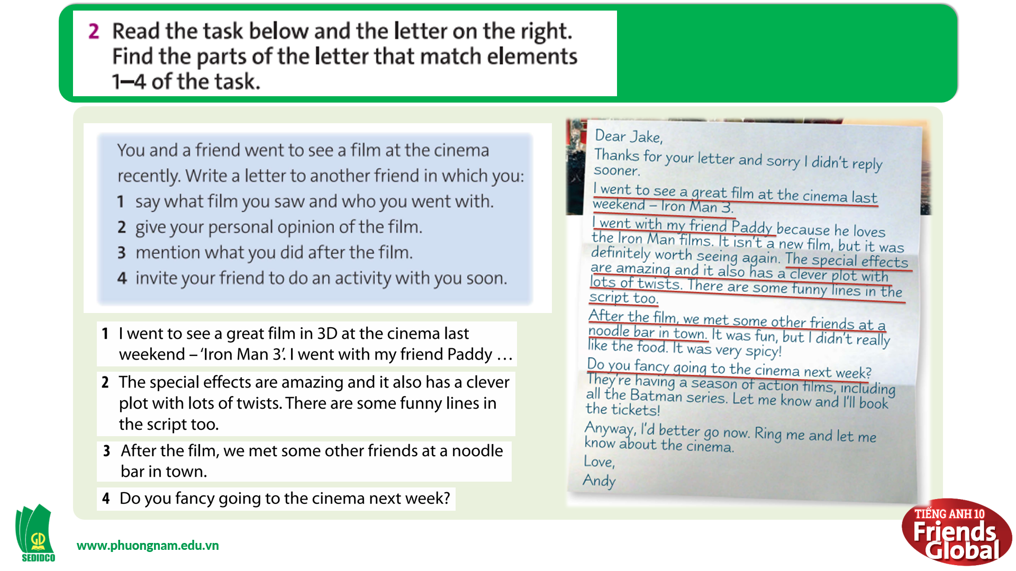  Answers:  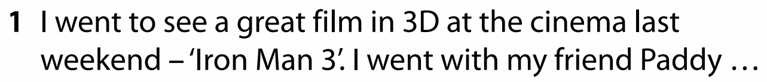  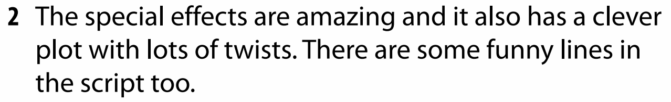  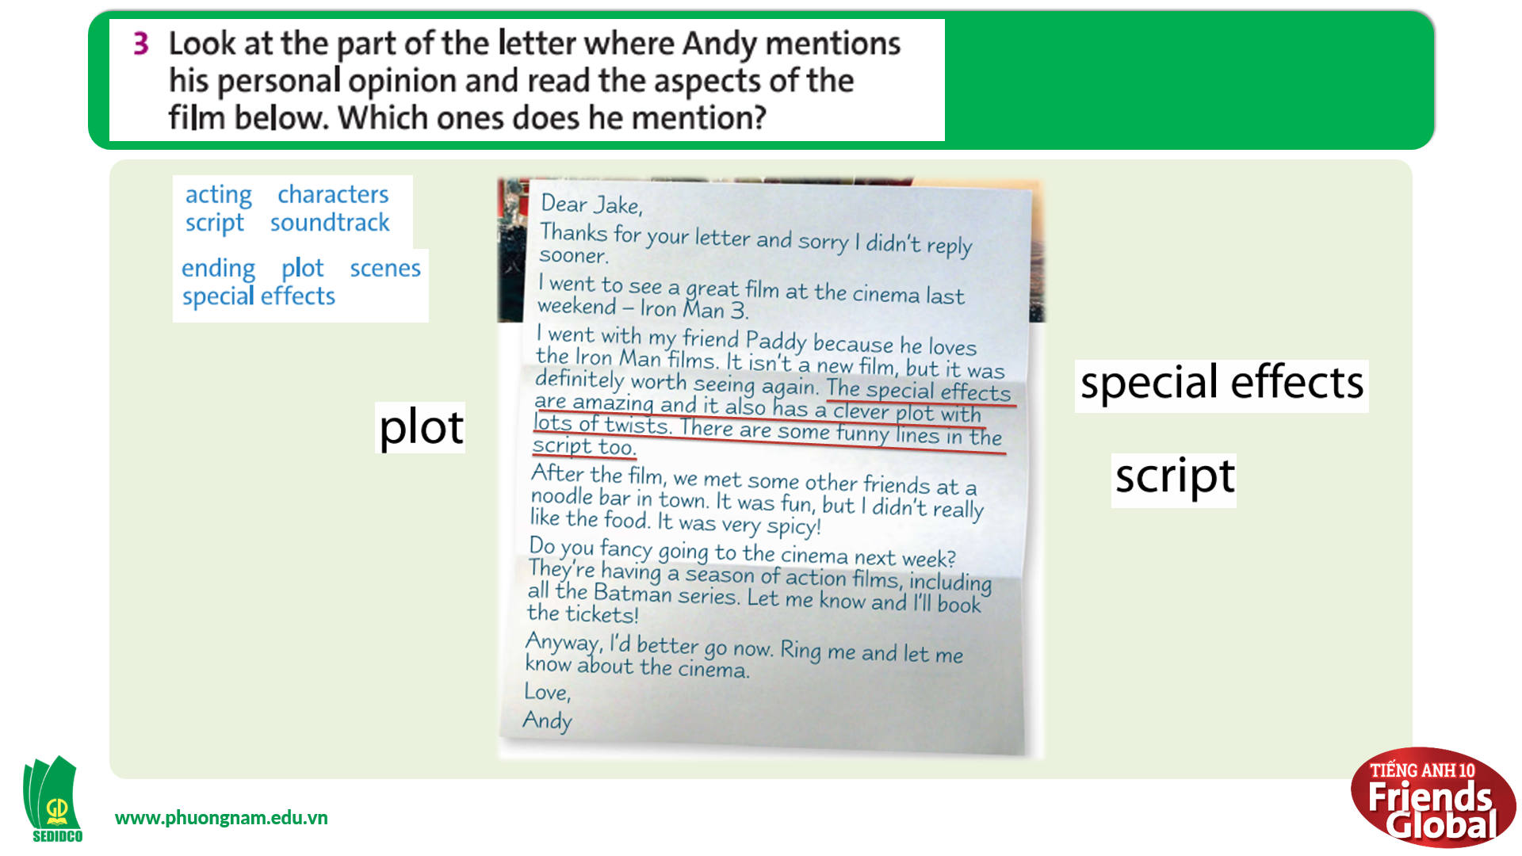  Answers:  special effects, plot, script  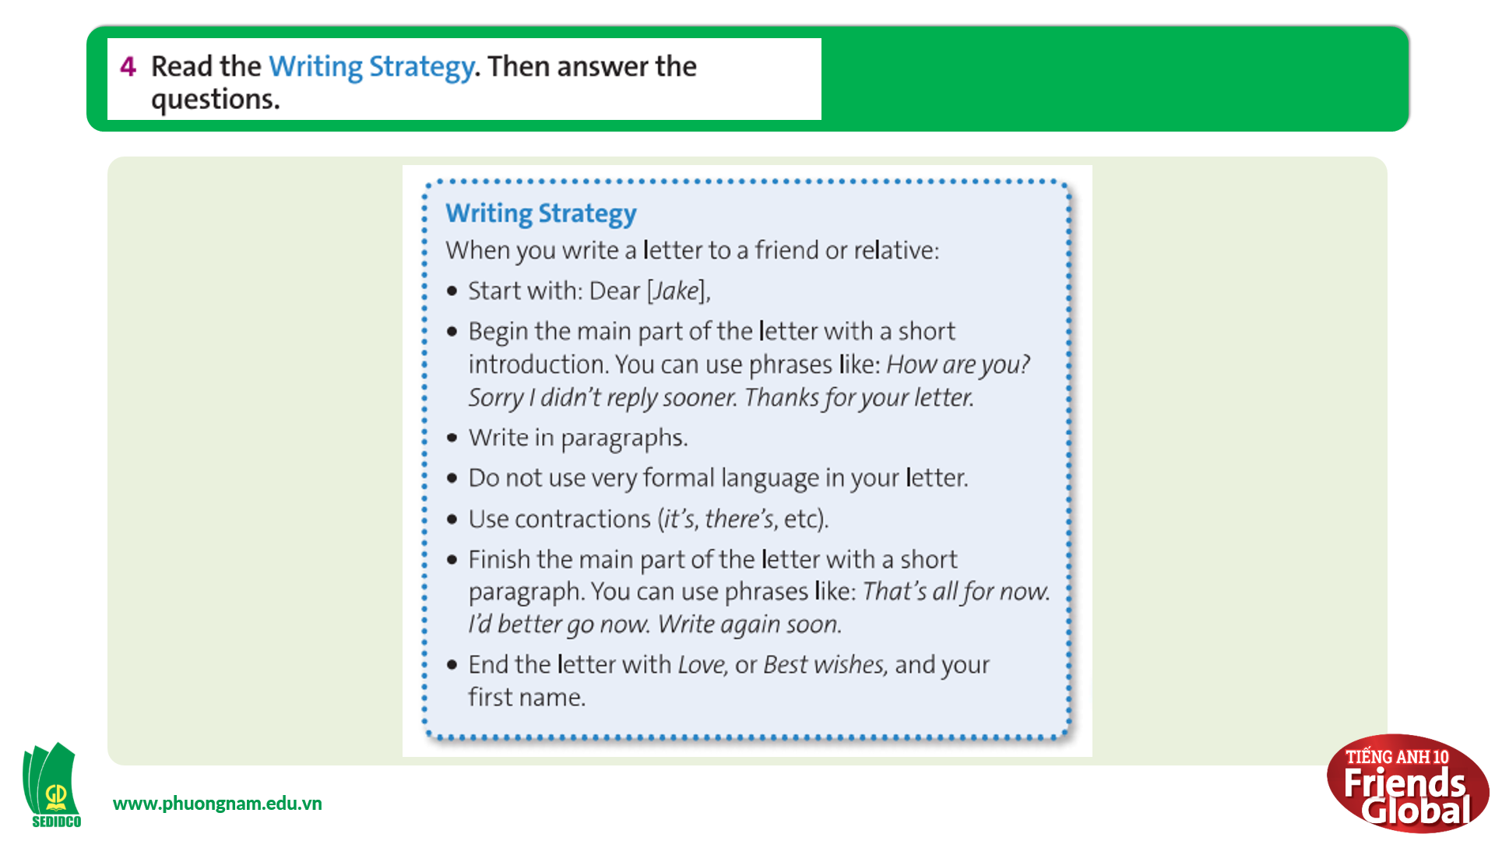  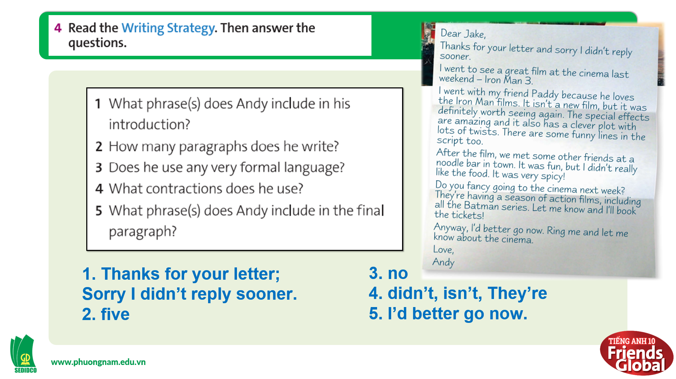  Answers:  1. Thanks for your letter;  Sorry I didn’t reply sooner.  2. five  3. no  4. didn’t, isn’t, They’re  5. I’d better go now.  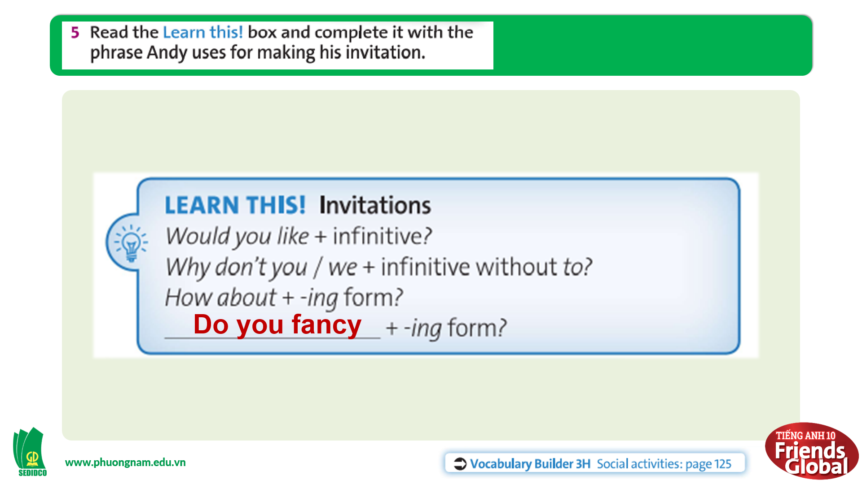  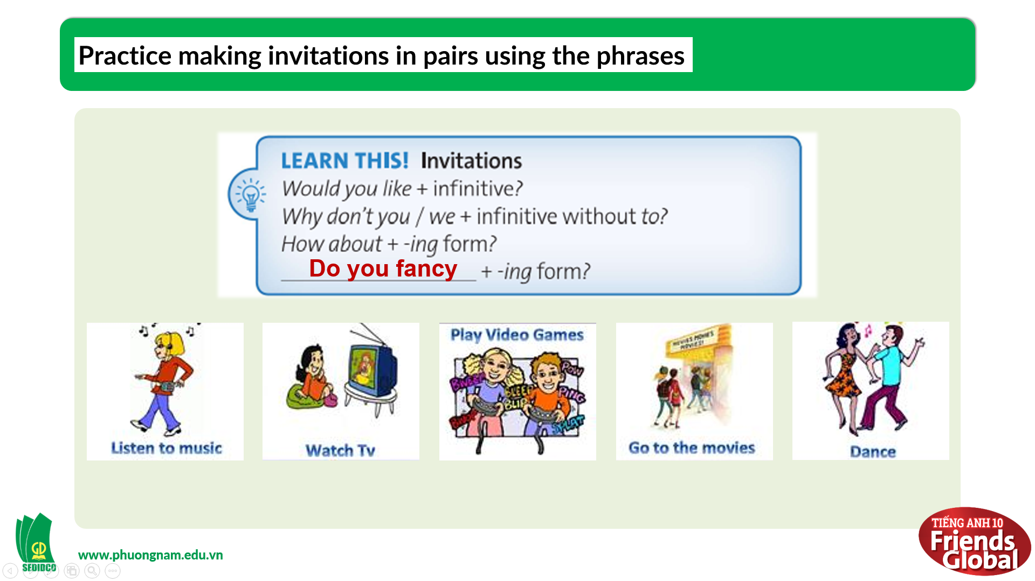

- Activity 3: Outcomes (10’)
a) Objective: Students plan and write a letter using the prompts and their own ideas.
b) Content: Task 6 page 43
c) Outcomes: Students can write an informal letter with their own ideas.
d) Competence: Collaboration, communication
e) Organisation of the activity:
TEACHER’S ACTIVITIES | STUDENT’S ACTIVITIES | CONTENTS
PRODUCT. T-Ss/ S-S/ Indiv.  Task 6 page 43  - Go through the instructions together and make sure students understand what they have to do  - Monitor and help with grammar and vocabulary where necessary  - Give students the writing strategy, prompts and some examples (Andy’s letter in Ex2, Carl’s letter, etc.) | - Listen to the teacher and take notes if needed  - Make an outline for the letter before start to write  - Write an informal letter using the prompts given and their own ideas  - Students can use examples to help if needed | 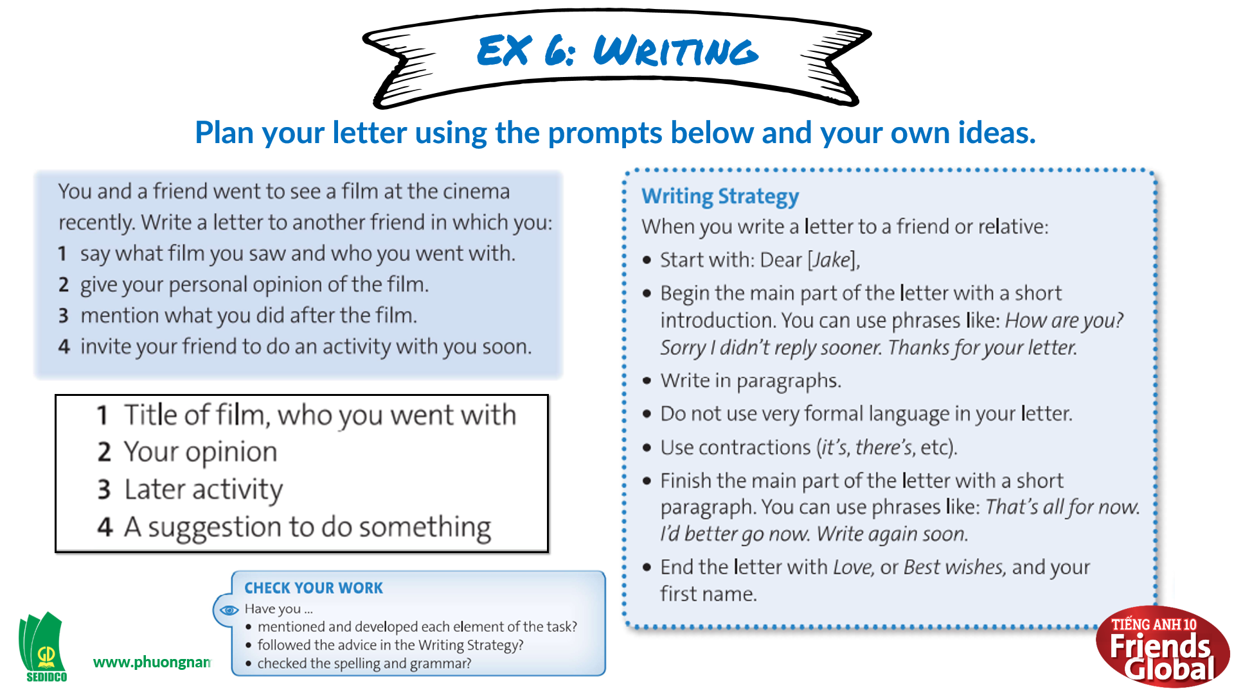  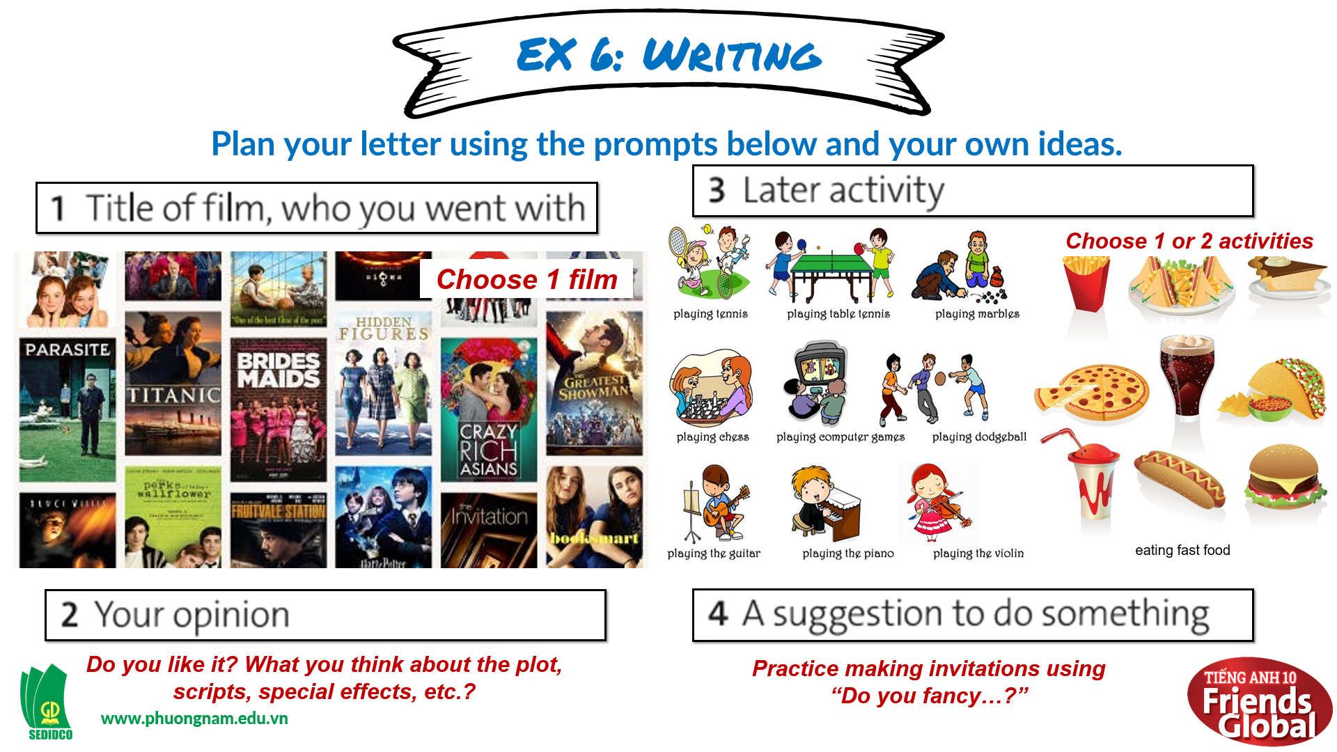  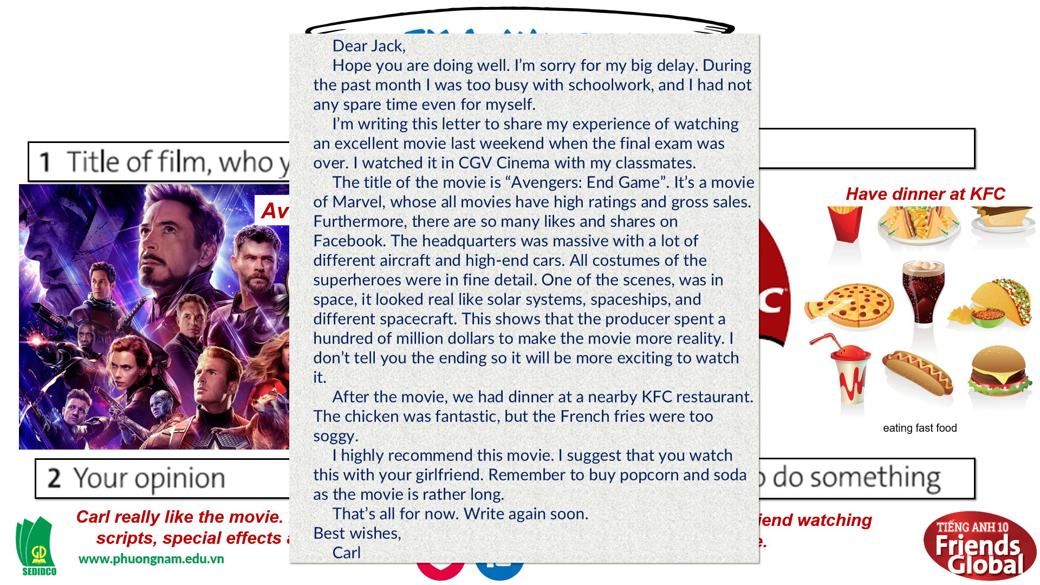
C. Consolidation (3’)
- Students can plan and write a letter using the prompts and their own ideas.
D. Homework (2’)
- Finish writing the letter
- Prepare: Unit 3I: Culture (page 44 – SB)

