TIẾNG ANH 6 – I-LEARN SMART WORLD

UNIT 6 TEST
ANSWER KEY

Note: Each correct answer earns 0.2 points.

I. PRONUNCIATION (0.8 points)
A. Choose the word whose underlined part is pronounced differently.
1. A. talk B. walk C. should D. simple
2. A. listen B. costume C. pasta D. plastic
B. Choose the word that has a different stressed syllable from the rest.
3. A. wildlife B. bottle C. protect D. office
4. A. newspaper B. recycle C. hospital D. charity
II. VOCABULARY AND GRAMMAR (2.4 points)
Choose the best option (A, B, C or D) to complete each of the following sentences.
5. At the concert, you can get food and drink for _______. You don’t have to pay money for it.
A. reuse B. free C. recycle D. charity
6. _______ in this lake. It’s very deep and dangerous.
A. Swim B. Swimming C. Don’t swim D. You can swim
7. There’s _______ new girl in our class. _______ girl’s brother is in Dan’s class.
A. a/ The B. the/ The C. a/ A D. the/ A
8. I need to go to the _______ to send these letters to my grandparents.
A. library B. police station C. supermarket D. post office
9. I like going to the _______ because I can read and borrow many interesting books there.
A. bookstore B. library C. department store D. school
10. You should recycle empty cans and bottles. Don’t just _______.
A. throw it B. reuse them
C. throw them away D. donate it
11. You can _______ old books and computer equipment to charity.
A. donate B. protect C. reuse D. get
12. We have to _______ wild animals, such as whales or tigers, or they will disappear.
A. pick up B. take part in C. look D. protect
13. There is a _______ near my school. Homeless people go there for free meals and a place to stay.
A. organization B. charity C. hospital D. police station
14. A: I believe everyone can help save the environment.
B: _________
A. What’s wrong? B. Yes, I’d love to.
C. Yes, I think. D. I agree.
15. What does the poster mean?
 | A. Don’t pick flowers.  B. You can pick flowers.  C. There aren’t any flowers here.  D. You can’t plant flowers here.

16. What does the sign mean?
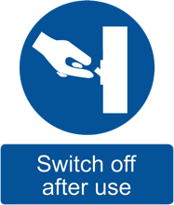 | A. You can use the lights here.  B. You can’t use the lights here.  C. Turn off the lights when you don’t use them.  D. Switch on the lights when you don’t use them.
III. WORD FORMATION (1.2 points)
Write the correct forms of the words in the brackets.
17. Students can join one of our ____cleanups______ to clean rivers and beaches all around Vietnam. (CLEANUP)
18. We are taking these old newspaper to the __recycling/ recycle________ bins in town. (RECYCLE)
19. You can help by ___donating________ money to the charity. (DONATE)
20. We can ___reuse_______ empty glass jars to store food, like jam and nuts. (USE)
21. Trees are very ____useful______. They give food to people and animals. (USE)
22. Act Green Vietnam is an ___environmental_______ charity in Ho Chi Minh city. (ENVIRONMENT)
IV. LISTENING (2 points)
A. Listen to a man talking about the Global Penguin Society and complete the following sentences. Write ONE WORD or A NUMBER for each blank.
23. There are ____18/ eighteen______ kinds of penguins in the world.
24. The Global Penguin Society is a ___charity_______.
25. It helps to protect penguins and other __wildlife________.
26. Over ___6,000_______ school children visited and learned about groups of penguins.
27. They collect ___money_______ on their website.
B. You will hear people asking for and giving directions to five different places. Listen and label the maps.
28. Where is the bus station? | 29. Where is the library?
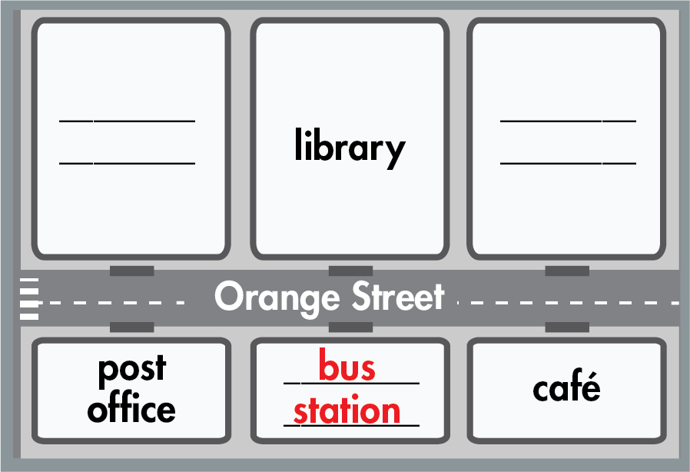 | 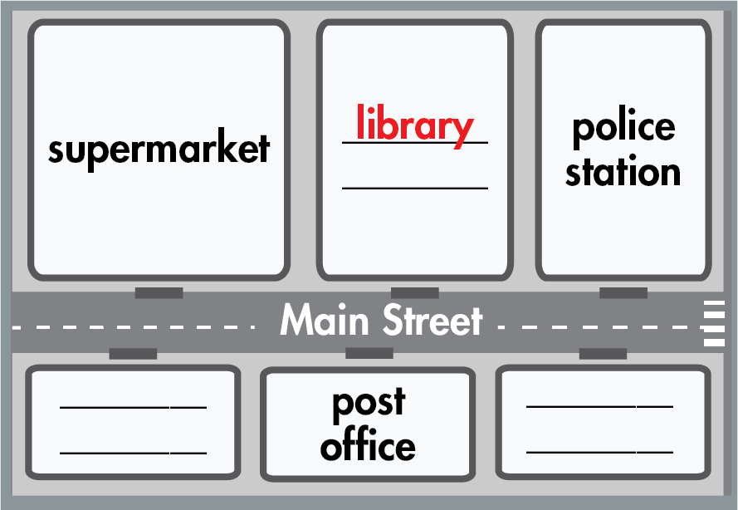
30. Where is the hospital? | 31. Where is the bus station?
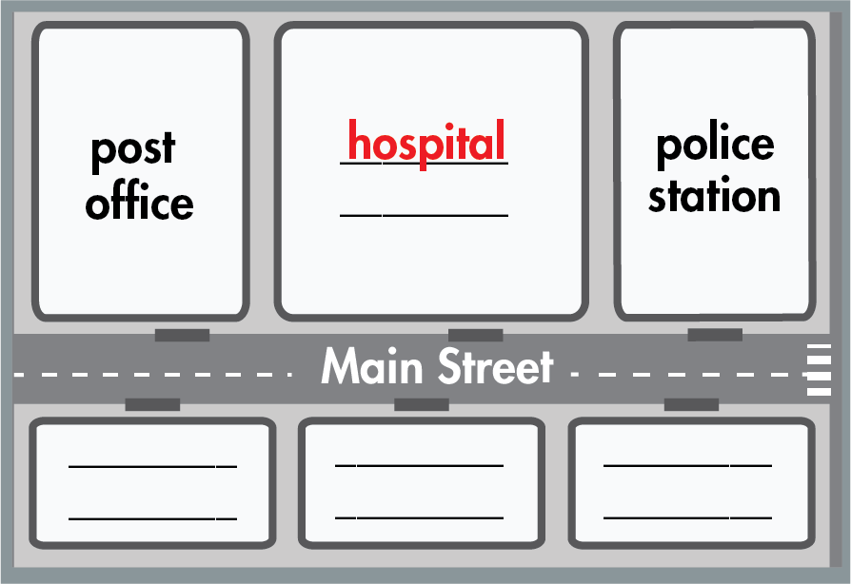 | 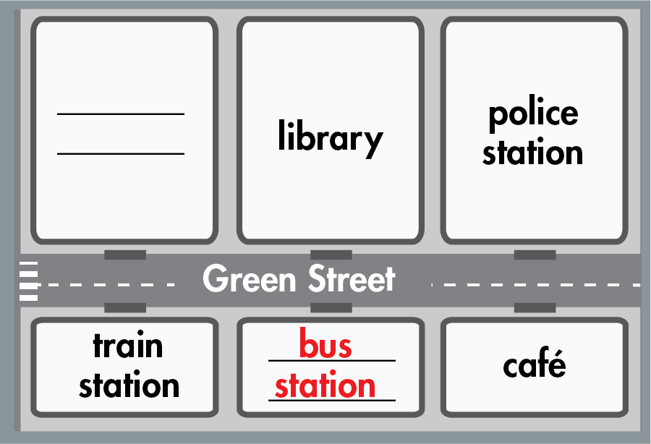
32. Where is the train station?
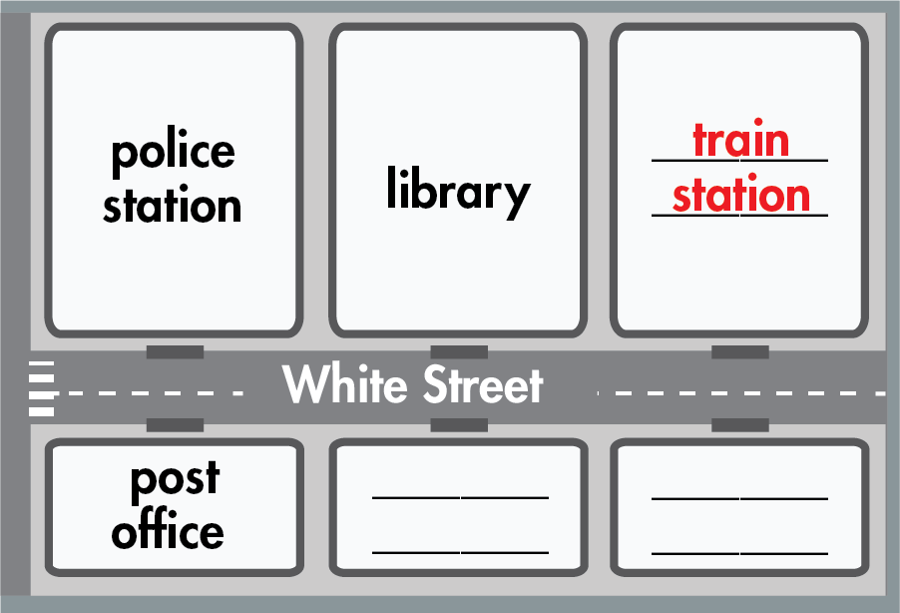
V. READING (2 points)
A. Read the following passage. For questions 33 – 37, decide whether the statements are True (T), False (F) or No Information (NI).
The World Wide Fund for Nature (WWF) is a very large charity in the world. They first started in 1961 in Switzerland. They work in six areas: food, climate, freshwater, wildlife, forests and oceans. The WWF has offices in more than 100 countries. To help the WWF, people can ‘adopt’ an animal. People can choose the animals they like, such as tigers, butterflies, bears, birds, etc and make a donation. The WWF will send them photographs, information and an adoption certificate. It’s a great way to learn more about animals. Or they can donate money by buying toy animals. The WWF-Vietnam started in 1985. They help to save wild animals, such as Saolas, rhinos, elephants, tortoises and turtles. They also make wildlife documentaries to teach young children to love wild animals and live in peace with nature.
33. WWF only work to protect wild animals. False
34. There are WWF offices in more than 100 countries. True
35. To ‘adopt’ an animal in the WWF, you choose an animal and donate money. True
36. The WWF-Vietnam is very famous. NI
37. The WWF-Vietnam teaches young children to make wildlife documentaries. False

B. Read the following passage and fill in each blank with a suitable word or phrase from the box. There is ONE word/phrase that you don’t need.
reuse electricity water plastic free picking up
Our planet is in big trouble – animals are disappearing, the sea and the air are dirty. But there are many different things we can do to protect the environment. First, recycle everything you can. Don’t throw away plastic bottles, glass jars, cardboard boxes or cans. We can (38) __reuse_______ them to store food, toys or grow flowers. Second, why not walk or cycle to school or work? It’s (39) __free_______, good exercise and good for the environment. Third, don’t waste (40) __electricity_______. Switch the lights off when you leave the room. And keep the city clean by (41) ____picking up_____ litter off the streets. When you go shopping, bring your own bags instead of taking (42) __plastic_______ bags. Together we can make a big difference and help save the planet.
VI. WRITING (1.6 points)
A. Put the words in the correct order to make correct sentences.
43. me,/ is/ bus/ a/ Excuse/ near/ there/ here/ station/?/
→ Excuse me, is there a bus station near here?
44. like/ you/ take/ Would/ to/ in/part/ school’s/ cleanup/ our/ ?/
→ Would you like to take part in our school’s cleanup?
45. environment/ help/ Trees/ the/ clean/ green/ to/ and/ keep/./
→ Trees help to keep the environment clean and green.
→ Trees help to keep the environment green and clean.
46. You/ old/ can/ charity/ clothes/ give/ local/ the/ to/./
→ You can give old clothes to the local charity.
B. Rewrite the following sentences without changing the meaning.
47. The police station is to the left of the movie theater and the post office is to the right of the movie theater.
→ The movie theater is between the police station and the post office.
→ The movie theater is between the post office and the police station.
48. Keep our community clean by picking up trash.
→ Pick up trash to keep our community clean.
C. Use the given words to make complete sentences.
49. cinema/ Miller Street,/ opposite/ arcade/.
→ The cinema is on Miller Street, (and) opposite the/an arcade.
50. There/ shopping mall/ next/ train station.
→ There is a shopping mall next to the train station.

***End – Of – Test***

Audio scripts
Listening 1:
B: Did you know that there are eighteen different kinds of penguins in the world? The Global Penguin Society (GPS) is a charity. It helps to protect penguins and other wildlife. To do this, GPS works with governments and communities. They helped over six thousand school children visit groups of penguins to learn about them. The Global Penguin Society collects money on their website. Donate there to buy equipment for the charity and to pay for their worker’s wages.

Listening 2:
Conversation 1:
Bob: Exercise me. Is there a bus station near here?
Wilma: Yes. There’s a bus station opposite the library.
Bob: Oh, great. Thank you.
Conversation 2:
Martha: Excuse me. Is there a library near here?
Frank: Yes, there is. It’s opposite the post office on Main Street.
Martha: Thank you.
Conversation 3:
Bill: Excuse me. Is there a hospital near here?
Lisa: yes. It’s between the police station and the post office.
Bill: Thank you very much.
Conversation 4:
Laura: Excuse me. Is there a bus station near here?
Bob: Yes. The bus station is on Green Street. It’s next to the train station.
Laura: Thank you.
Conversation 5:
Martin: Excuse me. Is there a train station near here?
Betty: Yes. The train station is next to the library.
Martin: Is that on White Street?
Betty: That’s right.
Martin: Thank you.

