BỘ ĐỀ ÔN LUYỆN NƯỚC RÚT  ĐỀ THI THỬ SỐ 15  (Đề thi có 7 trang) | KỲ THI TỐT NGHIỆP TRUNG HỌC PHỔ THÔNG  Môn thi: TIẾNG ANH  Thời gian làm bài: 50 phút, không kể thời gian phát đề
Họ, tên thí sinh: ……………………………………………  Số báo danh: ………………………………………………. |  | Mã đề: 1126

Read the following letter and mark the letter A, B, C or D on your answer sheet to indicate the option that best fits each of the numbered blanks from 1 to 6.
Customer Complaint Letter
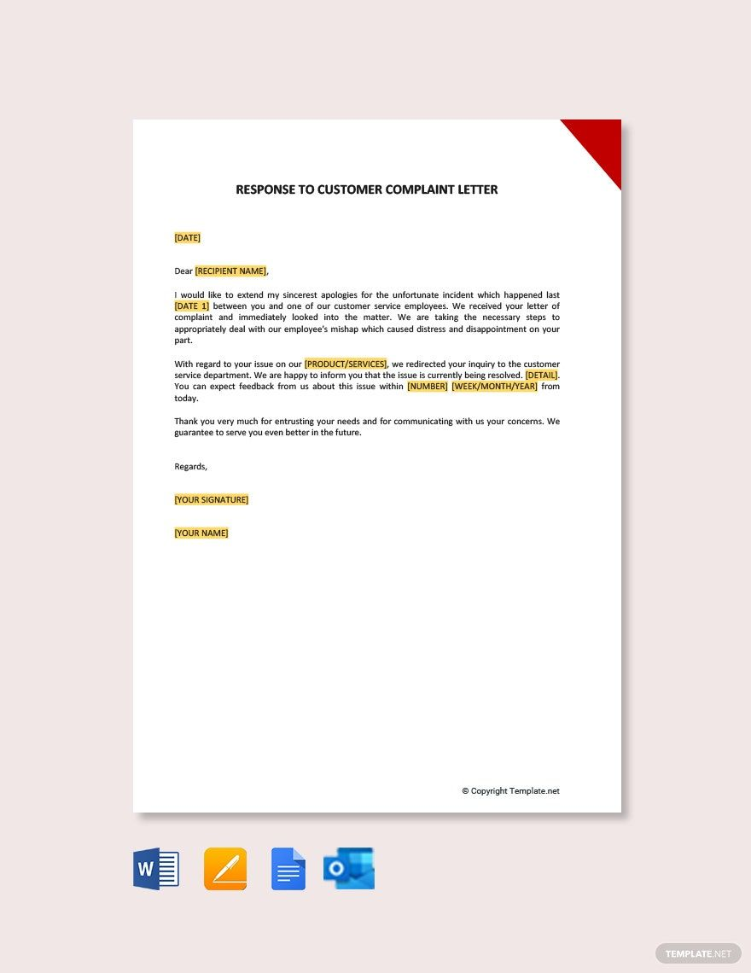
Dear Customer Service Manager,
I am writing to express my dissatisfaction with the service I received at your Manchester branch on 15th October. Despite waiting for over an hour, no staff member (1) ______ any effort to assist me with my inquiry about a faulty product.
When I finally spoke to an advisor, they showed (2) ______ interest in resolving my issue. The representative suggested I contact the manufacturer directly, (3) ______ your store policy clearly states that returns are handled in-store within 30 days of purchase.
Furthermore, the staff displayed what I can only describe as a/an (4) ______ throughout our interaction. I have been a loyal customer for five years and expected better treatment.
I request a full refund and would appreciate it if you could look (5) ______ this matter urgently. Your company has always prided itself on excellent customer care, but this experience has severely (6) ______ my confidence in your brand.
I look forward to your prompt response.
Yours sincerely,
Margaret Thompson
  - (Adapted from genuine consumer complaint templates, Which? UK Consumer Rights)
Question 1. A. made B. did C. took D. gave
Question 2. A. a great deal of B. a number of C. plenty of D. little
Question 3. A. whereas B. moreover C. therefore D. otherwise
Question 4. A. dismissive unprofessional attitude B. unprofessional dismissive attitude
C. unprofessional attitude dismissive D. attitude unprofessional dismissive
Question 5. A. into B. after C. through D. over
Question 6. A. undermined B. overwhelmed C. overturned D. undertaken

Read the following announcement and mark the letter A, B, C or D on your answer sheet to indicate the option that best fits each of the numbered blanks from 7 to 12.
Vietnam Pho Festival 2025 – Singapore Edition
Bringing Vietnamese Culinary Heritage to the World
The Vietnam Pho Festival 2025 will take place in Singapore, representing a significant milestone in promoting Vietnamese cuisine on the international stage. This cultural and culinary celebration aims (7) ______ the beloved pho dish and other traditional Vietnamese delicacies to global food enthusiasts.
Festival Highlights
The programme showcases an extraordinary (8) ______ of culinary experiences, from authentic pho preparation demonstrations by master chefs to interactive cooking workshops where participants can learn traditional techniques. Visitors will also enjoy cultural performances, art exhibitions, and storytelling sessions (9) ______ illuminate the historical significance of Vietnamese gastronomy.

Renowned restaurants and food entrepreneurs from Vietnam have been carefully (10) ______ to represent the nation’s diverse regional flavours. The festival creates a meaningful space for cultural exchange, allowing Singaporean audiences and international visitors (11) ______ appreciate the depth and complexity of Vietnamese culinary traditions.
This gastronomic journey promises to be an (12) ______ experience that transcends mere dining, offering insights into Vietnam’s rich cultural tapestry through its most iconic dish.
Don’t miss this celebration of flavour and heritage!
For event details, visit https://vnphofest.sg/
  - (Adapted from https://oananews.org)
Question 7. A. introducing B. to introduce C. introduce D. introduced
Question 8. A. breadth B. width C. extent D. span
Question 9. A. who B. where C. that D. when
Question 10. A. singled out B. picked out C. sorted out D. worked out
Question 11. A. to B. for C. with D. at
Question 12. A. forget B. forgetting C. unforgettable D. unforgettably

Mark the letter A, B, C or D on your answer sheet to indicate the best arrangement of utterances or sentences to make a cohesive and coherent text.
Question 13. Dear Mr. Hassan,
a. This confirmation letter serves as official documentation that you have successfully passed all stages of our rigorous recruitment process.
b. Congratulations! We are extremely pleased to inform you that you have been selected for the Software Engineer position at Innovation Labs.
c. Your official start date is January 15th, and you will be assigned to the Development Team under the supervision of Lead Engineer Sarah Mitchell.
d. Please complete the pre-employment medical examination and background verification by December 20th as mandated by company policy and local regulations.
e. For administrative queries or assistance with relocation arrangements, please contact our HR department at onboarding@innovationlabs.com or telephone 0456789012.
Yours faithfully,
HR Department-Innovation Labs
A. a-b-c-d-e B. b-c-a-d-e C. b-a-c-d-e D. c-b-a-d-e
Question 14. a. Mason: True, yet television builds a shared viewing culture and trust.
b. Ella: I agree, but YouTube gives more freedom to choose what you like.
c. Ella: Do you often watch traditional TV programs?
d. Mason: Not much. I spend more time on YouTube, but TV still feels more organized.
e. Ella: So both have their advantages depending on how we use them.
A. a-b-c-d-e B. c-d-b-a-e C. a-c-b-d-e D. b-a-d-e-c
Question 15. a. Government portals streamlined services, while e-commerce logistics connected micro-sellers to nationwide demand.
b. Concurrently, skills programs and sandbox policies nurtured startups, attracting investment and cross-border partnerships.
c. As scale accelerates, safeguarding privacy, competition, and inclusion becomes decisive for sustainable growth.
d. Vietnam’s digital economy has entered an inflection point, scaling from start-up promise to platform ubiquity.
e. Smartphone penetration, affordable data, and fintech adoption deepened participation across cities and provinces.
A. d-a-e-b-c B. e-d-a-b-c C. d-e-a-b-c D. d-e-b-a-c
Question 16. a. Professor Williams: Let me check the assignment requirements, but I think we can work something out.
b. Jason: Professor Williams, I’m having some difficulties with the research paper due to unexpected family circumstances.
c. Jason: I understand it’s late notice. Would it be possible to have until Friday instead?
A. c-a-b B. b-c-a C. c-b-a D. b-a-c
Question 17. a. Last semester, I took on a part-time job while maintaining a full course load at university.
b. I believed I could kill two birds with one stone by managing both commitments without compromising either one.
c. However, I quickly became overwhelmed and my grades suffered while my job performance remained barely adequate.
d. That demanding period was eye-opening and showed me the necessity of setting realistic goals and boundaries.
e. Afterward, I reduced my work hours and communicated openly with both my employer and professors.
A. a-c-b-e-d B. d-a-b-c-e C. a-b-c-e-d D. a-b-c-d-e

Read the following passage and mark the letter A, B, C or D on your answer sheet to indicate the option that best fits each of the numbered blanks from 18 to 22.
Cybersecurity has become essential as our lives move online. Personal data, financial records, and sensitive communications all flow through digital networks. (18) _______. Meanwhile, cybercriminals develop more sophisticated methods to exploit vulnerabilities. Basic protection starts with strong passwords and regular software updates. Two-factor authentication adds an extra layer of defense against unauthorized access. (19) _______. Organizations then invest in employee training programs to reduce human error. However, technology alone cannot guarantee complete safety. Some worry that constant security alerts create fatigue and careless behavior. Clear policies and regular audits help maintain vigilance over time. (20) _______. Security teams explain the reasoning behind protocols, not just the technical steps. Managers balance convenience with protection when designing user interfaces. (21) _______. Cybersecurity professionals also share knowledge–about emerging threats, incident response, and best practices. When collaboration is effective, users stay informed while systems remain secure. (22) _______.
  - (Adapted from Anasco Group, "Understanding the Basics of Cybersecurity: Protecting Your Digital World")
Question 18. A. These developments mean that cybercriminals who can target victims across continents with minimal technical obstacles or resource requirements
B. Such changes enable malicious actors to exploit vulnerabilities globally with relatively limited technical expertise or infrastructure
C. These shifts allow threat actors to launch attacks internationally with increasing barriers for entry or operational costs
D. Such transformations will soon permit hackers to compromise systems worldwide with progressively fewer technical skills or financial investment
Question 19. A. Organizations recognize that a single security breach can severely damage their reputation and result in substantial financial consequences
B. Companies understand that one cybersecurity incident can significantly harm their credibility and lead to considerable economic losses
C. Enterprises acknowledge that an individual data compromise can markedly affect their standing and cause notable monetary damages
D. Businesses realize that one security failure can seriously undermine their image and generate significant fiscal repercussions
Question 20. A. These measures ensure employees comprehend why safeguards matter and understand how security breaches occur in realistic scenarios
B. Such programs guarantee that staff appreciate the importance of protections and recognize how vulnerabilities emerge in practical contexts
C. These approaches verify that personnel grasp the significance of defenses and perceive how compromises happen in actual situations
D. Such initiatives confirm that workers understand the value of precautions and identify how incidents develop in real-world circumstances
Question 21. A. Advanced security protocols and authentication systems explained to network administrators by senior cybersecurity consultants
B. Comprehensive protection strategies and verification procedures were described to technical staff by experienced security specialists
C. Sophisticated safeguard mechanisms and identity confirmation methods should be clarified to system managers by expert security professionals
D. Detailed defense frameworks and access control measures are presented to IT personnel by seasoned cybersecurity advisors
Question 22. A. There is considered to be a significant gap between current security practices and the rapidly evolving landscape of digital threats
B. There appears to be a substantial discrepancy between existing protection measures and the continuously changing nature of cyberattacks
C. There seems to be a considerable disparity between present defense strategies and the progressively advancing sophistication of threats
D. There exists an important divergence between contemporary security approaches and the increasingly complex character of cyber risks

Read the passage and mark the letter A, B, C or D on your answer sheet to indicate the best answer to each of the following questions from 23 to 30.
In contemporary America, “affordable” housing is conventionally pegged to the HUD threshold of 30 percent of income, yet millions exceed it by punishing margins. For low-income renters, housing often devours over 70 percent of earnings as stagnating wages meet quickening rents. What counts as affordable is indexed to area median income (AMI), so a unit labeled “affordable” in the Bay Area may dwarf market prices elsewhere. The pandemic magnified precarity, pushing evictions and prices upward, especially among marginalized households.
Policy quarrels trace a long federal–local tug-of-war. Deregulatory voices would relax permits and zoning to let supply expand; interventionists prefer mandates and direct aid. If zoning were substantially loosened, advocates contend, supply would swell and prices would retreat accordingly. Since the 1970s, tools like Section 8 vouchers and the low-income housing tax credit have predominated, with HUD coordinating alongside local authorities. Yet waiting lists are chronic, landlords sometimes spurn vouchers, and periodic funding gaps blunt intended reach.
Today, local zoning often entrenches scarcity: minimum lot sizes inflate land costs; parking quotas devour buildable area; bans on high-rises and caps on height stifle infill. Homeowners – keen to defend asset values and neighborhood “character” – mobilize procedurally to resist multifamily projects. Filtering exists, but its trickle is slow and uneven, rarely keeping pace with need. In places like Palo Alto, dramatic demand from tech employment collided with inelastic supply, so rents escalated as available units lagged far behind entrants.
Supply shortfalls predate COVID-19. The subprime mortgage crisis precipitated mass foreclosures, pushing former owners – now with impaired credit – into already tight rental markets. Pandemic relief briefly forestalled deeper damage; when that aid ended, eviction filings surged, with near-record dockets in 2022 as inflation lifted the price of basics. In a climate of scant inventory and soaring home values, minimum-wage earners were priced out, while would-be buyers, unable to qualify for mortgages, remained renters, intensifying competition for too few units.
  - (Adapted from https://www.ebsco.com/research-starters/politics-and-government/affordable-housing-crisis-overview)
Question 23. The word stagnating in paragraph 1 can be best replaced by ______?
A. ballooning B. plateauing C. volatile D. equalizing
Question 24. Which of the following is TRUE according to paragraph 2?
A. HUD replaced all local authorities in administering housing after 1970.
B. Most landlords are legally required to accept vouchers in every city.
C. Market deregulation and state mandates advocate the same basic remedy.
D. The debate centers on deregulation to expand supply versus mandates and direct aid.
Question 25. The word magnified in paragraph 1 is OPPOSITE in meaning to ______.
A. alleviated B. intensified C. compounded D. aggravated
Question 26. The word that in paragraph 4 refers to ______.
A. the pandemic itself B. the government relief
C. the surge in eviction filings D. the subprime mortgage crisis
Question 27. Which of the following is NOT mentioned in paragraph 3 as a way zoning constrains affordable supply?
A. Imposing rent caps on luxury developments to discourage speculative leasing in overheated downtown districts
B. Limiting multifamily construction through minimum lot sizes and parking quotas near transit corridors
C. Capping building heights to preserve a suburban “character” and frustrate dense, mid-rise infill development
D. Banning high-rise buildings outright in neighborhoods where homeowners organize to oppose change
Question 28. Which of the following best paraphrases the underlined sentence in paragraph 2?
A. Advocates argue that relaxing zoning restrictions would stimulate construction, ultimately moderating market prices through increased availability.
B. Reducing zoning stringency, proponents claim, would boost housing stock and trigger corresponding declines in property values.
C. Easing zoning constraints would expand housing supply, thereby exerting downward pressure on prices across the market.
D. According to reformers, liberalizing zoning would multiply housing units, which should ease cost burdens for renters and buyers.
Question 29. Which paragraph mentions that what counts as “affordable” varies with local AMI?
A. Paragraph 1 B. Paragraph 2 C. Paragraph 3 D. Paragraph 4
Question 30. Which paragraph mentions long-standing federal tools such as vouchers and tax credits?
A. Paragraph 1 B. Paragraph 2 C. Paragraph 3 D. Paragraph 4

Read the passage and mark the letter A, B, C or D on your answer sheet to indicate the best answer to each of the following questions from 31 to 40.
Many jurisdictions zealously protect suspects from self-incrimination, yet ordinary netizens are routinely nudged – or plainly coerced – into divulging intimate data that can later be weaponised against them. The analogy is unsettling: if the state may not prise open your phone, why may platforms prise open your life? [I] In digital markets configured around consent fatigue and dark patterns, individuals are rendered complicit in their own exposure. To arrest this perversity, reformers argue for data fiduciaries – actors bound by duties of loyalty and care – not merely better privacy notices or labyrinthine settings.
Online, the most delicate signals – health status, trauma histories, precarious finances – are siphoned, scored, and auctioned to the highest bidder. These dossiers feed targeting engines that steer people toward exploitative products and discriminatory decisions. Some intermediaries behave like data vultures, thriving on asymmetries of knowledge and power. [II] If trust is the axle of fiduciary relations, vulnerability is the wheel that turns upon it: by entrusting what matters, we are exposed; by accepting entrustment, professionals owe us trustworthiness – and must never turn that knowledge against us.
Fiduciary duties arise precisely where expertise and incentives can diverge from a client’s welfare – finance, medicine, law, and now data. Fiduciaries must act in the data subject’s best interests, and, when conflicts materialise, must subordinate their own; if unwilling to carry that burden, they should refuse entrustment. This ethical grammar converts discretion into obligation. [III] It also clarifies accountability: misuse is not a mere terms-of-service breach but a dereliction of duty toward someone rendered dependent by design.
Critics protest that Big Tech already owes fiduciary loyalty to stockholders, especially under Delaware doctrine prioritising shareholder welfare. But doctrines admit ordering: user-first duties could be given priority where interests clash, or fines could be set so steep that compliance becomes the rational path. [IV] Ultimately, alignment is the point: if companies wish to risk our data, they should risk their business in tandem. Absent such stakes, they will continue to gamble with others’ exposure while keeping the winnings.
  - (Adapted from Ada Lovelace Institute, “The ethical case for data fiduciaries”)
Question 31. The word perversity in paragraph 1 mostly means ______.
A. sharply contrary B. mildly eccentric
C. broadly normative D. loosely benign
Question 32. Where in the passage does the following sentence best fit?
This comparison is not mere rhetoric; it explains why ‘consent’ collapses under coercive interface design.
A. [I] B. [II] C. [III] D. [IV]
Question 33. Which of the following best summarises paragraph 2?
A. Sensitive online data is traded and weaponised, so trust-anchored duties must prevent experts from exploiting asymmetry.
B. Advertising improves relevance when platforms learn vulnerabilities, enhancing user welfare through personalised curation overall.
C. Market transparency alone deters profiling because informed consumers refuse intrusive data extraction at meaningful scale.
D. Data brokers stabilise prices by pooling risk signals, thereby reducing discrimination across multiple decision systems.
Question 34. What do data-fiduciary duties primarily address?
A. Conflicted incentives online B. Interface colour choices
C. Harmless data trivia D. Mere notice fatigue
Question 35. According to paragraph 3, when conflicts arise, fiduciaries must ______?
A. place clients’ interests above their own, converting discretion into enforceable obligations
B. disclose risks quarterly to regulators without modifying internal incentive structures
C. obtain renewed consent every session under refreshed, simplified privacy banners
D. outsource decisions to auditors who guarantee neutrality through standard checklists
Question 36. What does the passage imply about firms unwilling to bear data duties?
A. They should exit data collection rather than retain power without correlative obligations to users.
B. They should collect less data until regulators propose entirely new statutory frameworks.
C. They should rely on anonymisation technologies that fully eliminate re-identification risks.
D. They should publish transparency reports detailing aggregate request volumes annually.
Question 37. The phrase data vultures in paragraph 2 refers to ______.
A. resellers B. predators C. brokers D. criminals
Question 38. Which of the following can be inferred from the passage?
A. Without credible sanctions or priority rules, firms will rationally keep exploiting data asymmetries despite public commitments to ethical design.
B. Stronger privacy notices are sufficient to eliminate coercive architectures and restore fully informed, unpressured consent online.
C. Fiduciary models in medicine and law are inapplicable to data because knowledge asymmetries are negligible in digital contexts.
D. Delaware corporate law absolutely forbids any prioritisation of user interests over shareholder welfare in all circumstances.
Question 39. Which of the following best paraphrases the underlined sentence in paragraph 3?
Fiduciaries must act in the data subject’s best interests, and, when conflicts materialise, must subordinate their own; if unwilling to carry that burden, they should refuse entrustment.
A. When duties clash with self-interest, custodians must privilege the data subject’s welfare or decline the role since acceptance entails binding obligations.
B. Whenever disagreements occur, companies may continue prioritizing revenue if users accepted terms because consent legitimizes discretionary choices under contract law.
C. In complicated cases, experts can balance interests by averaging utilities over time without needing to relinquish conflicting opportunities immediately.
D. If conflicts are rare, providers may postpone decision-making until neutrality is restored by independent market pressures ensuring eventual equilibrium.
Question 40. Which of the following best summarises the passage?
A. To counter coerced exposure and power asymmetries, impose user-first fiduciary duties on data holders and align incentives with sanctions.
B. Data extraction is inevitable; therefore, users should acclimate to targeted offers and algorithmic triage in digital markets.
C. Corporate law already prevents abuse; additional duties would duplicate protections and generate needless compliance burdens.
D. Privacy can be fully protected through clearer notices and optional settings without restructuring platform incentives.
--------------------- THE END ---------------------
- Thí sinh không được sử dụng tài liệu;
- Giám thị không giải thích gì thêm.

