|  |  |
| --- | --- |
| **PART 1** | **Listening (10 questions)** |

**You will hear an announcement about Earth Day at a secondary school. Listen and decide whether the following statements are True (T) or False (F). (5 questions)**

| **Answers** | **True** | **False** |
| --- | --- | --- |
| 1. The Earth Day activities are on Saturday afternoon. | **◯** | **◯** |
| 2. The first activity is planting trees. | **◯** | **◯** |
| 3. Students are going to hear a talk on weather forecasts. | **◯** | **◯** |
| 4. Students also learn to create works of art from recycled materials. | **◯** | **◯** |
| 5. Students need to bring empty plastic bottles, gloves and glue for the art class. | **◯** | **◯** |

**You will hear a man explain how the recycling system works. Listen and complete each blank with NO MORE THAN TWO WORDS AND / OR A NUMBER. (5 questions)**

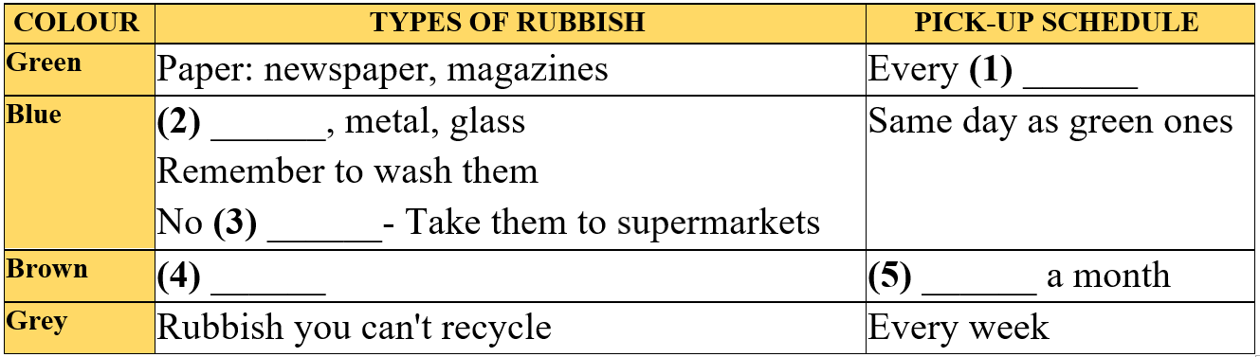

(6)___________________  
(7)___________________  
(8)___________________  
(9)___________________  
(10)___________________

**---THE END---**