School: ……………………………………….. | Date:…………………………………..
Class: ……………………………..................... | Period: …………………………..........

UNIT 3: MUSIC AND ARTS
Lesson 4 – Review (Pages 88, 89)

I. OBJECTIVES
By the end of the lesson, Ss will be able to:
1.1. Language knowledge and skills
- review words about music types (classical music, rock, country music, pop, hip hop, folk music, reggae, etc.) and talk about them.
- review grammar: Present simple for facts; prepositions of time; possessive adjectives.
- review how to make plans to go to a music event.
- pronoun some sounds correctly: /s/, /a/, /ɔ/, /æ/, / z/.
1.2. Competences
- improve speaking, listening, reading and writing skills.
- improve the use of English.
1.3. Attributes
- have positive attitude in English language learning so that they actively participate in all classroom activities.
- review the old lesson and have good preparation for any assessment.

II. TEACHING AIDS AND LEARNING MATERIALS
1. Teacher’s aids: Student book and Teacher’s book, class CDs, Digital Book (DCR phần mềm tương tác SB, DHA (từ vựng/ cấu trúc) phần mềm trò chơi tương tác), projector/interactive whiteboard / TV (if any), PowerPoint slides, handouts.
2. Students’ aids: Student’s book, workbook, notebook.

III. ASSESSMENT EVIDENCE
Performance Tasks | Performance Products | Assessment Tools
- Listening: You will hear five short conversations. You will hear each conversation twice. There is one question for each conversation. For each question, choose the correct answer (A, B, or C). | - Ss’ answers. | - T’s feedback/Peers’ feedback.
- Reading: Read the paragraph. Choose the best word (A, B, or C) for each space. | - Ss’ answers. | - T’s feedback/Peers’ feedback.
- Vocabulary: Number the pictures. | - Ss’ answers. | - T’s feedback/Peers’ feedback.
- Grammar: Underline the mistakes and write the correct answers on the lines. + Write sentences using the prompts. | - Ss’ answers. | - T’s feedback/Peers’ feedback.
-Pronunciation: sound and stress. | - Ss’ answers/ presentation. | - T’s observation, T’s feedback/Peers’ feedback

IV. PROCEDURES
A. Warm up: (5’)
a) Objective: Introduce the new lesson and set the scene for Ss to acquire new language; get students' attention at the beginning of the class by enjoyable and short activities as well as to engage them in the follow-up steps.
b) Content: Songs.
c) Expected outcomes: Ss are ready for the new lesson.
d) Organization of the activity:
TEACHER’S ACTIVITIES | STUDENTS’ ACTIVITIES
- Option 1: Sing a song (Karaoke)  - Choose a simple English song and find its beat  - Play the clip of the song with lyrics.  - Have the whole class sing the song together.  à Lead to the new lesson.  *Suggested song: The farmer in the dell.  - Link: https://www.youtube.com/watch?v=tYoYuqBFsRU  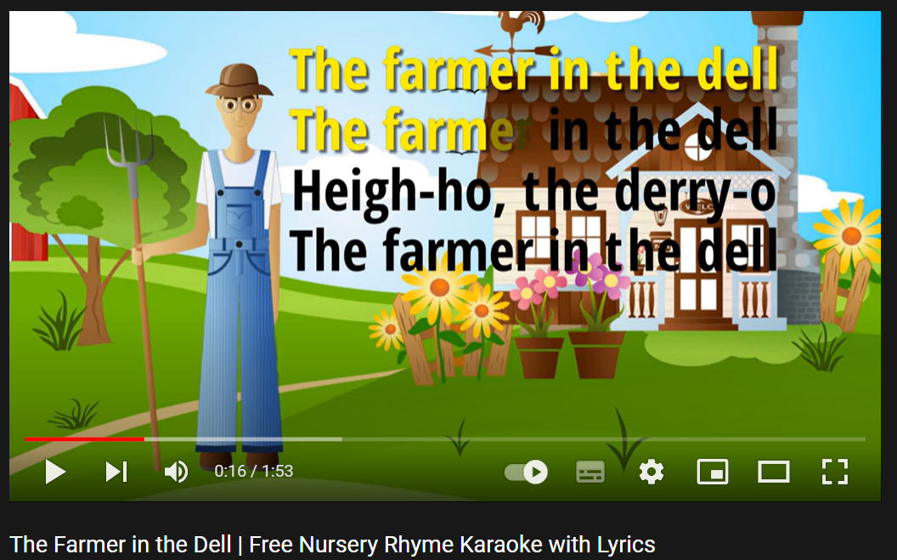  - Option 2: What song is it?  - Prepare the sound files / video clips of some songs. T chooses songs that are popular with teenagers.  - Play the files / clips, have Ss listen and give names of the songs.  - If Ss give an incorrect answer, T continues to play the song. If Ss can give a correct answer, T stops and move to another song.  - Give feedback.  àLead to the new lesson.  Suggested song list:  1 Baby once more time (Britney Spears)  2 My hear will go on (Celine Dion)  3 Dance Monkey (Tones and I)  4 Lily ( Allen Walker)  5 Despacito ( Luis Fonsi)  6 Lemon Tree (Fools Garden)  7 Senorita (Shaw Mendes)  8 Maps (Maron 5)  9 Happy new year (Abba)  10 Happy birthday to you ( many versions) | - Look and sing together.  - Give answers.  - Listen.  - Listen and give names of the songs.

B. New lesson (35’)
- Activity 1: Listening (7’)
a) Objective: Help Ss improve their listening skill.
b) Content:
- Listen to five short conversations. There is one question for each conversation. For each question, choose the correct answer (A, B, or C).
c) Expected outcomes: Ss listen in details and get familiar with the listening test format.
d) Organization of the activity:
TEACHER’S ACTIVITIES | STUDENTS’ ACTIVITIES
You will hear five short conversations. You will hear each conversation twice. There is one question for each conversation. For each question, choose the correct answer (A, B, or C).  - Have Ss read through the listening part.  - Demonstrate the activity by using the example.  - Play the audio (CD 2 – Track 36).  - Have Ss check answers with pairs and then give answers.  - Check answers as a whole class using DCR. | - Read in silence.  - Listen and then give answers.  Answer keys  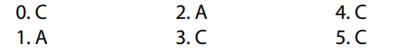
- Activity 2: Reading (7’)
a) Objective: Students can improve their reading skill.
b) Content:
- Read the paragraph. Choose the best word (A, B, or C) for each space.
c) Expected outcomes: Ss read for comprehension and get familiar with the reading test format.
d) Organization of the activity:

TEACHER’S ACTIVITIES | STUDENTS’ ACTIVITIES
Read the paragraph. Choose the best word (A, B, or C) for each space  - Demonstrate the activity by using the example.  - Have Ss read the article and choose the correct answer, underline the supporting ideas for their answers.  - Call Ss to give answers, explain.  - Give feedback and evaluation. | - Observe and listen.  - Work individually.  - Give answers, explain.  Answer keys  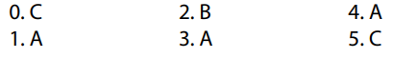

- Activity 3: Vocabulary (7’)
a) Objective: Ss can review vocabulary about music types.
b) Content: Number the pictures.
c) Expected outcomes: Ss produce the new language successfully, and they can use these words in speaking and writing.
d) Organization of the activity:
TEACHER’S ACTIVITIES | STUDENTS’ ACTIVITIES
Number the pictures  - Have Ss read the phrases and observe the pictures.  - Ask Ss to work in pairs to number the pictures.  - Have Ss give answers, tell the meaning of the words /phrase again.  - Check answers as a whole class using DCR. | - Read the phrases and observe the pictures.  - Work in pairs.  - Give answers.  Answer keys  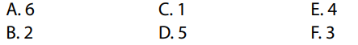
- Activity 4: Grammar (10’)
a) Objective: Ss can review the use of English: Present simple for facts; prepositions of time; possessive adjectives.
b) Content:
- Underline the mistakes and write the correct answers on the lines.
- Write sentences using the prompts.
c) Expected outcomes: Ss produce the new language successfully, and they can use the grammar points in speaking and writing.
d) Organization of the activity:
TEACHER’S ACTIVITIES | STUDENTS’ ACTIVITIES
Task a. Underline the mistakes and write the correct answers on the lines.  - Have Ss retell the way to use present simple tense for facts.  - Ask Ss to work individually to underline the mistakes and write the correct answers on the lines.  - Have Ss work in pairs to check each other’s work.  - Call Ss to give answers, explain for their choice.  - Check answers as a whole class using DCR.  Task b. Write sentences using the prompts  - Have Ss write sentences using the prompts.  - Ask Ss to work in pairs to check each other’s work.  - Have Ss write answers on the board.  - Check Ss’ answers, give feedback. | - Review old knowledge.  - Work individually.  - Work in pairs.  - Give answers.  Answer keys  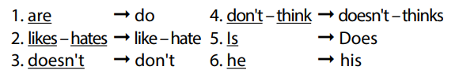  - Do the task.  - Exchange answers.  - Write answers on the board.  Answer keys  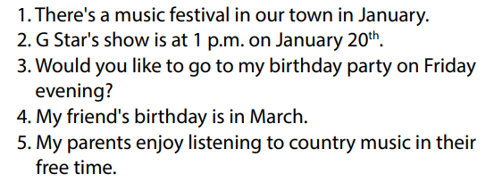
- Activity 5: Pronunciation (4’)
a) Objective: Ss can review the word stress and vowels.
b) Content:
- Circle the word that has the underlined part pronounces differently from the others.
- Circle the word that has different stress from the rest.
c) Expected outcomes: Ss produce the new language successfully.
d) Organization of the activity:
TEACHER’S ACTIVITIES | STUDENTS’ ACTIVITIES
Task a. Circle the word that has the underlined part pronounced differently from the others.  - Have Ss distinguish the sound /s/, /a/, /ɔ/, /æ/, / z/.  - Ask Ss to work individually to circle the answer.  - Have Ss work in pairs to check each other’s work.  - Call Ss to give answers, pronounce the words again.  - Give feedback, correct Ss’ pronunciation if necessary.  Task b. Circle the word that differs from the other three in the position of primary stress in each of the following questions.  - Remind Ss some basic rules of putting stress on words with 2 or 3 syllables.  - Ask Ss to work individually.  - Have Ss work in pairs to check each other’s work.  - Call Ss to give answers, pronounce the words again.  - Give feedback, correct Ss’ pronunciation if necessary. | - Listen.  - Work individually.  - Work in pairs.  - Give answers.  Answer keys  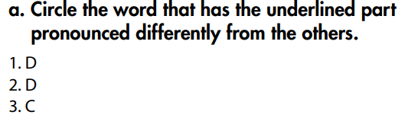  - Listen.  - Work individually.  - Work in pairs.  - Give answers.  Answer keys  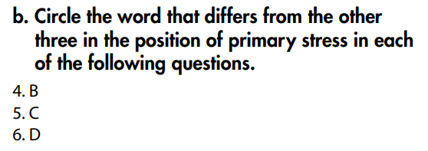

C. Consolidation and homework assignments (5’)
* Consolidation:
* Grammar of Unit 3: Present simple for facts; prepositions of time; possessive adjectives.
* Vocabulary of Unit 3: Words about music types (classical music, rock, country music, pop, hip hop, folk music, reggae, etc.).

* Homework:
- Review vocabulary, grammar of unit 3.
- Do the exercises in WB: Review of Unit 3 (page 64).
- Prepare: Unit 4 – New words and Reading (page 28 – SB).

D. Reflection
a. What I liked most about this lesson today:
…………………………………………………………………………………………
- What I learned from this lesson today:
…………………………………………………………………………………………
c. What I should improve for this lesson next time:
…………………………………………………………………………………………

