ĐÁP ÁN ĐỀ THI HK2 KHỐI 11 NĂM 2021-2022

Câu 1a: Xét tính liên tục của hàm số  $f\left(x\right)=\begin{aligned}\left\{\frac{x^{3}−3x−\text{52}}{x−4}\text{ khi }x≠4 | \right.\end{aligned}$tại $x_{o}=4$  $$f\left(4\right)=\text{28}$$  $$\begin{aligned}\underset{x→4}{\text{lim}}f\left(x\right)=\underset{x→4}{\text{lim}}\frac{x^{3}−3x−\text{52}}{x−4}=\underset{x→4}{\text{lim}}\frac{\left(x^{2}+4x+3\right)\left(x−4\right)}{x−4} \\ =\underset{x→4}{\text{lim}}\left(x^{2}+4x+3\right)=\text{45}\end{aligned}$$  Vậy hàm số gián đoạn tại $x_{o}=4$. | 0,25  0,25  0,25  0,25 | $$\begin{aligned}c)y={\text{tan}}^{3}\sqrt{2x^{2}−3x+5} \\ ⇒y'=3{\text{tan}}^{2}\sqrt{2x^{2}−3x+5}\left(\text{tan}\sqrt{2x^{2}−3x+5}\right)' \\ =\frac{3\left(4x−3\right){\text{tan}}^{2}\sqrt{2x^{2}−3x+5}\left(1+{\text{tan}}^{2}\sqrt{2x^{2}−3x+5}\right)}{2\sqrt{2x^{2}−3x+5}}\end{aligned}$$ | 0,25  0,25
 | 0,25  0,25  0,25  0,25 | Câu 3a: viết pt tiếp tuyến của $\left(C\right):y=2x^{3}−2x^{2}−4x−5$ tại điểm có hoành độ $x_{o}=−2$  $$\begin{aligned}\text{y'}=6x^{2}−4x−4 \\ {\text{ y}}_{o}=−\text{21} \\ \text{ f}\left(x_{o}\right)=−\text{21} \\ \text{PTTT}:y=\text{28}x+\text{35}\end{aligned}$$ | 0,25  0,25  0,25  0,25
Câu 1b: Tìm m để hàm số  $f\left(x\right)=\begin{aligned}\left\{\frac{\sqrt{3x+\text{10}}−4}{x^{2}−4}\text{ khi }x>4 | \right.\end{aligned}$liên tục tại $x_{o}=2$  $$f\left(2\right)=\frac{−4m}{5}=\underset{x→2^{−}}{\text{lim}}f\left(x\right)$$  $$\begin{aligned}\underset{x→2^{+}}{\text{lim}}f\left(x\right)=\underset{x→2^{+}}{\text{lim}}\frac{3x+\text{10}−\text{16}}{\left(x^{2}−4\right)\left(\sqrt{3x+\text{10}}+4\right)} \\ =\underset{x→2^{+}}{\text{lim}}\frac{3}{\left(x+2\right)\left(\sqrt{3x+\text{10}}+4\right)}=\frac{3}{\text{32}}\end{aligned}$$  Để hàm số liên tục tại $x_{o}=2$ thì $\frac{−4m}{5}=\frac{3}{\text{32}}⇒m=\frac{−\text{15}}{\text{128}}$ | 0,25  0,25  0,25  0,25 | Câu 3b: viết pt tiếp tuyến của $\left(C\right):y=\frac{x^{2}−2x+1}{x+1}$ biết tiếp tuyến song song $d:5x−9y+7=0$  $$y'=\frac{x^{2}+2x−3}{{\left(x+1\right)}^{2}}$$  $$\begin{aligned}\text{ f}'\left(x_{o}\right)=\frac{5}{9} \\ ⇒ \\ \end{aligned}\begin{aligned}[x_{o}=2⇒y_{o}=\frac{1}{3} \\ [x_{o}=−4⇒y_{o}=−\frac{\text{25}}{3}\end{aligned}[⇒\text{TT}:\begin{aligned}[y=\frac{5}{9}x−\frac{7}{9} \\ [y=\frac{5}{9}x−\frac{\text{55}}{9}\end{aligned}[$$ | 0,25  0,25  0,25  0,25
Câu 2: Tìm đạo hàm của hàm số sau:  $$\begin{aligned}a)y=\frac{2}{5}x^{5}−3x^{2}+\text{cot}x−3 \\ ⇒y'=2x^{4}−6x−\left(1+{\text{cot}}^{2}x\right)\end{aligned}$$ | 2 ý  0,25  0,25  0,25  0,25 | Câu 4:  $$\begin{aligned}⇒y'=\text{cos}2x−2x\text{sin}2x \\ ⇒y^{\text{,,}}=−4\text{sin}2x−4x\text{cos}2x \\ ⇒y^{\text{,,,}}=−\text{12}\text{cos}2x+8x\text{sin}2x\end{aligned}$$  Ta có:  $$\begin{aligned}{\text{xy}}^{\text{'''}}+4\text{xy}'+8y=0 \\ ⇔−\text{12}x\text{cos}2x+8x^{2}\text{sin}2x+4x\text{cos}2x−8x^{2}\text{sin}2x+8x\text{cos}2x=0 \\ ⇔0=0\left(đ\right)\end{aligned}$$ | 0,25  0,25  0,25  0,25
$$\begin{aligned}b)y=\frac{x^{2}}{2x^{3}+5} \\ ⇒y'=\frac{\left(x^{2}\right)'\left(2x^{3}+5\right)−x^{2}\left(2x^{3}+5\right)'}{{\left(2x^{3}+5\right)}^{2}} \\ =\frac{−2x^{4}+\text{10}x}{{\left(2x^{3}+5\right)}^{2}}\end{aligned}$$ | 2 ý  0,25  0,25  0,25  0,25 |  | 0,25  0,25  0,25  0,25
Câu 5:

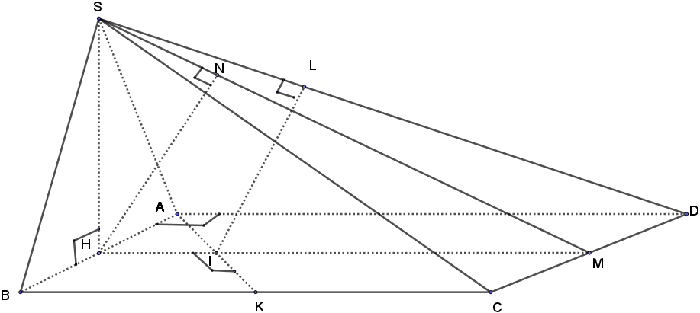
- Chứng minh $\text{SH}⊥\left(\text{ABCD}\right);\left(\text{SBC}\right)⊥\left(\text{SAB}\right)$  $$\begin{aligned}\begin{aligned}\left\{\text{SH}⊥\text{AB}\left(\text{SA}=\text{SB}\right) | \right.\end{aligned} \\ \end{aligned}$$ | 0,25  0,25  0,25  0,25  0,25  0,25  0,25 | b) Tính $\left[\text{SC};\left(\text{ABCD}\right)\right]$  Ta có HC là hình chiếu của SC lên mp (ABCD)  Nên $\left[\text{SC};\left(\text{ABCD}\right)\right]=\left(\text{SC};\text{HC}\right)=S\hat{C}H$  $$\text{SH}=a$$  $$\text{tan}S\hat{C}H=\frac{\text{SH}}{\text{HC}}=\frac{1}{\sqrt{5}}⇒S\hat{C}H≈{\text{24}}^{O}$$ | 0,25  0,25  0,25  0,25  0,25  0,25  0,25
c) Tính $\left[\left(\text{SCD}\right);\left(\text{ABCD}\right)\right]$  Ta có$\left(\text{SCD}\right)∩\left(\text{ABCD}\right)=\text{CD}$  Trong $\left(\text{ABCD}\right):\text{ HM}⊥\text{CD}$  Trong $\left(\text{SCD}\right):\text{ SM}⊥\text{CD}\left(\text{CD}⊥\text{HM};\text{CD}⊥\text{SH}\right)$  $$⇒\left[\left(\text{SCD}\right);\left(\text{ABCD}\right)\right]=\left(\text{HM};\text{SM}\right)=S\hat{M}H$$  $$\text{tan}S\hat{M}H=\frac{\text{SH}}{\text{HM}}=\frac{1}{2}⇒S\hat{M}H≈{\text{27}}^{O}$$ | 0,25  0,25  0,25  0,25  0,25  0,25  0,25 | d) Tính $d\left[A;\left(\text{SCD}\right)\right]$  Ta có$\text{AH}\text{//}\left(\text{SCD}\right)$  Ta có $d\left[A;\left(\text{SCD}\right)\right]=d\left[H;\left(\text{SCD}\right)\right]$  Kẻ $\text{HN}⊥\text{SM}$tại N  $\text{mà}\text{HN}⊥\text{CD}\left(\text{HN}⊂\left(\text{SCD}\right)⊥\text{CD}\right)$$\begin{aligned}⇒\text{HN}⊥\left(\text{SCD}\right) \\ ⇒d\left[H;\left(\text{SCD}\right)\right]=\text{HN}=\frac{\text{SH}\text{.}\text{HM}}{\text{SM}}=\frac{2a\sqrt{5}}{5}\end{aligned}$ | 0,25  0,25  0,25  0,25  0,25  0,25  0,25
 | 0,25  0,25  0,25  0,25  0,25  0,25  0,25 | e) Tính $d\left[\text{AK};\text{SD}\right]$  Gọi $I=\text{AK}∩\text{HD}$  Ta có $\text{tan}B\hat{A}K=\text{cot}A\hat{H}I=\frac{1}{2}$  $$\begin{aligned}⇒B\hat{A}K+A\hat{H}I={\text{90}}^{o}⇒\text{AK}⊥\text{HD} \\ \text{MÀ}\text{ AK}⊥\text{SH} \\ \text{Nên AK}⊥\left(\text{SHD}\right)\end{aligned}$$  Kẻ $\text{IL}⊥\text{SD}$tại L  $$⇒\text{IL}⊥\text{AK}\left(\text{IL}⊂\left(\text{SHD}\right)⊥\text{AK}\right)$$  Suy ra IL là đoạn vuông góc chung của AK và SD.  $$⇒d\left[\text{AK};\text{SD}\right]=\text{IL}$$  $$\begin{aligned}\text{sin}S\hat{D}H=\frac{\text{IL}}{\text{ID}}=\frac{\text{SH}}{\text{SD}}⇒\text{IL}=\frac{2a\sqrt{\text{30}}}{\text{15}} \\ \text{cos}A\hat{D}I=\frac{\text{AD}}{\text{DH}}=\frac{\text{DI}}{\text{AD}}⇒\text{DI}=\frac{4a\sqrt{5}}{5}\end{aligned}$$ | 0,25  0,25  0,25  0,25  0,25  0,25  0,25

