|  |  |
| --- | --- |
| **Tiếng Anh 8 Friends Plus** | **FP 8 - UNIT 2 - TEST 2**  **Test for Unit**  *Thời gian làm bài: 40 phút (Không kể thời gian giao đề)*  *-------------------------* |

**I. Pronunciation (1-4)**

**Câu 1.** Which word has the underlined part pronounced differently from that of the others?

**A.** taste  **B.** alpaca  **C.** fate  **D.** famous

**Câu 2.** Which word has the underlined part pronounced differently from that of the others?

**A.** beaches  **B.** fixes  **C.** roses  **D.** runs

**Câu 3.** Which word has a different stress pattern from that of the others?

**A.** probably  **B.** describe  **C.** activist  **D.** durian

**Câu 4.** Which word has a different stress pattern from that of the others?

**A.** invited  **B.** spaghetti

**C.** provided  **D.** restaurant

**II. Choose the answer (A, B, C or D) that best fits the space in each question. (5-14)**

**Câu 5.** We ______ (just/finish) our project.

**A.** have just finished  **B.** just finished

**C.** had just finished  **D.** just finish

**Câu 6.** They ______ (spend) their summer vacation in Europe last year.

**A.** spend  **B.** have spent

**C.** spent  **D.** had spent

**Câu 7.** We ______ (not have) a meeting yesterday.

**A.** had not had  **B.** had not have

**C.** have not had  **D.** did not have

**Câu 8.** He ______ (not see) that movie yet.

**A.** had not seen  **B.** seen not

**C.** has not seen  **D.** did not see

**Câu 9.** She ______ (be) sick for three days.

**A.** has been  **B.** was  **C.** be  **D.** had been

**Câu 10.** She ______ (study) English since 2010.

**A.** studied  **B.** has studied

**C.** study  **D.** had studied

**Câu 11.** How do you usually spend your weekends?

**A.** My favourite food is pizza.

**B.** I spend time with my friends and family, and sometimes go on outdoor adventures.

**C.** I like to watch movies in the summer.

**D.** I'm going to visit my grandparents this weekend.

**Câu 12.** My favourite ______ is chocolate ice cream.

**A.** resident  **B.** sensation  **C.** taste  **D.** lasagne

**Câu 13.** A ______ person cannot hear anything.

**A.** hearing  **B.** anosmic  **C.** deaf  **D.** touch

**Câu 14.** The ______ sense allows us to see the world around us.

**A.** smell  **B.** touch  **C.** sight  **D.** taste

**III. Look at the signs. Choose the best answer (A, B, C or D). (15-16)**

**Câu 15.**

School Excursion:

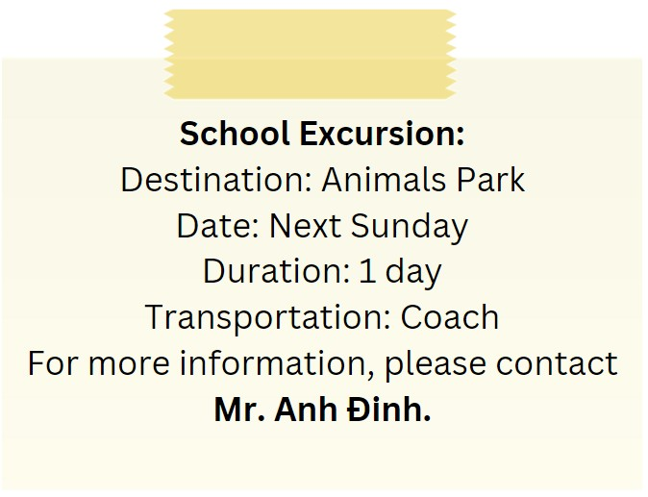

**A.** Transportation is by train.

**B.** The excursion is to an Animals Park for 1 day, and transportation is by coach.

**C.** The destination is a Science Museum.

**D.** The excursion is for two days.

**Câu 16.**

We're hiring!



**A.** The shifts are 8 hours long.

**B.** There are 5 part-time positions available.

**C.** Previous experience is required for the sales assistant positions.

**D.** No previous experience is required, and the shifts are 3 hours long.

**IV. Read the following passage and do as direct. (17-22)**

Sign languages are visual languages that use hand gestures, body movements, and facial expressions to communicate. They are not universal and differ from country to country. Sign languages have their own grammar, syntax, and vocabulary, just like spoken languages. They are used by millions of people worldwide, including the deaf community and people with hearing impairments.

Sign languages are not just a mode of communication, but also an important part of the cultural identity of the deaf community. They are used to tell stories, express emotions, and convey complex ideas. Sign languages have been recognized as official languages in many countries, and efforts are being made to provide education and resources to deaf people to learn and use sign languages.

However, sign languages still face many challenges, including limited access to education and employment opportunities in some countries, as well as a lack of recognition and support from some governments and societies. Despite these challenges, sign languages continue to thrive and evolve, enriching the lives of those who use them and promoting greater inclusivity and diversity in our world.

**Câu 17.** Sign languages use hand gestures, body movements, and facial expressions to communicate.

**A.** False  **B.** True

**Câu 18.** Sign languages have their own grammar, syntax, and vocabulary, just like spoken languages.

**A.** True  **B.** False

**Câu 19.** Sign languages are universally the same and do not differ from country to country.

**A.** False  **B.** True

**Câu 20.** Sign languages are not used by millions of people worldwide, including the deaf community and people with hearing impairments.

**A.** False  **B.** True

**Câu 21.** What is the main characteristic of sign languages?

**A.** They use hand gestures, body movements, and facial expressions

**B.** They have no grammar or syntax

**C.** They are universally the same

**D.** They are primarily auditory languages

**Câu 22.** What is true about sign languages?

**A.** They are solely used for communication, not cultural expression

**B.** They have no unique grammar, syntax, or vocabulary

**C.** They are not used by millions of people worldwide

**D.** They are recognized as official languages in many countries

**V. Choose the word (A, B, C or D) that best fits the blank space in the following passage. (23-28)**

Football is an incredibly exciting **____23____** that is loved the world over. With its fast-paced action, nail-biting suspense, and heart-stopping **____24____**, it's no wonder that so many people are drawn to it. Whether you're watching a game on TV or playing in the park with your friends, there's nothing quite like the rush of adrenaline that comes with a football **____25____**.

But it's not just the excitement that makes football so **____26____** - it's also the teamwork, the strategy, and the skill that go into every game. From the precision passing to the lightning-fast footwork, every aspect of the game requires focus, dedication, and a willingness to push **____27____** to the limit.

So if you're looking for a sport that will challenge you both physically and mentally, look no further than football. With its intense competition, **____28____** fans, and thrilling moments, it's a sport that will keep you on the edge of your seat from start to finish.

**Câu 23.** Football is an incredibly exciting ___ that is loved the world over.

**A.** pastime  **B.** activity  **C.** thing  **D.** sport

**Câu 24.** With its fast-paced action, nail-biting suspense, and heart-stopping ___, it's no wonder that so many people are drawn to it.

**A.** moments  **B.** goals  **C.** plays  **D.** saves

**Câu 25.** Whether you're watching a game on TV or playing in the park with your friends, there's nothing quite like the rush of adrenaline that comes with a football ___.

**A.** tournament  **B.** contest

**C.** match  **D.** competition

**Câu 26.** But it's not just the excitement that makes football so ___ - it's also the teamwork, the strategy, and the skill that go into every game.

**A.** specialty  **B.** unique  **C.** unbeloved  **D.** popular

**Câu 27.** From the precision passing to the lightning-fast footwork, every aspect of the game requires focus, dedication, and a willingness to push ___ to the limit.

**A.** yourself  **B.** themselves

**C.** itself  **D.** ourselves

**Câu 28.** With its intense competition, ___ fans, and thrilling moments, it's a sport that will keep you on the edge of your seat from start to finish.

**A.** passionate  **B.** undedicated

**C.** unenthusiastic  **D.** disloyal

**VI. Supply the correct form of the word given in each sentence. (29-34)**

**Câu 29.** The police were able to ________ the suspect using security camera footage. (identification)

**Câu 30.** Scientists are working to ________ a new vaccine for the virus. (development)

**Câu 31.** The ________ Eiffel Tower is a must-see attraction in Paris. (fame)

**Câu 32.** The history of ancient civilizations is a ________ subject. (fascinate)

**Câu 33.** The violin is a beautiful musical ________. (instrumental)

**Câu 34.** It is ________ to stay hydrated during hot weather. (importance)

**VII. Rearrange the groups of words in a correct order to make complete sentences. (35-36)**

**Câu 35.** Fish and chips / on Fridays. / dish that is enjoyed / by many / people, especially / is a classic British

…

**Câu 36.** up of millions / of cells, each / The human / body is made / with a unique / function.

…

**VIII. Rewrite each of the following sentences in another way so that it means almost the same as the sentence printed before it. (37-40)**

**Câu 37.** Bill Gates founded Microsoft, the company developed Windows OS. (passive)

Microsoft, …

**Câu 38.** Susy has worked at the local supermarket for 3 months.

Susy began …

**Câu 39.** I have never seen such a beautiful coastal village before.

This is the first time …

**Câu 40.** Tim started playing soccer 3 years ago.

Tim has …

**IX. Listening: listen and do as direct.**

*Listen and fill in the blanks (1 to 3 words each blank).*

**Câu 41.** Lucy and Sara greet each other and ask how they __________ doing.

**Câu 42.** They discuss their __________ for the weekend and Lucy reveals she hasn't made any plans yet.

**Câu 43.** Sara suggests going for a hike in the __________ and Lucy is interested in the idea.

**Câu 44.** They decide to take the hiking trail at __________ and plan to meet at the train station at 10am on Sunday.

**Câu 45.** Sara offers to bring snacks and __________ for the hike.

**Câu 46.** Lucy is excited to spend time __________ with Sara.

**Câu 47.** They agree that Sunday is a good day for the hike, but Saturday would __________ too.

**Câu 48.** Sara has heard that the hiking trail at Box Hill is really __________ and Lucy agrees to try it.

**Câu 49.** Lucy plans to relax and catch up on some __________ after the hike.

**Câu 50.** Lucy thanks Sara for inviting her on the hike and says she is __________ forward to it.

**----HẾT---**