Period
LESSON PLAN
TIẾNG ANH 10 FRIENDS GLOBAL
UNIT 3: ON SCREEN
LESSON 3A: VOCABULARY – FILMS AND TV PROGRAMMES
I. OBJECTIVES:
By the end of the lesson, students will be able to:
1. Knowledge:
- Understand and can distinguish many types of TV programmes and films
- Vocabulary: films and TV programmes, action film, animation, chat show, comedy, documentary, fantasy film, game show, horror film, musical, news bulletin, period drama, reality show, romantic comedy, science fiction film, sitcom, soap opera, talent show, thriller, war film, weather forecast, western, confusing, convincing, gripping, imaginative, spectacular, unrealistic, violent, acting, ending, plot, scenes, script, soundtrack, special effects, etc.
2. Ability:
- main skills: listening and speaking skills
- sub skills: reading and writing skills
- Apply new words to share their opinion, feeling about movies they like or dislike
3. Quality:
- Have positive attitude in English language learning so that they can participate enthusiastically in all classroom activities, especially with the topic conducted by the teacher
- Can distinguish many types of films or TV programmes
- Know how to share their opinion, feeling about movies they like or dislike
II. TEACHER AIDS AND LEARNING MATERIALS:
Lesson plan, PPT slides, student’s book, workbook, notebook, personal computer (if any), projector/TV. Speakers, IWB software.
III. PROCEDURES:
A. Warm-up (5’)
a) Objective: Introduce the new lesson and set the scene for students to acquire new language; get students' attention at the beginning of the class by means of enjoyable and short activities as well as to engage them in the steps that followed.
b) Content: Warm-up game
c) Outcomes: Students can gain more confidence and interest in the lesson
d) Competence: communication, guessing, collaboration
e) Organisation of the activity:

TEACHER’S ACTIVITIES | STUDENT’S ACTIVITIES | CONTENTS
Warm-up T-Ss- T/ Ss – Ss  Game “CAN YOU NAME THESE MOVIES?”  (Task 1 page 34)  - Divide class into two large groups  - Open some short English movie clips and ask students to name the movie titles, characters, actors, etc.  - Lead to the lesson: “Films and TV programmes” | - Play game in groups and volunteer to answer  - With one correct movie title, a whole group get one point. They also get bonus points if they can name the characters appear in the movie.  - Open the book page 34 |   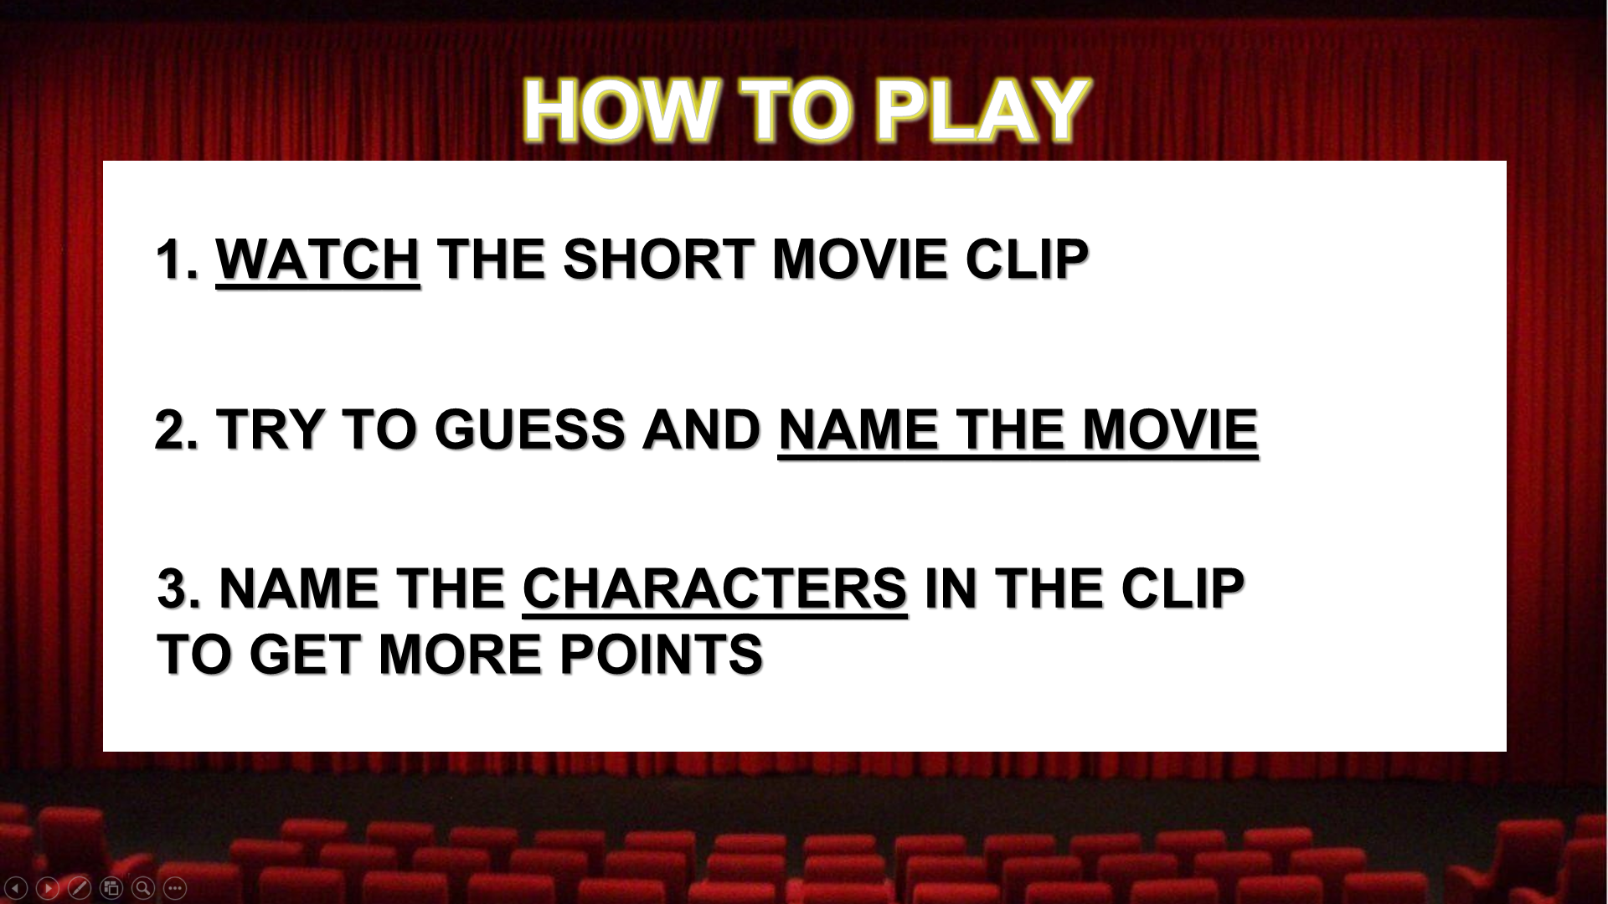  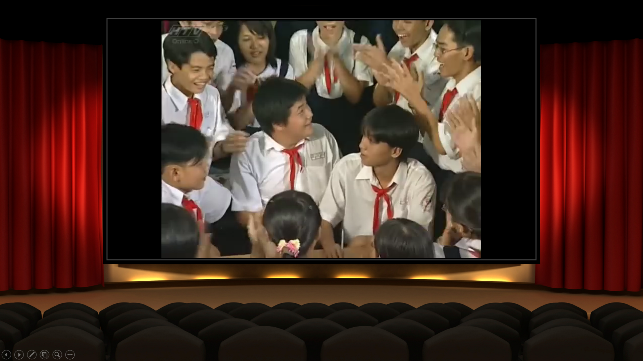  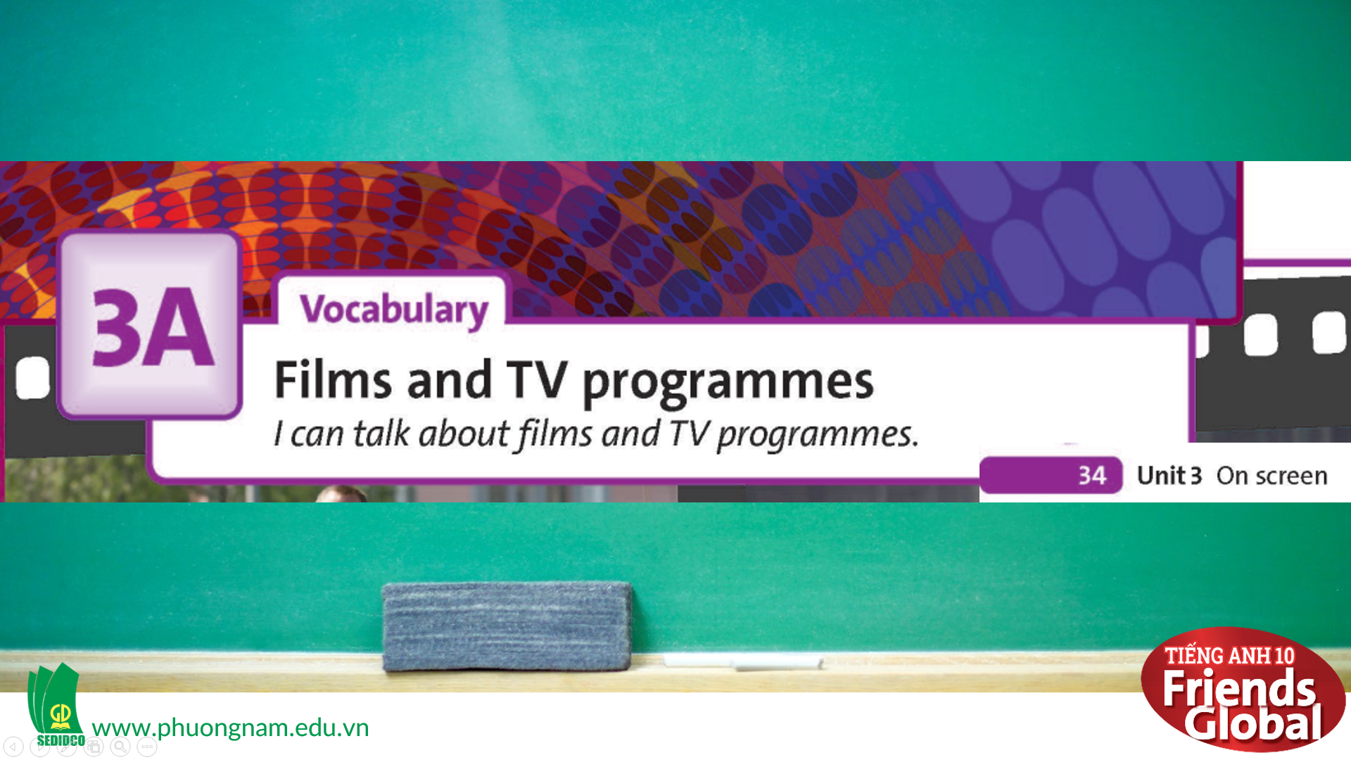

B. New lesson (35’)
- Activity 1: Vocabulary (15’)
a) Objective: Students know more words about types of films and TV programmes.
b) Content:
Vocabulary
Listening
c) Outcomes: Students know how to pronounce the new words precisely and use them in appropriate contexts.
d) Competence: communication, collaboration, presentation
e) Organisation of the activity:
TEACHER’S ACTIVITIES | STUDENT’S ACTIVITIES | CONTENTS
PRESENTATION. T -Ss- T/ Ss- Ss/ Individual  Activity 1 (6’): Teach new vocabulary  - Use GIFs and short explanation to present new words  - Have students practice their pronunciation drills  New words:  action film (n)  animation (n)  chat show (n)  comedy (n)  documentary (n)  fantasy (n)  game show (n)  horror film (n)  musical (n)  news bulletin (n)  period drama (n)  reality show (n)  romantic comedy (n)  science fiction film (n)  sitcom (n)  soap opera (n)  talent show (n)  thriller (n)  war film (n)  weather forecast (n)  western (n)  Activity 2 (2’): Task 2 page 34  - Ask the students to match the words in the box below with each photo (A-D)  - After students finish, play the audio of each picture for students to check their answers.  - Give the answers to the class  Activity 3 (5’): Task 3 page 34  - Ask the students to listen to six short excerpts and match each excerpt a type of film or TV programme from the box above  - Give the answers to the class  Activity 4 (2’): Teach new words  - Use gestures, GIFs and short explanation to present new words  - Have students practice their pronunciation drills  New words:  confusing (a)  convincing (a)  gripping (a)  imaginative (a)  spectacular (a)  unrealistic (a)  violent (a) | - Some students will answer the question in order to learn new words.  - Listen to the teacher and repeat in whole class and individuals  - Listen to the audio and complete the task  - Listen again to check the answers  - Check the answers with the teacher  - Listen to the audio and complete the task  - Check the answers with the teacher  - Look, listen, and repeat in chorus in whole class and individuals | New words:  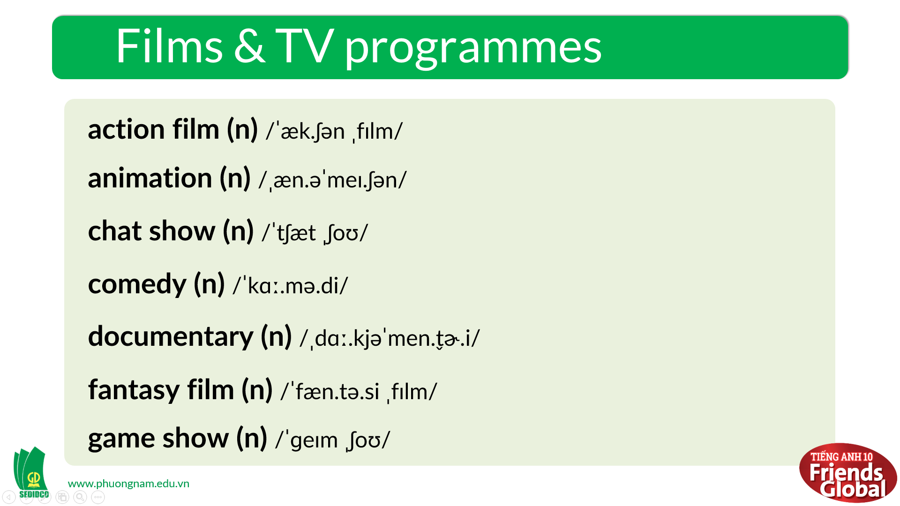  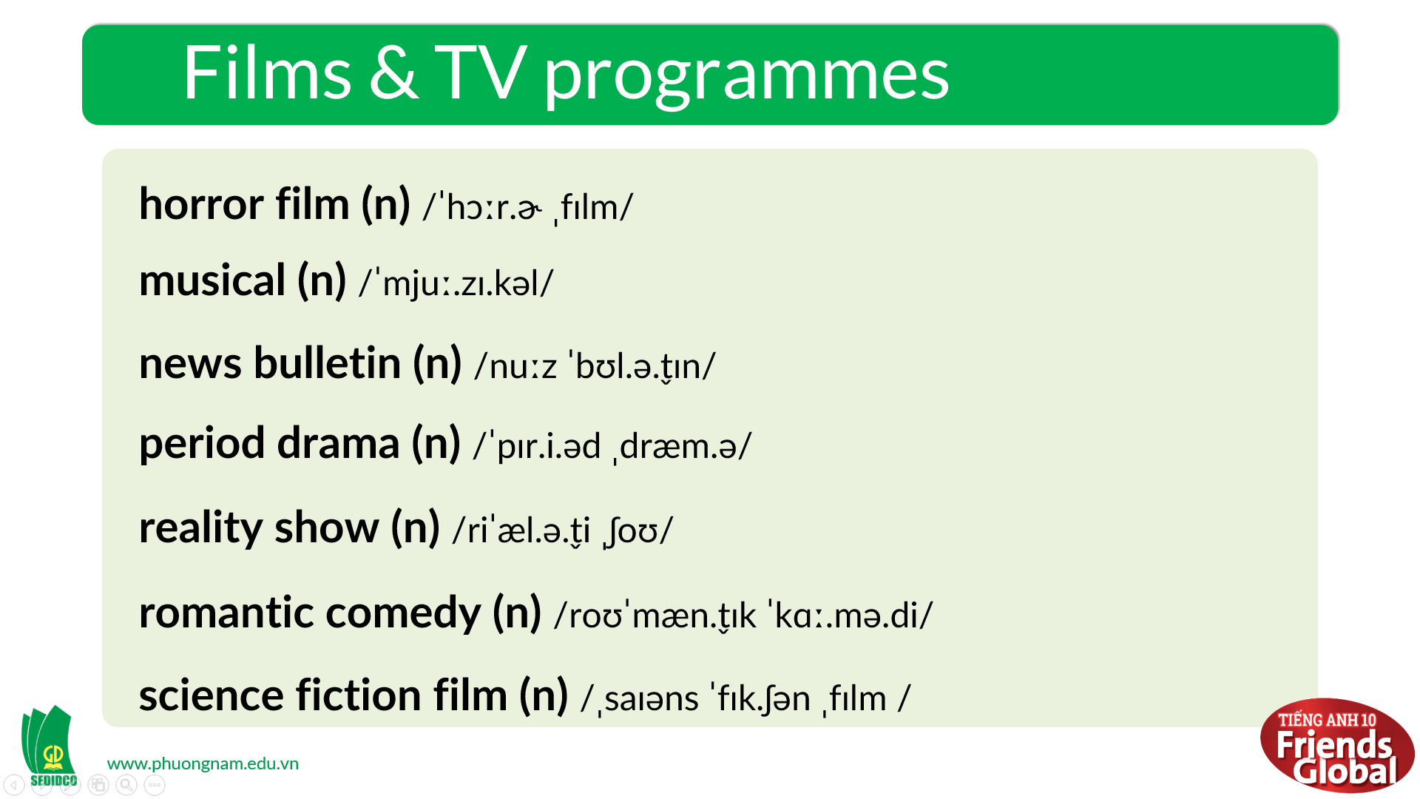  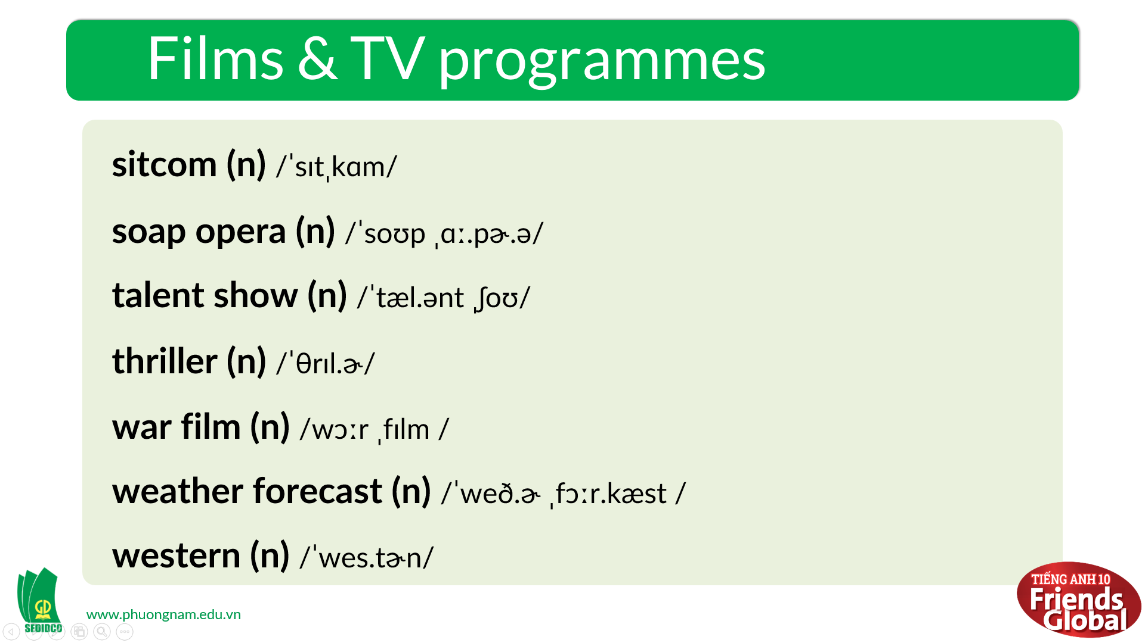  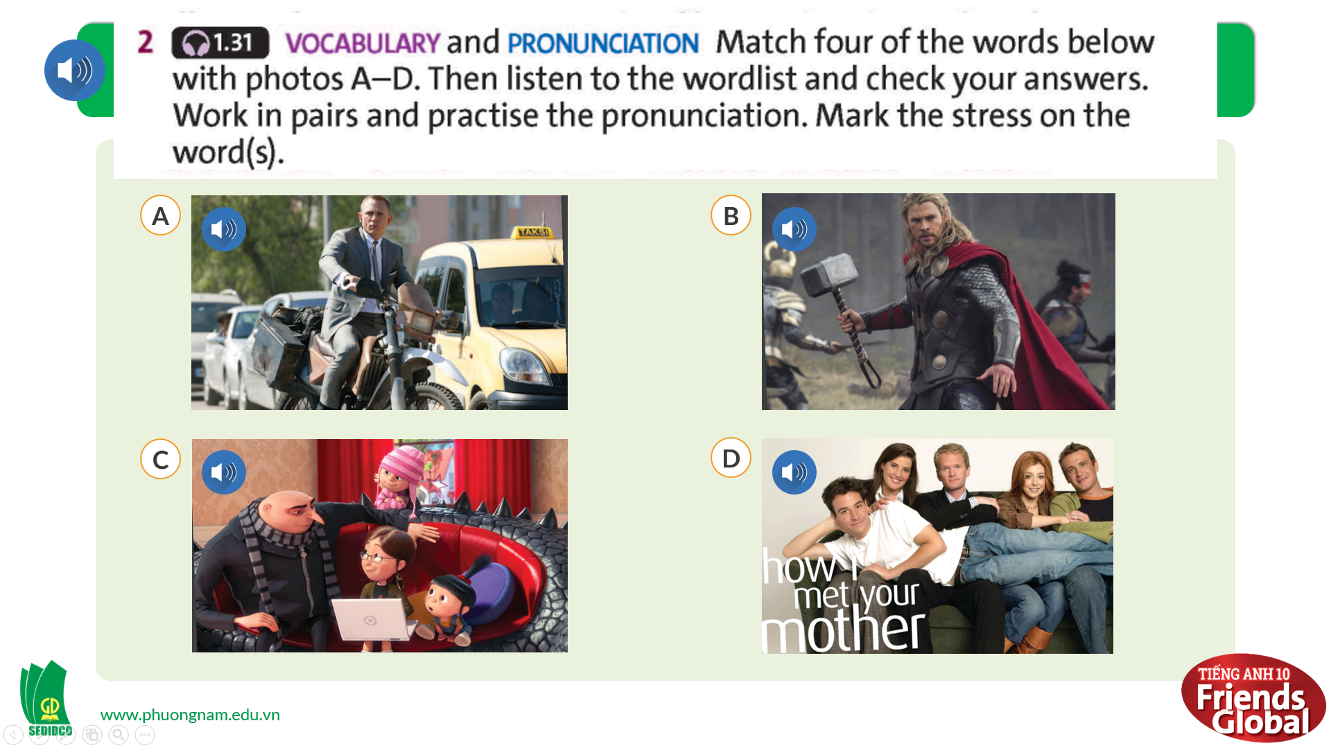  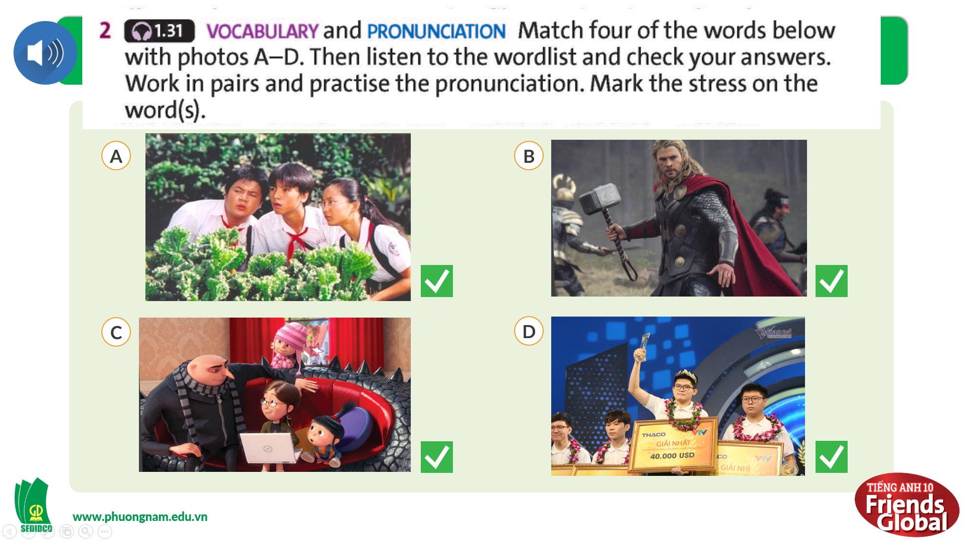  Answers:  1. action film  2. fantasy film  3. animation  4. sitcom  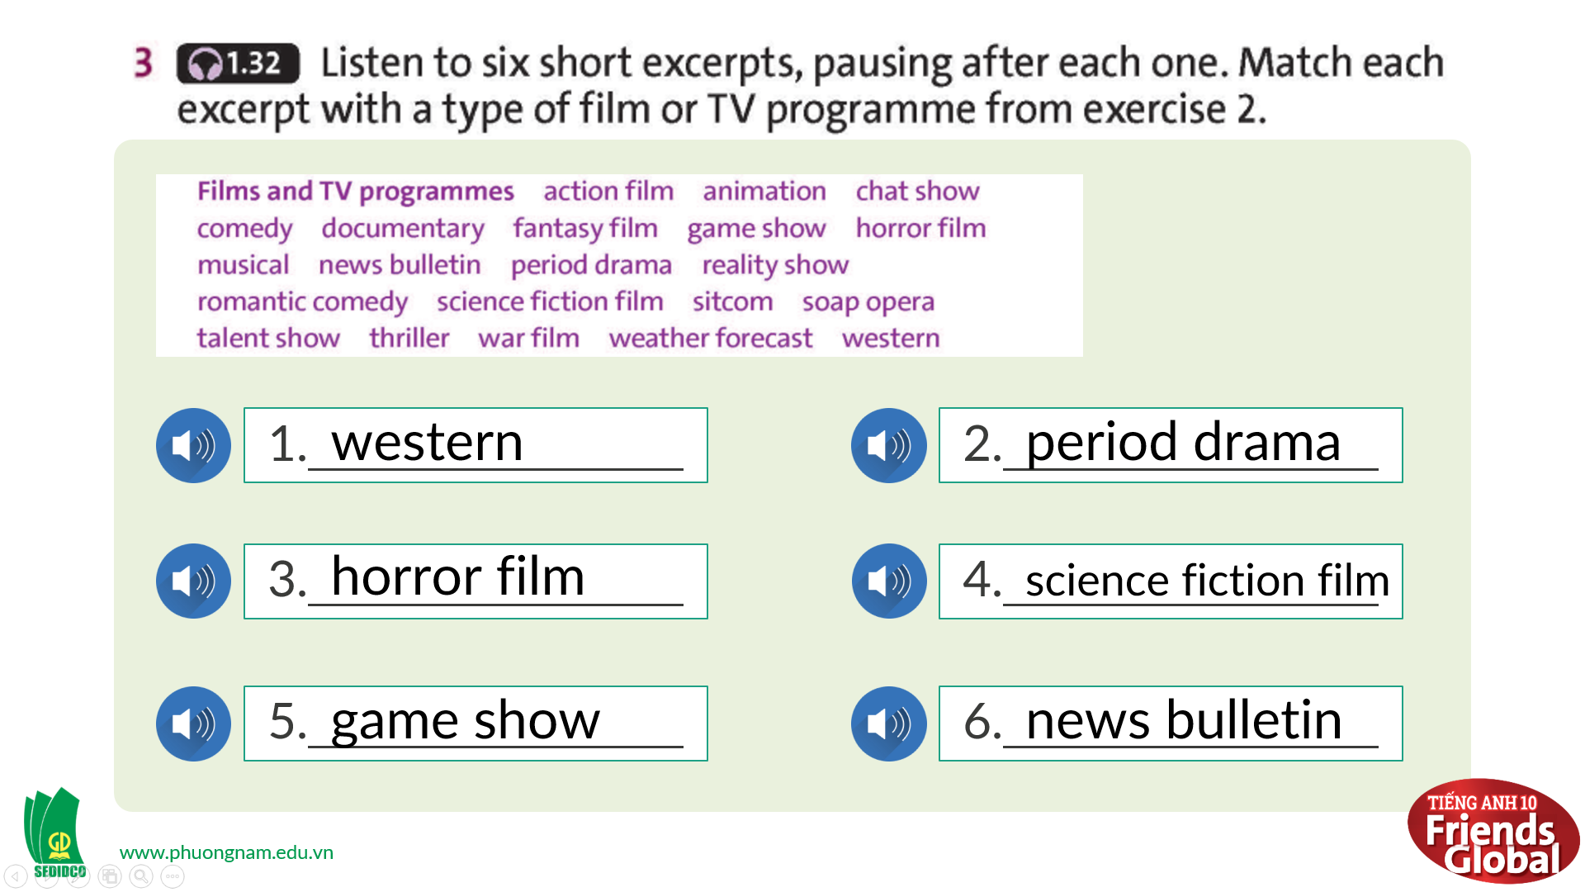  Answers:  1. western  2. period drama  3. horror film  4. science fiction film  5. game show  6. news bulletin  New words:  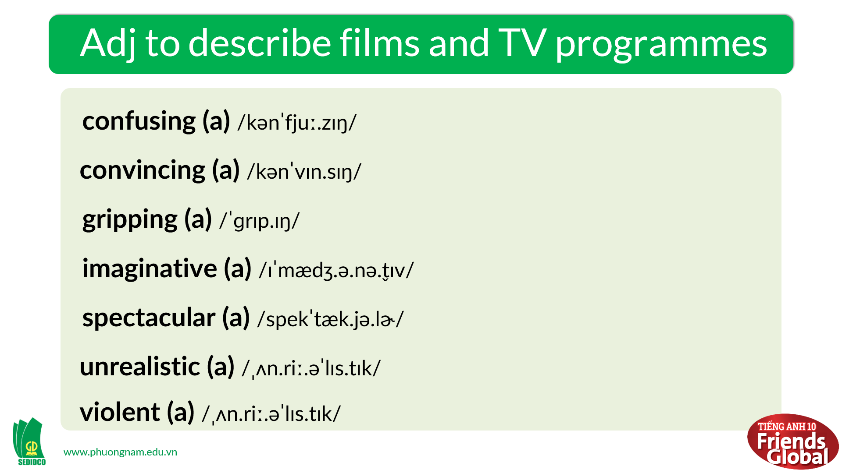
- Activity 2 Practice (12’)
a) Objective: Students can answer the questions to critical thinking, and they can also finish the tasks in the textbook. Critical thinking skills (guessing/ reasoning) and communication can also be practiced.
b) Content: Students answer questions, classify words, choose the correct answer, listen and complete, listen and match.
c) Outcomes: Students read and listen, and they can apply the useful language in everyday listening and speaking.
d) Competence: collaboration, guessing, matching, communication
e) Organisation of the activity:
TEACHER’S ACTIVITIES | STUDENT’S ACTIVITIES | CONTENTS
PRACTICE. T-Ss- T/ S – S/ Individual  Activity 1 (4’): Task 4 page 34  - Ask students to discuss with their partners about which types of films and TV programmes they like or dislike  - Give students some example sentences to use  Activity 2 (3’): Task 5 page 34  - Ask the students to listen to four dialogues and complete the task  - After students finish, play the audio of each picture for students to check their answers.  - Give the answers to the class  Activity 3 (5’): Task 6 page 34  - Use gestures, GIFs and short explanation to present new words  - Have students practice their pronunciation drills  New words:  acting (n)  ending (n)  plot (n)  scenes (n)  script (n)  soundtrack (n)  special effects (n)  - Ask the students to listen to four dialogues again and complete the task  - Give the answers to the class | - Discuss with their partners about the given topic  - Try to use the language given by the teacher  - Listen to the audio and complete the task  - Listen again to check the answers  - Check the answers with the teacher  - Look, listen, and repeat in chorus in whole class and individuals  - Listen to the audio and complete the task  - Check the answers with the teacher | 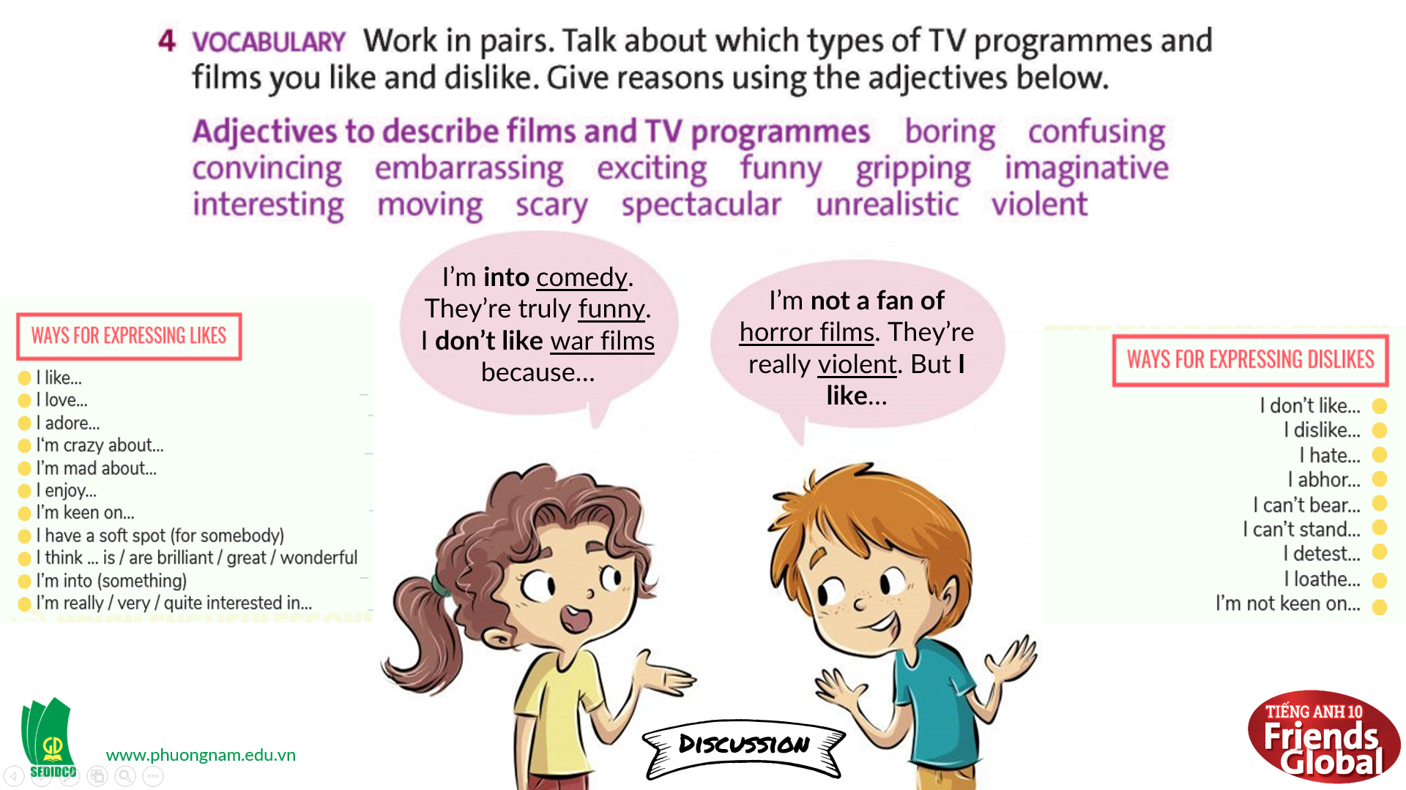  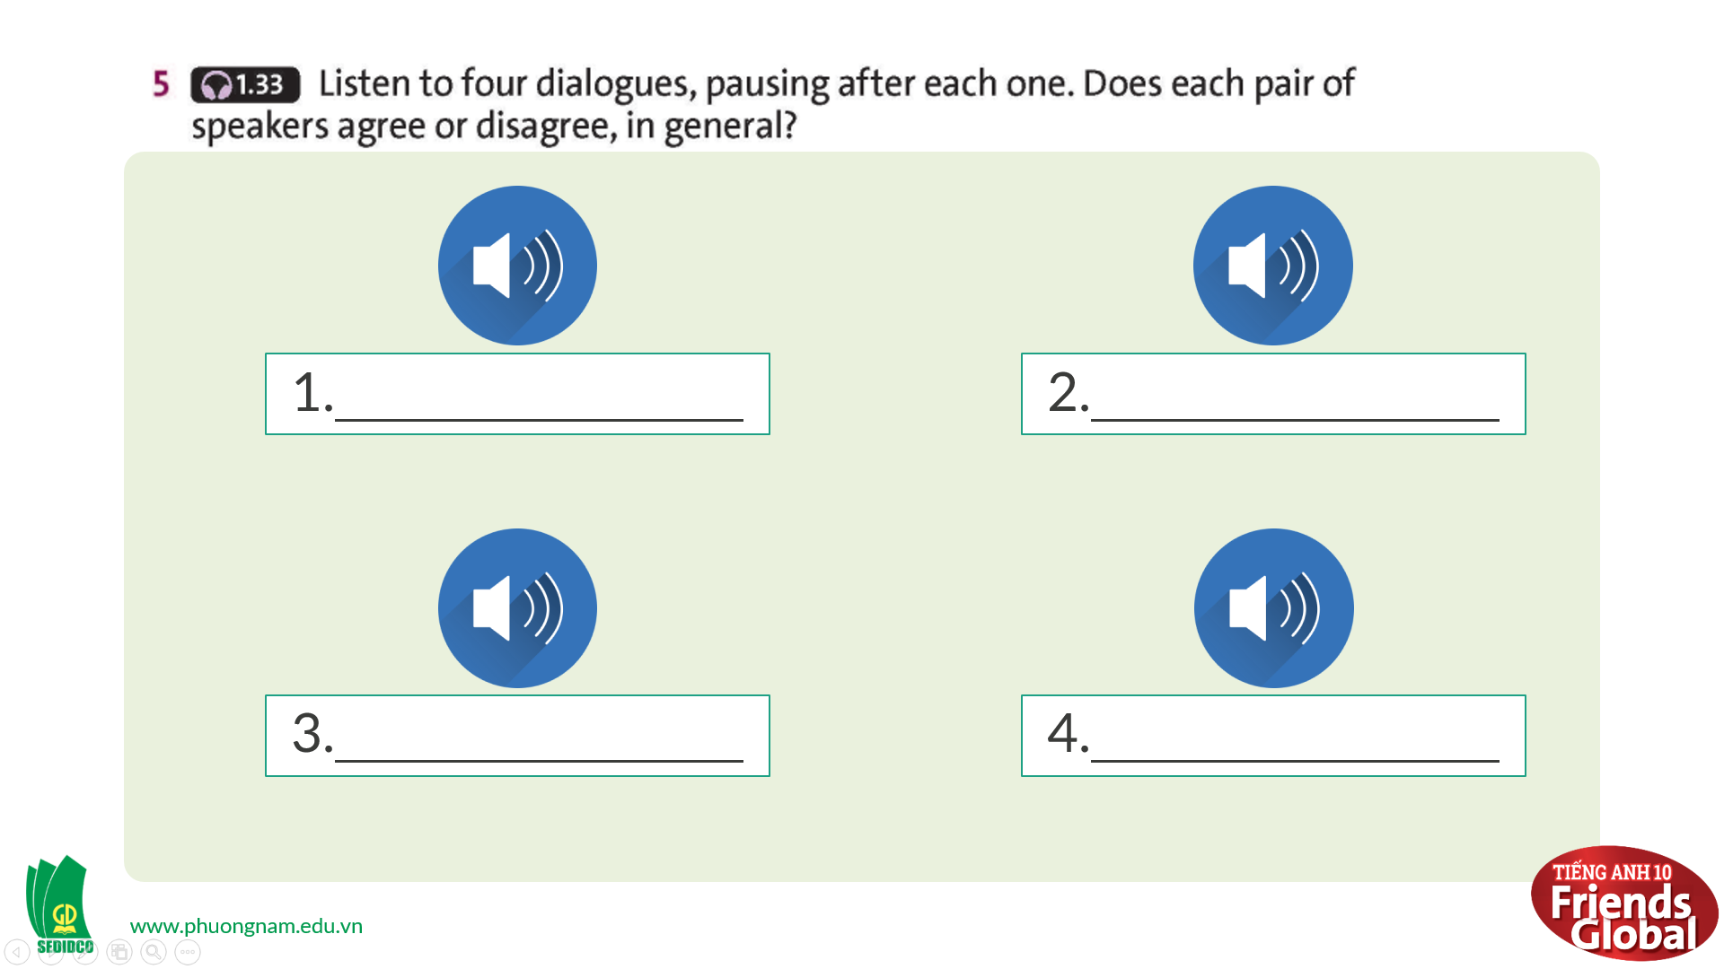  Answers:  1. They agree  2. They disagree  3. They disagree  4. They agree  New words:  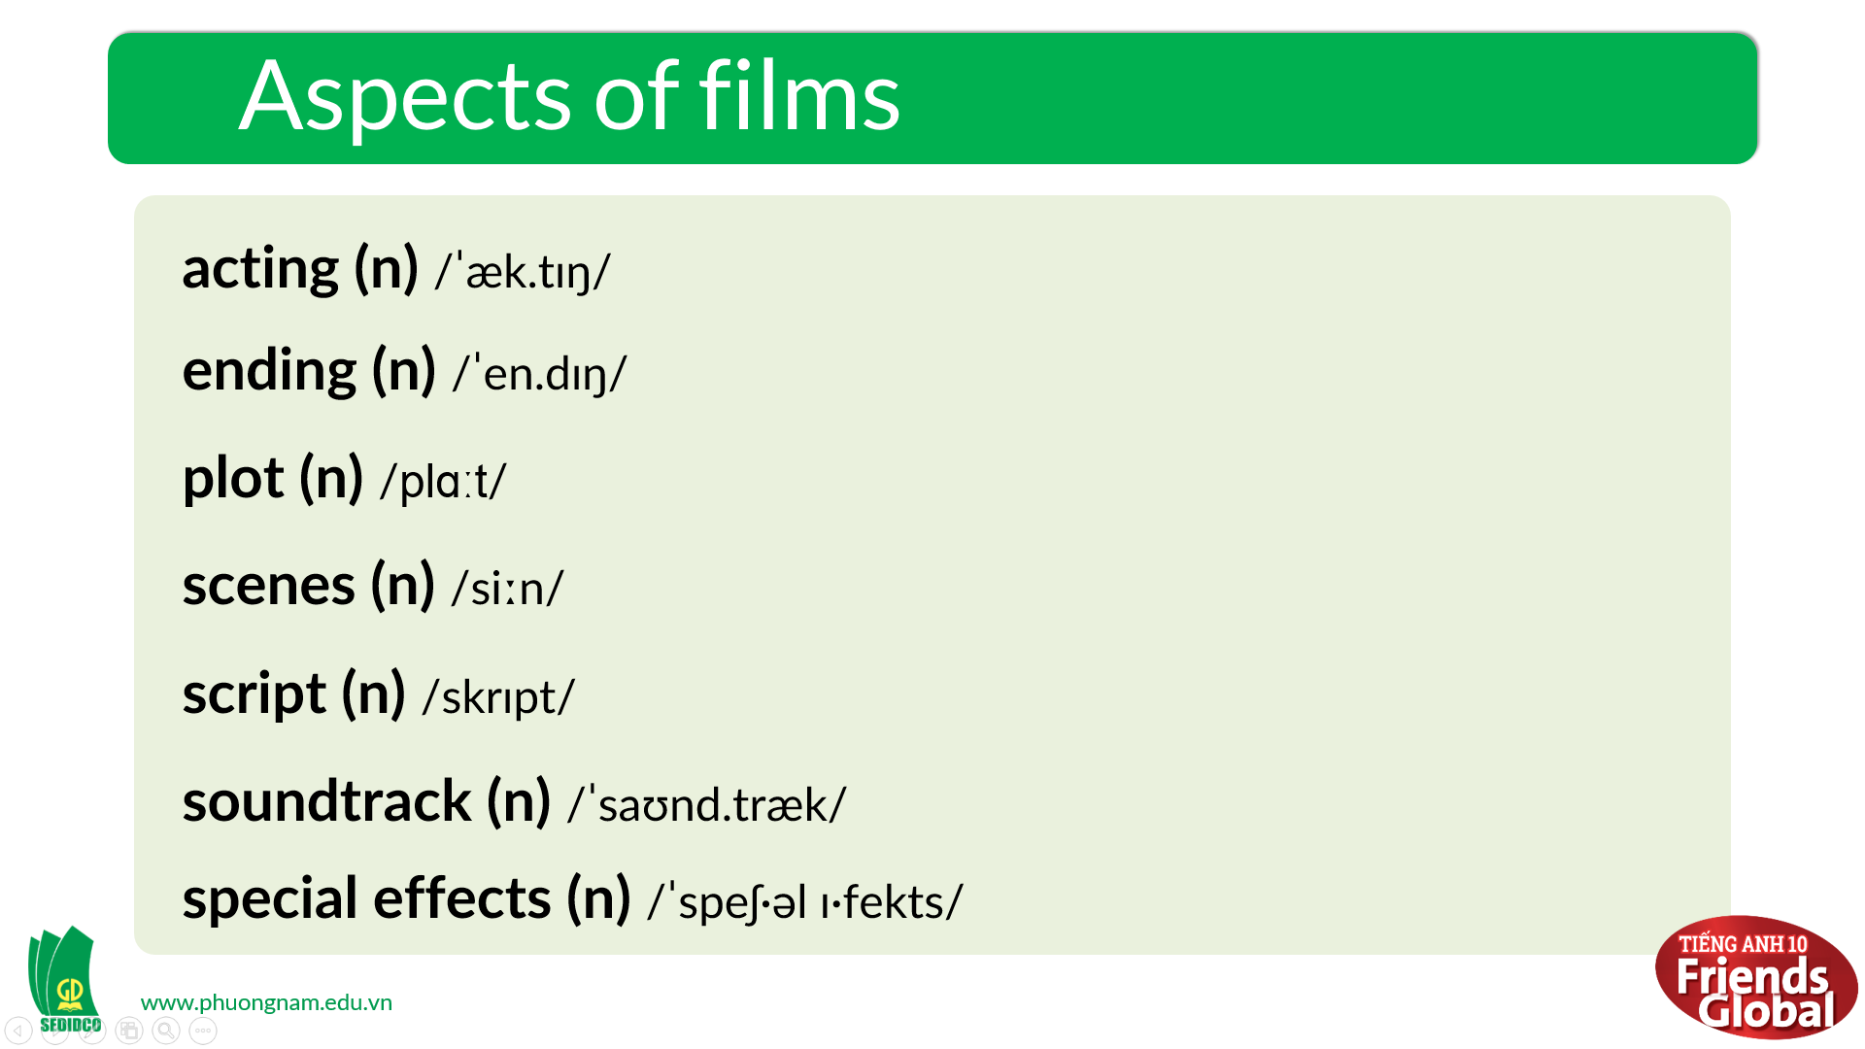  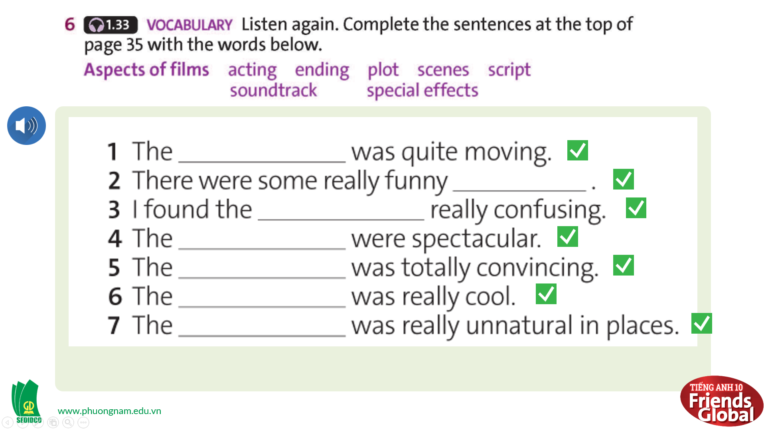  Answers:  1. ending  2. scenes  3. plot  4. special effects  5. acting  6. soundtrack  7. scripts

- Activity 3: Outcomes (8’)
a) Objective: Students can talk about their favorite types of films, express their opinion about a movie they saw recently.
b) Content: Discussion, Film and TV Quiz
c) Outcomes: Students speak and listen mutually, they can apply new words they have learnt in their conversation.
d) Competence: Collaboration, communication
e) Organisation of the activity:
TEACHER’S ACTIVITIES | STUDENT’S ACTIVITIES | CONTENTS
PRODUCT. S – S/ T – Ss  Discussion (3’): Pair-work  - Ask students to share their opinion of a film they saw recently with their partners  - Give students some example sentences to use  - Try to encourage students to use the language they have learnt  Film and TV Quiz (5’):  - Ask students to work with their friends to complete the Quiz  - Give the answers to the class | - Discuss with their partners about the given topic  - Try to use the language given by the teacher  - Try to use the language they have learnt in the lesson  - Work with their groups to complete the Quiz in limited time  - Check the answers with the teacher | 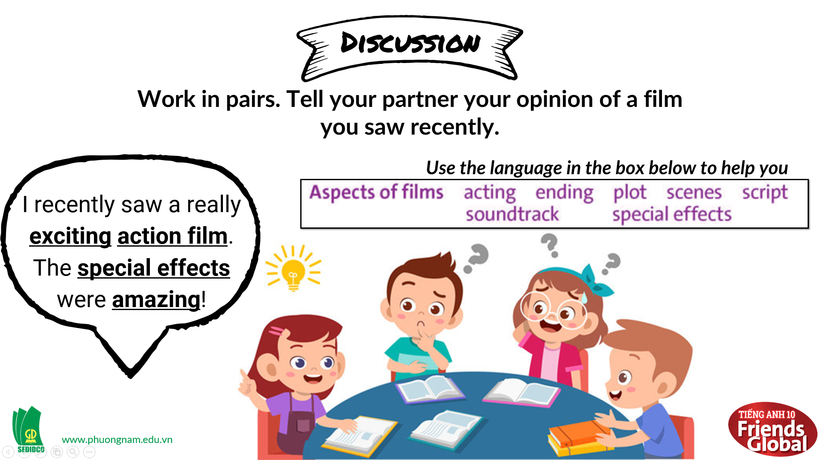  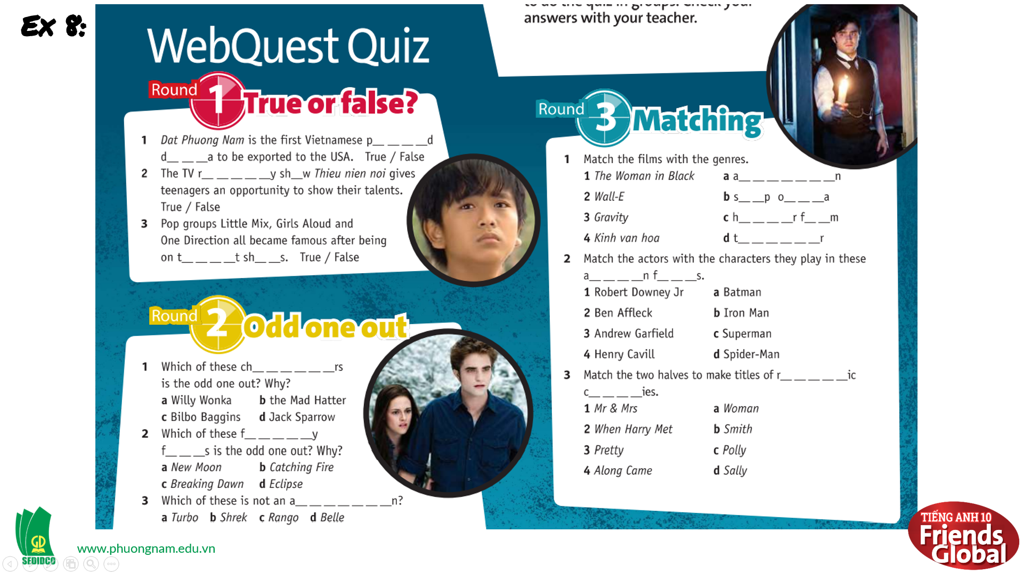  Answer:  R1: T/ F  1. True  2. True  3. True  R2: Odd one out  1. c  2. b  3. c  R3: Matching  1.1. c 2.1. b 3.1. b  1.2. a 2.2. a 3.2. d  1.3. d 2.3. d 3.3. a  1.4. b 2.4. c 3.4. c

C. Consolidation (3’)
a) Vocabulary: films and TV programmes, action film, animation, chat show, comedy, documentary, fantasy film, game show, horror film, musical, news bulletin, period drama, reality show, romantic comedy, science fiction film, sitcom, soap opera, talent show, thriller, war film, weather forecast, western, confusing, convincing, gripping, imaginative, spectacular, unrealistic, violent, acting, ending, plot, scenes, script, soundtrack, special effects, etc.
b) Give opinions and review a film or TV programme
D. Homework (2’)
- Learn by heart new words
- Practice review a film or TV programme saw recently
- Do exercise in the workbook
- Prepare: Unit 3 – B-Grammar (page 36 – SB)

